ISSN 2093-3584

The KMI News Letter
Ocean & Future

March 2015. Vol.60

- Opinion

Direction of Response for Advancing into Fisheries Industry in Arctic High Seas
  - Measures to accelerate modernization of Korea’s coastal vessels

- Ocean Policy

Considerations for developing LNG bunkering facilities in Korea

- Research Findings

Measures to Re-define Functions of Free Trade Zone According to Changes in Foreign Investment Factors

- Research Projects

- KMI News & Events

Direction of Response for Advancing into Fisheries Industry in Arctic High Seas

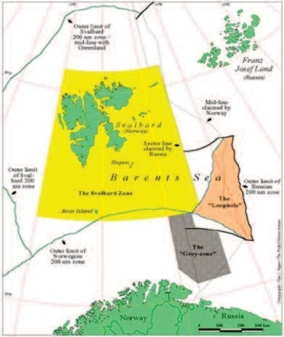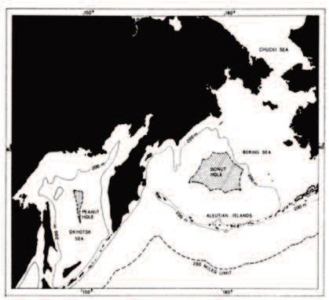As the thawing of sea ice in the Arctic Ocean is accel- erating, the possibility and expectation of fisheries industry in the Arctic Sea are increasing. Specifically, interests in in- ternational regulations on fishing operations at high seas are rising in case that the fishing operations at Arctic high seas are allowed.

Major coastal countries have built solidarity and strengthen their rights and interests at high seas in accor- dance with the United Nations Convention on the Law of the Sea (UNCLOS) and other international regulations re- garding fisheries management. Accordingly, high seas be- come more of ‘closed seas’ rather than ‘open seas’. As a result, legal status of high seas is converging to that of Ex- clusive Economic Zone (EEZ).

In fact, there are four pocket high seas surrounded by EEZs of coastal countries where fishing operations are pro- hibited, losing its status as open seas; Donut Hole in Bering Sea, Peanut Hole in Okhotsk Sea, Loop Hole in North At- lantic Ocean and high sea pockets in South Pacific.

Under the circumstances, the analysis on the interna- tional legal status and related trends of the Arctic Ocean re- sults in the following implications. First, regulation measures of fisheries management in high seas are to strengthen the management system for high seas fisheries industry itself. Second, the areas under the management are expanded through interactions with other areas such as trade to reflect the changes of high sea fisheries manage- ment. Third, high sea fisheries order is increasingly con- nected to the preservation of marine environments. Forth, the principle of international cooperation has been speci- fied by regional fisheries organizations, becoming a prac- tice. Fifth, the precautionary principle for fisheries management in high seas is not remained as a declaratory statement, but is implemented based on scientific grounds.

In order to cope with these international trends, it is important to actively participate in regional fisheries organ- izations for the Arctic Ocean and its adjacent waters. Also, mid- and long-term strategy for developing deep sea fish- eries industry should be in place for utilizing fisheries re- sources in the Arctic Ocean and high seas. Lastly, it is
necessary to raise our capacity related to the Arctic Ocean by conducting a case study on fisheries management in high seas and education training.

<Figure 1> Loophole, Barents Sea

Source: http://www.fao.org/docrep/006/y4652e/y4652e0e.htm

<Figure 2> Donut Hole, Bering Sea

Source: http://www.fao.org/docrep/003/t3740e/T3740E21.gif

<Figure 3> Peanut Hole, Okhotsk Sea

Source: http://www.ofis.or.kr/
<Figure 4> Distribution of Pocket High Seas in South Pacific

Source: Conservation and Management Measure for Temporary Extension of CMM 2008-01

Contact Information
Seonhee Eom sheom@kmi.re.kr

Measures to accelerate modernization of Korea’s coastal vessels

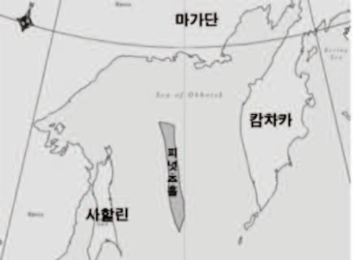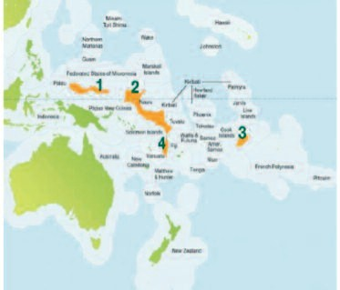Current Status and Prospects

Since the Sewol ferry sinking last year, concerns on ship safety are increasing with domestic navigation vessels (pas- senger, freight, government vessels) aging. As of the end of 2013, 24%(42 ships) of 173 passenger ships in total and 18% (268 ships) of the total 1,490 excursion ships and ferries age older than 21 years.

Korea has operated the entire quantity of passenger ships by adopting second-hand ships from foreign coun- tries. This is closely related to the problems of domestic shipyards. Although large shipyards have a capacity to build large passenger ships such as car ferry, shortage of contin- uous demand has made them reluctant to build coastal ships. Also, small and middle sized shipyards are unwilling to take new orders due to lack of shipbuilding capacity, rel- atively expensive unit cost and risk of bankruptcy caused by management crisis. While international organizations such as IMO are calling for introduction of environmental friendly ships, keeping coastal ships in poor shape runs counter to the request.

Korean Government’s Policy for Modernizing Coastal Vessels

The Korean government announced ‘Safety Manage- ment Reform for Coastal Vessels’ in October 2014 and has actively implementing relevant policies. This is to address the aging of coastal passenger ships and enhance their safety. In particular, the government measures include the adoption of ‘Shared Ship Building System’.

The Shared Ship Building System is to set up a public investment vehicle for building coastal ships and share the required fund with shipping companies (public investment vehicle shares 70~90%). This is considered an excellent sys- tem in that shipping companies can take little burden at the initial stage.

This system is already implemented in Japan, laying the groundbreaking foundation for modernizing vessels. Japan came up with the system as the country suﬀered frequent passenger ship accidents in the 1950s. In 1959, Japan started introducing the Shared Ship Building System’ to modernize

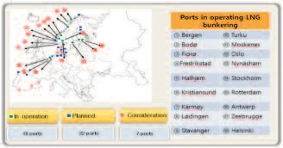
and secure safety of the passenger ships, building 3,900 ves- coastal vessels will meet the demand of modernizing aging sels (25% of them are passenger ships) so far. ships after the Sewol ferry disaster. Second, Korea’s small
and middle shipyards will enhance their building capacity The Korean government is reviewing the details of the of passenger ships leading to future growth. Third, building system (optimal interest rates, funds repayment system) to eco-friendly ships will help response to IMO regulations provide practical support to the industry. With the budget such as limiting greenhouse gases, NOx and SOx. Fourth, already secured, the government is also scheduled to review since coastal vessels serve as an essential transportation on introducing the Shared Ship Building System in cargo mode for industry supplies, tool for economic activity in is- ships with private businesses. land areas, vehicle for marine tourism and emergency transportation in time of national disaster, it will have a rip-
3. Expected Benefits ple eﬀect on relevant fields.

The modernization of coastal vessels is expected to have
Contact Information
a substantial impact on various areas including coastal ship- KIM TAE-IL
ping industry. First, strengthening safety management of ktizorro@kmi.re.kr
OCEAN POLICY
Considerations for developing LNG bunkering facilities in Korea

Lowering sulfur limit to 0.1%m/m (enacted by IMO) 1.World Trends of building LNG bunkering facility
for emission control area (ECA) started this year in 2015.
And the sulfur limit for normal sea will be reinforced to As for European ports, 35 ports are planning or con- 0.5%m/m in year 2020 or 2025 from the current 1.0%m/m. sidering building LNG bunkering facilities for LNG fuelled European ports are not only quick to respond to this rein- ship. In Europe, about 18 ports including the Port of Rot- forced emission regulations, but also respond to user’s en- terdam, Antwerp are operating LNG bunkering facilities. vironmental needs for obtaining competitive advantage. And 22 ports plan to build LNG facilities. Other 7 ports are Adopting LNG (liquefied natural gas) as a fuel is the most considering building the facilities.
attractive way to achieve this goal, helping to reduce SOx
and PM by 100%, NOx by 85 to 90%1) , and CO2 by 20%. <Figure 1> European Ports with LNG bunkering facilities
Major ports are considering or developing LNG bunkering facilities for ships. Under the IAPH, World Port Climate Initiative has LNG fuelled vessels working group studies and considers port cooperation for LNG bunkering. Most of the participating ports in this study are located in Europe with 2 US ports. The ports covered by this study are Antwerp, Amsterdam, Bremen/Bremerhaven, Brunsbüttel, Gothenburg, Gothenburg, Hamburg, Le Havre, Los Ange-
Source: Korea Maritime Institute, Interim Report, “Considerations for LNG
les, Long Beach, Rotterdam, Stockholm and Zeebrugge. bunkering port facilities in Korea”, ’15.01.23

1) In case of Adopting EGR (Exhaust Gas Recirculation)

  - Port of Rotterdam

From March 2013, two LNG fuelled inland barges op- erating on the Rhine started to be bunkered in Rotterdam. With active participation of port authority, the municipality of Rotterdam amended port management regulations to allow bunkering to inland shipping from July 2013. Seago- ing vessels were accepted as of 1 July 2014 as the munici- pality amended port management regulations. Port of Rotterdam, therefore, became the first European port where bunkering of LNG was legally regulated. Vopak and Gasunie (two of three initiators and partners of Gate ter- minal) are developing a terminal next to Gate LNG termi- nal where LNG can be handled as a fuel for small oceangoing vessels, bunker barges and trucks2). The termi- nal is expected to be operating in 2015. Also Shell is sched- uled to start LNG bunkering at the port with three bunkering shuttle ships of 13,000m2 and one with 6,700m2 storage capacity. The Port expresses its ambition to be a main gas hub and LNG feeder distribution center in the world.

  - Port of Antwerp

Port of Antwerp takes an initiative for port response of LNG bunkering. The port of Antwerp accepted the leading role of an international port working group of LNG fueled vessels as part of the world climate initiative in the Inter- national Association of Ports and Harbors (IAPH). In De-

cember 2012, the first LNG bunkering has been done at the port of Antwerp where the dual-fueled oil tanker Aragon was bunkered. In September 2013, the port was granted a subsidy from European Commission to build an LNG bunkering station for barges. LNG bunkering of Antwerp currently seems to concentrate on in-land barge bunkering with LNG master plan for the Daunube-Main-Rhine. How- ever bunkering for ocean-going vessels from Antwerp does not seem to be promising compared to that of Rotterdam. A selected strategic partner, EXMAR decides against build- ing LNG bunkering vessels considering situation of Rotter- dam port in February 2015.

- Port of Stockholm

In 2013, the port of Stockholm started to oﬀer a LNG bunkering solution to a large passenger ferry. On January 2013, Stockholm fueled the Viking Grace, a passenger ferry via LNG truck. Viking Grace is the first large LNG fuelled passenger ferry in the world. In March 2013, the first ship to ship bunkering to Viking Grace has been implemented by a small LNG fuelling ship, the Seagas with a 180 m2 tank onboard. The LNG comes mainly from Nynashmn import terminal, south of Stockholm operated by AGA. Current LNG bunkering in Stockholm is designed specifically for Viking Grace. If more LNG-fuelled ships begin to operate, the LNG infrastructure needs to be developed further.

Besides European ports, port of Fujairah in Iran, port

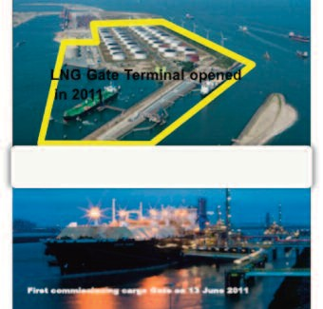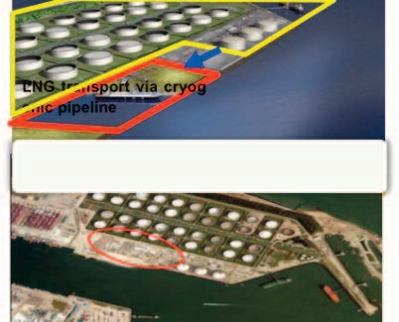
<Figure 2> Development of Rotterdam LNG bunkering facility

LNG Gate Terminal opened in 2011 LNG transport via cryogenic pipeline

2) Siyuan and al., The development of LNG bunkering facilities in North-European ports

of Singapore, Port of Zhousan in China considers building LNG bunkering facilities for ocean-going vessels. Port of Nanjing has built small scale bunkering facilities with 500m2 storage and conduct bunkering for in-land barge.

2. Needs to develop LNG bunkering facilities in Korea

Thanks to the rise of Shale gas developed in the US, US gas price has dropped to around $3 per mmbtu (Henry-Hub Price) and this makes US to become an energy exporter from importer. Guaranteed low LNG price, Korea has a bet- ter position for LNG bunkering for vessels compared to Singapore for Busan has shorter distance from US west coast, saving 5days of LNG carrier operation, which leads
to price advantage. Considering Future LNG vessel adop- tion for ocean going vessels, Korea needs to conduct a fea- sibility study of LNG bunkering facilities before 2020 or 2025 SOx limit enhancement. Considering the time to adopt port development plan for policy, at least 2 years for policy adoption and 4~5 years for building infrastructure, now is the right time to start conduct a thorough feasibility study for building LNG bunkering facilities. Once we are late for building facilities, and Singapore and China take initiative building LNG bunkering facilities, Korea will be losing the race once LNG fuelled vessels comes in.

Contact information Kim Jung Hyun jh-kim@kmi.re.kr

Measures to Re-define Functions of Free Trade Zone According to Changes in Foreign Investment Factors

Purposes

It aims to suggest the measures to re-define functions of free trade zones and improve institutions based on a de- tailed analysis on changing foreign investment patterns ac- cording to the recent change in the global economic environment. It aims to increase global competitiveness of Korea’s free trade zones. The ultimate objective of the re- search is to establish a foundation to increase national wealth and employment.

Methodologies and Features

- Methodologies
port type and airport type. However, it was hard to classify related laws and regulations and institutions and the access to related data was restricted. Therefore, the study was ex- panded to include industrial complex type and airport type upon its necessity.
The current status and features of Korea’s free trade zones were analyzed and the current situations of the free trade zones were evaluated according to its purposes. And the changes in the global conditions and its influence on the free trade zones were reviewed. In addition, informa- tion and opinions were exchanged through overseas case study and small-scale expert seminars. Based on the result, the measures to improve free trade zone systems were pro- posed.

<Table> Characteristics of the Methodologies

Features | Major description | Data collection | Reasons for choice
Basic analysis | - Current status and evalua- tion of free trade zones in Korea  - Case study of China, Thai- land and the US | - Related literature – Profes- sional consultation | - It is necessary to understand the current status and con- duct basic research
Internal seminar | - Current status and changes of foreign investment attrac- tion environment in Korea  - Facilitation of value chains and business attraction  - Operation system and cur- rent management status of free trade zones | - Advisory conference includ- ing presentation and discus- sions of the experts in various areas | - It is considered that commu- nications and idea exchanges with experts in various areas through internal seminars are eﬀective in developing measures to improve institu- tions
Statistical analysis | - Major factors that influence the foreign investment amount in free trade zones | - Related literature  - Information DB | - Empirical analysis is needed
Expert consulta- tion and joint research | - Change in the foreign invest- ment attraction environment  - Current status and change in free trade zones in China | - Getting advice from and lis- tening to experts | - It addresses limitations of the existing literature research

- Features

The study mainly focuses on port type free trade zones among three major types that are industrial complex type,

Results

- Summary

Among the four major purposes for free trade zones in Korea, foreign investment attraction, trade promotion and facilitation of international logistics are considered to be achieved well above the certain level. However, it requires time to see the purpose of regional development as it was recently introduced.
China has continued to introduce new institutions, keeping up the changing conditions. It opened Shanghai Pilot Free Trade Zone in 2013 following Bonded Area (1999), Foreign Trade Zone (2000), Bonded Logistics Zone (2003) and Bonded Port (2005). Unlike the free trade zones in Korea, that restrict business types, it’s relatively free for service business to move in the free trade zones in China. Korea’s free trade area systems do not keep up with the global environment. The governance structure and similar systems are duplicated and mixed and conflict with customs laws. Such issues require solutions. Among existing func- tions of the free trade zones, the two functions with high possibility of conflict, strengthening of trade function and regional development, should be separated and re-aligned
to properly operate free trade zones in Korea.
The dualized institutional structure is suggested as fol- lows. The zones with high connectivity with global value chains and frequent foreign investments such as the capital area, southeast area and central area are selected as leading regions (First-Class Free Trade Zone). The areas with a big- ger local development function such as Gangwon area and Jeonbuk area is separated as a special area (Second-Class Free Trade Zone).
The institutions that should be newly introduced or en- acted in the leading areas are as follows. It is necessary to improve the business environment-related institutions, which include introduction of cluster support and promo- tion system, post-evaluation support system, eﬃcient man- agement and operation of foreign investment committee and transition of move-in methods, reduction of inventory management obligations, simplification of export and im- port declaration process and mitigation of access control.
The following are the policy direction proposals for the special areas. It is necessary to increase incentives to free trade zones, relax the regulations on move-in qualifications and export ratio and to give preferential treatment to small- and medium-sized company tenants.
And it is necessary to revise the free trade zone law and system, newly enact integrated laws on foreign investment attraction, analyze riﬄe eﬀects of foreign investment attrac- tion, establish standardized evaluation index and statistics for added values of the free trade zones and improve gov-
ernance and management, operation systems.
At the same time, it is necessary to promote best prac- tices, develop and strengthen free trade zone-related busi- ness models, establish systematic business attraction strategies and establish growth foundation for sustainable investment.

- Policy contribution

It presents the direction and measures to improve Korea’s free trade zone system

- Expected benefits

It is expected that the purpose and intention of intro- ducing the free trade zone system is realized through im- provement of Korea’s free trade zone move-in related systems and management and operation measures. It will increase competitiveness of Korea’s free trade zones and fa- cilitate foreign investment attraction. It will solidify a foun- dation to create national wealth and employment.

Contact information Lee Sung Woo waterfront@kmi.re.kr

  - A study on expansion of aquaculture insurance items
  - The 3rd nationwide costal port master plan revision (prospects for development condition)
  - A study on port development condition prospects and reestablishment of development direction for the 3rd basic plan (revised) on national trade ports
  - A mid and long term study of eﬀective preservation and smart usage of Suncheon bay
  - Yeosu project - SOI support project for CBD
  - The 2nd port redevelopment basic planning (academic research)
  - Consigned operation of 2015 shipping, port and logis- tics information center homepage
  - 2015 National transportation surveys and DB establish- ment
  - 2015 follow-up study on the basic plan of the Arctic pol- icy
  - Survey on fisheries equipment industry and promotion measures
  - A validity study on master planning of Russia Far East Port
  - A validity study and revised plan (draft) on public water reclamation
  - Comprehensive report on Sewol ferry sinking
  - A basic Plan on Myanmar port development and its va- lidity
  - 2015 analysis on actual conditions of beaches and man- agement types
  - Impact of radioactive substance concentration on fish- eries products and case study (3rd)
  - A study on biz model development and luring of busi- ness in Pyongtaek-Dangjin Port
  - A study on establishment of mid and long term develop- ment strategy for cruise industry (co-work)
  - Korea-China-Japan transportation and logistics cooper- ation measures (6th)
  - A study on international agreements related to marine life resources
  - A policy study on developing GTO customized to Korea
  - Actual condition survey of beaches and establishment of basic plan
  - 3-2 stage project for building shipping market informa- tion networks
  - A study on pricing systems of Terminal Operating Companies (TOC)
  - Performance evaluation of unified cargo handling equipment and design development of loading/unload- ing work area (2nd year)
- Consigned host of business forum on Korea-Russia Lo- gistics Cooperation Promotion
- System improvements for attracting overseas fisheries investment in Fareast Russia
- Foundation establishment for undersea tests of ocean drilling equipment
- Manual of coastal development plans and follow-up measures for equipment management
- A study on operation, maintenance and management of floodgate facilities
- A study on advancement into special logistics market (centering on joint logistics, cold chain and project lo- gistics)
- Measures for establishing FTZ cold chain hub and net- works
- Survey on distribution channels of renewable energy cargoes at hinterlands in metropolitan area
- The 9th Seoul International Maritime Forum
- A study on fisheries related industry of coastal countries in the Arctic Ocean
- Analysis on polar Arctic/Antarctic policies of major na- tions and international organizations (2015)
- A validity study on the introduction of maritime eco- nomic special zone
- A study on sea areas under environmental management and environmental management system of beaches
- Measures to transport daily necessities to islands
- A study on standard synchronization of port cargo han- dling equipment
- A study on improvement measures for rationalizing public water management
- LNG bunkering supportive ports development measures
- A study on more distribution of small and medium- sized LNG ships
- Follow-up measures for coastal passenger ship safety management innovation
- Entrance plan into shipping and logistics market of Rus- sia Fareast
- A policy study on utilization of container searcher
- Measures to support leisure boat manufacturers
- System improvements of public vessel orders
- A study on preservation and development of Jeju Inter- national ship register system
- Development of fishing villages into the 6th industry (direction and models)
- Korea-China FTA domestic supplementary measures
- 2014 Information provider on overseas market for ocean plant service industry

  - A basic study on introduction of total coastal pollution load management to Ulsan waters under special man- agement
  - Operation measures for changes rates for container cargo handling
  - Advancement into shipping and logistics market in the Black Sea
  - Technology development prepared for coastal erosion (2nd year)
  - Impact analysis on Korea-China FTA
  - Redevelopment project of Donghae Mukho Port (1st stage)
  - Mobile rack and simple cargo handling support technol- ogy for eﬀective and easy cargo handling
  - 2014 Designation and conservation measures for ma- rine life under protection
  - A study on improvement measures for running wage guarantee fund for seafarers
  - A study on autonomous fishing management and meas- ures to build national statistics
  - Impact analysis on Korea-Vietnam FTA
  - Measures for the 4th fisheries development comprehen- sive plans
  - Policy development to utilize oﬀshore geological storage of CO2
  - 2014 Operation and performance evaluation of fisheries self-help fund
  - A validity study on general cargo terminal at Pyongtaek- Dangjin International Passenger Ports
  - Measures to innovate fishing boat policy including in- crease in safety investment for aging fishing boats
  - A study on problems and prior tasks of Korea's advance- ment into overseas aquaculture industry
  - Estimation of added values for key business index
  - A study on development condition for marina ports and demand estimation
  - R&D on marine environment and ecosystem manage- ment nearby Saemanguem
  - Investigation and analysis on investment conditions for advancement into deep sea fishery in Myanmar
  - Technology development for low carbon automation container terminals
  - Negotiation Plan to implement port redevelopment at dredged soil landfill at Myodo, Gwangyang port
  - Consigned negotiation for building marina port at Hupo, Uljin
  - Prospects of applying showroom business model cus- tomized to Korea
- Designation and management of coastal erosion man- agement zone
- A study on international cooperation and overseas ad- vancement to address coastal disasters
- Exploration of 2014 maritime and fisheries ODA proj- ects
- A review on total port load system and economic valid- ity of new target ports
- A review on economic validity and financial soundness of port logistics (Philippines port development)
- An analysis on SOI of Convention on Biological Diver- sity

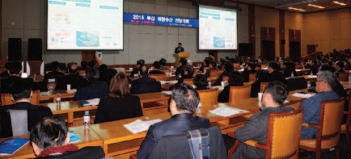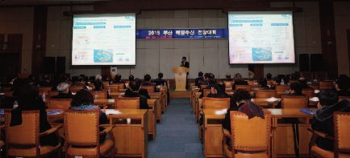Major Activities conducted in February, 2015

2015 Busan KMI Maritime & Fisheries Outlook Conference
  - Time / Place: February 10 (13:30~17:00)/ Busan City Hall Int'l Conference Hall
  - Topics: Global maritime and fisheries outlook and trend in 2015
  - Co-organized and hosted by KMI, Busan Metropolitan Government

Distribution of 'Ocean Story', 2014 High School and General Marine Textbook
  - Distributed at maritime education pilot school libraries and national libraries in Korea

2015 Joint Media Report
  - Future Food Report - Find from the Ocean (Joongang Daily / JTBC)
  - Ocean Creates Jobs. (News 1)
  - Smart Era, ICT Meets Ocean. (YTN)

Major Activities planned in March, 2015

Discussion on the legislation of ‘Act on Maritime Economic Special Zone’
  - Time / Place : March 16 (Mon) (Tentative) / Seoul (BPA Oﬃce)
  - Participants : MOF, KMI, KIEP, Busan Metropolitan City etc.
  - Major Contents : Review the results of demand survey and analysis of current issues in preparation for vice ministers’ meeting presieded by the chief of economy

Forum for Next Logistics Technology Holds the 1st International Seminar
  - Host: KMI, Transportation Research Forum of the US
  - Time / Place : March 13 (Fri) 13:00 / Georgia Tech. Hotel & Conference Center, USA
  - Presenter : Professor Anthony M. Pagano (UIC), 6 Peo- ple including research head Kwon Yong-Jang (Korea Railroad Research Institute)

Publisher
Kim Sung Gwi - President, Korea Maritime Institute

Editor-in-Chief
Choi Jae Sun - Director General, Planning & Coordination Division

Editorial Board
Mok Jin Yong - Director General, Marine Policy Research Division
Joung Myung Saeng - Director General, Fisheries Policy Research Division Kim Woo Ho - Director General, Maritime Industry & Safety Research Division Jun Chan Young - Director General, Port Research Division
Kim Jong Deog - Director General, Strategy Research Division

Secretary
Song Wonkeun - Planning & Coordination Division Lee Yun Jung - Planning & Coordination Division

Contact Information
Address: 26, Haeyang-ro 301beon-gil, Yeongdo-gu, Busan, 606-080, Korea Tel: +82-51-797-4800
Fax: +82-51-797-4810
Email: jschoi@kmi.re.kr, wksong7@kmi.re.kr

