ISSN 2093-3584 October, 2012. Vol.32

- Opinion
  - Joint Development of Mineral Resources in North Korea and Its Implications on the Inter-Korean Shipping
  - The Comparison on Port Competitiveness by Nation: with Focus on IMD World Competitiveness Yearbook

- Ocean Policy
  - Propelling Accordance between Port ODA and “the International Cooperation Law”

- Research Findings
  - Measures to Improve the License System of Coastal Passenger Transportation Business

- Research Projects

- International Cooperation

- News & Announcements

01
Opinion

Joint Development of Mineral Resources in North Korea and Its Implications on the Inter-Korean Shipping

Importance of Mineral Resource Use in North Korea

A stable supply of mineral resources is critical to Korea since the nation imports 90% of them. Korea’s import of mineral resources more than doubled from USD 8.6 billion in 2003 to USD 30 billion in 2010. Therefore, a source of mineral resources is the key to their stable supply.

Recently, mineral resource development in North Korea has been in the spotlight as China and EU geared up their efforts in North Korea. Although South Korea is participating in resource development in North Korea, its investment or the amount of secured resources never seems enough. The global attention to mineral resources in North Korea is justified: mineral resources in that reclusive country have huge potential as for the amount and value.

According to the Korea Resource Corporation, North Korea’s reserves of magnesite, tungsten, molybdenum, gold and mica are the world’s tenth largest and their potential value is estimated at KRW 4.321trillion. In contrast, the potential value of mineral resources in South Korea is merely KRW 132 trillion and the country is heavily dependent on imported mineral resources by more than 90%. As resource nationalism is expected to prevail, South Korea should seek ways to steadily use mineral resources in North Korea, as part of it resource securement.

New Opportunities for Coastal Shipping

At the 10th Economic Cooperation Committee held in Seoul, August 2004, the two Koreas agreed to seek out a cooperation model in which the North provides the South with mineral resources and the South offers technology and light

[Table-1] Mineral Resource Reserves and Their Value (South Vs. North Korea)

 | Type | Unit | Reserves |  | Potential Value (KRW 100 million)
 |  |  | South | North | South | North
Metal | Gold | Ton | 42.7 | 2000.0 | 13,093 | 613,274
 | Silver | Ton | 1349.8 | 5000.0 | 5,162 | 19,124
 | Bronze | 1,000 ton | 51.0 | 2900.0 | 1,631 | 92,791
 | Lead | 1,000 ton | 372.0 | 10600.0 | 3,892 | 110,913
 | Zinc | 1,000 ton | 557.9 | 21100.0 | 6,892 | 260,680
 | Fe | 100 M ton | 37.3 | 5000.0 | 22,717 | 3,045,300
 | Tungsten | 1,000 ton | 128.6 | 246.0 | 212 | 406
 | molybdenum | 1,000 ton | 24.2 | 54.0 | 7,470 | 16,669
 | Mn | 1,000 ton | 176.4 | 300.0 | 1,096 | 1,864
 | Ni | 1,000 ton | - | 36.0 | - | 4,290
 | Sub-total | - | - | - | 62,165 | 4,165,311
Non-metal | Flaky graphite | 1,000 ton | 121.6 | 2000.0 | 732 | 12,049
 | Limestone | 100 M ton | 103.3 | 1000.0 | 1,223,344 | 11,838,000
 | Kaolinite | 1,000 ton | 110773.4 | 2000.0 | 19,336 | 349
 | Talcum | 1,000 ton | 11131.2 | 700.0 | 13,357 | 840
 | Fluorite | 1,000 ton | 477.0 | 500.0 | 1,198 | 1,256
 | Barite | 1,000 ton | 842.1 | 2100.0 | 1,369 | 3,415
 | Apatite | 100 M ton | - | 1.5 | - | 388,326
 | Magnesite | 100 M ton | - | 60.0 | - | 26,797,320
 | Sub-total | - | - | - | 1,259,336 | 39,041,555
Total |  | - | - | - | 1,321,501 | 43,206,866
Source: Korea Resource Corporation

industry goods to the North. The agreement built the foundation to increase the amount of mineral resources from the North.
Under the agreement, the South provided the North with clothes, shoes and other raw materials for production from 2005, while the North ensured the South’s investment in resources, such as zinc and magnesite along with mineral products. Accordingly, mineral products including zinc and magnesite began flowing to South Korea from 2005.
The inflow of mineral resources from North Korea continued to increase until it started
falling since the Lee Myung-bak Administraion (2008). This is largely contributable to soured relationship after President Lee Myung-bak took office. Nevertheless, the premise is that inter- Korean economic cooperation should continue regardless of administration change. Therefore, the basic plan that mineral resources in North Korea should be jointly developed and used by South Korea remained intact.

According to a distribution map, mineral resources are evenly distributed across 80% of North Korean land and the number of resources

with high economic use value reaches 200. In particular, reserves of magnesite, graphite, iron ore and tungsten are the world’s tenth largest. Reserves of gold, silver, bronze, zinc, Fe, molybdenum, Mn and Ni 90% of which the South imports are known to be huge.

At present, North Korea exports mineral products and steel to import light industry products, consumer goods and capital goods. This trade structure means that mineral resources are an important item to earn foreign currency. Meanwhile, South Korea imports more and more mineral resources. As resource protectionism got strengthened, stability in mineral resource supply became all the more important. In this sense, the two Koreas’ economic interests are complimentary because the North wants to secure foreign currency, consumer goods and

President Lee took the helm, the volume continued to decrease. Such disruption was caused by political reasons, not by economic reasons. Therefore, if political tension between the Koreas gets loosen, they are likely to resume mineral resource trade.

In this regard, the economic cooperation model agreed at the 10th South-North Economic Cooperation Committee can be promoted based on expanded economic cooperation. This, in turn, will possibly create huge demand for inter- Korean transportation, in particular, of mineral resources. Because North Korea’s railways and roads are dilapidated, transportation demand will be centered around ports. Accordingly, the inter- Korean seaborne transportation will greet new business opportunities.

< Distribution of Mineral Resources in North Korea >
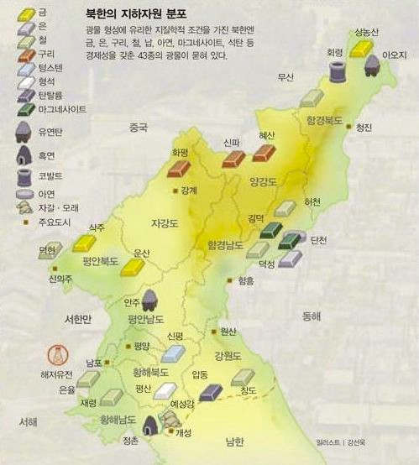

capital goods while the South wants to attain mineral resources.
Over the years, inter-Korean trade volume in mineral resource kept increasing. However, since

Implications

The map on mineral resource distribution in North Korea shows that magnesite, zinc, gold,

silver and cooper, which take up a lion’s share out of the South’s mineral import, are located in Pyongan-do and Hamgyong-do. So the transportation distance is very long between production origin of the North and consumption areas of the South. Moreover, aging railways and roads of the North make inland transportation difficult and the North is unlikely to approve transportation which passes through its inland. Under the circumstances, seaborne transportation holds the highest chance. The inter-Korean marine transportation is defined as “coast-wise transportation” under the South-North Shipping Agreement.

Thus, inter-Korean development and use of mineral resources will provide great opportunities to the coastal shipping industry. Still, political risk is high and coastal shipping companies in the South are not ready to take the opportunities. Therefore, the government and shipping companies need to take the following approach.

Firstly, costal shipping companies should keep away from excessive competition and promote unified shipping operation. In this way, they can distribute business risks, reduce operation unit costs, and secure profitability. Moreover, inter-Korean transportation has far longer operation distance, compared to the one within South Korea. Therefore, the fleet should be larger to secure economic viability.

Secondly, base works should be done to minimize political impacts on inter-Korean marine transportation business. For example, an official consultative organization needs to be in place as an economic cooperation body to ensure consistency of marine transportation business regardless of political relation between the two Koreas (the Article 13 of the South-North Shipping Agreement stipulates the establishment of an inter-Korean maritime affairs consultative body). In addition, a joint shipping company needs to be established and operated by both the

South and North. This will reduce the possibility that North Korea sacrifices the business for political gains, while securing stability of the inter-Korean marine transportation business.

Contact Information Name: Chun, Hyung-Jin E-mail: chun@kmi.re.kr Tel: +82-2-2105-2790

The Comparison on Port Competitiveness by Nation: with Focus on IMD World Competitiveness Yearbook

IMD National Competiveness

Since Michael Porter1) introduced the concept of “competitiveness” in 1990, the idea has been widely used in various areas. As national competitiveness as well as industrial competitiveness were highlighted, studies on national competitiveness have been conducted constantly. The National Competitiveness Index refers to a comprehensive quantity index which characterizes a nation’s whole structure. It can be used for comparison studies on each nation’s competitive edge.

National competitiveness evaluation organizations with a global authority include the World Economic Forum (WEF) and the International Institute for Management Development (IMD). Both of them heavily reflect statistics and expert surveys as detailed indicators of a nation’s competitive advantage. When it comes to national competitiveness, however, the WEF puts focus on the possibility of sustainable economic development, while IMD emphasizes business environment for companies.

This report will mainly discuss national competitiveness of the IMD. According to IMD, “competitiveness is a field of economic theory, which analyzes the facts and policies that shape the ability of a nation to create and maintain an

environment that sustains more value creation for its enterprises and more prosperity for its people.” (IMD, IMD World Competitiveness Yearbook 2011)

Transportation Infrastructure Competitiveness by Nation

As part of detailed national competitiveness, the IMD includes ‘basic infrastructure.’ Transportation infrastructure is a sort of basic infrastructure and it consists of roads, railways, airports and ports. The following table shows how a nation’s competitiveness was calculated by item in 2011. According to the table, competitive edges of roads and railways were evaluated with 2009 statistics but those of airports and ports were based on expert surveys conducted in 2011. Since statistics have a 2 year time gap, they refer to things in the past. However, survey results reflect expert’s perception of the present and future.

1 Porter, M. E., 1990, The Competitiveness Advantage of Nations, New York: Free Press

< Table 1 > How to Measure 2011 Transportation Infrastructure Competitiveness by Nation

Item | Source Type | Year | Note
Roads | Statistics | 2009 | World Roads Statistics (www.irfnet.org)
Railways | Statistics | 2009 | International Railways Statistics
Airports | Surveys | 2011 | Quality of air transportation
 |  |  | deters business development |  |  |  |  |  |  | encourages business development
 |  |  |  | 1 | 2 | 3 | 4 | 5 | 6
Ports | Surveys | 2011 | Water transportation (harbors, canals, etc.)
 |  |  | does not meet business requirements |  |  |  |  |  |  | meets business requirements
 |  |  |  | 1 | 2 | 3 | 4 | 5 | 6
Source: ∫IMD, IMD World Competitiveness Yearbook 2011

According to the following graph on Korean competitiveness of transportation infrastructure by year, ranking of roads and railways (based on statistics) remained stagnant, while that of airports and ports (based on surveys) changed
drastically. Over the last two years, the ranking of roads, railways and ports was between the 23rd to the 25th but that of airports was higher than the 10th place.

< Figure > Trends of Korean Transportation Infrastructure Competitiveness
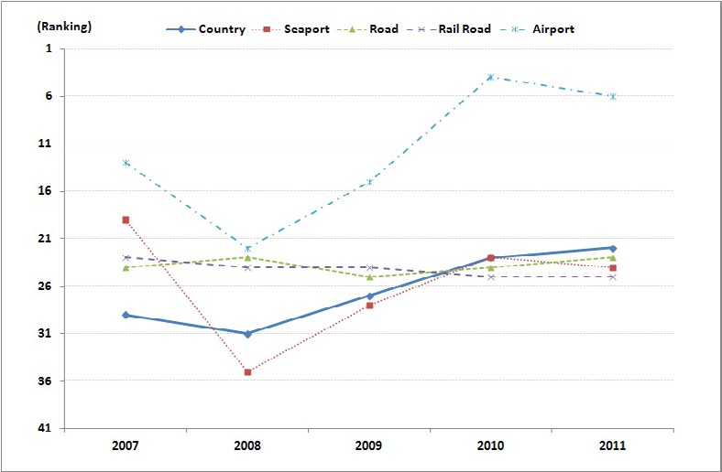

The ranking of Korean ports fell from 19th in 2007 to 35th in 2008, but rose again to 24th in 2011. The first place for port competitiveness went to Denmark, Island or Finland for the last three years. As for container throughput2) in 2010, however, three nations ranked the 60th, lower than 60th and 50th respectively.

It turned out that about eight nations ranked higher than 20th both at the 2011 IMD competitiveness index and the 2010 container throughput3). As for Singapore, Germany and Spain, their places at the IMD competiveness are similar to container throughput index.

< Table 2 > Transportation Infrastructure Competitiveness by Nation

Item | Year | Nation |  |  | 1st place
 |  | Korea | China | Japan
Road | 2007 | 24 | 42 | 4 | Belgium
 | 2008 | 23 | 42 | 4 | Belgium
 | 2009 | 25 | 37 | 4 | Belgium
 | 2010 | 24 | 36 | 4 | Belgium
 | 2011 | 23 | 34 | 4 | Netherlands
Railway | 2007 | 23 | 43 | 17 | Hong Kong
 | 2008 | 24 | 43 | 17 | Hong Kong
 | 2009 | 24 | 43 | 17 | Hong Kong
 | 2010 | 25 | 43 | 17 | Hong Kong
 | 2011 | 25 | 44 | 17 | Hong Kong
Airport | 2007 | 13 | 23 | 28 | Singapore
 | 2008 | 22 | 37 | 17 | Singapore
 | 2009 | 15 | 33 | 22 | Finland
 | 2010 | 4 | 36 | 25 | Singapore
 | 2011 | 6 | 34 | 24 | Singapore
Port | 2007 | 19 | 27 | 21 | Singapore
 | 2008 | 35 | 34 | 19 | Singapore
 | 2009 | 28 | 31 | 16 | Finland
 | 2010 | 23 | 32 | 19 | Iceland
 | 2011 | 24 | 30 | 23 | Denmark
Note: China refers to mainland China, excluding Hong Kong. Source: IMD, IMD World Competitiveness Yearbook 2007-2011

2 National Container Company, Containerization International Yearbook 2012
3 The latest statistics on container throughput are based on 2010.

< Table 3 > Top 20 Ranking Countries in IMD Competitiveness Index and Container Throughput

Ranking | IMD  Competitiveness | Container throughput | Ranking | IMD  Competitiveness | Container throughput
1 | Denmark | China | 11 | Canada | Netherlands
2 | Netherlands | US | 12 | Swiss | Spain
3 | Singapore | Singapore | 13 | US | Italy
4 | Finland | Hong Kong | 14 | Malaysia | India
5 | Norway | Korea | 15 | Spain | Indonesia
6 | Belgium | Malaysia | 16 | Taiwan | Brazil
7 | Sweden | Japan | 17 | Austria | Egypt
8 | Germany | United Arab Emirates | 18 | Iceland | UK
9 | Iceland | Germany | 19 | Portugal | Australia
10 | Hong Kong | Taiwan | 20 | Chile | Thailand
Note: China refers to mainland China, excluding Hong Kong.
Source: IMD, IMD World Competitiveness Yearbook 2011/NCC, Containerization International Yearbook 2012

Port Competitiveness Need to be Stronger than National Competitiveness

The IMD competitiveness indexes include qualitative variables, which imply possible evaluation errors by respondents. Because in many cases respondents are high ranking managers at companies, the results might be their perception about a nations’competitiveness level. To calculate competitiveness in transportation infrastructure, the IMD relies on statistics (2009) for railways and roads but expert surveys (2011) for ports and airports.

The IMD port competitiveness refers to ports’ level of meeting business requirements according to expert surveys for individual nation. In this sense, the results are a little different from container throughput of each nation. Therefore, the IMD port competiveness shows the degree of
port support for industrial demand.

According to the IMD competitiveness, Korea’s port competitiveness ranked 24th, lower than the whole national competitiveness which ranked at 22nd. This means that more efforts are required to advance port competitiveness ahead of national competitiveness.

Contact Information Name: Lee, Min-Kyu
E-mail: minkyu@kmi.re.kr Tel: +82-2-2105-4928

02
Ocean Policy

Propelling Accordance between Port ODA and “the International Cooperation Law”

Enforcement and Amendment of “the International Cooperation Law”

The Korean government plans to expand its ODA budget to 0.25% (ODA budget to GNI) in 2015. Korea became the 24th member of the OECD DAC (Development Assistance Committee) as of November 2009. As Korea expands ODA budget and influence on ODA (Official Development Aid) in the world, there have been discussions and trials over “the International Cooperation Act” to strengthen accordance between individual ODA programs and national ODA plans. Under the Act, the Master Plan on International Cooperation will be prepared every 5 years. After working committees agree on the plan, it is submitted to the International Development Cooperation Committee which finalizes the master plan.

Each Ministry as an individual implementing agency submits its own international cooperation plans for the next 5 years to lead agencies, the Ministry of Strategy and Finance and the Ministry of Foreign Affairs and Trade. The MSF (Ministry of Strategy and Finance) and the MOFAT (Ministry of Foreign Affairs and Trade) prepare “the International Development Cooperation Implementation Plan” and then proceed for approval processes of the international development cooperation committee. Also, “the Comprehensive International Cooperation Plan by Sector” is established for each year and goes through the same procedure as “the International Development Cooperation Implementation Plan”

ODA of the MLTM and its Accordance with “the International Development Cooperation Plan”

“The Master Plan of International Cooperation” was decided at the 8th International Development Cooperation Committee Meeting on October 21, 2010. Accordingly, “the

Comprehensive International Cooperation Plan by Sector” was prepared for 2011 and 2012 respectively. Later in December 26, 2011, “the 2012 Comprehensive International Cooperation Plan” was approved at the 11th International Development Cooperation Committee Meeting. The total ODA budget increased by 12% from 200 billion won to 1.9 trillion won, which boosted the ratio of ODA budget to GNI up to 0.15%. Loan ODA is focused on green growth, transport, energy, and governance sector while grant ODA is focused on education, food, agriculture, forestry, fisheries, public policy, and health care. Accordingly, the Prime Minister's office set up the Country Partnership Strategy (CPS) for 3 countries in 2011 and CPS for 26 core nations will be completely in 2013. CPS is to enhance aid-effectiveness and national-wide coherence to reduce overlapping aids among individual agencies. Therefore, each Ministry should be actively involved in setting up CPS and settle the International Cooperation Plan to enlist its own ODA programs as well as to mitigate duplication of coordination among the agencies. A total of 9 countries already set up their CPS and every country has core cooperation sectors relevant to the Ministry of Land, Transport, and Maritime Affairs (MLTM). Ghana, Solomon islands, Sri Lanka, and Indonesia want port development while 8 countries except Azerbajjan have development needs for roads. Korea's core cooperation field to Azerbajjan includes development of water resources and power supply. Therefore, it is important for the MLTM to actively participate in ODA programs under CPS scheme and suggest its own ODA programs such as “the Port
ODA development model” to the lead ODA ministries, the MSF and the MOFAT.

Port ODA Program under CPS

While a comprehensive point of view is required to pursue the Port sector ODA, it is also important that the MLTM coordinate and activate the Port ODA with its own specialty and strengths. The MLTM has gained strengths as it has developed and managed hundreds of national Port SOC for the past 60 years. Functional port systems have driven trade of Korea for the last several decades as Korea has established Port SOC successfully. Technical advancement in design, construction and operation skills, such as installation of port IT devices gave Korea an edge to disseminate success stories and experiences to developing countries. And the MLTM ought to perform a central role in coordinating Port ODA programs with its long- term know how of developing and managing Port SOC.
Each ministry plans to suggest its own “ODA model “ to the lead ODA ministries, then the KOICA will apply this to the Priority Program List for ODA . The MLTM, therefore, can make use of this policy and pursue “the Port ODA development model.”

Contact Information Name: Kim, Jung-hyun
E-mail: jh-kim@kmi.re.kr Tel: +82-2-2105-2943

- Ocean Policy 11

03
Research Findings

Measures to Improve the License System of Coastal Passenger Transportation Business

The license system regulates entrants into the current passenger transportation market. Transportation demand is pivotal in deciding qualifications for the license. For example, licenses are issued only when transportation demand is large enough for both new and established players to secure stable business even after the new player joins the market. To put it differently, the license standards were prepared to curb new market participation.

A comparison on transportation business entrance standards in Korea and other countries shows that Korean coastal passenger ships have the strictest criteria for transportation demand. Others have rather lenient requirements. For instance, Japan changed the license system to permit system and eventually abolished the demand and supply control system in 2000. The UK embraces the liberal marine passenger transportation and imposes no barriers on license, permission or registration.

Therefore, future direction for coastal passenger transportation license is geared towards easing up the current competition restraints, particularly the standards for transportation demand. Moreover, criteria for transportation facility, ship age and ship volume will be overhauled to encourage new entrants to the market as well.

When the license standards are reviewed, the coastal transportation market should be categorized, depending on its need for protection or competition before preparing adequate standards. For example, the standards should consider whether the routes are for people’s livelihood or tourists, as well as competition between exclusive routes and rival routes.

Most of all, criteria for transportation demand, the key in costal transportation demand standards, should reflect

characteristics of the demand and rivalry structure to make a distinction from others. Routes for people’s livelihood should protect ‘transportation right’of people living on islands, while those for exclusive use and business should consider competition between routes.

On top of that, transportation demand standards need to improve the demand calculation methods by simplifying the intricate formula and using more objective criteria for transportation capability. In addition, the transportation demand at break-even point can be used to reflect actual profitability of the coastal passenger transportation industry.

Given seriously aging coastal passenger ships in Korea, the system needs to be improved to induce market entrance by new ships. License requirements should be lowered to lure new ships into the market and replace ships aged more than 21 years old. It is advised to prepare separate standards for WIG ships, a new marine transportation mode.

In addition, governmental supports are necessary to help businesses to secure new ships for the modernization of coastal passenger ships. In this regard, Korea can benchmark Japan’s Shared Ship Building System. The Flexible Rate System is another possibility since it helps to secure profitability and enhance user convenience of coastal passenger ships.
Contact Information Name: Chun, Hyung-Jin et al. E-mail: chun@kmi.re.kr
Tel: +82-2-2105-2790

- Research Findings 13

04
Research Projects

•Establishment of aquaculture complexes for export (abalone aquaculture island)
A study on domestic shell fish production area hygiene management
The study on commercialization of vertical aquaculture Reform of Busan port container terminal rent calculation Implementation system for integrated coastal management plan
A study on the condition and effects of dredged soil dumping areas
Introduction of ITQ fisheries resource management system The basic plan on sea areas under environmental management and plan for each sea areas
Establishment of integrated logistics network for advancement into ASEAN
The study on income project models that link fishing villages, ports and grounds
The impacts of small fish catch on fisheries resources and demand/supply
A review on the project proposal for Jebu marina port
Logistics demand prediction for the Inchon New Port hinterland development
The study on Korea's responsive measures against Korea
China FTA (fisheries sector)
Establishment of the fishing boat trading system for fisheries industry advancement
A validity study on Shinsundae terminal berthing facility improvement project and its design.
An analysis on the Arctic and Antarctic Sea policies of major nations and international organizations
The shipping transportation system prepared for changes in interKorean relation
A validity study on the Honduras port development master plan
The study on enactment of port operation and management Strategies to enter the West China logistics market through

ChinaCentral Asia cooperation
2015 Korea China Japan dynamics and response
2012 ASEAN shipping and port training project Response to the 67th UN general assembly meeting on fisheries resolution
The study on and long term development
direction for autonomous fisheries management A reanalysis on possible throughput at the Masan Port Terminal (1 1)
Mid and long term development strategy for KIMST
A validity study on the establishment of the knowledge industrial center at Gwangyang logistics park
Establishment of coastal disaster vulnerability evaluation system
Chinese domestic logistics business model development and implementation study
Hwasung fishing village comprehensive development plan
The study on supply and demand of ship crew The seashore cadastral survey and management type categorization
2012 operation of the international logistics investment analysis center
Information providence for the overseas ocean plant service industry
ISP establishment for advanced aviation information system
FTA Implementation Support Center Fisheries DB Establishment Project
Implementation of fisheries cooperative association’s economic projects
The study on measures to facilitate the seaweed seeds industry
Northern and Northwestern part of Sri Lanka Aquaculture Development (2011 Yeosu project 2nd year study)
A study on the South and East South sea of
Grenada (2011 Yeosu project 2nd year study)
2012 East Asia Multilateral Marine Environment international Cooperation
A study on close cooperation between ports in Northeast Asia
A basic plan for the Gwangyang Bay mid term

port development
Improvement of appropriated wharf at Gwangyang port
A review on the Gohyun Port development
The study on bulk cargo handling market structuring
A statistical research on deep sea fishery North Korean port basic plan
Cameroon's coastal protection/development plan scenario and master plan
Consigned operation of 2012 shipping, port, logistics information center
2012 Fisheries traceability consigned projects Facilitation of Busan Dongsam Innovation zone marine clusters and their utilization
The analysis on port demand estimation as part of preliminary validity standards study on port projects
An analysis on imported fishery price
Direction for the fishing village specialized development (2012 fishing village resource analysis project)
A validity study on the establishment of refrigerated warehouses at the Gwangyang port logistics park
A review on the Baekwoon marina port development project
2012 port demand prediction center
The study on fisheries resource protection zone and water surface improvement
The joint study on Russia International
Fisheries Trade Center
2012 Aquaculture HACCP projects
Landbased pollutant management and total pollution load management system
System foundation for polar policies
A study on rent and evaluation system at port type free trade zones
Logisitcs park and global logistics business valley development plan
Commercialization for the item expansion of aquaculture insurance
Madagascar port and logistics infrastructure development project
New project exploration and long term development direction

- Research Projects 15

An economic feasibility analysis of discharging blue crab and sea cucumber
The review on functional ports
Establishment of joint logistics for mid and small shipping companies' competitiveness
2012 national transportation survey and DB establishment
KoreaChina fisheries FTA negotiation scenario
analysis
An economic feasibility analysis on the Jukbyun and Gyojin port high utilization
A study on the development of a yacht marine silk road
A roadmap for port private projects in the long term
2012 economic development experience sharing: policy advice to Equatorial Guinea
A validity study on the Banguhjin, Gusipo port high utilization
A study on foundation establishment for Co2 capture and marine storage
A study on the Hadong port basic plan
Northeast Asian port competition and cooperation preparing for international changes Hwasung coastal management local plan
The study on fisheries basic system improvement
A study on system improvement for the marina industry development
Direction for national maritime policies for the era of per capita income 40,000 dollars
A validity study on the port logistics and economic feasibility of Cambodia port development
A validity study on the design of Jeju port (coast guard)
A basic plan for modernization of cargo handling equipment at port
The 2nd stage project for the establishment of shipping market information networks
The study on establishment of Asia
inland integrated logistics system
A study on and term development strategy establishment
2012 conservation study of marine species under protection

Standard manual and guidelines for marine port establishment and management
Impact of radioactive substance concentration on fisheries products and case study
Systematic response to international conventions for overseas biological resource cooperation
A study on the pacific oyster seed production technology development
An analysis on the mudflat fisheries damaged by oil spill

International Cooperation
05

Korea-China-Japan Port Directors Conference
- Time & Place: October 6~10, Sapporo, Japan
- Participants: MLTM, Kim, Hyung-geun (director general, KMI) and Kim, Geun-sup (senior researcher, KMI)

2012 International Conference on Logistics Engineering and Management (ICLEM 2012)
- Time & Place: October 8, Southwest Jiaotong University, Chengdu, China
- Presentation: Logistics cooperation measures in Northeast Asia (by Lee, Joo-ho, associate research fellow, KMI)

MOU Signed between KMI and Fiji University and 2012 KOSOPFF Fiji Symposium
- Time & Place: October 17, University of South Pacific (USP)
- Topics: Maritime and fisheries joint research and establishment of a joint research center
- Participants: Rajesh Chandra (president, USP), Kim, Hak-so (president, KMI), Chung, Hae-wook (Korean ambassador to Fiji), Joeli Veitayaki (co-chairman, KOSOPFF) and Lee, Jong-hwan (co-chairman, KOSOPFF)

KMI Seminar on Abalone with Overseas Experts
- Time & Place: October 24, KMI
- Topics: The current Australian and Korean Abalone Industry, its development and cooperation measures
- Participants: Dr. Nick Elliott (senior researcher, CSIRO), Mr. Dan Machin (chairman, AAGA), Kim, Hak-so (president, KMI), Ministry for Food, Agriculture, Forestry and Fisheries, Korea Abalone Industry Association and the National Fisheries Research & Development Institute

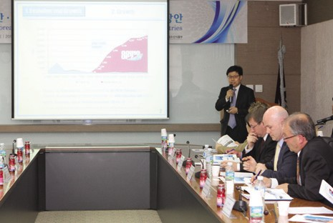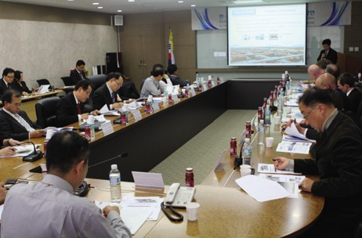Visit by Officials from State Oceanic Administration (SOA)
Source: KMI
Source: KMI
  - Time & Place: October 30, KMI
  - Participants: Officials from SOA

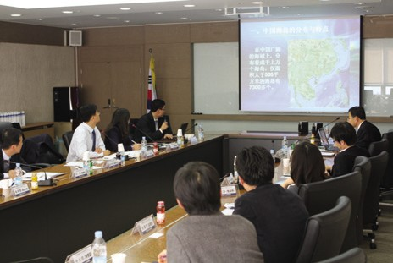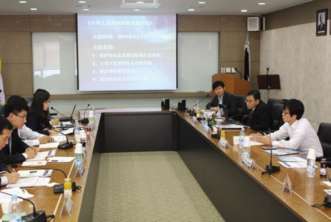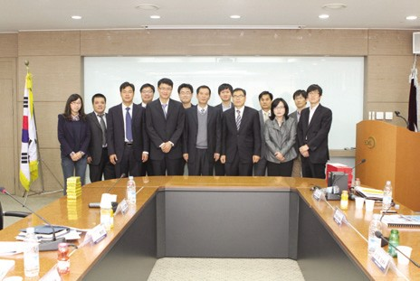The Shanghai CEO Forum
Source: KMI
Source: KMI
Source: KMI
- Time & Place: October 24, Shanghai, China
- Topics: Structural analysis on the China’s west logistics market and strategies for market entry

The 2nd Korea-Japan Logistics Technology Workshop
- Time & Place: October 26, Waseda Univ., Japan
- Topics: Logistics technology issues
- Participants: Kim, Sung-jin (president, Hankyong Univ.), Choi, Sang-hei (Director, KMI) and others from Waseda Univ. and Japanese companies

The 1st Korea-China Marine Development Forum
- Time & Place: October 30, Ocean University of Qingdao
- Topics: Review on the Korea-China maritime cooperation, marking the 20th anniversary of diplomatic ties and future development direction
- Participants: Li Hua Jun (vice president, Ocean University of Qingdao), Rim, Jong-kwan (vice president, KMI) and Yoon, Jin-sook (director general, KMI)

Major Activities Conducted in October, 2012

KMI Special Lecture (6th, 2012)
- Time & Place: October 8, KMI
- Lecture: “Change, the Key to Survival” (by Uhm, Gil-chung , Professor, Kyonggi Univ.)
- Participation: All employees at KMI
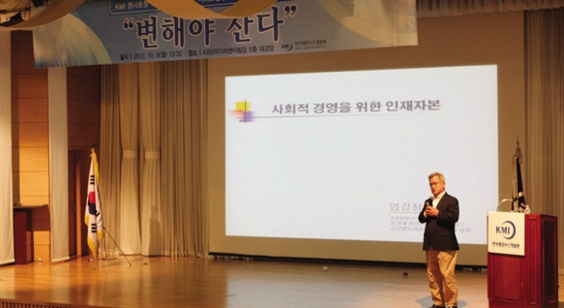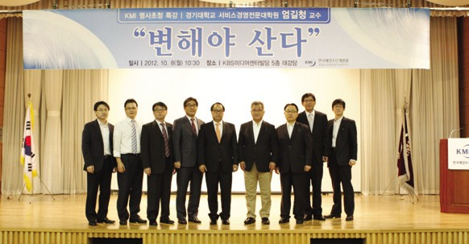
Source: KMI
Source: KMI

The International Seminar on Yellow Sea Rim Logistics Cooperation
- Time & Place: October 10, Pyungtaek Univ.
- Presentation: “Policy Measures to Facilitate the Korea-China Train Ferry” (by Chun, Hyung-jin, associate research fellow, KMI)
06

News & Announcements

Source: KMI

MOU Signed between KMI and KMA (Korea Meteorological Administration)
Source: KMI
Source: KMI
- Time & Place: October 15, KMI
- Topics: Development and implementation of maritime meteorological and fisheries service, maritime information sharing and welfare promotion of those in the sector
- Participants: Cho, Seok-Joon (administrator, KMA), Kim, Hak-so (president, KMI) and Rim, Jong-gwan (vice president, KMI
Source: KMI

The 3rd Port Industry CEO Forum
  - Time & Place: October 11, Busan Regional Maritime Affairs and Port Office
  - Topics: Facilitation Strategies for Ship Maintenance Complex and others
  - Participants: Kim, Hak-so (president, KMI), Kim, Hyoung-geun (director-general, KMI), Shim, Gi-sup (director, KMI) and CEOs of port businesses in Busan

The Logistics Company CEO Forum
  - Time & Place: October 12, Korea Federation of Banks Bldg.
  - Topics: Inaugural assembly and commemorative seminar

2012 2H Work Shop on Aquaculture Industry Development
  - Time & Place: October 12~13, Kyonggi Maritime and Fisheries Resource Institute
  - Topics: Improvements of fisheries forecast projects for stable supply of cultured seafood and mid- and long-term policy direction for the aquaculture industry
  - Participants: 32 people from MIFAFF, Kyonggi Maritime and Fisheries Resource Institute and fisheries forecast center of KMI
Source: KMI

2012 International Jurist Convention
- Time & Place: October 19~20, Busan National Univ.
- Topics: Choi, Jee-hyun (senior researcher, KMI), Lee, Chang-ryul and Park,Young-gil (senior researcher, KMI)

2012 Seminar on Shipping, Logistics and Trade Industry’s Development
- Time & Place: October 19, COEX
- Presentation: “Global Shipping Market Condition and Future Prospects” (by Kim, Woo- ho, director-general, KMI)

The Northeast Asia Trade and Transportation Forum
- Time & Place: October 23~24, KITA trade tower

- Topics: Private-Government cooperation for active trade in Northeast Asia and international multimodal transportation development
Source: KMI
- Presentation: NEAL-NET-based Logistics Information Sharing

The Symposium on the Current Korean Fisheries Industry and Prospects
- Time & Place: October 24, Gangneung-Wonju National Univ.
- Participation: Kim, Dae-young (research fellow, KMI)

The 4th Land and Maritime Research Society Seminar
- Time & Place: October 25, Seoul Palace Hotel
- Topics: Land and maritime policies based on people’s livelihood
- Participants: Gwon, Do-yup (minister, MLTM), Gwon, Yong-woo (professor, Sungshin Women’s Univ.), Lee, Woo-jong (professor, Gachon Univ.), Park, Yang-ho (president, KOTI), Yoo, Hyo-sup (president, KICT), Hong, Soon-man (president, KRRI), Kang, Jung-geuk (president, KORDI), Kim, Hak-so (president, KMI), Lee, Jae-boong (president, KITCCEP) and Shin, Pyung-sik (president, KIMST)

Korea Shipping Logistics Society Fall Symposium
- Time & Place: October 26, Graduate School of Logistics, Inchon Univ.
- Presentation: “Consumer Preference Analysis on Cruises” (by Lee, Min-kyu, senior researcher, KMI)

The 4th Ocean Vision Forum
- Time & Place: October 31, Korcham
- Topics: The current ocean service industry and measures for its encouragement
- Participants: Choi, Jang-hyun (co-chairman), Kim, Hak-so (co-chairman), Yoon, Jin-sook (director- general, KMI), MLTM, KMIST and others
Source: KMI
Source: KMI
Source: KMI

Source: KMI
Source: KMI

Major Activities Planned in November, 2012

2013 Global Shipping Outlook International Seminar
- Time & Place: November 1, Korea Federation of Banks Bldg.
- Topics: Development of emerging markets and shipping market outlook

The 7th Shanghai CEO Logistics Forum
- Time & Place: November 2, Shanghai
- Topics: Understanding of the cold chain logistics market in China and Korea-China cooperation

The China Economy Monitoring Seminar
- Time & Place: November 5, Palace hotel
- Presentation: “China-Central Asia International Cooperation and Logistics Market in Western China” (by Lee, Joo-ho, associate research fellow, KMI)

2013 Global Shipping Outlook International Seminar
- Time & Place: November 5, Korea Federation of Banks Bldg.
- Presentation: “Ocean and Logistics integration in East Asia and Development Strategy for Logistics and Ports” (by Kim, Woo-ho) and “National Wealth Creation through Marine Protection and Use” (by Hwang, Kee-hyong)

MOU to be Signed between KMI and Myanmar Maritime University
- Time & Place: November 7, Park Royal Hotel, Myanmar
- Participants: KMI, MIFAT, KOTRA, KOICA, Ministry of Transportation (Myanmar), Myanmar Maritime University and Korea Maritime Business Association

2012 2nd Shipping Finance Seminar
  - Time & Place: November 9, Marriott hotel
  - Topics: Operation of a shipping market forecast center, 2013 shipping market forecast (by KMI) and strategies for shipping finance development (discussion)

2012 ASEAN Training in Shipping and Ports
  - Time & Place: November 11~17 (6 days and 7nights), Songdo bridge hotel, Inchon
  - Target: 20 port operation officials from 10 ASEAN member countries

The 111st KMI Ocean Policy Forum
  - Time & Place: November 14, Shilla hotel
  - Topics: “Future Vision for Korea” (by Kim, Jin- hyun, the Korea History Museum Foundation Committee)

The 2nd Korea Fishery Policy CEO Forum
  - Time & Place: November 14, Kyoyuk Munhwa Hoekwan
  - Participants: Kim, Hak-so (president, KMI) and other members

KMI-Tokyo University of Marine Science and Technology International Seminar
  - Time & Place: November 16, Seoul Palace hotel
  - Participants: Kim, Hak-so (president, KMI) and Nobuaki Okamoto(president, Tokyo University of Marine Science and Technology)

The Local Expert Workshop on Northern China Port Operation Condition
  - Time & Place: November 19~22, Shanghai/ Tianjin/Quindao
  - Participants: Shipment cargoes throughput

estimation based on Northern China port operation condition analysis
- Schedule
Shanghai (19): China’s five major container ports operation analysis (by Kim, Ki-young, Hanjin shipping)
Quindao (20): Quindao port operation analysis and prospects (by Li Jian, professor)
Tianjin (21): Tianjin port operation analysis and prospects (by Liu Bing Lian, professor)

KMI-ESCAP Joint International Seminar
- Time & Place: November 20~24, ESCAP headquarters, Bangkok
- Presentation: “Trend of cargo and container movements”
- Participants: Rim, Jong-kwan (vice-president, KMI), Kim, Soo-yeob (director, KMI), Lee, Sung-woo (director, KMI) and Lee, Gun-woo

The Third International Symposium on Scientific and Legal Aspects of the Regimes of the Continental Shelf and the Area
- Time & Place: November 21~24, Beijing, China
- Participants: Park, Young-gil (senior researcher, KMI), Choi-Young-suk (senior researcher, KMI)

Presentation at the Korea Institute of Maritime and Fisheries Technology
- Time & Place: November 21, KIMFT
- Presentation: “OSV Market Condition and Advancement of Korean Companies” (by Park, Gwang-suh, KMI)

The 9th China Local Logistics Seminar
- Time & Place: November 25~28, Hainan Sheng, China
- Topics: Shipping, port and logistics condition in Hainan Sheng and future prospects

The International Symposium on Maritime and Fisheries ODA Facilitation
- Time & Place: November 27, Palace Hotel
- Participants: World Bank, FAO, OECD officials, MLTM, MIFAFF, MIFAT, KOICA and Nam,
Jung-ho (research fellow, KMI)

The 4th International Forum by the Future Logistics Technology Forum
- Time & Place: November 27, TBD
- Topics: Collaborative Activities for Improving Logistics in Asia Pacific Region
- Participants: Professors from UIC and others, Kim, Sung-jin and members of NeLT

The International Seminar on Sea crew Policy Development
- Time & Place: November 29, L-tower
- Topics: Supply and demand of sea crew, basic policy direction and basic welfare policy
- Presentation: “Integrated Maritime Conventions and ILO Sea Crew Welfare Policy” (by Brandt Wagner, senior maritime expert, ILO); “BIMCO Global Sea Crew Supply and Demand” (by Wang Jie, professor, China); “Sea Crew Supply and Demand in Korea and Policy Tasks” (by Hwang, Jin-hoi, director, KMI) and “Sea Crew Welfare Basic Policy and Policy Measures” (by Chun, Young-woo, KIMFT)

Publisher
Kim, Hak So - President, Korea Maritime Institute

Editor-in-Chief
Choi, Jae Sun - Director General, International Cooperation & Public Relations Division Dean, Ocean Academy

Editorial Board
Kim, Woo Ho - Director General, Maritime Industry & Logistics Division Kim, Hyoung Geun - Director General, Port Research Division
Yoon, Jin Sook - Director General, Marine Policy Research Division
Joung, Myung Saeng - Director General, Fisheries Policy Research Division

Secretary
Kwon, Hye Jin - International Cooperation & Public Relations Division Chung, Kyung Hwa - Planning & Coordination Division

Contact Information
Address: 21F KBS Media Center Bldg., #45, Maebongsanro, Mapo-gu, Seoul, 121-915, Korea
Tel: +82-2-2105-2733, 4901
Fax: +82-2-2105-4990
Email: jschoi@kmi.re.kr, kwonhj@kmi.re.kr

