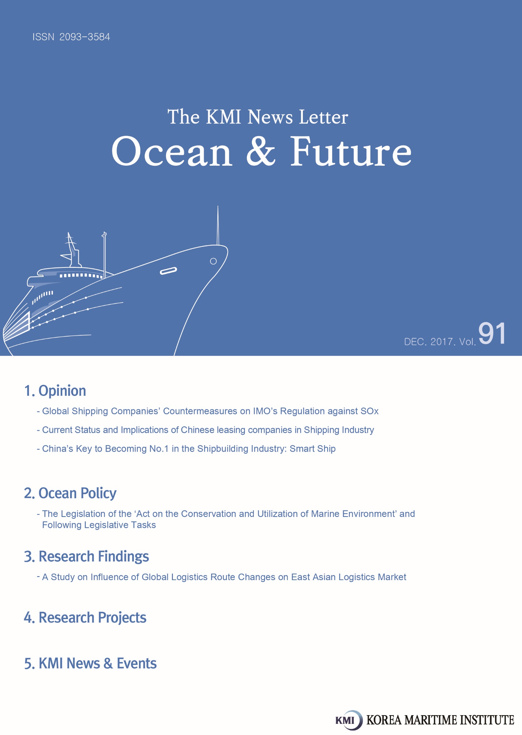

Global Shipping Companies’ Countermeasures on IMO’s Regulation against SOx

IMO’s regulation and response measures against Sox
The International Maritime Organization announced on October that it was going ahead with a global sulfur cap of 0.5% on marine fuels starting from January 1, 2020. There are generally three measures to respond to the new regulation; (a) using low sulfur fuel oil, (b) installing scrubber (a piece of equipment for purifying exhaust gas), and (c) using alternative fuels, such as LNG etc.
At present, global shipping companies centers on the use of low sulfur fuel oil as the most preferred response measure while the use of alternative fuels such as LNG and the installation of scrubber are limited. That is, shipping companies rather use expensive low sulfur fuel oil, instead of installing scrubbers or using LNG fuel, both of which have uncertain economic feasibility.

Current status of low sulfur fuels
Low sulfur fuel oil can be produced by many methods, but the following four ways are generally used; (a) produce based on marine gas oil (MGO) and marine diesel oil (MDO), (b) produce with diesel in an indirect desulfurization method, (c) produce with diesel in a direct desulfurization method and (d) produce by distilling gas oil.
According to a report published by the International Petroleum Industry Environmental Conservation Association (IPIECA), if global shipping companies use low sulfur fuel oil, most of the fuel will be produced by (a) method. It has also forecasted that additional facilities for refinement will be necessary to reduce the sulfur content of heavy or diesel oil.

The use of low sulfur fuel increases the burden of shipping companies
The price difference between existing heavy oil and low sulfur fuel oil has a significant impact on how actively low sulfur fuel can be utilized in the future. The fuel cost accounts for more than 20% of a shipping company’s total operation cost. Therefore, increasing fuel cost would have a huge impact to shipping companies. However, there is no consensus forecast on the price difference between low sulfur fuel with sulfur content lower than 0.5% and existing bunker C (with a sulfur content of 3.5%).
During the period from 2010 to 2017, the price difference between low sulfur fuels with lower than 1.0% sulfur content and bunker C with the sulfur content of 3.5% used in ECA is 25 dollars on average. Therefore, reducing 0.1% of sulfur content is estimated to cost about 1 dollar (calculated by subtracting 1.0% from 3.5% and then divided by 25). Since global ships will have to use fuel oil on board with a sulfur content of no more than 0.50% from 2020 onwards, the price difference between bunker C and low sulfur fuel oil is 30 dollars. If the total amount of fuels to which global shipping companies need to convert is presumed to 200 million ton annually, the shipping industry will have to bear additional 6 billion dollars every year.
Additionally, there is an increasing need for production facilities that are able to satisfy the rising demand of low sulfur fuel oil. Given the current status of production facilities of low sulfur fuel oil, its demand will not be satisfied when the regulation is hurriedly introduced in 2020. As a result, there is a concern that the price of low sulfur fuel oil would rapidly increase.

Trends of global shipping companies’ countermeasures against the Sox regulation
Currently, most of the global shipping companies give up installing scrubbers or building new LNG fueled ships. Rather, they would choose to infuse low sulfur fuel oil, bearing more expensive price. This is because the installation of scrubbers or the construction of LNG fuelled ships requires high initial costs.
From now on, a systematic investigation is required to analyze the price of low sulfur fuel oil and ensuing changes of behavioral patterns by global shipping liners. Higher the price of low sulfur fuel oils, the more shipping companies uses LNG fuels or installs scrubbers, instead of infusing low sulfur fuels. Furthermore, Clarkson, the world's largest shipbroker, analyzed and worried that an increasing price of low sulfur fuel oil will deteriorate the loss of shipping companies, even to the level of lower than break-even point. Clarkson pointed out that excessive rise of freight rates will transfer the burden to shippers and consumers, dragging down the overall efficiency of the society.

Contact Information
Name: Ahn, Young Gyun
E-mail: ahnyg@kmi.re.kr
Current Status and Implications of Chinese leasing companies in Shipping Industry

Increase of Chinese leasing companies’ influence in the global Shipping industry
Since the China Banking Regulation Commission (CBRC) revised its regulation on financial leasing companies in 2007, commercial banks have been allowed to set up financial leasing companies as a subsidiary. As a result, many of China’s major commercial banks have started establishing financial leasing companies, giving a powerful momentum for the rapid growth of the financial leasing industry. As of November 2017, China boasts 20 financial leasing institutions involved in ship leasing, with the asset value related to shipping finance surpassing 200 billion yuan. In particular, major domestic financial leasing companies with size of assets over 100 billion, including ICBC Leasing, Minsheng Leasing, CMB Leasing, and CDB Leasing are participating in the shipping finance market. While most of ship financial leasing takes the form of financial leasing in the beginning, nowadays witness an increasing share of operating lease, exceeding 30% of the total. ICBC Leasing, a leading leasing firm in China, has provided the loan of 15 billion yuan for exporting 70 vessels constructed in Chinese shipyards.¹⁾

The reason of Chinese leasing companies’ growth in the global shipping industry
Since a huge downturn of the global shipping market, European financial companies and US private equity funds who used to drive the market have switched to become passive and reduced the investment in the shipping industry. This has increased the share of Chinese capital, rebalancing the shipping finance market from Europe to Asia. As the shipping crisis has particularly dwindled the lending source in which commercial banks used to play a central role, financial leasing companies have started to fill up the funding gap between the supply and demand of shipping finance.
1) '中国“金融船东”需积极提升专业化水平', 中国船舶报, 2017.11.20, http://www.7hcn.com/article/304831-1.html

Moreover, the shipping industry is a representative capital-intensive industry. While the price of a ship, which is the main asset of a shipping company, is very high, that of highly advanced maritime equipment and offshore plant is estimated to cost billions of dollars. Therefore, shipping companies rarely purchase a vessel outright with owner’s capital. They rather access the banking sector tapping into borrowed capital, which usually increases debt to equity ratio, deteriorating their financial structure. However, operating leases take the form of off-balance sheet financing, in which shipping companies makes a small down payment and then monthly lease payments. Since it allows shipping companies to acquire additional assets without deteriorating their balance sheets, shipping companies are increasingly using leasing products.

Implications of Chinese leasing companies’ growth on Korea Shipping industry
If certain conditions are met, CBRC plans to allow financial leasing companies to establish and operate a subsidiary specializing in shipping finance not only in mainland China, but also in foreign countries, such as Hong Kong and Taiwan. Therefore, Chinese leasing companies will have a growing influence in the global shipping industry.
As part of an effort to develop Busan as the center of Asia’s maritime finance, Korea established Busan International Finance Center (BIFC) in which the Korea Development Bank, the Export-Import Bank of Korea and the Korea Trade Insurance Corporation etc. have resided. Next year, the Korea Maritime Corporation will also be established. However, the development of Korea’s marine finance shows limitation since government financial institutions such as export credit agencies (ECA) are playing a central role. Korea also needs to benchmark cases of Chinese financial leasing companies, encouraging private financial institutions and other relevant players to actively participate in maritime finance.

Contact information
Name: Kim, Ju hyeon
E-mail: jhkim@kmi.re.kr

China’s Key to Becoming No.1 in the Shipbuilding Industry: Smart Ship

China ranks No.1 in the global shipbuilding industry for the last 11 months
China is leading the global shipbuilding market. For the last 11 months, China has cemented the top position by clinching the largest number of shipbuilding orders in the global shipbuilding industry, surpassing South Korea. According to the data released by Clarkson Research Services, a British shipbuilding analysis agency, China's shipbuilding order volume totaled 7.13 million gross tons from 324 vessels from January to November. China's shipbuilding industry secured 36.3 percent of the global market, 7 percentage points higher than South Korea, which accounts for 29.4 percent of global orders. It is the first time that China has exceeded South Korea in the number of shipbuilding orders.
China’s shipbuilding industry has upgraded itself to another level through technological advancement and innovation as the industry has become more intelligent and environmentally friendly. Having unveiled a goal to become a strong shipbuilding country by 2020, China has accelerated the development of advanced intelligent manufacturing and industrial equipment capability.

China’s shipbuilding industry; the keyword is Smart Ship
Developed and built by China State Shipbuilding Corp (CSSC), China’s first smart ship ‘Great Smart’ made its first voyage. The ship is a modified version of the Green Dolphin, a bulk carrier developed by the Shanghai Merchant Ship Design and Research Institute (SMSDRI) in 2012, to make it more fuel efficient. Great Smart also has the "intelligent ship" notation from China Classification Society.
Developed by the China State Shipbuilding Corporation (CSSC), China's first smart ship ‘Great Intelligence’ made its debut in Shanghai. The 179-meter-long ship, Great Intelligence, is 32-meters-wide and 15-meters-high. Installed with a domestically developed intelligent navigation system, the ship can analyze real-time navigation and meteorological data, discover the best routes and alert the crew to hidden dangers in advance.
Great Intelligence becomes smarter as it accumulates more data. The ship not only can it spot dangers and system bugs, it also can lower transport costs and raise efficiency. Technical performance of the ship has reached advanced levels, and it has passed official assessments by the China Classification Society and Lloyd's Register of Shipping.

<Great Intelligence>
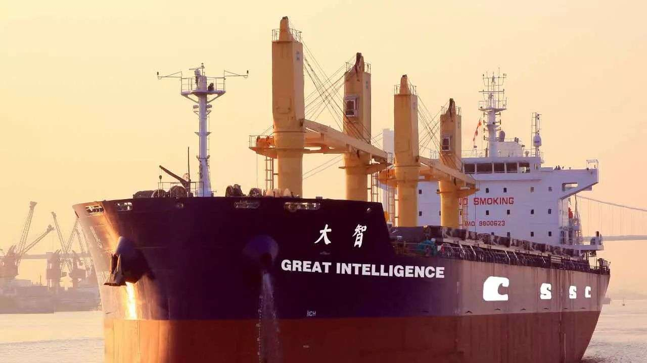

Facing limitations of low price strategy, Chinese shipbuilding industry will raise price for new orders
Chinese shipbuilders have been able to maintain top position in shipbuilding orders because many shipping companies have paid a lot of interest to Chinese shipbuilders due to their low price strategy. Having failed to generate profits, however, Chinese shipbuilders are shifting their position, starting to increase their price for shipbuilding orders.
The biggest challenge faced by Chinese shipbuilders is the lack of human resource working in basic design who are capable of meeting the demands of potential ship owners. In this case, it would be difficult to meet the delivery date of a ship. This is because shipbuilding cost is hard to estimate and shipbuilding workers cannot promptly respond to problems occurred during the construction. Hence, the lack of a shipbuilder’s capability in basic design leads to huge losses.

Chinese shipbuilders’ increasing price of orders become favorable to Korea’s top 3 shipbuilders
The more Chinese shipbuilders construct new ships and operate shipping yards, the higher cost it entails, which results in zero margin for ship construction. Worse yet, the cost is getting even higher since Chinese shipbuilders are increasingly abiding by environmental and safety regulations and participating in five kinds of social insurance is mandatory for their yard workers. Hence, Chinese shipbuilders are starting to increase the price for ship orders saying higher cost. Such a movement is expected to bring a very advantageous position to Korea’s big three shipbuilders. So far, the competitiveness of Korea’s shipbuilding industry has been low due to China’s aggressive low price strategy. If China starts raising the price of a ship, however, Korean shipbuilders, equipped with advanced technological capability, will be seen more attractive to potential ship owners.
Contact Information
Name: Lee, Sun Ryang
E-mail: srlee@kmi.re.kr

The Legislation of the ‘Act on the Conservation and Utilization of Marine Environment’ and Following Legislative Tasks

A law has been taking effect, which reflects new legislative demands and complements problems of the existing ‘Marine Environment Management Act’
Korea has legislated and proclaimed a new framework act in the realm of marine environment on March 21, 2017. The Act on the Conservation and Utilization of Marine Environment (hereinafter referred to as the Marine Environment Conservation Act) has been legislated and taking effect since September 22. The preceding framework act in the area of marine environment was the Marine Environment Management Act, which was established in 2007. However, concerns has raised that the contents are widely extensive and the provisions are not organized as the sections of principle and execution are mixed up. Additionally, the law was not appropriately reflecting the international movement in managing the marine environment, such as climate change. Therefore, the Act in effect aims to supplement the legal shortcomings of the existing Marine Environment Management Act while implementing appropriate policies befitting to the characteristics of the marine environment by reflecting new legal demands such as climate change and Marine Spatial Management.
Major contents of the Marine Environment Conservation Act include as follows. First, the provisions of definition clarify unclear terms such as the deterioration of marine ecosystem and the standards of marine environment etc. It also explains newly introduced systems including the conservation and utilization of marine environment and ocean health.
Second, the new Act establishes and implements the plan and policy for the conservation and utilization of the marine environment by dividing entities into the central government, local governments, the public and operators, then assigning respective responsibilities. The previous Marine Environment Management Act did not distinguish the responsibility of the central government and that of local governments. However, the Marine Environment Conservation Act clearly distinguishes the responsibilities of the two, emphasizing their roles. Whiling abiding by the international agreements, the central government should establish and implement national plans and policies. Meanwhile local governments should establish and implement plans and policies for the sea areas under their jurisdiction considering regional characteristics and conditions.
Third, the Act allows the central as well as local governments to manage the marine environment considering the ocean health and the acceptance of the marine environment. In particular, the Act stipulates that any activities for using and developing the oceans should be carried out in the boundary that the marine environment is able to accommodate. This provides a firm ground for the TMDL (Total Maximum Daily Loads) Management System.
Fourth, the new Act intends to strengthen the systematic method of marine environmental management. As such, the law requires the assessment results of marine environment (such as the assessment of ocean health, the quality assessment of marine environment) and relevant research as well as the survey information of international cooperative projects being respectively reflected to the comprehensive marine environmental plan and the comprehensive information network of marine environment.
Fifth, the law highlights that the standards for marine environment should maintain the adequacy depending on the changes of the marine environment. Furthermore, mayors and provincial governors are able to establish a strengthened marine environmental standards befitting to individual regions. Prior to the amendment, the Marine Environment Management Act did not have any contents in regards to the maintenance of marine environmental standards. Additionally, the previous law allows mayors and provincial governors to only establish milder marine environmental standards than the law stipulates, representing limitations.
Sixth, the new Act includes the content related to marine environmental education. Prior to the amendment, the Ministry of Oceans and Fisheries is only able to support marine environmental education in accordance with the Environmental Education Promotion Act. However, the new Act provides solid grounds for independently establishing plans and supporting relevant expenses.

Legal improvements are still necessary such as organizing the provisions relevant to the existing Marine Environment Management Act and supplementing the content
The legislation of the Marine Environment Conservation Act is meaningful for the following reasons. The new law provides an opportunity to establish a legal system for marine environment mutually beneficial to the existing land-based environmental law system. To achieve this, the law intends to complement the shortcomings found during which individual decrees related to the marine environment law has been implemented. Having reflected new legislative demands, the law presents various policies necessary to establish the foundation for a comprehensive and systematic marine environmental policy.
However, the law still has the following problems. To begin with, the Marine Environment Conservation Act does not explicitly describe the relationship with other systems which were already stipulated in the existing Marine Environment Management Act. These systems include the Environment Management Sea Area, the Consultation on utilization of sea area and the Sea Area Utilization Impact Assessment.
Instead of using the term ‘Environment Management Sea Area’ stipulated in the Marine Environment Management Act, the new law uses another term ‘Marine Environment Management Sea Area’. Although the new law stands as a framework law, the existing Marine Environment Management Act does not reflect relevant provisions from the new law. Therefore, a more detailed review is required such as summarizing the terms related to Marine Environment Management Act and additional inclusion of provisions of Marine Environment Conservation Act into the Marine Environment Management Act.
Furthermore, the law has introduced new systems such as the assessment of ocean health and Marine Spatial Management. However, it only stipulates that relevant regulations will be established in enforcement ordinance, lacking detailed provisions concerning system operation.

Understandably, it has been only three months since the new law took effect. However, relevant guidelines should be immediately established such as the one for the assessment of ocean health as well as for marine spatial management so that relevant policies are implemented smoothly.
Lastly, the section of marine environmental standards of the new law is not different from that of the Marine Environment Management Act prior to the amendment. This is because the notification, which regulates specific environmental standards, was not revised. Another legislative limitation is pointed out that the enforcement decree of the new law does not have contents regarding job delegation, only mentioning contents related to job consignment.
As an old saying goes ‘a journey of a thousand miles begins with a single step’, the system and content of recently legislated ‘Marine Environment Conservation Act’ is not satisfactory, only taking a mere first step. However, the new law requires constant interest and efforts to identify shortcomings and problems and address them. Only then, the Marine Environment Conservation Act will duly serve as a role of framework act which is able to implement a comprehensive policy for marine environmental management in the future.

Contact Information
Name: Choi, Seok Mun
E-mail: leedsud@kmi.re.kr

A Study on Influence of Global Logistics Route Changes on East Asian Logistics Market

1. Purpose
○ This study aims to analyze influences that the changes of East Asia-North America and East Asia-Europe global logistics routes have on East Asia’s shipping/port/logistics markets.
- The global logistics routes include East Asia-North America and East Asia-Europe container transport routes which have Busan as the port of call.
- The study reviews the current status of the subject global logistics routes of containers and conditions that change the existing global logistics routes of containers.
- It analyzes which channels have competitiveness based on the analysis model of the competitive relation of global logistics routes and forecasts influences that the changes of global logistics routes would have on East Asia’s shipping/port/logistic sectors.

2. Methodologies and Features
1) Methodologies
○ Analyze various literatures including previous domestic and foreign studies and utilize experts’ advises in related sectors in order to draw competition factors and analyze the competitive relations of global logistics routes.
○ Compare transport distances, time and costs among competing routes to analyze the competitive relations by global logistics routes, and use the Log-Log model as the statistical analysis to predict cargo volume.
- For Log-Log model analysis, use the WISERTrade DB data of WISER (World Institute for Strategic Economic Research) that provides the trade statistics, data by import/export items and other information of about 130 countries around the world.
- Use AXSMARINE Data (www.axsmarine.com) for maritime transport distances and time and Time&Date (www.timeanddate.com) for inland transport distances.
- Use the data of Freight Analysis Framework Version 3 (FAF3) to analyze U.S inland logistics costs, the data of Euro-Asian Transport Linkages (UNECE, 2012) for Europe’s logistics costs, and use market prices such as the actual market charges by Korea’s major shipping companies for ocean freight charges.

2) Features
○ This study identifies which region is most affected geographically by the changes of global logistics routes from a global perspective and how such changes ultimately influence East Asia’s logistics market, rather than analyzing competitiveness and influence within limited zones which have been mainly covered by existing studies.
- In particular, it sheds light on the changes of global logistics routes from an East Asian perspective, presenting the direction and strategies that related Korean logistics companies and the government should take to approach the future logistics market.

3. Results
1) Summery
○ In general, global maritime logistics routes have been connected from Asia to Europe via the Sues Canal, or from Asia to U.S west coast ports or via the Panama Canal to U.S east coasts without any significant changes for a long time.
- As the second Suez Canal was opened in 2015 and the Northern Sea Route that has been received attentions since the mid-2000s was commercialized, huge changes are expected for global logistics routes.
- In addition, the development of the Nicaragua Canal in South America and the Kra Canal in Asia is currently under discussion.
○ This study analyzes competitiveness by channels by applying the change factors of the Suez Canal, Panama Canal, and North Pole Route out of global logistics routes.
- It draws competitiveness factors (time, cost) through review on previous studies, analyzing influences that the total transport costs by channels have on the cargo volume change through the Log-Log model with the data of VISERTrade.
- As for the routes from East Asian ports to U.S east coast ports, when comparing the U.S inland multimodal transport route and all water routes via the Panama Canal, the inland multimodal transport has slightly more competitive in terms of time, but the competitive advantage is expected to change depending on the origins/destinations of cargo in terms of cost.
- As for Europe routes, TSR is shown to be most competitive, followed by the North Pole Route and Suez Canal, and such competitive edge becomes different depending on origins/destinations in Europe.
○ The influences that above results have on East Asia’s logistics market are as follow.
- Due to the expansion of the Panama Canal, the calling fleets are expected to be enlarged in U.S east coast ports, and as a result, ports would be required to improve port facilities and services for large ships to call at.
- Since the opening of the second Suez Canal reduced the ship transit time, Hong Kong could have an advantage if cargos are transported toward U.S via the Panama Canal and Singapore could be more favorable if they pass through the Suez Canal to U.S in terms of cost and time.
- Such changes would alter the calling pattern of transshipment cargos within the East Asian region, and it is possible that the transshipment function of Hong Kong becomes weaker while that of Singapore becomes stronger.
○ Korean logistics companies including shipping companies and port management companies are responding to the changes of global logistics routes as bellow.
- Logistics companies need strategies to diversify and expand the comprehensive and professional service areas in respond to the change of end consumers’ purchasing pattern and especially require strategies for the Central Eastern and Central and Southern U.S and Central and Eastern Europe where pierce competition is expected.
- The competition range would be expanded for port management companies, and like Hong Kong the attracting strategies of cargos are required for ports that would have more options of cargo transport routes due to the change of the Suez Canal and Panama Canal.
- Strategies should be established to undertake new projects including securing logistics centers at major hubs with the changing global logistics map and then to secure port hubs by stages.

2) Policy Contribution
○ By analyzing the change of the global logistics map from various angles, this study helps the Korean government establish future response strategies and helps logistics companies extend their businesses abroad.

3) Expected Benefits
○ Reduce the logistics costs and risks of companies by seeking the logistics routes with competitive advantages in North America and Europe which are the major trading regions of East Asian countries.
○ Analyze the change of global logistics environment and utilize such analysis for logistics cooperation among East Asian countries down the road.
○ Utilize such analysis as references for the overseas expansion of Korean private and public logistics companies.

● A study on the strategies of connected development between Korea’s major industries and ports
● A study on the establishment of basic plan for new ports and reestablishing its functions
● A plan for implementing the study on comprehensive plan for the development of island areas in Taean
● A study on the establishment of maritime and fisheries development plan for Gyeongsangnam-do
● A study on strengthening the international cooperation to facilitate the advancement to Arctic routes
● The establishment of a basic plan for the development of fishing communities and ports in Chungcheongnam-do (1st round in 2016, 2nd round in 2017)
● Technological development of glass only mobile-rack for transportation to improve loading efficiency and unloading convenience (The 4th year)
● A study for strengthening the cooperation in port areas with Asia-pacific developing countries and support companies to enter the market
● Development of fishing nets for aquaculture grounds utilizing UHMWPE
● The internationalization and KS standardization of the process and information model for real-time management and safety for bulk cargo (agricultural and fishery products) (3rd year)
● Basic plan for utilization of port and surrounding coastal space
● Investigation of the conditions on the fishery seed industry and the establishment of basic plan
● The establishment of integrated management system for fishery waste polystyrene buoy in 2016 (2nd phase)
● Consignment project on the type 2 hinterland complex for phase 2 development of Incheon South Port
● Establishment of a basic plan for status survey of uninhabited islands and pilot survey
● The evaluation of operation and result of check-off programs for fishery products in 2015~2016
● A Feasibility study on the construction of fishery processing facility and frozen storage in Angola
● Research project on monitoring non-tariff barriers of fishery products
● Marine accident investigation system and related case analysis
● 2017 establishment of foundation for marine industry statistics production
● Arrangement of a system framework for safety disaster of fishing operation and discovery of improvement measures
● A study on the establishment of legal system for sailors
● Establishment of underwater leisure activity basic plan
● Establishment of mid-and long-term roadmap for ocean new industry
● 2016 Evaluation study on implementing environmental management plan for each sea
● Introduction and implementation of coastal pollution load management in Ulsan and Gwangyang Bay
● 2017 Introduction and implementation of coastal pollution load management in Masan Bay
● A study on measures to facilitate the cooperative relations among Northeast Asian ports
● A feasibility study on the suitability assessment of coastal sea areas and supporting the activation of coastal erosion management areas
● A study for introducing a national certificate system for shipping brokers
● A study on discovering representative species in water systems of five major rivers and regional activation measures
● A study on the assessment of technological level of establishment of fisheries science and the establishment of future direction
● Act as deputy for evaluating certification system of excellent logistics companies in 2017
● Risk communication project
● Advanced fishing operation system for large purse seine fishery
● A study on policy foundation establishment for e-Nav marine safety comprehensive management system
● Development of ecosystem-based marine spatial analysis and utilization technology (2017)
● A study on exploration and practical application of marine healing resources for revitalization of the marine industry
● A study on the improvement measures for reasonable management of uninhabitable islands
● A study on the establishment of a master plan for advancing railway logistics system
● A study on the evaluation of implementing a basic plan for preservation and management of marine ecosystem
● A policy study for the application of container scanner (3rd stage of the 4th year)
● Development and commercialization of traditional fisheries products suited for each seas
● A Feasibility study on the introduction of National security fleet system
● The establishment of comprehensive development plan of Pohang Port
● Basic plan for establishment of East Sea rim civilization museum.
● 2017 protected marine life conservation management research
● A study on the legislation of subordinate statutes for ocean waste management law
● A study on the tasks and countermeasures of marine environmental diplomacy
● 2017 Yeosu Academy on international law
● A study on the development of efficiency model for fishery map utilizing big data

Major Activities Conducted in December 2017

1. National Forum of Maritime and Fisheries – Chungnam Seminar
○ Time: Dec. 05 (Tue) 13:30~17:30
○ Place: Yeosu Expo convention center, conference hall
○ Contents: Suggesting national agendas and regional development strategies in the realm of maritime and fisheries, Presenting major tasks and current affairs of maritime and fisheries in Jeollanam-do
○ Hosted and organized by: KMI, Gwangju Jeonnam Research Institute, Korea Research Institute for Human Settlements (KRIHS)
○ Participating institutes: Jeollanam-do provincial assembly, Mokpo National Maritime University, Chonnam National University, Jeonnam Bioindustry Foundation, Jeonnam Fisheries Management Association, Jeollanam-do Oceans Fisheries Science Institute etc.

2. The 2nd Future Investment Forum for Aquaculture
○ Time: Dec 8 (Fri) 13:30~18:00
○ Place: Sheraton Seoul D cubecity Hotel 6th floor, Grand ballroom
○ Contents: Vitalizing the investment in advanced aquaculture and equipment
○ Hosted and Organized by: MOF and the Secretariat of the Future Investment Forum for Aquaculture
○ Participants: About 300 experts from the government, industry, universities and research institutes

3. 2017 Forum for Next Logistics Technology (NeLT)
○ Time: Dec 8 (Fri) 11:00~18:00
○ Place: Trade Tower 51th floor, Conference room
○ Contents: The 4th Industrial Resolution Technology and Logistics
○ Hosted by: Forum for Next Logistics Technology, KMI, KITA
○ Participants: 200 guests including President Kim Sung jin and Chairman Yang Chang-ho of Operating Committee

4. 2017 International Logistics Investment CEO Forum
○ Time: Dec 13 (Wed) 07:00~10:30
○ Place: President Hotel
○ Contents: Forecasting changes of international logistics and global SCM in the era of platform and the counterstrategies companies in shipping, ports and international logistics
○ Host: MOF
○ Organizer: International Logistics Department of KMI
○ Participants: About 50 executive members from MOF, Port Authorities and shipping and port industry

Major Activities Planned in January 2018

1. 2018 KMI Maritime & Fisheries Outlook Conference
○ Time: January 10 (Wed), 09:30~18:00
○ Place: COEX conference room (no. 401)
○ Contents: Major tasks are discussed for the promotion of global growth, regional development and job expansion along with sustainable development in the realms of marine, fisheries, shipping, maritime, ports and logistics
○ Hosted and organized by: Korea Maritime Institute (KMI)
○ Participants: 1,500 guests including Minister Kim Young-choon of Ministry of Oceans and Fisheries, members of the National Assembly and experts in the maritime and fisheries sector

2. KMI – Bangchon Dokdo Research Society International Academic Conference
○ Time: January 18 (Thu), 09:00~18:00
○ Place: Korea Press Center, conference room
○ Contents: Summarization of 70 years of Dokdo research and seeking for the direction of future study
○ Hosted and organized by: KMI, Bangchon Dokdo Research Society
○ Participants: 200 guests including discussants and presenters as well as honorary chairperson Choi Seo-myun and Chairman Gong Ro-myung of Bangchon Dokdo Research Society, President Yang Chang-ho of KMI

3. NeLT-INSTR Joint International Seminar
○ Time: January 18 (Thu), 16:00~18:00
○ Place: CBD Campus, The University of Sydney
○ Contents: Presentation on logistics technology R&D in domestic and overseas countries and discussions on joint research plans of the future
○ Hosted and organized by: Forum for Next Logistics Technology and the University of Sydney
○ Participants: 100 guests including President Kim Sung-jin of NeLT and researchers of the University of Sydney

Publisher
Yang, Chang Ho - President, Korea Maritime Institute

Editor-in-Chief
Kim, Woo Ho - Director General, Planning & Coordination Division

Editorial Board
Kim, Jong Deog - Director General, Industry Intelligence & Strategy Research Division
Mok, Jin Yong - Director General, Marine Policy Research Division
Cho, Jung Hee - Director General, Fisheries Policy Research Division
Kim, Beom Jung - Director General, Maritime Industry & Safety Research Division
Lee, Sung Woo - Director General, Port & Logistics Research Division

Secretary
Lee, Sun Woo - Planning & Coordination Division
Lee, Yun Jung - Planning & Coordination Division

Contact Information
Address: 26, Haeyang-ro 301beon-gil, Yeongdo-gu, Busan, 49111, Korea
Tel: +82-51-797-4800
Fax: +82-51-797-4810
E-mail: neoport@kmi.re.kr, rheesw@kmi.re.kr

