ISSN 2093-3584 February, 2013. Vol.36

- Opinion
  - Improvement Direction for Safe Water-Related Leisure Activities
  - Dynamics of Competition and Cooperation between Busan and Kobe Port

- Ocean Policy
  - Change in National Fishing Port Vitalization Project
  - Completion of ‘the Zero Ocean Dumping of Land Waste Plan’

- Research Findings
  - Shipping Companies’ Management Strategies in the Era of Ship Oversupply

- Research Projects

- News & Announcements

01
Opinion

Improvement Direction for Safe Water- Related Leisure Activities

Increasing Skin Scuba Activities at Home and Abroad

Tourism of the past was mostly done in land and tended to be static. However, latest tourism is more dynamic and carried out in the ocean. Tourism in the ocean is commonly called skin scuba but may include skin diving and snorkeling. However, this paper mainly deals with skin scuba, excluding skin diving and snorkeling which have few issues in regulation, system and safety.

The first skin scuba in Korea traces back to the Korean War. After the truce was called, the Korean navy was created for special warfare and conducted training for skin scuba. It was introduced to the general public around 1968. According to “Tourism Vision 2020” by The United Nations World Tourism Organization (UNWTO), the number of divers in 2000 was estimated at 7 million but the number jumped to 10 million in 2005, 2~3 million of which are jumping into water for purely recreational purpose.

Since some pioneering people learned skin scuba at college clubs back in 1968, the number has continued to increase. However, it is hard to estimate the exact number because there are lots of small or big training organizations and many of them are reluctant to reveal the number of trainees because of some business reasons, whether trainees are at basic-level up for certification card (C-card) or at high- level. According to the only report by the Korea Diving Educational Council (KDEC) in 2011, the number of new C- card holders was about 22,500 in 2010 and the total number of certified skin scuba divers was 334,060 as of the end of 2010. In addition to those at coastal areas, basic level trainings have been carried out at Jamshil (Seoul), Busan and other

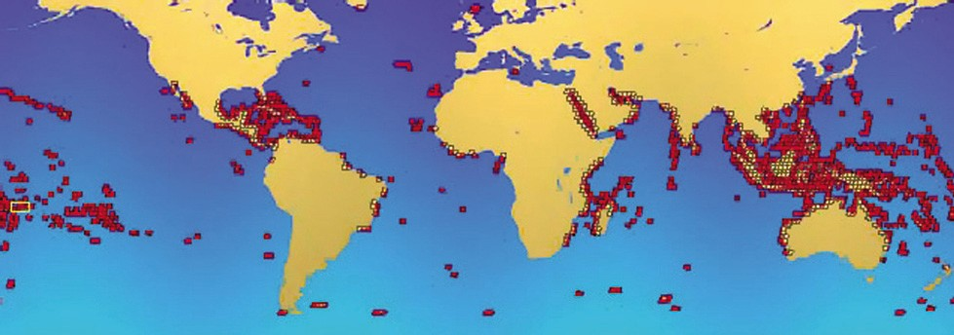
<Figure 1> Major Points for Skin Scuba

metropolitan areas, which signifies increasing participation of the general public.

Obstacles against Domestic Skin Scuba Activities

There are some obstacles which limit skin scuba in Korea. The biggest obstacle is transportation. Sea borne transportation of divers is regulated by the Water-Related Leisure Activities Safety Act, the Excursion Ship and Ferry Business Act and the Act on Fishing Management and Promotion. However, these acts have some irrational provisions when it comes to having divers on board.

Under the Act on Fishing Management and Promotion Act, fishing boats target people who are willing to do fishing at fishing spots. Accordingly, divers cannot get on fishing boats. The Water-Related Leisure Activities Safety Act regulates that those who do water-related activity should wear life vests unless otherwise directed. However, ‘divers putting on life vests’ is clearly a nonsense. According to the Excursion Ship and Ferry Business Act, excursion ship fields should
be equipped with proper-sized wharf, a passenger transportation ship and an emergency rescue ship. Since divers usually use small ships, it goes too far if these ships should be equipped with the above facility and equipment.

The second obstacle is insufficient infrastructure and safety system. For example, beach diving stairs are essential for the safety of novice divers. However, those stairs are regulated by the Public Water Management and Reclamation Act, which makes their construction tricky. Even erecting a safety board on wharf involves legal and institutional problems. In some cases, local fishing village fraternities are opposed to construction of facility or diving itself.

The third obstacle is hostility or confliction between local fishing community and divers. Since village fishing grounds and various fishing rights are scattered in Korean coast, ‘divers in fishing ground’ can be a problem. In some cases, divers steal fisheries products, making matters worse.

For ‘Safe and Conflict-free’ Skin Scuba Activities

Therefore, certain measures need to be implemented for ‘safe and conflict-free’ skin- scuba activities. Firstly, regulations on diver transportation and relevant institution should be improved. In some areas, divers use rubber boats registered as water-related leisure equipment, which is very convenient. However, they have to illegally get on fishing boats or other ships in different areas. Relevant regulations need to be revised to allow fishing boats and others or local ordinance should include certain provisions.

Local people, divers and diver shops should try to mend their fences continuously, building trust and resolving conflicts through agreement.

The root cause of conflict is divers doing damage to fishing grounds or stealing fisheries products. This problem should be addressed by inducing divers to have a sense of ‘eco-diving’ in which divers don’t collect things underwater but enjoy sightseeing or take pictures. Building trust in local people through this way is the only way to expand spaces for diving activity. The next step is legal and institutional approach necessary to secure safe infrastructure. For example, coastal structure can be used as stairs for beach diving.

Moreover, a win-win model should be developed for both local communities and divers. Although constant protection of natural environment eased local anxiety about seafood theft to some degree, local people cannot rid mind of doubt about divers in their fishing

ground. Local people earn nothing from divers on material or monetary front, which gives them no reason to allow diving activity. Therefore, a win-win model between local community and divers needs to be developed. For example, divers pay back fishing villages by using local lodging, restaurants, and transportation, while fishing villages provide divers with discounts for local specialty. Such monetary relationship satisfying the both parties should be in place for their own benefit.

Contact Information Name: Lee, Jong-hoon E-mail: sinto@kmi.re.kr Tel: +82-2-2105-4973

Dynamics of Competition and Cooperation between Busan and Kobe Port

Introduction

The port of Busan and the port of Kobe are representative container ports of Korea and Japan respectively. Change of their status from the 1970s to the 2010s presents a variety of dynamic competition and cooperation among container ports in Northeast Asia. During the initial stage of containerization, from the late 1960s to the late 1970s, Busan port without any container terminals had its own liner and feeder networks to neighboring hub ports such as Kobe, Yokohama, Keelung and Hong Kong, with the main feedering through Kobe port. On the other hand, Kobe port which started operating a container terminal in the

early 1970s dominated the transshipment container market in Northeast Asia and became a hub port in the region.

The interaction of the two ports was cooperative at the initial stage of containerization in the 1970s and the cooperation continued till the mid 1980s. However, it turned to be competitive from the mid 1980s. Thanks to aggressive expansion of its port facilities, Busan port was able to lead the transshipment market in the region from the 1990s. The dynamics of interrelationship between the two ports implies the future of hub ports in the region in the 21st century.

1971
1972
1974
1976
1978
1980
1982
1984
1986
1988
1990
1992
1994
1996
1998
2000
2002
2004
2006
2008
2010

<Figure 1> Container throughput of Busan port and Kobe port from 1971 to 2010

(Thousand TEU)

Development of Busan Port and Kobe Port

Although the two ports share the common feature as the gateway to each country, they have different historical background. Busan port handled unitized cargoes such as pallets and containers during the Korean War, according to the CONNEX project, a plan of logistic rationalization by the US Army. However, Busan port served container ships in the conventional berths till the late 1970s and handled larger vessels, using barges. It has begun to operate a container terminal since 1979. Therefore, it used two shipping networks: its own shipping networks to other ports in the world; and feedering networks to Kobe and other Japanese ports for transshipment service in the 1970s. By opening new container terminals in 1979, berth 5 and 6, and Busan could accommodate larger mother vessels and be connected to other container ports.

In accordance with the construction of container terminals, Busan port has recorded a continual increase in container throughput since the 1970s. The container throughput of Busan port has been rising steadily from 20 thousand TEU in 1971 to 380 thousand TEU in 1976, 1 million TEU in 1986 and 4.4 million TEU in 1996. In 2011 it ranked the world’s top 5, recording 16.2 million TEU in throughput.

Kobe port, a gateway to Japan, also handled military cargoes in pallets and containers in the 1950s and operated container terminals in the
early 1970s. Kobe port has been operated by two entities: the Port and Harbour Bureau of the City of Kobe and the Kobe Port Terminal Corporation. The former operated public berths while the latter was dedicated to berths leased on the long-term basis or exclusive usage basis to global liners (Chang, 2000). It played as a hub port in the region, connecting Chinese, Korean and Taiwanese ports through feeder networks. In Japan, Kobe port served larger hinterlands including Osaka, Hyogo, and Kinki regions than other hub ports such as Tokyo, Osaka, and Yokohama. The spatial range of Kobe port covered nation-wide areas in Japan. In the 1970s it ranked the world’s top 5 in container movement.

Nevertheless, the Japanese government tried to decentralize container throughput concentrated around the five major ports such as Kobe, Tokyo, Yokohama, Nagoya, and Osaka in order to lessen vessel and cargo congestion in the five major ports in the 1980s. Since the Japanese government assisted the growth of regional ports, the five major ports faced a new challenge from regional ports. Furthermore, the regulation on stevedoring with the agreement system of vessel’s calling among main players including liners, labor unions, and stevedoring companies increased cargo handling costs in Japanese ports.

The container throughput of Kobe port has risen from 140 thousand TEU in 1971 to 1.31
million TEU in 1976, 2.6 million TEU in 1991, but decreased to 2.56 million TEU in 2010.

<Table 1> Number of liner routes in Korean and Japanese port for Korean shippers in 1971

Source: Korea Shipping Gazette, 1971

Analysis on Competition and Cooperation between Busan Port and Kobe Port

The cooperative relationship between Busan port and Kobe port in the 1970s started as shipping networks, relying on feeder service between Korean and Japanese ports. In the early 1970s, Busan port was connected to the rest of world mainly by conventional liner service but rarely by container service. In contrast, Kobe port provided shippers with frequent container service to South America and the Middle East, and linked Northeast Asia with more ports as shown in Table 1. Therefore, both Busan port and Kobe port were benefitted by their cooperative relation.

Although the boom in the Korean economy from the later 1970s, resulting from the participation of Korean companies in construction in the Middle East, expanded shipping routes of Busan port to the Middle East and Indian Continent, Busan port relied partially on shipping
networks of Kobe port in order to be connected to other ports where it had no direct links. Nevertheless, constant containerization and integration of conventional service of liners diminished the spatial range of container shipping networks of Busan port in the early 1980s, compared to that of conventional liners.

Due to the operation of newly built container terminals and cost competitiveness in handling containers in Busan, the port of Busan could sharpen its edge over small regional ports of Japan from the late 1980s. In fact, Japanese shippers located at the Western part of Japan cut logistics costs by using Busan port. Adversely, feeder shipping companies which connected Busan port to Kobe port shifted their activities in order to collect Japanese transshipment containers for Busan port. Since the early 1990s Busan port has expanded its feedering networks with Japanese regional ports and could receive transshipment containers from Japan, China and other countries.

The Granger causality test and correlation

index of Busan port and Kobe port show that the relationship between the two ports changed from cooperation from the 1970s till the late 1980s to competition from the late 1980s to the 1990s and eventually to independence in the 2000s. Correlation index of container throughput for the two ports were positive till the late 1980s but turned negative in the 1990s.

Conclusion

The relationship between Busan port and Kobe port from 1970s till 2010 shows us dynamics of cooperation, competition and independence. The dynamics mirrors relative competitiveness of container ports in Northeast Asia, challenges and responses around port activities under shipping industrial change. In this context, the future interaction between hub ports in the region can be forecasted.

Contact Information Name: Park, Yong-An
E-mail: yapark@kmi.re.kr Tel: +82-2-2105-2789

02
Ocean Policy

Change in National Fishing Port Vitalization Project

National fishing ports of the past were mostly production facility for fishermen. However, as visits by city dwellers increased, these fishing ports began playing diverse functions for tourism and leisure activities. In this regard, ‘the Multifunctional Port Development Project’ adequately answers such needs of the time. It is an exemplary model which combines sightseeing, leisure activity and tourism with fishing ports. By adding sightseeing and tourism to the basic function of fishing ports, the project opened them to the public as well as fishermen. As of 2012, the project has developed six multifunctional fishing ports (model 2) and seven complex spaces at fishing ports (model 1) of which eight are completed and the other five are under construction.

‘The Multifunctional Port Development Project’ expanded the focus to include convenience facility as well as basic facility. Accordingly, fishing ports are being used for various purposes and presenting better environment. However, development of convenience facility is mostly about beautifying scenery or landscape and hardly increases income of fishing households, the ultimate goal of the project.

‘The Port Use Enhancing Plan’ started from 2012 to strengthen port function as the economic and social core of local communities. The plan aimed to maximize port functions through liaison development of surrounding areas, in addition to intensifying basic functions of port facility and enhancing efficiency of nearby land.

‘The Port Use Enhancing Plan’ is currently carrying out pilot projects at Bangohjin, Jukbyun, Gojin and Muchangpo. ‘The Port Use Enhancing Plan’ and ‘The Multifunctional Port Development Project’ share the common feature that they

develop spaces for the general public for cultural, commercial and tour activities. However, ‘The Port Use Enhancing Plan’ is different from ‘The Multifunctional Port Development Project’ on the following aspects:

Firstly, the plan includes fishery hygiene improvement, such as comprehensive seafood treatment system which is neglected by the ‘The Multifunctional Port Development Project.’ The main and the most important function of fishing ports is to increase added value of fishery products produced at those fishing villages. Secondly, the plan links local resources by developing fishing grounds, fishing ports and fishing villages in connection, playing as the center of local economic activities. Thirdly, it focuses on maximizing effects of port development through comprehensive projects which connects development of local neighborhood with surrounding areas.

If ‘the Port Use Enhancing Plan’ develops certain fishing ports, the ports will be able to function as the basis for others in vicinity. Therefore, the development will be comprehensive, considering convenience facility, scenery, access, hinterland and tourists at once. On economic front, this will increase income and jobs as the development boosts added value of fishery product and tourism facilities. On social front, these fishing ports will be at the center of hands-on activities and leisure activities at
fishing villages, thereby vitalizing local culture through exchanges with city dwellers.

Contact Information Name: Goh, Min-gyu
E-mail: mggo@kmi.re.kr Tel: +82-2-2105-4982

02. Ocean Policy 11

Completion of ‘the Zero Ocean Dumping of Land Waste Plan’

The Ministry of Land, Transport and Maritime Affairs (MLTM) revised the Enforcement Decree of the Marine Environment Management Act on December 21 last year, completing the roadmap for zero ocean dumping of land waste. According to the revision, ocean dumping of food waste water, excreta and excreta sludge is banned from 2013 and the prohibition will be expanded to include industrial waste and waste water sludge from 2014. This is a staged prevention of ocean dumping of land waste which started in 1988 and an institutional implementation of ‘the Zero Ocean Dumping of Land Waste Plan’ by the MLTM (July 31, 2012). Meanwhile, MLTM also carried out regulations on total ocean dumping of land waste and the total quantity will be cut from 2.5 million tons to
1.2 million tons.

Korea is the only OECD member that still dumps land waste into the ocean and the only nation that ratifies the London Convention but doesn’t follow up with it. The London Convention prohibits ocean dumping of land waste and Korea has been criticized for its failure to live up to it. Therefore, the implementation from 2014 will free Korea from international blame, while improving its relation with neighboring nations.

However, it is another matter whether Korea will succeed in implementing the roadmap or not. First of all, ocean dumping of food waste water is prohibited from January this year but the ban has not been effective. This is partly because
that waste water treatment facility in metropolitan areas are not completed as scheduled. Therefore, it is urgent to build waste treatment facility before carrying out ‘the Zero Ocean Dumping of Land Waste Plan’

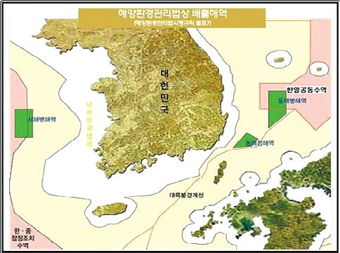
Note: Ocean dumping is allowed in green areas.

Contact Information Name: Park, Young-kil
E-mail: yk405@kmi.re.kr Tel: +82-2-2105-2995

Shipping Companies’ Management Strategies in the Era of Ship Oversupply
03

Research Findings

Purpose

•This study sought management strategies for shipping companies to ride over the sluggish shipping market which was characterized by faltering seaborne throughput and ship oversupply amid global economic slowdown.
- The result can be actively used by Korean shipping companies undergoing liquidity crisis which was caused by excessive ship supply, dropping rates, dwindling seaborne throughput, rising ship operation costs under high oil prices and wrong timing of ship purchase due to insufficient funds.

Methodologies and Feature

  - Methodologies
•S-R model to analyze adaptability of Korean shipping companies
•Case analyses on foreign shipping companies
•Interviews on Korean shipping companies, financial statement analysis and expert consultation

  - Feature
•The study tried to find crisis passing strategies for domestic shipping companies in this era of ship over supply. It sought feasible policy measures by bringing in managers at shipping companies and other outside experts.

Results

  - Summary
•The main ship types of Korean shipping companies are bulk ships and container ships with low added value and their key business area is cargo transportation. Therefore,

diversification of fleet and business areas is required above all.
•In order to create stable profits and operate the business against shipping rate change, shipping companies need ‘the business portfolio strategy’ which diversifies investment into container terminal operation, fisheries industry, marine resource development along with marine cargo transportation.
•As a solution to the chronic fleet supply structure, tonnage banks need to be established and other measures should be in place to induce private fund surplus to the shipping industry.
- For that purpose, large ship owners should be permitted to invest in the shipping industry and a review on the expansion of shipping businesses is required.
•The study presented policy measures as well as improvement measures to help shipping companies to overcome the recent crisis.
- Improvement measures: fleet diversification for stable profit creation, business expansion into container terminal operation, fisheries industry, marine resource development along with marine cargo transportation
- Policy measures: establishment of the tonnage bank to support ship finance, the Shipping Act revision to induce large cargo owners’ participation into the shipping industry and expansion of shipping business

  - Policy contribution
•The study can serve as the basic material in setting the direction for policies which can help shipping companies over the crisis.
  - Expected benefits
•To present the direction for future business of Korean shipping companies
    - The study indentified the basic cause of the current shipping market crisis and compared domestic and foreign cases, which could help domestic shipping companies to prepare future direction.
•To strengthen governmental support to resolve the chronic fleet supply structure
    - The study could help the institutional preparation, such as ship finance expansion and the Shipping Act revision, required to attract large scale money to the shipping industry.

Contact Information Name: Hwang, Jin-hoi et al. E-mail: hjh@kmi.re.kr
Tel: +82-2-2105-2792

04

•Madagascar port and logistics infrastructure development project
•New project exploration and long term development direction
•Review on logistics validity of transshipment system and demand prediction
•An economic feasibility analysis of discharging blue crab and sea cucumber
•The review on multi-functional ports
•Establishment of joint logistics for mid- and small shipping companies' competitiveness
•2012 national transportation survey and DB establishment
•Korea-China fisheries FTA negotiation scenario analysis
•An economic feasibility analysis on the Jukbyun and Gyojin port high utilization
•A study on the development of a yacht marine silk road
•A roadmap for port private projects in the long term
•A validity study on car-only terminal at Pyeongtaek-Dangjin Port
•Detailed planning for species development of halibut for export
•2012 economic development experience sharing: policy advice to Equatorial Guinea
•A validity study on Gunsan port 7 terminal (75 berths) development
•A validity study on the Banguhjin, Gusipo port high utilization
•A study on improvement of regulations and guidelines for uninhabited islands
•A study on foundation establishment for CO2 capture and marine storage
•Overhaul of passenger boat charge support system for island inhabitants
•A study on the Hadong port basic plan
•Northeast Asian port competition and cooperation preparing for international changes
•Hwasung coastal management local plan
•The study on fisheries basic system improvement
•A study on system improvement for the marina industry development
•Direction for national maritime policies for the era of per capita income 40,000 dollars
•A validity study on the port logistics and economic feasibility of Cambodia port development
•A validity study on the design of Jeju port (coast guard)
•A basic plan for modernization of cargo handling equipment at port

Research Projects

•Feasibility analysis on port private investment and management measures
•The 2nd stage project for the establishment of shipping market information networks
•The study on establishment of Korea-Asia inland integrated logistics system
•A study on effective management of Busan passenger terminal and other public facilities
•A study on effective public facility management such as Busan passenger terminal
•A study on mid-and long-term development strategy establishment
•2012 conservation study of marine species under protection
•Standard manual and guidelines for marine port establishment and management
•Impact of radioactive substance concentration on fisheries products and case study
•Systematic response to international conventions for overseas biological resource cooperation
•Fundamental technology research for u-shaped shipping, logistics system
•A study on the pacific oyster seed production technology development
•A validity study on establishment of offshore plant support stations
•Establishment of maritime environment standards and improvement (6th)
•A study on improvement of port and fisheries damage compensation
•Core technology development for national marine ecosystem comprehensive management
•Establishment of Dokdo Digital Archive (DDA)
•An analysis on polar policies of major nations and international organizations
•Climate change impact analysis model-fisheries sector (1st year)
•Ulneungdo and Dokdo maritime and fisheries long-term development plan
•An analysis on the mudflat fisheries damaged by oil spill
•2013 international logistics investment analysis center
•Consigned operation of 2013 Shipping, Port, Logistics Information Center homepage

Major Activities Conducted in February, 2013
05

The 10th KMI Special Lecture (2nd, 2013) News & Announcements
- Time & Place: February 4, KMI
- Topics: “Korean Creation DNA, Artisan Spirit” (by Yu, Hong- june, Myongji Univ.)
- Participants: All employees of KMI and others
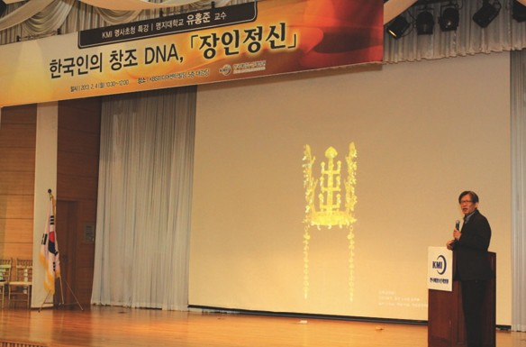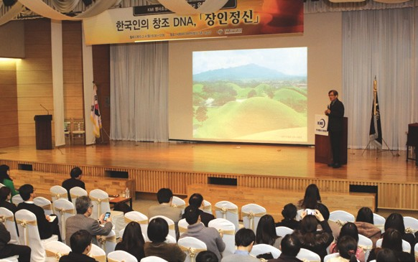
Source: KMI
Source: KMI
Source: KMI

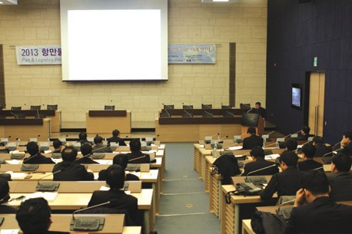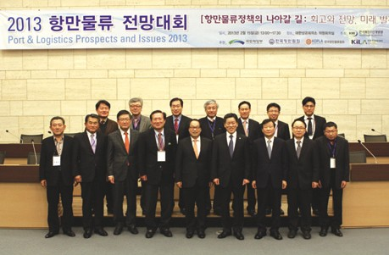The SPIDC Expert Workshop
Source: KMI
Source: KMI
- Time & Place: February 4, KMI
- Topics: Exploration of CP (Contents Provider) and reviews on the project plan

The Colloquium on Dokdo Digital Archive (DDA) Establishment
- Time & Place: February 6, KMI
- Participants: National Institute of Korean History, Yoon, Jin-sook (Director General, KMI) and others

The Ship Finance Seminar
- Time & Place: February 14, Dalgaebi
- Purpose: 2013 shipping market forecast and review on development direction for ship finance
- Topics: Better development direction for ship finance, ways of financing, establishment timing and implementation strategies
- Participants: MLTM, financial organizations and ship owners’ association

The Shipping, Port and Logistics Outlook Conference
- Time & Place: February 15, KCCI
- Topics: Analyses on major pending issues in 2013 and future prospects (‘A Way forward for Port and Logistics Policies: Review, Prospects and Future Development’)
- 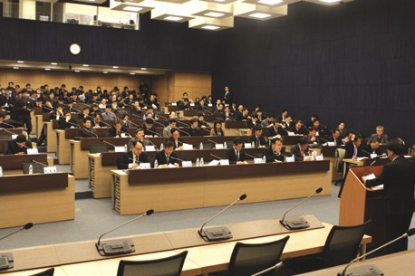Participants: Port industry, government, municipalities, port authorities and research society
Source: KMI

The Mid-term Briefing on Systematic Responses to International Agreements for Foreign Biological Resource Cooperation and Expert Seminar
  - Time & Place: February 18, Seoul station
  - Participants: Park, Su-jin (associate research fellow, KMI), Choi, Myong-bum (MLTM) and Lee, Hee-seung (KIOST)

A Meeting with Fishermen for Aquaculture Insurance Item Expansion
- Time & Place: February 19~21, Hadong and Tongyoung
- Participants: Gang, Jong-ho (research fellow, KMI)

The Tongyong Sea Farm Management Committee
- Time & Place: February 25, Tongyong City Hall
- Topics: Validity of 2013 post management of Tongyong sea farms
- Participants: Kim, Dae-young (research fellow, KMI)

Major Activities Planned in March, 2013

The 11th KMI Special Lecture (3rd, 2013)
- Time & Place: March 4, KMI
- Topics: “See your mind- laws of communication” (by Kim, Chang-oak, Seoul Womens Univ.)
- Participants: All employees of KMI and others

The Colloquium by Dokdo-Marine Territory Research Center
- Time & Place: March 8, KMI
- Topics: Expansion of marine economic territory
- Presentation: Yang, Hee-chul (KIOST)

2013 KMI-FIO Marine Cooperation Seminar
- Time & Place: March 12, Xiamen, China
- Topics: Island development, coastal management policy and Korea-China cooperation measures
- Participants: FIO, TIO (the 3rd Ocean Research Center), Mokpo Univ., Xiamen Univ. and Mok, Jin-yong (research fellow, KMI)

The 4th Anniversary Symposium of Gwangyang Bay Area Free Economic Zone Authority
- Time & Place: March 21, Gwangyang
- Topics: Ways to invigorate Gwangyang Port

KMI-ESCAP International Joint Seminar
- Time & Place: March 21~22, KITA
- Purpose: Case presentation and discussion on multimodal transportation networks
- Topics: Seminar on Development of a Comprehensive Transport and Logistics Network in N.E. Asia Subregion

The Seminar on Ministry of Maritime Affairs and Fisheries Projects
- Time & Place: March 27, Press center

The 3rd Shipping Logistics Company Conference
- Time & Place: March 27, KMI
- Topics: Logistics companies’ foreign market entry and joint entrance into ambatovy mineral development
- Participants: MLTM, KMI, major shipping and logistics companies

The International Seminar on the Pan Yellow Sea Port & Logistics Cooperation
- Time & Place: March 28, Tianjin, China
- Purpose: Case presentation and discussion on multimodal transportation networks
- Topics: Port and logistics development in Pan- Balhae area and Korea-China Cooperation Measures
- Participants: Tianjin government, logistics purchasing association, Nankai Univ. logistics companies, KOTRA, KITA and manufacturing companies

05. News & Announcements 19

Publisher
Kim, Hak So - President, Korea Maritime Institute

Editor-in-Chief
Choi, Jae Sun - Director General, International Cooperation & Public Relations Division Dean, Ocean Academy

Editorial Board
Kim, Woo Ho - Director General, Maritime Industry & Logistics Division Kim, Hyoung Geun - Director General, Port Research Division
Yoon, Jin Sook - Director General, Marine Policy Research Division
Joung, Myung Saeng - Director General, Fisheries Policy Research Division

Secretary
Kwon, Hye Jin - International Cooperation & Public Relations Division Chung, Kyung Hwa - Planning & Coordination Division

Contact Information
Address: 21F KBS Media Center Bldg., #45, Maebongsanro, Mapo-gu, Seoul, 121-915, Korea
Tel: +82-2-2105-2733, 4901
Fax: +82-2-2105-4990
Email: jschoi@kmi.re.kr, kwonhj@kmi.re.kr

