ISSN 2093-3584

The KMI News Letter
Ocean & Future

January, 2015. Vol.58

- Opinion
  - The Eurasia Initiative of Korea and the New Silk Road of China
  - A Proposal to Establish South - North Korean Rail Transport Network

- Ocean Policy
  - Deregulations to Boost Investment in Port Hinterland

- Research Findings
  - A Study on Measures to Improve Eco-Friendly Technology Certification (Green Certification) in Port Logistics
  - A Study on Conflict Management Measures of Fishing Community Project

- Research Projects

- KMI News & Events

The Eurasia Initiative of Korea and the New Silk Road of China

In an effort to link South Korea with North Korea via railroad with the potential extension into China and Russia, the South Korean government is going to propose a trial run of inter-Korean trains connecting to Seoul and Pyongyang first and then to two other major cities, Sinuiju and Rajin later. The Park Geun-hye Administration recently stated that the two Koreas’ western and eastern railways will be restored to operate trains from Seoul to the North Korean border cities. The government hopes this plan will be successfully carried out in August of this year after further discussions with the North, making this year a turning point in the unification of the two Koreas. In the past, the two Koreas discussed and restored some severed segments of the inter-Korean railways and operated trains in trial programs in 2007.

Connecting the inter-Korean railway services will eventually reach the Trans-China Railway (TCR) and the Trans-Siberian Railway (TSR). Having the North’s participation and cooperation, the project will expedite other economic projects while linking the two Koreas and its neighboring countries: i.e., China and Russia. Sinuiju is on the northwestern tip of North Korea bordering China while Rajin, a port city, lies on the eastern coast approximately near Russia, which allows sea, rail or road multimodal transport services more feasible.

While pushing forward the inter-Korean railway project, the South Korean government has an ambitious plan of operating an express train from Seoul to Europe via China, Mongolia and Russia on routes of the TCR and TSR. The so called Eurasia Initiative is President Park’s vision to boost economic activities, infrastructure development and free trade among the Eurasian nations by linking their railways. The government has already had talks with Russia in using the TSR and achieved some progress in the discussions. The Korean Peninsula, being at the gateway of Eurasia, would be able to promote the regional prosperity and peace while achieving the win-win strategy of cooperation and networks in logistics and energy in light of reduced logistics cost and revitalized intra- regional trade.
However, China, one of the big influencers in the region, is aggressively working on building a New Silk Road belt and a New Maritime Silk Road that encompasses Central Asia and South East Asia respectively. These strategies are to boost regional economic integration in terms of traffic connectivity, strategic partnership and so forth. The Silk Road economic belt and the 21st century maritime Silk Road with an aim to resurrect ancient trade routes will be built as a land-based belt from China via Central Asia and Russia to Europe. In addition, a maritime shipping route will be established through the Strait of Malacca to India, the Middle East, East Africa and eventually Europe.

The regional cooperation and infrastructure investments, partially supported by the newly established Silk Road fund and the Asian Infrastructure Investment Bank (AIIB) which was advocated by China recently, are going to enhance economic cooperation, traffic connectivity, as well as people-to-people and cultural exchanges. These movements are, however, warmly welcomed or cautiously watched over in the region. China’s rising power and influence is felt in every aspect these days. As China is actively gearing up and gaining a foothold in logistics and energy markets, China is still highly dependent on imported energy and resources.

Likewise, Korea has very similar interests and is making efforts in participating in overseas logistics investment and infrastructure development. In these circumstances there will be a window of opportunities for China and Korea to work together to make their new visions or initiatives more economically viable. As two countries already have conducted various cooperative projects and maintain very close ties to each other, both countries will be able to work closer to achieve a common interest for a better mutual benefit. In the meantime, Korea, while implementing the Eurasia Initiative, should try to create fresh investments and job opportunities.

With this and new perspectives with the unification on the Korean peninsula in mind, China will be able to mitigate tensions and contribute to improving political

and diplomatic relations with North Korea. Regional prosperity and stability will be secured by working together and actively participating cooperative projects. Intermodal logistics network in Eurasia and the Northeast Asia in light of shipping and logistics linkage will serve and benefit all in the region. A new era must

be opened in partaking cooperative spirits and goals.

Contact information Choe Yung-Sok yschoe@kmi.re.kr

A Proposal to Establish South - North Korean Rail Transport Network

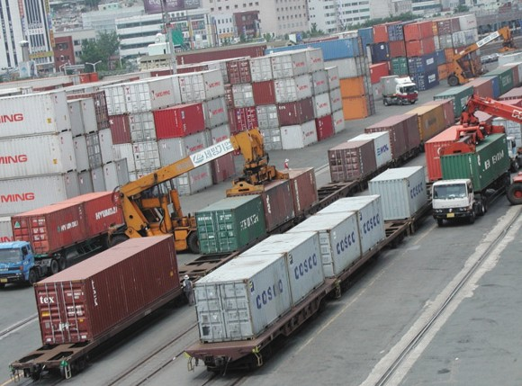Background

Trade volume between South and North Korea has grown gradually, together with major trade commodities widening to manufactures including electric and electronic items from agricultural products. The increasing trade volume and expanded trading areas caused high logistics costs for trading partners. Such high cost logistics is a result from limited trading channels such as trucking between the Gaesung Industrial District in DPRK and major cities in ROK. Because of such limited and complex logistics channels, high cost logistics has been unavoidable.

Efficient Transport Network Necessary for Lowering Logistics Costs

In order to solve high cost logistics and complex logistics procedures, logistics for North-South trading commodities should be simplified as in the case of third country trading. In a way to resolve these logistics problems, it is reasonable to designate a free trade zone (railway station) near the boundary between North and South Korea. The trading partners may use the free economic zone where all economic activities such as manufacturing, assembly, processing, quality checks and intermediary trading may be conducted in the single free trade zone.

Such transport channels may help firmly build systematic specialization between Pyongyang Nampo area in the North and metropolitan area in the South. Core industries such as machinery, textile, food and non-metal industries are concentrated in Pyongyang and Nampo, together with foreign investments. In the context, building of diverse transport networks
including rail and shipping may bring out various effects such as reduced logistics costs, transfer of technology and exchange of skilled manpower between North and South Korea.

Rail Transport Channels Considered between North-South Korea

North Korea's transport network has been developed largely based on the rail transport. The role of rail service in the North Korea has been critical. Major rail service routes are Kyongeu Line(Kaesong-Sariwon- Pyongyang-Shineuju), Wonna Line(Wonsan- Heungnam-Chongjin-Najin) and Pyongwon Line(Pyongyang-Wonsan). International rail service lines are four routes: Shineuju-Dandong, Dandong- Tumen, Manpo-Jian, Tumengang-Hassan and Rajin- Hassan. Linking service between Namyang and Tumen is a part of Chongjin Namyang-Tumen- Yenji rail service line and Chongjin port and Rajin port are used as a transit route for Chinese export commodities.

<Figure> Railway Transport of containers in Busan (2009)

Considering characteristics of North-South economic cooperation, rail transport and shipping seem to be proper channels for bulky commodities such as mineral resources. North-South economic cooperation is being carried out within limited conditions. And as distances between major industrial parks and cities between South and North Korea are over 300 km and transport service is supplied under state control, the rail service has various advantages. Rail safety and connected services are essential for rail service. This means that rail operators of South and North Korea can manage rail service with close collaboration. The rail transport can provide traders with stable service without modifications of cargo transport networks between North and South Korea. It is a strong merit for both of them.

Connected rail service can be provided in various ways. First, railways may be connected, while rail service operations may be conducted by North and South rail authorities respectively. Secondly, North and South rail authorities may conclude a joint operation agreement and may also reach an agreement to make a common pool of train engines and cargo trains and operate cargo service jointly. Thirdly, North and South rail operators may establish a train cargo service company which will carry out rail services independently. In a long term perspective, an international intermodal service agreement may be concluded by South and North Korea, China, Mongolia and Russia so that the rail services including South Korea and North Korea may be provided among the North East Asian countries.

Rail service by connecting railroads can be done like this. South and North rail authorities operate rail services respectively by designating hub transshipment railway stations and exchange trains and cargoes at the railway stations. The transport procedures at a transshipment station may be such as transit of the South Korean boundary immigration and customs clearance entry into the North Korean station
-customs clearance delivery and receipt of trains and cargoes confirmation process separation of trains and cargoes allocation of North trains by destination confirmation of cargoes by North Korean train operator start of North trains allocation of South

trains start towards South Korea.

A joint train operation may be realized when South and North rail authorities reach an agreement of a joint rail operation. Taking into account guaranty of planned production and service safety, cargo trains should operate under a common service schedule. To carry out a joint rail service provision, all regulations concerning not only input of rail facilities, train engines and cargo trains but also information management, signal systems, fare arrangements and train operations should be applied jointly.

Policy Recommendations

A proposal to establish a single rail service company may be considered as a long term project, considering separate operation of passengers and cargoes, an operating system of major rail service countries. In this case, the rail service company may use the existing railroads and develop an inclusive business strategy inducing intermediary trading cargoes of North East Asian countries. According to this operating method, the rail service company may utilize international intermodal services and function as a rail fare negotiator. All the regulations concerning rail service operation between South and North Korea should be applied as in the case of joint rail service agreement.

Contact information Park, Yong-An yapark@kmi.re.kr

Deregulations to Boost Investment in Port Hinterland
- Huge expansion of autonomy and incentives to new investment -

The Ministry of Oceans and Fisheries announced ‘the revised Administrative Guidelines on the First- Class Port Hinterlands’ on 11th, to promote job creation and business investment in the areas.

The revised guidelines partly allow investor integration and the transfer and sublease of a leased property to the businesses operated in the hinterlands. And the high value-added activities such as job creation and new investment were highlighted on the business performance evaluations.

Under the previous guidelines, the businesses were strictly restricted from changing the initial investors and transferring or subleasing a leased property for fair business selection process through an open competition. However, the businesses have complained the guidelines present an obstacle to organization of new business items or new investment attraction.

The ministry reflected the voice from the field on the revised guidelines. With the revision, the businesses are allowed to make a partial change to the initial investors if they maintain the same level of
business capacity from its selection. They are also allowed to transfer or sublease a part of the leased property under the same conditions.

Moreover, the triennial business performance evaluations were revised with the bigger ratio of cargo creation and the smaller one of employment creation. It also helps the businesses to attract more investment by providing incentives for attraction of new foreign investment and acquisition of warehouse certification.

The ministry relaxed the qualification of the manufacturing business in its revised business selection system on July 11th. In the same way, the businesses that are already operating in the hinterlands can receive substantial benefits from the revised guidelines such as reduction of rent when they receive high marks at the evaluations for the increase of new investment and job creation.

Contact information Kim Woo sun firstkim@kmi.re.kr

RESEARCH FINDINGS

A Study on Measures to Improve Eco-Friendly Technology Certification
(Green Certification) in Port Logistics
1. Purposes

•While most industries in Korea present fairly systematic green certification classification systems
and certification levels, the port logistics area still
has a room for improvement in terms of institution and system.

•The study aims to make institutional improvement in eco technology certification system including green certified product in port logistics area, technology classification system and technological level in order to facilitate the green port logistics industry of Korea, to establish a ground to enter the global market with leading technologies and to contribute to the identification of new future industries.

Methodologies and Features

Methodologies

•Domestic and foreign literature investigation and internet search

  - Certification authority’s classification system, certification level and procedures are surveyed through domestic and foreign literature investigation and internet search. It aims to analyze the current status of green technology at home and abroad, the idea of green certification, institutional certification and management status.

•In-depth interview and survey

  - Administrative organizations executing green certification system, legal and institutional experts, green technology developing port logistics companies, green companies and certification applicants in the port logistics area are interviewed and surveyed.
  - The current status of green technology management in the port logistics area is studied and the issues including problems and users’ institutional demands are identified.
  - A direction in the improvement of the Management Code on Green Certification System in port logistics is identified.

•Expert planning committee and workshop

  - Expert planning committees and workshops are held in various areas to find and verify measures to improve the Management Code on Green Certification System

•Application of technology classification system methodology

- Four different classification systems are applied for analysis, which include the design-assembly type, the principle-application type, the plane arrangement-pluralistic arrangement type and the enumeration-combination type.

Features

•The study result is directly related with the 2015 revised Management Code on Green Certification System in the port logistics area.

- The Management Code on Green Certification System will be revised based on the new green certification improvement measures developed through a discussion and agreement among green certification managers of the Korea Institute for the Advancement of Technology and the Korea Institute of Marine Science & Technology Promotion.

Results

Summary

•Improvement of classification system for eco technology certification (green certification)

  - Under the green technology certification system, logistics is added to a bigger category and the medium category is consisted of logistics equipment, logistics facilities and logistics system.
  - Based on this, the smaller category is composed of container (quay/yard/transport vehicle), bulk (quay/yard/transport vehicle), storage facilities, infrastructure and port logistics system.
  - It identifies improvement measures for classification system, which will encourage participation of a wider variety of technology development companies and facilitate the green port logistics industries.

•Improvement of green business certification classification system

    - It provides improvement measures for the existing green business certification classification systems under which port logistics were not included within its categories and port logistics companies (388 container and bulk port operators) were unable to obtain a green port industry certificate.
    - ‘Logistics system’ is added to the bigger category of the green business certification area and introduction and distribution projects of ‘eco- friendly high efficiency logistics facility’, ‘eco- friendly high efficiency logistics equipment’ and ‘eco-friendly high efficiency logistics IT’ are added to the medium category.

•Improvement and complementation of green technology certification’s key technologies

    - As the number of existing smaller classification systems increased from three to nine, the composition of key technology has become more subdivided throughout the wider scope of area.
    - Composition of core technologies is one of the ways to expand the certification participation of technology development companies. Therefore, bulk-related eco-friendly technologies are added to the existing container-centered composition and the container technology sector is also further divided by product’s detailed equipment unit with a wider scope of subjects for the technological development.
    - As a result, the number of key green technologies increased from 14 to 54.

•Establishment of certification level for the green technology certification’s key technology

    - The existing standards for the technology level are extensive and its targets are vague. It requires improvement, specified for each key technology.
    - The certification standards in the port logistics area are revised and improved with quantifiable and objective numbers. It provides a ground on which related technology development companies can obtain a certificate if the quantified comparison standards fulfilled.

•Improvement of green certification activation plan

  - It presents institutional and system improvement measures to facilitate the green industry by increasing the number of green technology and business certification issuance. The measures include an increase in green certification promotional activities and incentives, securing certification authority and establishment of green business certification system by class.

Policy contribution

•It presents basic data for the revision of the 2015 ‘Management Code on Green Certification System’ for port logistics.

  - Roughly five standards revisions are made, which include improvement of green technology certification classification system, improvement of green business certification classification system, improvement and complementation of green technology certification’s key technologies, establishment of the certification level for green technology certification key technologies, improvement measures to facilitate green certification, etc.
  - The five revisions are expected to be reflected on the 2015 revised Management Code on Green Certification System through a discussion among the Korea Institute for the Advancement of Technology and the Korea Institute of Marine Science & Technology Promotion, who is in charge of port logistics.

•It increases the possibility that more port logistics companies would get the certification for green technology and green industry.

  - It contributes to the increase in the number of green certification issuance to port logistics companies based on the eco-friendly technology certification revision (draft) and system and institution improvement measures.

Expected benefits

•Facilitation of Korea°Øs green port logistics industry

  - The green port logistics industry will be expanded

as port logistics companies develop more green technologies and increase green projects.

•It will create future economic values by opening up a new market, including development of green port logistics technologies.

    - It will facilitate the green industry by shedding a new light on the green port logistics technologies and the industries upon the enforcement of the carbon emissions trading system from 2015.
    - Leading green technologies will be secured in the port logistics industries, contributing to securing

business competitiveness and finding new growth industries for Korea.

Contact information Choi, Sang-hei shchoi@kmi.re.kr

Lee, Eon-kyoung
eklee@kmi.re.kr

Jeon, Hyeong-mo
hmjeon@kmi.re.kr

A Study on Conflict Management Measures of Fishing Community Project

Purposes

•The fishing communities, as the foundation of the fishing society, have many conflicts. Among them, community work-related ones are analyzed in the study.

•It aims to present policy tasks and mid- and long- term road map that can address conflicts in the fishing villages by type and stage (preventative measures and conflicts at the initial stage and advanced stage). It ultimately aims to promote sustainable stability and development of the fishing society that gradually slows down.

Methodologies and Distinctiveness

•As a basic framework, it analyzes and summarizes various fishing community work cases and conflicts home and abroad to understand the real situations of the conflicts and to identify the measures to address them.

•In order to differentiate it from preceding researches, it conducts an in-depth analysis on the cases and GIS-based space analysis and gathers opinions of stakeholers in various areas.

Results and Policy Suggestions

Summary

•Conflicts in fishing villages are inevitable in the coruse of promoting vibrant economic activities and sustainable development. Therefore, it is necessary to convert people’s awareness and establish a systematic conflict management framework, so that the conflicts are more efficiently managed and utilized for the development of the fishing community rather than making efforts to eliminate them to the root.

  - First, the conflict management system for the fishing community should be advanced, scientific, rational, organized, private-led and professional, taking a bold move of turning away from the posterior, arbitrary, impromptu, unsystematic and administration-led response.
  - Second, a clear direction should be presented for the enactment of the Law on Conflict Management Support for Fishing Community (tentative). A conflict management task force should be established and conflict management professionals should be trained. A conflict management system should be adapted to strengthen the foundation for fishing community conflict management.

    - Third, as a prior preventative measures, conflict management capacity building education should be expanded along with the pre-evaluation of conflict management before executing community projects.
    - Fourth, customized conflict management strategies such as fishing village on-site forum, alternative dispute arbitration system and criminal arbitration system are suggested according to the stage and intensity of the conflicts.
    - ‘The adaptation of fishing community conflict level and history management system is suggested to better manage community projects.
    - Lastly, the implementation tasks for the fishing community conflict management should be gradually carried out from 2015 to 2024 and it is estimated to require a total budget of 64 billion won.

Policy suggestions

•It is proposed to enact the Law on Conflict Management Support for Fishing Community

(tentative) as a comprehensive conflict management measure to promote sustainable development of fishing community.

•It is suggested to execute a pilot project for the fishing villages suffering with conflicts.

- Based on the evaluation of the pilot project achievements, budget should be secured and conflict management body should be established for sustainable project execution in the future.

•In many cases, fishing communities start a new community project without addressing old existing conflicts. It is suggested to change the Ministry of Oceans and Fisheries guidance on implementation of marine and fisheries community projects.

Contact information Park, Sang-woo swpark@kmi.re.kr

RESEARCH PROJECTS

•A study on regulation costs according to total regulation cost management
•A study on ocean and fisheries industry categorization system and statistical foundation
•Strategies for Arctic Ocean and Fareast Russia logistics linkage
•Coastal basic analysis
•Impacts of Korea-China-Japan FTAs on fisheries sector and responsive measures
•Development of national fishing ground usage models and present condition investigation
•Integrated export certification and national brand development
•Operation of private-government-industry-university conference at Ulsan coast and the Gwangyang Bay

•Provision of the Regional Study on Efficient and Effective Logistics Information System for the UNESCAP
•2014 Entrusted operation of shipping demand prediction center
•The 1st study on unification preparation (shipping industry)
•Certification of good logistics warehouses in port area
•2014 national transportation surveys and DB establishment
•2014 consigned operation of shipping, port logistics information center homepage
•National contest on knowledge sharing for fishermen
•A validity study on international cruise tourism and master plan establishment
•Development of marine safety index and validity of

hands-on experience facilities
•A consulting project on 2014 Ongjin-gun Fisheries Mutual Logistics
•Preparation for bilateral and multilateral shipping service negotiation, incl. Korea-China FTA
•A study on abalone processing industry and processed products
•2014 operation of international logistics analysis center
•Regional model development for access to biological resources and benefit sharing
•Fisheries export market development before Korea-China FTA
•Pilot projects on fisheries observation
•A validity analysis on Boryong multifunctional development and basic plan
•2014 Yeosu International Academy Project
•2014 implementation of total pollution load management system on the Masan Bay special management water
•Improvement of search and rescue under ocean disaster
•A study on Eurasia intermodal transportation/logistics networks building
•Follow-up measures for Arctic Policy Master Plan
•A study on environmental standard establishment for each water
•2014 analysis on actual condition of beaches and management types
•Special categorization of fisheries industry and statistics analysis
•Polar sea utilization measures through analyses on major nations' arctic policies
•Improvement on strategic environmental effect evaluation system
•Global network building to strengthen maritime territory, incl continental shelf
•A study on definition and scope of fishing villages for comprehensive fishing village development
•An In-depth analysis on responsive measures prepared for TPP participation
•Strategies to enter logistics market in Northeast China: based on China-North Korea cooperation
•Pilot supply and demand forecast under changing environment and institutional improvements
•A survey on promising fisheries export items to China
•Implementation plans for 'Beautiful Busan Port'
•Impacts of radioactivity on fisheries and radio activity pollution cases
•Development of EBSA national report on biodiversity convention
•An estimation of social costs of maritime accidents
•A study to promote cooperative relation among

Northeast Asian ports
•A study on maritime and fisheries future vision establishment
•A study on improvement and promotion of towage system
•Comprehensive plan on marina port development in Choongchungnamdo
•Estimation of adequate investment in port infrastructure and policy direction
•Institutional improvements to vitalize marine leisure activities
•Domestic supplementary measures for fisheries FTAs
•Coastal water in-depth investigation (basic research for systematic management of coastal line)
•Improvement measures for port modernization fund operation system
•Impacts of Korea-Australia, Korea-Canada and Korea-New Zealand FTAs
•Strategies and tasks for Ulju ocean industry development
•Basic design for marina port base: utilization of marina port for marine tourism
•A validity study on North Sea Wall construction (Donghae port 3 stage project)
•3-1 stage project on shipping market network construction
•Functional relocation of Incheon port and employment of dock workers
•Development of unified cargo handling equipment for less time consumption of cargo vehicles
•A validity study on 7 terminal development (74 berths) at Gunsan port
•Port redevelopment at dredged soil landfill at Myodo, Gwangyang port
•Case studies on city planning against coastal erosion and maintenance direction
•A study on maritime and fisheries ODA intl.conference
•A study on conservation of 2013 marine life under protection
•A study on 2nd costal development plan (revised)
•Management plan per waters for environmental management
•Results of 2014 Wando International Seaweed Expo
•2013 increase and restoration of marine life under protection
•Eurasia knowledge network building-Russia Vladivostok
•Negotiation plans for Busan North Port redevelopment project
•Tasks and direction for reciprocal fisheries relationship between Korea and Japan
•Systematic response to international convention on marine organism (2nd)
•Possible application of Basel Ⅲand its impact on National Federation of Fisheries Cooperatives

Major Activities conducted in December, 2014

KMI-SISI International Shipping Forum
- Time / Place: December 4 / Shanghai Ocean Hotel
- Major Contents: The outlook for the 2015 global shipping market conditions

Korea- China FTA Response Measures Seminar
- Time / Place: December 23, 14:00~17:00 / Korea Chamber of Commerce and Industry
- Major Contents: Discussion on Significance of the Korea-China FTA Agreement and Its Influence on Major Industries including Agriculture, Fisheries and Logistics

Source: KMI

Major Activities planned in January, 2015

Korea-China FTA Utilization Forum
- Time / Place: January 21/ Shanghai Hotel
- Topic: How to enter the service investment sector including finance and insurance and China's logistics and fishery market
- Co-organized by KMI and Korea Institute for International Economic Policy

2015 1st China Logistics Workshop
- Time / Place: January 29 / Chinese Studies Center Conference Hall
- Major Contents: The ways to enter the Northeast Logistics Market through Sino-North Korean cooperation

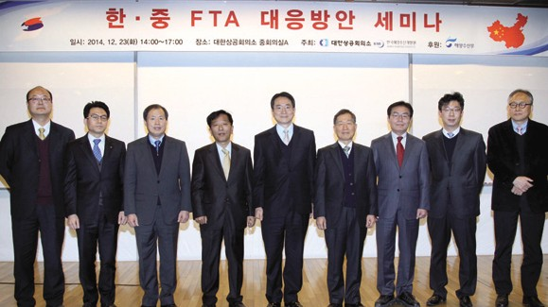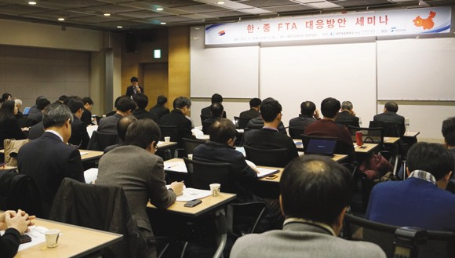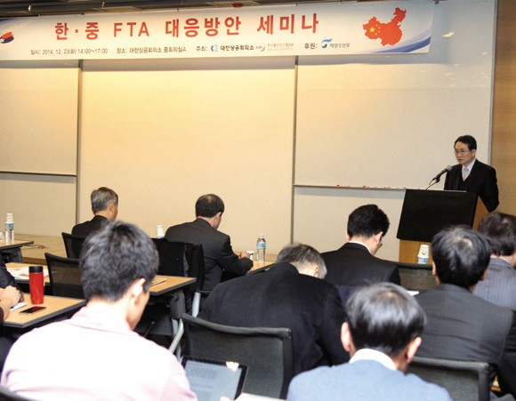

Source: KMI

Source: KMI

Publisher
Kim, Sung Gwi - President, Korea Maritime Institute

Editor-in-Chief
Choi, Jae Sun - Director General, Planning & Coordination Division

Editorial Board
Mok, Jin Yong - Director General, Marine Policy Research Division
Joung, Myung Saeng - Director General, Fisheries Policy Research Division Kim, Woo Ho - Director General, Maritime Industry & Safety Research Division Jun, Chan Young - Director General, Port Policy Research Division
Kim, Jong Deog - Director General, Strategy Research Division

Secretary
Song, Wonkeun - Planning & Coordination Division Jang, Hye Young - Planning & Coordination Division

Contact Information
Address: 21F KBS Media Center Bldg., #45, Maebongsanro, Mapo-gu, Seoul, 121-915, Korea
Tel: +82-2-2105-2700 Fax: +82-2-2105-2800
Email: jschoi@kmi.re.kr, wksong7@kmi.re.kr

