ISSN 2093-3584

The KMI News Letter
Ocean & Future

May, 2014. Vol.50

- Opinion

Higher Student Quota at Marine Universities and Its Implications
  - Recent Efforts on Securing Strategic Points in the Arctic Ocean

- Ocean Policy

The 2nd Marine Debris Management Master Plan to Be Implemented

- Research Projects

- Research Findings

Strategies for Eco-friendly Utilization and Industrialization of Fishery By-products
  - A Study on the Korea Fisheries Outlook and Simulation Model

- KMI News & Events

Higher Student Quota at Marine Universities and Its Implications

In an effort to foster more marine officers, the Korean government decided to increase entrance quota for majors at maritime universities. Marine officers are certified professionals in the field, helping the nation create national wealth and earn hard currency at domestic and international maritime markets. Currently, maritime universities, maritime high schools and the Korea Institute of Maritime and Fisheries Technology are organizations for marine engineer training in Korea.

Among them, marine universities will be able to allow in 60 more students from 2014. A total of 500 students will be added at stages until 2017. In accordance with rising student quota, professors and budgets will be increased as well.
minerals and energy resources. About 30% of oil resources are being produced underwater. The ocean is in the limelight as the only key to solving food shortage. Three quarters of global trade volume are being carried via ocean. And ocean also provides people with resting places. All these facts bring about fierce competition over the ocean.

With everlasting importance of the ocean and marine industrial development, demand for marine professionals is surging. Rising global trade resulted in increasing marine transportation, which push up the number of ships by 20,000 from 65,000 in 2002 to 86,000 in 2012. Accordingly, 420,000 more marine crew are in demand. Increasing seafood consumption, offshore plant market expansion, toughened marine environment and safety management

<Student Quota Increase Plan at Marine Universities>

University Total | '14 | '15 | '16 | '17 | Total
 | 60 | 195 | 180 | 65 | 500
Korea Maritime and Ocean Univ. | 30 | 90 | 80 | - | 200
Mokpo National Maritime Univ. | 30 | 105 | 100 | 65 | 300
Note: The figure is additional quota. (Source: Ministry of Oceans and Fisheries)

So far, student quota at maritime universities has continued to decrease, a reverse trends against increasing national flag carriers. While the number of ocean going merchant ships jumped from 100 in 1970s to 530 in the 1980s and to 1,000 in 2013, the student quota dwindled from 850 in the 1970s to 750 in the late 2000s. Under the great pitch for college entrance quota cut, the number of students at maritime universities was reduced despite their high potential in the future.

OPINION

This happened in Korea as Koreans failed to grasp importance of the ocean while futurologists emphasized potential of the ocean from early days. For example, Alvin Toffler chose information and communications, space development, bio-engineering and ocean as four key industries which would lead ‘the Third Wave.’ Paul Kennedy also picked out Multi-national capital, Mass media and Marines as 3Ms which would decide future of the humanity.

The ocean provides infinite value for the mankind. Land resources are being depleted but marine resources remain immeasurable. The sea is the treasure trove of
are all asking for more professionals in the field.

Responsibility of human resource development firstly falls on the government. Early governmental investment in marine professional fosterage paved the foundation for marine industrial rise of today. Therefore, the governmental decision on expansion of marine officer development program will greatly help to cultivate marine crew who will lead national marine industry and national advance- ment into global market. At the same time, the higher quota will create more jobs for the youth and other direct effects on the job market. In this regard, the recent decision can be seen as investment in the future where knowledge and experience in marine industry will be handed down and developed to realize ‘a creative economy.’ It will help Korea make a one step forwards ‘Dream and Happiness Realized through the Sea.’

Contact information Name: Hwang, Jin-hoi E-mail: hjh@kmi.re.kr Tel: +82-2-2105-2792

Recent Efforts on Securing Strategic Points in the Arctic Ocean

In last March, the UN Commission on the Limits of the Continental Shelf (CLCS) officially recognized submission of the Russian Federation on outer limits of the continental shelf in the Sea of Okhotsk beyond 200 nautical miles from the baselines. A hefty amount of energy resources are thought to be buried in the continental shelf of the Sea of Okhotsk. Russia has made constant efforts to expand its maritime influence in the Arctic. For example, it is modernizing port and airport facilities in the New Siberian Islands (Novosibirskiye) while embracing their strategic importance in the region. The New Siberian Islands are located in the East Siberian Sea, one of crucial bottle necks in the Arctic Ocean.

Russia plans to create military units stationed in the Arctic and build relevant facilities, trying to strengthen its control over the region. Therefore, Russia’s Arctic strategies are based on military capability for stronger clout in the Arctic Ocean. Moreover, the nation is expected to submit revised information on extended continental shelf to the CLCS in early 2015 in an attempt to extend Russia’s continental shelf in the Arctic and secure maritime jurisdiction over the North Pole.

Meanwhile, Canada submitted claims of extended continental shelf to the UN CLCS last December. It claimed that Arctic seabed including the Lomonosov Ridge is connected to continental shelf of Canada. The Lomonosov Ridge is known to have rich resources. Canada already submitted preliminary information which would be followed by additional documents. While presenting preliminary submission, it pointed out that harsh natural environment have delayed its efforts to collect necessary information. The preliminary information also said that continental shelf of Canada reaches beyond 350 nautical miles upto the Alpha Ridge and the Lomonosov Ridge, implying that the follow-up official documents would make seabed claims over the North Pole.

For analyses on submarine topography, Canada has been running USD 200 million worth projects. The Lomonosov Ridge area is an easy target for resource development since it is relatively shallow. For that reason, Canada considers that area as the core of the Arctic Ocean. Russia sent a submarine in 2007 and planted the
Russian flag on the seafloor of the Lomonosov Ridge to declare claim over it. Russia also claimed that the ridge is a continuation of its continental shelf. Canada predicts that an evaluation by the CLCS will take longer than a decade. Accordingly, Canada plans negotiations over delimiting its maritime boundary with Russia and Demark, depending on results by the evaluation.

As such, Russia and Canada, the two big Arctic states, are gearing up their first-stage efforts to argue sovereign right and control in the Arctic. They try to secure continental shelf and waters close to the North Pole and their approach for extended jurisdiction over their continental shelves has been very scientific and strategic. In these circumstances, Korea, as a non-Arctic state, under ‘the Arctic Policy Master Plan,’ should implement constant and strategic cooperation with Russia, Canada and etc. for Arctic routes and resource development. Moreover, it should pay keen attention to every strategic move of Arctic states in the Bering Strait between Siberia and Alaska and the Greenland- Iceland-UK (GIUK) gap, the other two critical bottle necks in the Arctic Ocean.

Contact information Name: Choe Yung-sok
E-mail: yschoe@kmi.re.kr Tel: +82-2-2105-2992

The 2nd Marine Debris Management Master Plan to Be Implemented

This year March, the Korean government announced ‘The 2nd Marine Debris Management Master Plan (2014 ~ 2018).’ This national plan was prepared for effective management of marine debris with participation of the Ministry of Oceans and Fisheries, the Ministry of Environment and the Korea Coast Guard under the Marine Environment Management Act.

The plan consists of four strategies, such as ‘Intensive Management of Marine Debris Sources,’ ‘Expansion of Marine Debris Collection Sites,’ ‘Advancement of Marine Debris Management Foundation,’ and ‘Target-tailored Education and PRs’. Under each strategy, detailed action plans are prepared. The government presents the vision of fundamentally blocking wastes inflow to the sea and systematically collecting old garbage settled in the beach, cultivating pleasant, safe, productive and waste-free sea until 2018 when the master plan is completed. A KRW
  - billion worth budget will be spent on implementing the plan.
The first strategy is ‘Intensive Management of Marine Debris Sources.’ In order to reduce and thwart wastes from land and sea at their roots, wastes created at river mouth will be closely watched under cooperation with the Ministry of Environment. Moreover, recovery rates of styrofoam floatage will be raised to 80% until 2018.

The second strategy is ‘Expansion of Marine Debris Collection Sites.’ So far, marine debris collection was focused on garbage settled in the ocean. Litters scattered in the beach, the so-called seaside wastes, have been in the grey area without investment nor management due to unclear jurisdiction among ministries. As a result, marine debris collection projects have been fragmentary at best. For more intensive projects, KRW 21.5 billion or 6.5% of the total budget for the 2nd Master Plan, will be invested. At the same time, constant projects will be carried on to get rid of floating wastes and litters from fishing grounds and fishing places.

<The 2nd Marine Debris Management Master Plan and Action Plans>

Strategy
Action Plans

    - Intensive Management of Marine Debris Sources

- (Focus) Intensive management of styrofoam floatage
- (Focus) Preliminary management of waste inflows from rivers & estuaries
- Distribution of biodegradable fishing gear
- Clean fishing village movements
- Installation of Debris collection places on deck

    - Expansion of Marine Debris Collection Sites
- (Focus) Marine waste purification projects
- (Focus) Collection of seaside debris
- Collection of debris in fishing grounds
- Collection of floating debris at ports
- Environmental improvements at fishing places
- Collection and treatment of disaster debris

    - Advancement of Marine Debris Management Foundation
- (Focus) Introduction of fishing gear management system & deposit system
- (Focus) Intensified functions of the Marine Litter Management Center
- Marine debris analysis guidelines and statistics methods development
- Expansion of national marine debris monitoring projects
- Strengthening of marine debris policy capability and cooperative governance
- Expansion of recycling shell

    - Target-tailored Education and PRs
- (Focus) Marine debris policy PRs for the public
- (Focus) Civil participation in coast cleaning
- Target-oriented education and PRs
- Active participation in regional seas international cooperation programme

The third strategy is ‘Advancement of Marine Debris Management Foundation.’ For higher policy response and group intelligence to the issue, ‘Marine Debris Policy Council’ will be built, consisting of the Ministry of Oceans and Fisheries, the Ministry of Environment, the Korea Coast Guard, local governments, research institutions and NGOs. Fishing gear has been considered as the main cause of sea-based debris. For their systematic management, fishing gear management system and deposit system will be introduced. The Marine Litter Management Center (http://info.malic.or.kr) will fortify its functions and the Marine Debris Annual Report will be issued from 2015. Moreover, surveys and statistics methods specialized in marine debris will be developed. Test areas will be expanded to include rivers and estuaries to establish comprehensive marine debris statistics encompassing lands and waters.
The fourth strategy is ‘Target-tailored Education and PRs’. In order to encourage ‘Private Governance’ engaged and led by the public, national marine debris monitoring sites will be increased from 20 coasts to 40 coasts. Relevant measures will be prepared to apply the results to policies. PR activities will be customized for each target, such as TV, the internet and SNS, while social acceptance will be enhanced through issuance of marine debris damage cases and annual reports as well as through programs which combine volunteering acts and hands-on activities.

Contact Information Name: Kim, Kyung-Shin et al. E-mail: kskim@kmi.re.kr
Tel: +82-2-2105-2775

RESEARCH PROJECTS

- R&D planning for integrated coastal management
- Institutional improvement for active logistics service at
Northeast oil hubs
- Strategies for negotiation on TPP fisheries subsidies
- Measures to enter the shipping and logistics market in
the Far East Siberia
- The 10th informal COP for the UN Fish stock
Agreement
- Development of fisheries distribution and processing
technology
- Support for private-government-industry-academia committee at Ulsan & Gwangyang coast
- A study on the basic planning of maritime territory
management
- Analysis on Korea-Thailand, Korea-Malaysia FTA
(fisheries sector)
- Development of coastal erosion response technology
- A review on Donghae-Mukho port project proposal and
its validity
- A study on fisheries distribution system improvement
- Measures to use waterside of Incheon Port
- Korea's experience sharing with Saudi Arabia for its
land or coastal aquaculture
- Policy measures for modernization of offshore fishing
boats
- A study on fisheries entrance into the Arctic Ocean
- Abandoned wells for undersea tests of ocean drilling
equipment
- Introduction of total pollution load management system
on Busan special management waters
- A study on overseas port development cooperation
- Issue development for response to international
organizations in shipbuilding and ocean sector
- Foundation technology for the U-based shipping and
logistics system-policies for container searcher use
- Port redevelopment project for Incheon yongjong island
dredged oil dump area
- A review on needs for shipping guarantee fund
- A validity study on small fishing grounds for fishing
villages (Mayhyang 2)
- The basic plan on the operation of marine economic
special zone
- Development of low carbon automation container
terminal technology
- Korea-China-Japan transportation and logistics
cooperation measures

  - Foundation for self management fisheries cultivation
and support
  - A study on Busan Port Comprehensive Development
Plan
  - Possible application of Basel Ⅲand its impact on National Federation of Fisheries Cooperatives
  - Tasks and direction for reciprocal fisheries relationship between Korea and Japan
  - Systematic response to international convention on
marine organism (2nd)
  - 2013 increase and restoration of marine life under
protection
  - Results of 2014 Wando International Seaweed Expo
  - Management plan per waters for environmental
management
  - A study on 2nd costal development plan (revised)
  - A study on conservation of 2013 marine life under
protection
  - A study on maritime and fisheries ODA intl.coference
  - Case studies on city planning against coastal erosion
and maintenance direction
  - Development of unified cargo handling equipment for
less time consumption of cargo vehicles
  - Functional relocation of Incheon port and employment
of dock workers
  - 3-1 stage project on shipping market network
construction
  - A validity study on North Sea Wall construction
(Donghae port 3 stage project)
  - Basic design for marina port base: utilization of marina
port for marine tourism
  - Impacts of Korea-Australia, Korea-Canada and Korea-
New Zealand FTAs
  - Improvement measures for port modernization fund
operation system
  - Estimation of adequate investment in port
infrastructure and policy direction
  - Comprehensive plan on marina port development in
Choongchungnamdo
  - A study on improvement and promotion of towage
system
  - A study on maritime and fisheries future vision
establishment
  - A study to promote cooperative relation among
Northeast Asian ports
  - An estimation of social costs of maritime accidents
  - Development of EBSA national report on biodiversity
convention
- Impacts of radioactivity on fisheries and radio activity
pollution cases
- Implementation plans for 'Beautiful Busan Port'
- A survey on promising fisheries export items to China
- Pilot supply and demand forecast under changing
environment and institutional improvements
- Polar sea utilization measures through analyses on major nations' arctic policies
- Special categorization of fisheries industry and statistics
analysis
- 2014 analysis on actual condition of beaches and
management types
- A study on environmental standard establishment for
each water
- Follow-up measures for Arctic Policy Master Plan
- 2014 implementation of total pollution load management system on the Masan Bay special management water
- A validity analysis on Boryong multifunctional
development and basic plan
- Pilot projects on fisheries observation
- Regional model development for access to biological
resources and benefit sharing
- 2014 operation of international logistics analysis center
- A study on abalone processing industry and processed
products
- Preparation for bilateral and multilateral shipping
service negotiation, incl. Korea-China FTA
- Development of marine safety index and validity of
hands-on experience facilities
- A validity study on international cruise tourism and
master plan establishment
- 2014 national transportation surveys and DB
establishment
- 2014 consigned operation of shipping, port logistics
information center homepage
- Certification of good logistics warehouses in port area
- The 1st study on unification preparation (shipping
industry)
- 2014 Entrusted operation of shipping demand
prediction center
- An analysis on SOI of convention on biological diversity
- Exploration of 2014 maritime and fisheries ODA
projects
- A study on expansion of aquaculture insurance items

Strategies for Eco-friendly Utilization and Industrialization of Fishery By-products

Purpose

  - The study aims to understand generation of fishery by-products and their treatment and analyze domestic and international cases in their regulations and institutions. Based on the analysis on good practices, it prepared direction and detailed strategies for eco- friendly utilization of fishery by-products and their industrialization as an industry with high-added value.

    - Firstly, the study comprehended the current condition for fishery by-products generation and their treatment. It also identified environmental impacts and other problems involving the treatment.
    - Currently, fishery by-products are under-utilized or discarded. The study analyzed domestic or international best practices and proposed institutions or systems in which such fishery by-products were reused eco-friendly or developed as a type of resource with high added value.

Methodologies and Feature

Methodologies

  - To carry out literature and statistics analyses, field investigations (domestic or international), joint research and consultation with domestic and international experts

  - Literature analyses were conducted on preceding
studies, relevant reports and policy materials.

  - For domestic field investigations, researchers visited Busan, Tongyong and metropolitan areas which created the bulk of fishery by-products. They collected statistics data, assessed the actual condition, and listened to people concerned.

  - For international field investigations, researchers visited Saitama prefecture and Hokkaido (Japan) which were gearing up for eco-friendly utilization of fishery by-products and their industrialization. They analyzed relevant policies and movements of the Japanese
fisheries industry.

- The study interviewed international and domestic experts in the field to explore problems and improvements of fishery byproduct industrialization.

- In order to draw implications, it conducted joint research with the National Research Institute for Fisheries Science (Japan) and Gyeongsang National University (Korea) on treatment of fishery by-products in Japan, cases of their eco-friendly utilization, treatment of shellfish byproduct in Korea and resource recovery cases.

Feature

- Fishery by-products have not been defined so far and few studies were conducted on generation and treatment of by-products out of the whole fisheries.

- Therefore, this study defined fishery by-products and proposed their types and scope. It was not limited to certain fishery by-products in certain areas but analyzed generation and treatment of the whole fishery by-products in Korea.

- After analyzing the actual condition, it benchmarked best practices of eco-friendly utilization or industrialization of fishery by-products in Korea and other countries. Based on the result, it presented the basic direction and detailed strategies for the purposes.

Results

Summary

- After defining fishery by-products and establishing their scope, the study identified problems of fishery by-products generation and their treatment.

- According to the definition, an estimated 800,000
~ 1,200,000 tons of fishery by-products are being generated every year.
- The by-products generated at processing facilities or large seafood restaurants are processed and used

as fish meal or feed. However, those from small restaurants or households are dumped as food waste.
  - Inadequate treatment of fishery by-products spoils urban landscape, creates odor and incubates pest.
  - Oyster shells are recycled as fertilizers but they are often neglected or illegally dumped into the sea as their amount is increasing.

- The study analyzed domestic and international regulations, institutions and policies on fishery by-products treatment and drew implications.

  - There are no domestic regulations which define fishery by-products and their treatment.
  - The Waste Treatment Act is the fundamental law which regulates treatment of fishery by-products. However, since fishery by-products are subject to this act, they face many limitations in their recycling.
  - In the US, materials destined for recycling are not defined as ‘wastes.’ ‘The clause of non-waste material’ holds if the materials are proven as part of production cycle and not to be discarded.
  - For eco-friendly utilization and commercial use of fishery by-products, their separation from waste should be institutionalized.

- After examining domestic and international cases in eco-friendly utilization of fishery by-products and their industrialization, the study drew implications.

  - In Korea, industrialization of fish by-products (out of the whole fishery by-products) reached certain level. However, production of high quality fish meals was difficult because foreign substances were often added during collection of fish by-products and product quality management was very weak.
  - Meanwhile, R&D investment was made into industrialization and eco-friendly utilization of shell fish by-products. However, research was small-sized and technology development in parts hindered comprehensive development or green technology development for the whole industry.
  - In Japan, oyster shells were categorized as ‘waste.’ However, according to guidelines by local governments, they were not defined as ‘waste’ if they were sprayed in coastal fishing grounds.
  - Korea should take a heed from Japan’s cases. The
government should initiate eco-friendly utilization of oyster shells and prove their effects. It needs to discuss minimization of waste and their higher recycling with the Ministry of Environment, which handles treatment of waste under the current Acts, for better environment of fishing grounds.

- The study presented detailed strategies for eco- friendly utilization of fishery by-products and their industrialization.

- It reviewed recent environmental changes regarding fishery by-products; more seafood was being consumed and more by-products were being generated. One of major governmental projects was ‘switch to resource circulation society.’ Technological advancement and changing recognition was booting value of fishery by-products.
- The study set the national goal for fishery by-products; ‘eco-friendly utilization of fishery by-products and their development into a high value-added industry’
- The three major directions were foundation to accelerated transition into resource circulation society, minimization of waste and their eco- friendly utilization as resources, diversification of fishery by-products and their development into a high-value added industry
- Under such goal, the study suggested detailed implementation strategies for the major three directions.
- As strategies for foundation to accelerated transition into resource circulation society, the study suggested establishing legal and institutional foundation, separating fishery by-products from wastes and operating fishery by-products examination system.
- As strategies for minimization of waste and their eco-friendly utilization as resources, it proposed mandatory separation and discharge of fishery by-products, exploring demand for their eco-friendly utilization, establishing quality (freshness) management system during collection, transportation and storage of fishery by-products, improving public awareness about f ishery by-products and their consumption and developing manuals on eco-friendly utilization of fishery by products and their recovery as resources.
- As strategies for technology development and their

commercialization as a high-value added industry, the study suggested developing technology tailored for commercialization, strengthening industry- university cooperation system, conducting pilot projects for industrialization and cultivating social enterprises.

  - For more effective implementation of strategies for ‘eco-friendly utilization and industrialization’ the study proposed dividing policies measures into those for institutional improvement, system construction and financial support.

Policy contribution

- The study helps to prepare practical policy measures which can minimize the amount of discarded fishery by-products and increase their eco-friendly utilization.

– It analyzed possible areas for eco-friendly utilization or industrialization of fishery by-products and provided useful information in establishing policy direction for that purpose.
- The study results can be used as foundation material in enacting laws, decrees or ordinances on fishery byproduct recycling promotion.

Expected benefits

- The study contributes to minimizing f ishery by-products and effective resource use in line with governmental philosophy titled ‘resource circulation society.’

- It helps to prevent environmental pollution and minimize socioeconomic costs by discouraging simple discarding of fishery by-products which are being incinerated, ocean dumped or land filled.
- It helps to create new jobs and income sources by promoting eco-friendly utilization or high value- added industrialization of fishery by-products which are being discarded or under-used.

Contact information Name: Lee, Jung-sam
E-mail: jlee8793@kmi.re.kr Tel: +82-2-2105-2917

A Study on the Korea Fisheries Outlook and Simulation Model

Purpose

  - The study is focused on upgrading ‘KMI-FSM (Fisheries Simulation Model) 2004’ to forecast short- and mid- term fisheries major index and to analyze external shocks or various policies effects for the Korean Fisheries sector.

    - The study built a new forecast model which resolved limitations and problems of the KMI-FSM 2004. This previous model has not been adequately managed since its establishment in 2004.
- It aims to build an improved fisheries forecast model which satisfies theoretical consistency, practicality and policy usability for its use in relevant policies and research.
- Especially, it presents various possible policy simulations, for example, impacts of variations in

international oil price or exchange rate.

Methodologies and Feature

Methodologies

- To build statistics database on macro economy, fisheries production, producer price index and consumer price index, import and export, fisheries household economy

- To build a simultaneous equations model with structural equation system and to analyze results based on the Regression Analysis of Time Series (8.0 Version)

- To consult with outside experts on methodologies for fish stock estimation which is necessary for fisheries production forecast

Feature

RESEARCH FINDINGS

- The study upgraded limitations and problems of the
KMI-FSM 2004 model as follows;

  - To expand categorization of fisheries from three (fish, shellfish and seaweed) to six (fish, crustacean, shellfish, mollusks, other fisheries and seaweed)
  - To re-estimate individual equations which compose the supply/demand model on six fisheries types, the fisheries household economy model and the aggregated index model

  - Results

Summary

- After reviewing important factors such as domestic and international changes and the study reflected them in the new model, the KMI-FSM 2013.

  - Fisheries demand-supply status and changes in fisheries management condition are inputted in equations of the new model.

- The study established basic statistics database and presented overall structure of the KMI-FSM 2013 and structures of its subordinate models.

  - A total of 300 databases were built on macro economy, fisheries production, fisheries prices, import, export, fishing village (household) economy and others.
  - The study presented individual structure of the fisheries production function model, the supply- demand model on six types of fisheries, the fishing village economy model and the fisheries aggregated index model as well as overall structure of the KMI- FSM 2013.

- The study estimated, tested, simulated and predicted individual equation and simultaneous equations of the KMI-FSM 2013.

  - It estimated around 70 individual equations with the Ordinary Least Squares (OLS). According to the results, the new model found superior to the 2004 model as for explanation power and statistical
significance.
- The estimation of simultaneous equation model showed that the new model has good suitability and prediction capability. (RMSPE, which determines suitability of prediction, is within 10 %.)
- According to the simulation under the assumption of increasing scenarios of international oil prices, fisheries production and fishing village/household economy indexes are to be negatively(-) affected as previously predicted. In particular, domestic marine fishery (littoral sea fishery) is under relatively bigger impact than other fisheries types.

- The study suggested future usages of the new model and
policy proposals.

- Future usages: The model can be used for policy simulation which analyses impact on macroeconomic changes and fisheries policies ex-ante or ex-post.
- Policy suggestions: Overall improvement of fisheries supply-demand statistics, in-depth analyses on seafood product yield rate compared to raw fish (raw material) in the fisheries import/export sector, writing and announcement of seafood supply- demand table and support for operation of fisheries forecast models

Policy contribution

  - Results of the new model and relevant data can be provided to the government, which would support governmental policies.

- The government can set short- and mid-term goals for policy projects according to major fisheries index forecasts by the model. It can also use the data in preparing various master plans for fisheries sector.

Expected benefits

- The new model provides more scientific and more rational forecasts on major fisheries indexes in the short- and mid-term.

- Such forecasts can be made on major fisheries indexes, including added value of fisheries industry,

total fishery production, fisheries import-export volume and amount, fisheries prices (producer and consumer), fishery household income, fishing villages and fishing population.

RESEARCH FINDINGS

  - The study holds academic significance as the basic study
on fisheries forecast.

    - Establishment of forecast models is active in the general economy and agricultural sector based on econometrical analyses. However, due to uncertainty of fisheries sector, research on establishing fisheries forecast models have been insufficient.
- This study will boost academic discussions on fisheries forecast models in the future.

Contact information Name: Lee, Hun-dong
E-mail: lhd7729@kmi.re.kr Tel: +82-2-2105-2749

Major Activities conducted in April, 2014

The Yanbian International Seminar

- Time & Place: April 11, Yanbian Baishan Hotel
- Topic: Northward logistics changes in Northeast Asia and future strategies
- Participants: Members of inter-Korean maritime and fisheries advisory committee and governmental officials

MOU Signed between the East West Center (EWC) and KMI

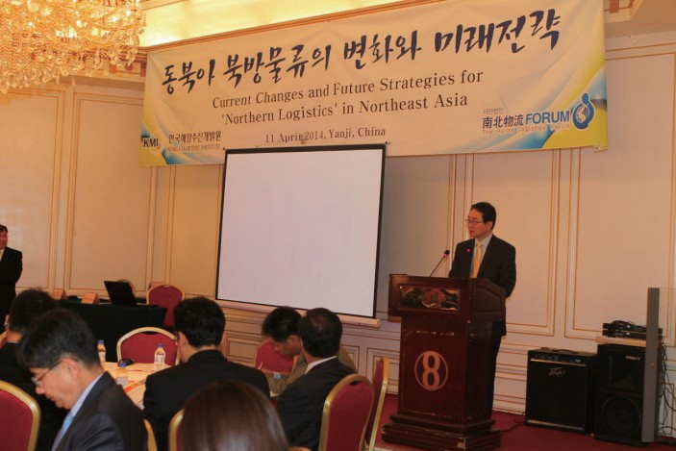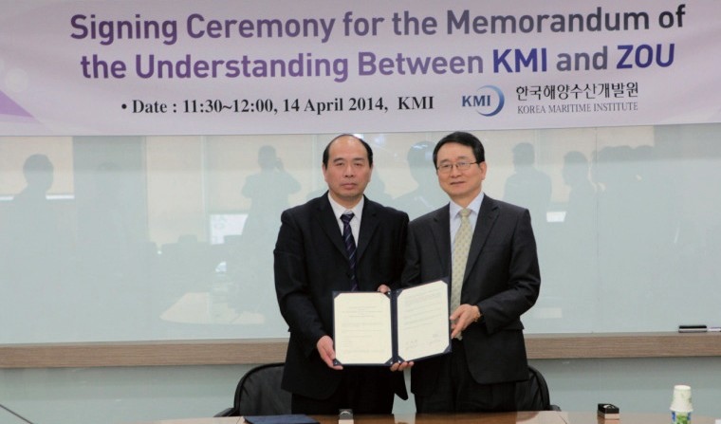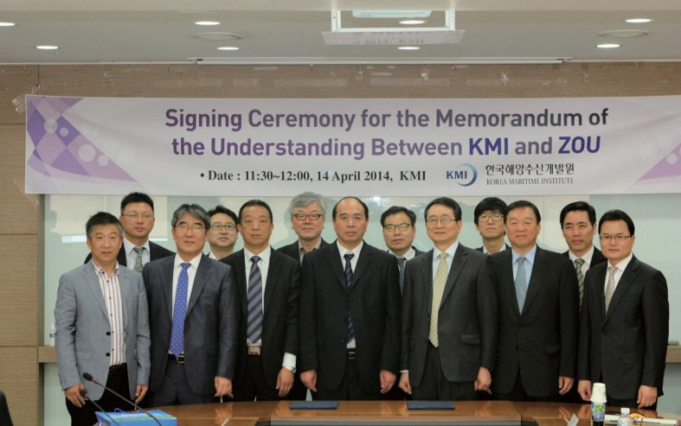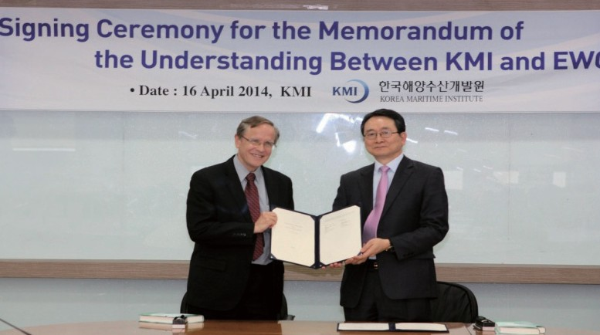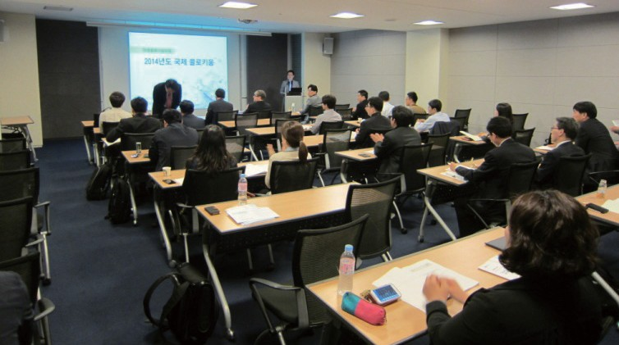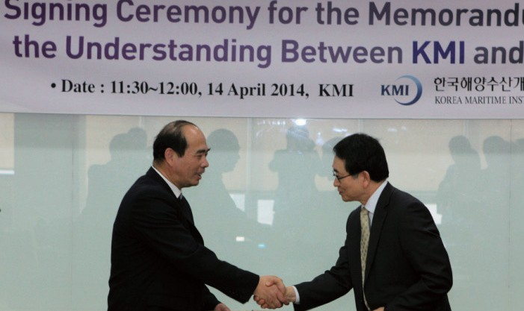

MOU Signed between Zhejiang Ocean University and KMI

- Time & Place: April 14, KMI
- Topics: MOU on joint research in fisheries, marine activities, tourism, shipping and logistics
- Time & Place: April 16, KMI
- Topics: MOU on joint research in national strategies in the Arctic Era and future research projects

2014 International Colloquium by Future Logistics Technology Forum

- Time & Place: April 16, Korcham
- Topic: World latest logistics technology trends

Major Activities Planned in May, 2014

2014 Inter-Korean Fisheries Cooperation Conference

  - Time & Place: May 14, Coex
  - Topics: Measures to reach the inter-Korean fisheries agreement

The Global Ocean Regime Forum (GORF)

  - Time & Place: May 15~16, Seoul National Univ.
  - Topics: 'East China Sea: How to Soften its Hardness and Promote Cooperation'
  - Participants: Domestic and international experts, including judges at the international tribunal

The Korea South Pacific Fisheries Forum

  - Time & Place: May 21, Suva, Fiji
  - Topics: Sustainable development of marine and fisheries sector of Fiji

International Symposium on the Prospects for Sustainable Port Development

  - Time & Place: May 28, Korcham
  - Topics: Adequate investment size for ports and SOCs and policy direction for the investment

Publisher
Kim, Sung Gwi - President, Korea Maritime Institute

Editor-in-Chief
Choi, Jae Sun - Director General, Planning & Coordination Division

Editorial Board
Mok, Jin Yong - Director General, Marine Policy Research Division
Joung, Myung Saeng - Director General, Fisheries Policy Research Division Kim, Woo Ho - Director General, Maritime Industry & Safety Research Division Jun, Chan Young - Director General, Port Policy Research Division
Kim, Jong Deog - Director General, Strategy Research Division

Secretary
Kim, Yu Jin - Planning & Coordination Division
Chung, Kyung Hwa - Planning & Coordination Division

Contact Information
Address: 21F KBS Media Center Bldg., #45, Maebongsanro, Mapo-gu, Seoul, 121-915, Korea
Tel: +82-2-2105-2700
Fax: +82-2-2105-2800
Email: jschoi@kmi.re.kr, kimyujin@kmi.re.kr

