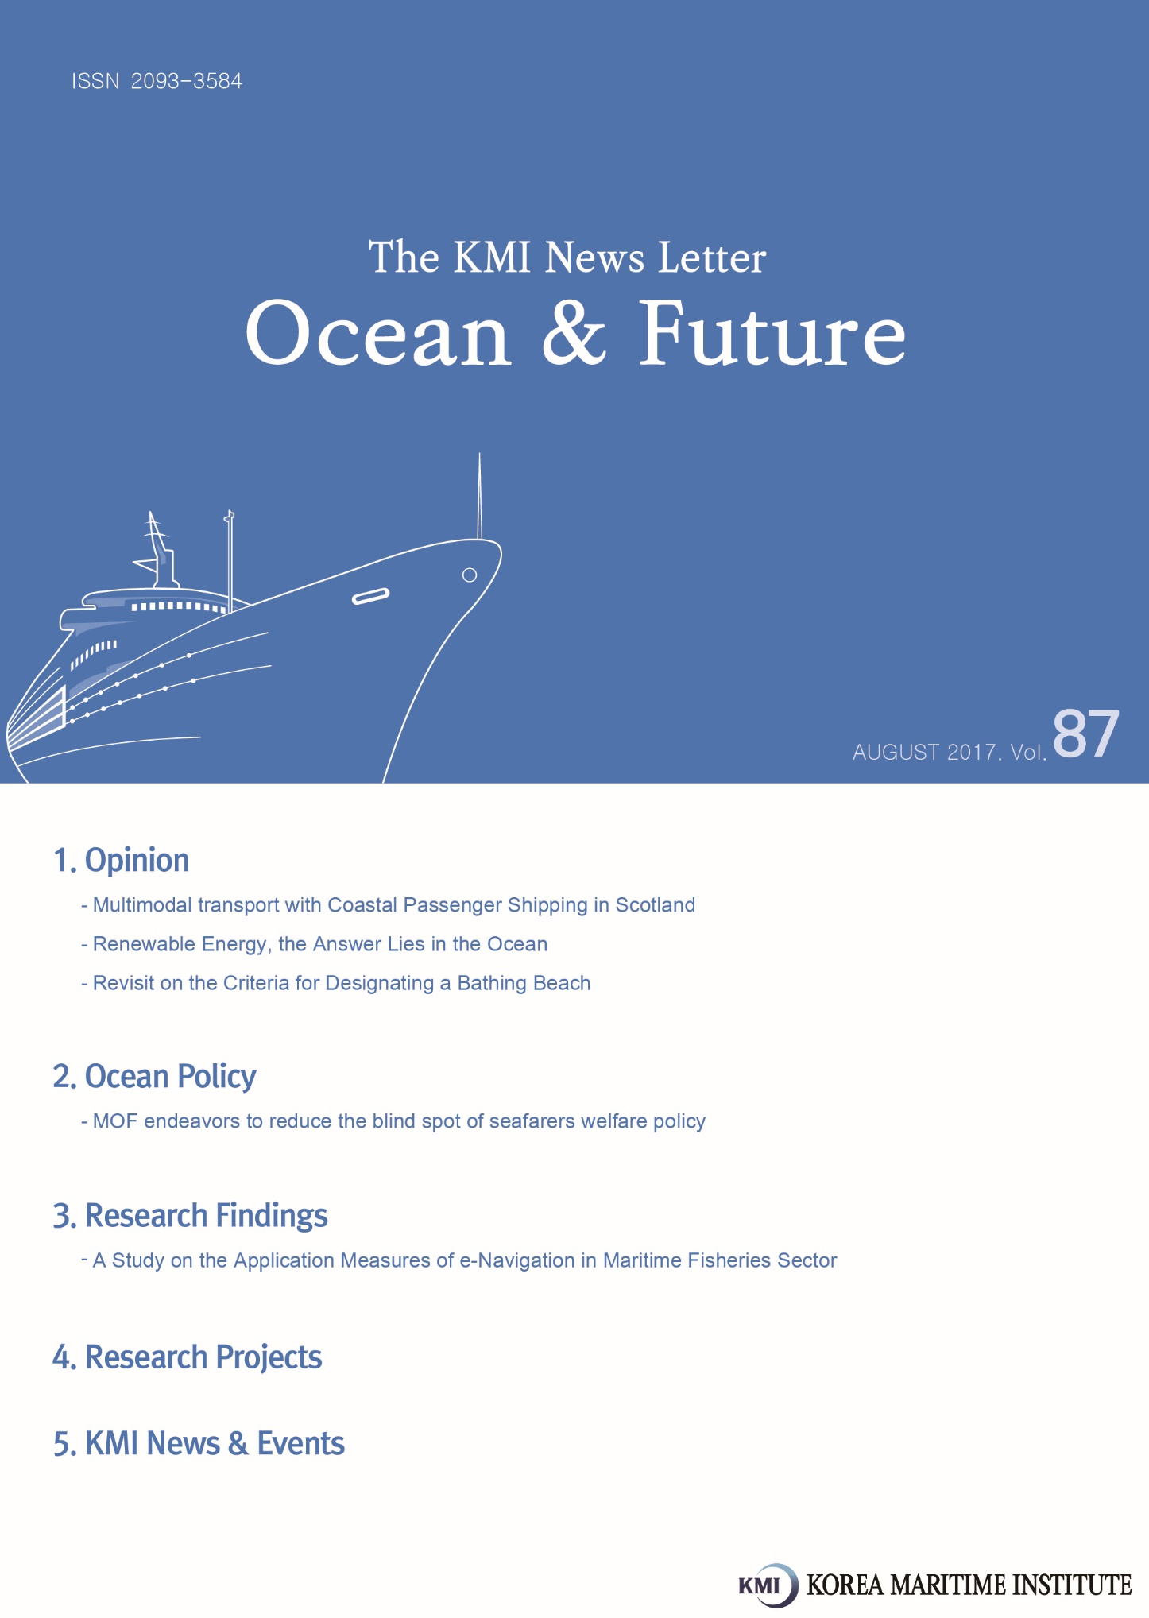

Multimodal transport with Coastal Passenger Shipping in Scotland

I. Introduction
Scotland is a region which possesses a lot of islands and remote areas of peninsula such as Cowal peninsula in the UK. Hence, the coastal passenger shipping industry has developed and the municipal government has endeavored to implement efficient policies. The Scotland municipal government divides the regions into several areas in accordance with coastal passenger shipping routes: Firth of Clyde; Inner Hebrides; Northern Isles; Skye, Raasay, the Small Isles and Knoydart; Southern Hebrides; and Western Isles.
The coastal passenger shipping services are delivered by different entities: a subsidiary of the Scottish government; local authorities such as communities; and private companies. In order to respond to various needs of transport, service providers of coastal passenger shipping have tried to provide multimodal transport to passengers,

<Figure 1> Ferry service of the Cowal peninsula
in Scotland
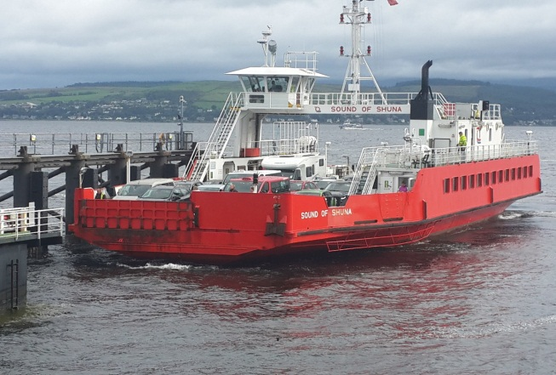
II. Multimodal Transport in Scotland
The remote areas necessitate a multimodal transport in order to improve connectivity and accessibility to central areas such as Glasgow and for the regions. Multimodal transport includes the form of combination of passenger shipping and bus transport, as well as passenger shipping and rail transport. For example, in the Cowal peninsula, the road to Glasgow has detouring courses and takes more time than the multimodal transport of passenger shipping and bus transport. The bus service from Dunnon Pier to Glasgow Central includes the ferry route between Hunters Quay and a pier in Gourock which connects the Cowal peninsula to Gourock transport hubs such as railway station. Passengers can enjoy convenience and short transit time without transferring for different transport modes between origin to final stop.

<Figure 2> Ferry and passenger waiting room
in the ferry
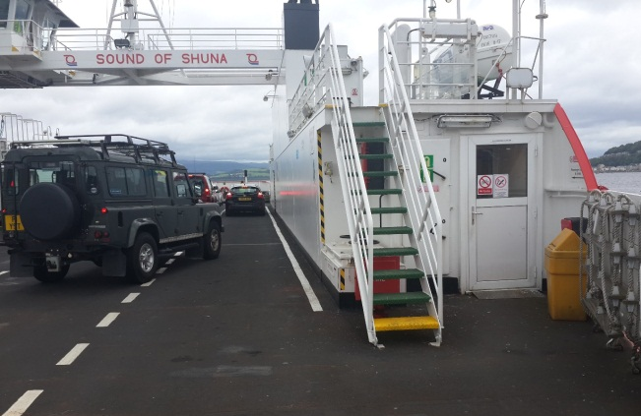

Piers usually have parking lots, bus stops and waiting places for passengers. Hence, passengers can transfer with minimum transit process and without consuming time and costs during transit. Waiting places provide a cozy room even in a bad weather. Tickets and tariffs are also in a single system. Passengers can use multimodal transport services by buying railway tickets or bus tickets or ferry tickets.

III. Policy implications and suggestions
Residents of islands and remote areas off the peninsula of Korea need a kind of multimodal transport services in order to improve connectivity and accessibility to central areas such as bus terminals and railway stations, and for the development of regions. The tendency of aging phenomena of passengers and seafarers also calls for improvement in connection and combination of different transport modes.
The case of Scotland`s multimodal transport with passenger shipping reminds us the necessity of combined transport around domestic passenger shipping in Korea. Policy makers and shipping companies have to try a new service by combining different transport services.

Contact Information
Name: Yong-An Park
E-mail: yapark@kmi.re.kr

Renewable Energy, the Answer Lies in the Ocean

The government pushes ahead a significant expansion on renewable energy
Having vowed to end use of nuclear power, the Korean government announced ‘Renewable 3020’ strategy of making renewable energy 20 percent of the country’s power source from the current level of 4.7% by 2030. Both plans strongly portend a major breakthrough for the paradigm of Korea’s energy policy. Countries around the world are increasing the investment on renewable energy projects as a solution for strengthening energy security, improving air pollution and addressing energy depletion etc. Hence, the portion of renewable energy is growing fast by making up for 11.3% of global power generation and 55.3% of the growth in power generation capacity. Korea also needs to roll up sleeves to promote the renewable energy industry in order to reduce its reliance on foreign energy imports (as high as 94%) and enhance the stability by diversifying the supply means of energy. In addition, renewable energy which is an eco-friendly new growth industry, can lead to a new source of earning and job creation for Korea.

The Ocean, a new arena for renewable energy
The ocean has various energy sources including tidal power, tidal current power, wave power, Ocean thermal energy conversion (OTEC) and salinity gradient power. For instance, tidal power makes use of the potential energy in the difference in height between high and low tides. Tidal current power takes advantage of the kinetic energy of moving water to power turbines. While wave power makes use of wind waves, OTEC (Ocean thermal energy conversion) or SWAC (Seawater Air Conditioning) tap into thermal energy of seawater. If the scope is expanded to all the energy sources existing in the ocean, offshore wind power, offshore Photovoltaic and ocean bio are also included.
Although ocean energy, such as tidal power, tidal current power and wave power, accounts for a mere 1% in renewable energy, recent technological development significantly increases the potential of its commercial use. Globally, ocean energy is abundant with its potential resource volume as much as 4 times more than annual electricity production. Having no risk of depletion, ocean energy is highly valuable as a clean energy with relatively low environmental impact as well as little operation cost once it is developed.
Compared to land, ocean has advantages in enlarging generation facilities and building large scale of generation complex. Therefore, ocean is more favorable place to build photovoltaic and wind power complexes which require a vast space for construction. Korea is estimated to have more than 18,000 MW in the ocean; 6,500 MW for both tidal power and wave power, 4,000 MW for OTEC and 1,000 MW for tidal current power etc. If the broader terms of ocean power is included such as 33,200 MW of offshore wind power and 5,400 MW of offshore photovoltaic power, its potential is enormous.

Korea is capable of leading the ocean energy
The narrow sense of ocean energy excludes offshore, wind power, offshore photovoltaic power and ocean bio. This narrow sense of ocean energy has not entered into the level of commercialization in the global market other than tidal power and seawater heat. However, European countries and the US are actively driving the development and demonstration tests. Major leading countries in ocean energy are starting the commercialization by establishing differentiated strategies per energy sources. For instance, the UK is concentrating the wave power and tidal current power while the US is carrying out construction project for an OTEC plant.
At present, Korea has successfully commercialized tidal power and seawater heat. Since the offshore wind power has entered into a semi-commercialization stage, the active inflow of investment is expected to allow its commercialization in earnest. Along with the level of commercialization, various factors should be considered, such as possession of technological infrastructure, conditions of selecting location, initial investment and maintenance cost. Taking these factors into consideration, Korea needs to concentrate on offshore wind power and seawater heat for ocean energy instead of tidal power. In the short term, it is difficult to implement tidal power in a large scale because of environmental issues in ocean. In this case, it is estimated to supply up to 30% of the target supply for renewable energy under ‘Renewable 3020’ strategy on the basis of potential resource volume. In the mid-to-long term, the potential power of massive ocean energy can be realized by commercializing the overall ocean energy sources, such as wave power and tidal power with which technological development is underway. If so, it is expected to make a huge contribution to the supply of renewable energy.

Policy support is necessary to expand the supply of ocean energy
Increasing the supply of ocean energy requires the government’s active policy supports. First, it is necessary to establish an innovative, open and convergent R&D system which is flexible to environmental changes. The R&D for the commercialization of ocean energy is inevitably a long-term large project. During the implementation process, internal and external environments are subject to change including market and competition conditions. Therefore, it is important to establish self-learning R&D system and a flexible decision-making system based on regularly or frequently revised roadmap.
In addition, an open R&D system is required to create new products and services by sharing internal and external resources. Secondly, a scientifically, economic and socially feasible system is required to choose a location. This is because a transparent decision making is necessary based on scientific materials in overall process from selecting a location to development process and post-development stage. For this purpose, a system overarching the whole process should be established in advance, including objective verification system, comprehensive impact forecasting system, marine spatial planning and mutually beneficial development etc.
Lastly, it is essential to devise a differential support policy for vitalizing the development of ocean energy early. The government should establish and implement a market expansion policy customized to energy resources considering the level of technologies and social carrying capacity. This policy should be applied per each ocean energy source which has a high potential for growth but remains at the early stage of development. And it should be implemented apart from renewable energy sources already developed. In addition, it is necessary to build public-private cooperation system in order to attract the participation of relevant industries. Furthermore, the Korean government needs to participate in the discussion of international standardization to gain a competitive edge in the technology and infrastructure market in ocean energy.

Contact Information
Name: Seok-Woo Choi
E-mail: schoi@kmi.re.kr

Revisit on the Criteria for Designating a Bathing Beach

Swimming at beaches is the most popular marine tourism activity in Korea. To help maintain beaches as safe and pleasant places for recreation and relaxation, the Korean government has enforced the Act on the Use and Management of Bathing Beaches since December 2014. The Act defines the term “bathing beach” as “an area designated and publicly notified pursuant to Article 6, comprised of natural or artificial water and land areas where leisure activities, such as water play, sunbathing, sand bathing, and sports, take place.” According to Article 6, local governments in charge of beaches should decide whether to designate it as a bathing beach based on status surveys every three years. Designation marks the beach as a place permitted for bathing, where a certain level of administrative services regarding water quality and safety are provided by local governments. For the designation, bathing beaches should meet the physical criteria for both beach backshores and foreshores.

Beach Backshore Criteria for Designation
In order for coastal regions to be designated as bathing beaches, where the total number of visitors in the previous year does not exceed 30,000, applied by the mean sea level, the length of the beach backshore should be more than 100 meters, while its width should be 20 meters. These criteria do not appear to be realistic in terms of the number of visitors, the mean sea level in the previous year, and the specific meters. First, there is no standard way for counting the number of visitors to bathing beaches. Moreover, management authorities often count not only those who stay within the bathing beach but also those who just pass by. Second, there is no data on the mean sea level of bathing beaches for a whole year. The survey on the current status of bathing beaches is not annually conducted. Even when the survey is conducted, the data on the mean sea level is done for about several months, not the whole year. Third, the specific rules for the length and width of beach backshores raise doubts when they are applied to the east and west coastlines of Korea. For the east coast, there are many small bathing beaches located continuously in a line. Even though a single bathing beach does not meet the criteria of scale, collectively they can become a great bathing beach. For the west coast which possess a large tidal range, the scale of bathing beach becomes flexible and difficult to be fixed.

Beach Foreshore Criteria for Designation
In order for a beach to be destined as bathing beaches, the water area that does not exceed 1.5 meters of depth should be more than 10 meters long at full tide, starting from the middle point of the lateral side of beach backshore. These criteria do not appear to be realistic in terms of the middle point, the depth of 1.5 meters, and the length of 10 meters. First, the middle point of the lateral side of beach backshore has no ground for a representative point to reflect the depth of water. People do not always gather around the middle point of beach backshore. Second, the depth of 1.5 meters depends on the datum plane, the horizontal plane from which heights and depths are calculated. Normally, it is easy to remind the depth of a 1.5 meter-swimming pool. However, the water level becomes different in drawing nautical charts and coastlines. Especially, in the east coastline where coastal erosion is serious, the depth of water rapidly changes.

The Key Element of Bathing Beach is Not about Scale but its Function
According to an investigation on the current status of bathing beaches (MOF, 2015), 68% of bathing beaches did not meet the physical criteria for beach backshores and 49% for beach foreshores. These percentages were higher with 74% and 57% respectively among designated bating beaches. Then what will happen to these bathing beaches that cannot meet the criteria? If the legal standards are strictly applied, management authorities would inevitably un-designate them.
In fact, the boundary of bathing beaches needs to be determined in the light of natural conditions and the long term development of beach management. However, current criteria do not appear to be set in such directions. If beach backshores and foreshores are clean and safe so that leisure activities, such as water play, sunbathing, sand bathing, and sports can pleasantly take place, it is sufficient to function as a bathing beach. Rather than fixing the specific scales of beach backshores and foreshores, demonstrating the boundaries for safety management will be more effective.

Contact Information
Name: In-Joo Yoon
E-mail: mouthpiece@kmi.re.kr

MOF endeavors to reduce the blind spot of seafarers welfare policy

Korea Seafarer’s Welfare & Employment Center opens two more offices
The Ministry of Oceans and Fisheries (MOF) establishes regional offices of Korea Seafarer’s Welfare & Employment Center (hereinafter referred to as the Center) in Pohang and Jeju in order to provide convenient welfare services to seafarers. Having established to enhance the welfare of seafarers and promote their job security, the Center has offered various services to seafarers as well as soon-to-be seafarers pursuant to the Seafarers’ Act.
Until now, there have been no regional offices other than the one in Busan, which makes seafarers living outside Busan difficult to use relevant services. Therefore MOF has decided to open additional offices, increasing its access to seafarers. While the Pohang office was established in the public service center of Pohang Regional Office of Oceans and Fisheries, Jeju office will be open in Seafarers Welfare Center at Hanlim port in mid-August.

Seafarers in the neighborhood will enjoy the benefits of the service
The regional offices of Korea Seafarer’s Welfare & Employment Center support seafarers’ job seeking activities by posting the notice of job search and job vacancies as well as providing interpretation service to foreign seafarers. In addition, the Center offers consultation for various welfare benefits, such as scholarship for seafarers’ children and pro bono services. Therefore, children of seafarers living other than Busan will no longer have to submit application via mail for scholarship, increasing the access and convenience for other services.
<Major services provided by the Korea Seafarer’s Welfare & Employment Center>
- Register the information of job search and job vacancies  - Publish statistics booklet on seafarers  - Provide scholarship to the families of seafarers  - Operate resort facilities (Condominium) to seafarers | - Provide convenient facilities (Seafarers Center)  - Support legal aid services for free  - Issue sailing career certificates  - Support staff members to obtain the license of mariner | - Pay funeral service expense for seafarers who died on duty  - Offer remote medical service on the sea  - Support the families of seafarers to visit working sites  - Provide seafarers with wedding hall

MOF plans to increase the number of regional offices depending on the success of new offices
MOF expects that the opening of new regional offices will strengthen the support of seafarers’ job seeking activities and their welfare, reducing the blind spot of their welfare policy. Furthermore, the government will increase the number of regional offices in the future based on the result of newly opened offices.

Contact Information
Name: Woo-Hyeon Jeon
E-mail: jwh0321@kmi.re.kr

A Study on the Application Measures of e-Navigation in Maritime Fisheries Sector

1. Purpose
The purpose of this study is to develop strategies to improve the application of Korean-version e-Navigation system, which is currently driven by the Korean government including the Ministry of Oceans and Fisheries. The Korean e-Navigation not only contains IMO’s policies and technological developments for ocean-going vessels, but also it seeks to provide wider services to small-sized ships and fishing boats. Therefore, the study suggested application strategies of e-Navigation by the type of ships for the successful implementation of Korean e-Navigation. This study aims to come up with measures with which e-Navigation can prevent marine accidents and enhance work efficiency. For this, it provides tasks and expected benefits per ocean-going vessel, coastal vessel, and other types of vessels, as well as policy suggestions.

2. Methodologies and Features
Since its first discussion at IMO in 2005, many countries have continued their consultations on e-Navigation and plan to discuss for its standardization and implementation in the future. Hence, the study looked into the current status of promoting e-Navigation in international organizations including IMO and major countries such as the EU, the US, Canada and Japan and their cases. It conducted Analytic Hierarchy Process (AHP) survey targeting experts to collect their opinions on the awareness, service demand and expected benefits of e-Navigation. Also, the study conducted a survey to those engaging in maritime and fisheries sector and the general public in order to understand the awareness on e-navigation, service priority and elements for activating the e-Navigation. The survey result showed positive response to the necessity of establishing the Navigation, and the government support including subsidy for the distribution and activation. The most anticipated services for e-navigation include providing real-time update on electronic navigation chart and supporting linguistic navigation safety information. Also, developing the e-Navigation system focusing user convenience will have a positive impact to vitalize the system. According to the survey, the greatest beneficiary by e-Navigation development turns out to be fishermen.

3. Results
1) Summary
The study suggests the following eight strategies to accelerate the introduction of e-Navigation. First, it is important to reflect the demand of users and encourage their active participation. Second, the workload of seafarers on board, who are the real user of e-Navigation, should be reduced and develop service and system to allow them to concentrate on their duty of safe navigation. Third, the system should be built favorable to seafarers considering user convenience, while increasing the compatibility with existing equipment. Fourth, it is necessary to consider financial support which is the foundation for attracting investment and essential to the establishment of a new system. Fifth, a customized service considering navigation conditions by the type of ships, working environments, etc. should be developed to enhance the application. Sixth, it is vital to establish infrastructure such as transportation networks for seamless communication between the ships and between the ship and the land. Seventh, information should be provided to increase the job effectiveness of users. Eighth, the system should contribute to a prompt and precise rescue operation in case of accident.

2) Policy contribution
The real users’ demand for e-Navigation should continue to be discovered including ship owners, fishing crews and crews of coastal ships. Also, the users of e-Navigation service include most of the general public including the passengers of coastal ships and pilot ships, those who enjoy marine leisure activities and sea fishing, let alone shipping companies and marine transportation officials. That is why the fundamental infrastructure including LTE-M should be strengthened. In addition, it might be difficult to secure the budget and continuity of the project without the legal ground. In this sense, it is necessary to legalize the mandatory use of the system for the prevention of marine accidents as well as the systematic response in case of emergency.

3) Expected benefits
The Korean e-Navigation, which is specialized for small sized ships and fishing boats, can be a valuable asset to maritime safety and supporting businesses for developing and under-developed countries in the future. The demand of e-Navigation discovered from the survey on experts and the general public should be represented for the system development and its implementation. The introduction of e-Navigation system will be an opportunity to boost the awareness and activities of those working in maritime fisheries industry. Also, it will contribute to raising the awareness and trust of marine safety among the general public. The introduction of e-Navigation is expected to contribute to the prevention of marine accident, reduction of environmental pollution and cutting navigation cost. Also it will play a key role to improve working conditions of inside a ship, and to encourage fast and prompt decision making of ship navigation and maritime safety related officials.

● Research project on monitoring non-tariff barriers of fishery products
● A study on measures to facilitate the cooperative relations among Northeast Asian ports
● Act as deputy for evaluating certification system of excellent logistics companies in 2017
● The establishment of comprehensive development plan of Pohang Port
● A study on policy measures for promoting the rights of fisherwomen
● The 2nd study on the revision of the basic plan for maritime fishery development
● (Proposed in 2013) Korea-ASEAN cooperation project (A study on the joint development of fisheries and aquaculture in ASEAN and the establishment of cooperation system
● Korea-China-Japan transportation logistics cooperation measures (7th round)
● A study on building processing clusters for seafood export by sea areas
● An analysis on promising areas for fisheries farming investment
● Research on measures to vitalize the investment of Korean offshore aquaculture industry
● The establishment of a comprehensive plan to support and prevent disasters in fishing operations and its current status survey
● A validity study on Pyungtaek port type 2 logistics complex development
● A case study on maritime boundary delimitation for negotiating countries
● The feasibility study and the establishment of plans for building sea fishing complex town
● A study on securing logistics base in Far Eastern Russia for activating northern logistics business
● A study on the preservation of marine biological resources in Polar Regions and sustainable fishery
● Review of proposal for development project of marina port at Waemok, Dangjin
● Necessity of local tax reduction to expand the international vessels registered in Korea
● Development and commercialization of traditional fisheries products suited for each seas
● 2017 future aquaculture investment forum operation
● 2017 consigned study on port demand forecast center operation
● A study on rationalization of fisheries port designation and its dismissal
● Study on the systematic management plan of the total cost of the port construction sector
● A review on possible functional conversion of aging terminals at Mokpo port (Samhak terminal)
● Basic planning of North Korean port logistics system in the Unified Korean peninsula era
● Strategies for fisheries subsidies negotiation prepared for the 11th WTO ministerial meeting
● Establishment of evaluation criteria for folding container pilot project (I)
● The development of next generation fishing vessels customized to Korea and its demonstration
● 2017 International logistics investment analysis center
● A survey on fisheries product production and distribution industry
● Master plan development for Algerian fisheries production increase
● Methods for climate change impact and vulnerability assessment of the fisheries industry
● Annual report on Dokdo and implementation plan development
● A study on establishment of the 2nd national port security plan
● A study on basic planning of fisheries distribution development
● A study on the sales trend of seafood following the implementation of the Anti-graft Act and preparing measure to minimize the impact
● A study for the establishment of sustainable development strategy in Garorim Bay area
● Study on export promotion of biodegradable fishing gears and feasibility Study on ODA Project
● Capacity building to manage Sri Lanka's marine debris (Yeosu proejct, R&D, 2nd year)
● Consigned study on aquaculture development based on warm water form power plant and implementation measures
● A review on demand prediction and economic validity of Thilawa, Myanmar
● A study on Northern logistics market model development and measures for its facilitation
● A study on port risk evaluation system advancement
● A study on future fusion and demand based shipping port logistics technology development
● A study on comprehensive management of Geokryol Biyol-do
● A study on the establishment of basic plan for maritime and fisheries development strategy in Gimje city
● Establishment of mid-to-long term development plan for marine tourism policy at Yeongdeok
● New fisheries policy tasks for future fisheries industry development
● Feasibility study for the construction of the third phase coal pier in Donghae port
● A study on the revised plan of fisheries subsidies in response to TPP
● Research on the establishment of maritime and fisheries development plan in Jeollabuk-do
● A study on Busan Mega port strategies for larger ships and port function redeployment
● A study on the feasibility review and the establishment of measures for integrating TOC of inner ports in Incheon

Major Activities Conducted in July 2017

1. Korea-Spain Ocean Forum 2017
○ Time: July 4 (Tue) 14:00~18:00
○ Place: The University of Las Palmas de Gran Canaria (2nd floor of the main building), Aula de Piedra
○ Contents: Tasks and future prospects of research cooperation in Korea-Spain maritime and fisheries sector
○ Host: KMI
○ Participants: President Yang Chang-ho of KMI, President Rafael Robaina Romero of ULPGC), President Luis Ibarra of Port Authority of Las Palmas, Consul General of Korea in Las Palmas Oh Dong-il etc.

2. Seminar on Promotional Strategy for Making Mega Port in Busan
○ Time: July 5 (Wed) 14:00~17:30
○ Place: Busan Port International Passenger Terminal 5th Floor, Conference Hall
○ Contents: Strategy for making Busan port into a mega port and plans for the rearrangement of terminal functions
○ Host: KMI
○ Participants: Vice president Joung Myung-saeng, Bureau chief Park Jun-kwon of Ports and Harbors Bureau in MOF, Associate research fellow Kim Guen-sub of KMI etc.

3. The 3rd Maritime Silk Road Port International Cooperation Forum
○ Time/Place: July 10 (Mon) ~ 13 (Thu) / Ningbo, China
※ The forum is held on July 11~12
○ Contents: Expanding the exchange and cooperation among ports, shipping companies and logistics companies along the One Belt, One Road Initiative by holding the 3rd
Maritime Silk Road Port International Cooperation Forum
○ Participants: Kim Geun-sub (KMI director/presenter), Kim Hyoung-geun (Center head), Kim Se-won (senior researcher), Hee Ga-hye (researcher)
※ About 10 organizations including port authorities(BPA, UPA), shipping companies (SM Line Corporation, Heung-A Shipping Company, KMTC, Sinokor) and logistics and other companies (YJC, Cyberlogitec, Korchina) etc.

4. Seminar on Implementation Strategy for Government Projects in Maritime and Fisheries
○ Time: July 31(Mon) 13:00-18:00
○ Place: National Assembly Members' Office, 1st meeting room
○ Contents: Seeking a strategy ‘To Make Everything about Ocean New’ to implement the new administration’s government projects in maritime and fisheries
○ Host: Members of National Assembly: Lee Kai-Ho, Kim Tae-Heum, Hwang Ju-Hong (Assistant administrator from 3 Parties in Agriculture, Forestry, Livestock Committee of the National Assembly)
○ Organizer: KMI
○ Participants: President Yang Chang-Ho of KMI, Minister Kim Young Choon of MOF, Members of National Assembly Kim Tae-Heum, Lee Koon-Hyon, Jung In-Hwa, and Ahn Sang-Su, About 250 people including experts and public officials on industrial, academic, research sector

Major Activities Conducted in August 2017

1. North Pacific Arctic Conference (NPAC)
○ Time/Place: August 10 (Thu) ~ 11 (Fri)/ Imin International Conference Center in the University of Hawaii
○ Contents: Strengthening the cooperation foundation of maritime fisheries in the Arctic Circle
○ Host: Jointly hosted by KMI and EWC
○ Participants: President Yang Chang-Ho of KMI, 30 guests from 9 countries including President Richard Vuylsteke EWC, Research Director Nancy Lewis of EWC

2. 「Forum for Next Logistics Technology」 NeLT-LogMS International Joint Seminar
○ Time/Place: August 25(Fri) / NHH, Norway
○ Contents: Holding NeLT-LogMS Joint Parallel Session under LogMS 2017 International Conference
○ Host: Co-hosted by NeLT and LogMS
○ Participants: Senior Researcher Kang Moo-hong of KMI, Professor Kim Kap-hwan of Pusan National University, Director Lee Suk of KRRI, Professor Fagerholt of NHH etc.

3. KMI- AsianSIL Joint Academic Conference
○ Time/Place: August 25 (Fri)~ 26 (Sat) / Lotte Hotel Seoul
○ Contents: Discuss current issues on international law under the theme of “Asia and International Law in Times of Uncertainty” participated by scholars, judges of international courts and heads of international organizations
○ Host: Co-hosted by KMI and AsianSIL
○ Participants: 500 guests including Former UN Secretary General Ban Ki-moon (Keynote speaker), President Vladimir Golitsyn of International Tribunal for the Law of the Sea, Former Prime Minister Awn Shawkat Al-Khasaweneh of Jordan, Former Foreign Minister Dipu Moni of Bangladesh, Former Foreign Minister Hassan Wirajuda of Indonesia, Director Hélène Ruiz

Publisher
Yang, Chang Ho - President, Korea Maritime Institute

Editor-in-Chief
Kim, Woo Ho - Director General, Planning & Coordination Division

Editorial Board
Kim, Jong Deog - Director General, Industry Intelligence & Strategy Research Division
Mok, Jin Yong - Director General, Marine Policy Research Division
Cho, Jung Hee - Director General, Fisheries Policy Research Division
Kim, Beom Jung - Director General, Maritime Industry & Safety Research Division
Lee, Sung Woo - Director General, Port & Logistics Research Division

Secretary
Lee, Sun Woo - Planning & Coordination Division
Lee, Yun Jung - Planning & Coordination Division

Contact Information
Address: 26, Haeyang-ro 301beon-gil, Yeongdo-gu, Busan, 49111, Korea
Tel: +82-51-797-4800
Fax: +82-51-797-4810
E-mail: neoport@kmi.re.kr, rheesw@kmi.re.kr

