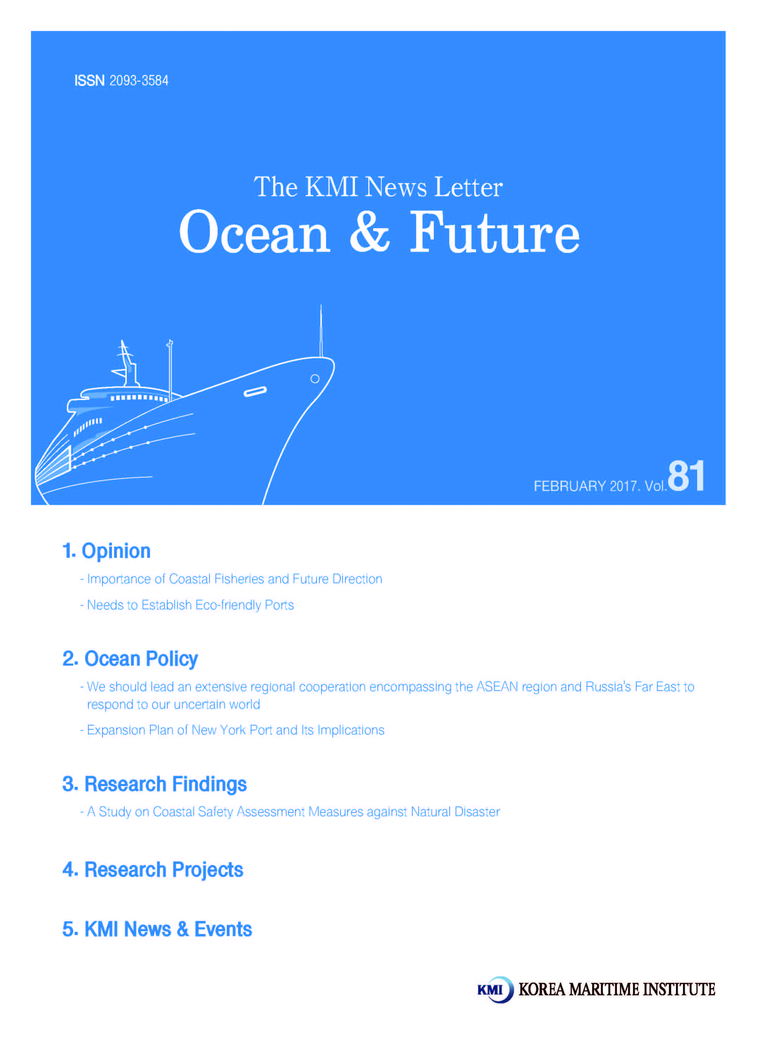
Importance of Coastal Fisheries and Future Direction

1. Importance of Coastal Fisheries
In the 「Fisheries Act」, coastal fisheries are defined as “any fishery business which uses a non-powered fishing vessel or a powered fishing vessel with a gross tonnage of less than ten tons, other than offshore fisheries, sectional fisheries and land based aquaculture”. The characteristics of coastal fisheries include the small-scale subsistence type and the difficulty of formalization due to various types of fishing gear and methods. In other words, small fishing vessels are more characteristic of subsistence fishing than of corporate fishing, due to limitations of fishing and storage.
In addition, there are various sub-types of fisheries in coastal fisheries, which make it more difficult to formulate the fisheries. The reason for this is that the fishing range of coastal fisheries is relatively narrow compared to offshore fisheries.Fishing methodshave been developed in accordance with the characteristics of specific waters, and state control related to fishing and fishing methods is relatively loosely applied. As such, diversity or complexity of fishing gear and methods related to coastal fisheries is difficult to formulate, so it is difficult to formulate regulations that reflect the characteristics of fisheries.It is also difficult to prepare customized policy instruments to match these characteristics.
In the characteristics of coastal fisheries, "small-scale subsistence" is mentioned, which is characteristic of coastal fisheries and includes the most important role. In other words, coastal fisheries play an important role as a means of subsistence for fishermen residing in underdeveloped coastal areas away from developed cities. Coastal areas are generally underdeveloped compared to cities, and lack jobs outside of primary industries. In particular, coastal areasare not well suited for agriculture in the primary industry, so the importance of fisheries will surely increase. Therefore, fishing villages with many fishing workers are formed on the coast, and coastal fishing is a major income source for job creation and subsistence in these fishing villages. Furthermore, coastal fisheries are linked to the maintenance and development of local communities.

2. Problems Faced by Coastal Fishing
In recent years, Korea's coastal and offshore fisheries have been in a state of historic stagnation in terms of production. More specifically, the average catch for the last three years has been at its lowest period since the mid-1970s, when fisheries technology and fishing capacity were unable to significantly increase catches. In the past, even if the production amount decreased, the price of the fishery increased greatly, and the income of the fishermen themselves tended to increase. In recent years, however, fishermen in the coastal areas have faced unprecedented difficulties as prices have not risen enough to offset the decline in catches. In particular, the situation is worsening as the market opening is increasing, imports of low-priced fishery products are increasing, and the economy of the whole country has not improved much.
These deteriorations are occurring in both coastal and offshore fisheries. However, this deterioration will have a more serious impact on coastal fisheries, including small-scale fisheries, when compared to relatively large-scale offshore fisheries with better funding ability. In particular, among the 44,872 fishing vessels in the coastal fishing areas, 2,630 offshore fishing vessels were found, while 42,242 coastal fishing boats were found. In addition, there is no exact figure on the number of fishermen engaged in the industry, but the number of coastal fishermen is overwhelmingly higher than that of offshore fishermen, so the deterioration of the situation described above has a great impact on the employment and subsistence of coastal fishermen.
In the case of coastal fisheries, which play an important role in maintaining fishery communities, balanced regional development including island areas, and creating local employment, the deterioration of the situation as described above can lead to far worse results than offshore fisheries. Moreover, this can lead to serious socio-economic problems such as uninhabited islands, the hollowing out of backward regions and the collapse of the fishing village society, employment decrease, income decrease and poverty. Therefore, it is very important for the national government as well as the fisheries to prepare the policy countermeasures to enable the coastal fisheries to perform their original functions without losing their vitality in the above situation.
However, in the case of Korea's fisheries policy, most of them are mixed with offshore fishery-related policies that are difficult to apply to coastal fisheries. As a result, the central government and municipalities are having difficulties setting direction for the advancement of coastal fisheries. In the field, there is confusion caused by lack of direction, and it is confronted with the limit to overcome the situation and the fishermen themselves are insufficient.

<Annual catch (above) and number of fishing vessels (below)>
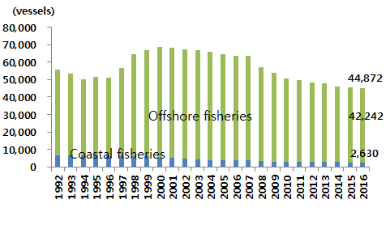
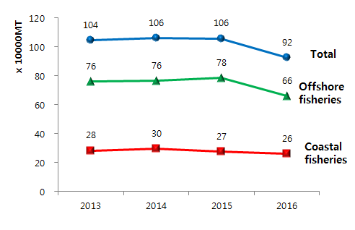

3. Advanced cases of the development of coastal fisheries
Recently, many fisheries in advanced countries including the EU and Japan are re-recognizing the importance of coastal fisheries and are trying to find a fundamental solution for improving their situation. In particular, Japan has been providing policy support to prevent coastal fisheries from losing their functions through a special system for coastal fisheries, such as the Law for the Improvement of Coastal Fisheries Improvement, and is developing self-reliance of coastal fisheries along with resource recovery related projects. Specifically, coastal fisheries are characterized by the establishment of various coastal fisheries funds aiming at improving profitability and regional development, and implementing policies that reflect the characteristics of each region in each local government.
Particularly, by emphasizing the role of coastal fisheries in regional development, the fishermen 's economic and social participation in the community is high. In addition, structural reform programs are underway to improve the profitability of fisheries. This policy is being implemented to improve the structure so that the fishing industry can realize sustainable fishery with a competitiveness beyond the level of reducing fishing boats. This is also applied to coastal fisheries. Examples related to this are the integration of fishing vessel modernization projects as a part of the fishery structural reform and the participation of female fishermen as part of coastal area development.
In the case of Sweden, coastal fishing itself is gradually losing its vitality, but the social safety net and universal welfare are complementing the various difficulties faced by coastal fishermen. The social security system for Swedish fishermen is characterized not by a system that identifies fishermen but by including fishermen in the national social security system. In other words, by stabilizing the economic instability and inequality faced by fishermen due to the unstable profit structure of fisheries through the national social security system, it seems that the fishermen can actively participate in the fisheries policy aimed at achieving sustainable fisheries.

4. Future policy direction
The advanced cases related to coastal fisheries showed that although the detailed business was different depending on the fishery situation in each country, they have the common goal of sustainable fisheries and raising the profitability of fisheries. With regard to profitability enhancement, the policy is focused on enhancing value added in the processing and sale of the catch rather than the catch itself. For sustainable fisheries, Japan managed to reduce the amount of fishery effort, while the EU managed catches, which was interpreted as reflecting fishery resources and fishery situation in each country. However, all of them are the same in that fisheries policy is promoted based on fishery resource management.
In order to develop coastal fisheries in Korea, it is necessary to review the management of fishery resources from the perspective of coastal fisheries, and based on this, a policy framework should be established to enhance the profitability of coastal fisheries. In particular, in conjunction with resource management, a careful examination of the fishing gear and methods and a policy demand survey on the replacement of old fishing vessels and the safety and welfare of fishermen should be prioritized. Therefore, the advancement of coastal fisheries can be divided into income stability and welfare and safety improvement.
Therefore, the advancement of coastal fisheries can be classified into two categories: (1) income stability and (2) welfare and safety improvement. Policy directions for income stabilization include restoration of coastal fisheries resources, conversion to cost-saving fisheries, increasing added value to the catch, and diversification of income. In the policy direction for improvement of welfare and safety, it is necessary to improve subsistence stability, enhance welfare and safety related to fishery work, and create a friendly fishery environment for elderly and female fishermen.

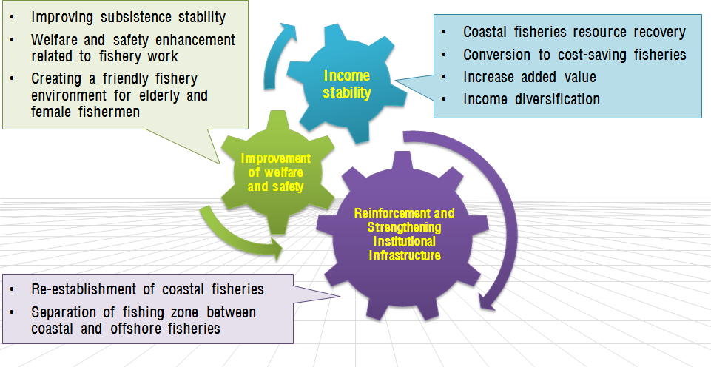
<Development Direction of Coastal Fisheries>

Contact Information
Lee, Jungsam
jlee8793@kmi.re.kr
An, Jieun
an2412@kmi.re.kr

Needs to Establish Eco-friendly Ports

1. Strengtheningglobal climate change agreement

Following the adoption of Paris Climate Agreement at the 21st Conference of the Parties (COP21) at the end of 2015, South Korea is expected to face more rigorous target for reducing greenhouse gases. The adoption of the agreement signals a red light for Korea to achieve its goal. In total, 195 countries, including advanced and developing countries, were participating the Paris agreement, accounting for 90% of global greenhouse gas emissions. The Kyoto Protocol presented its problems in that only some advanced countries had to burden the reduction mandate. China (26%) and the US (16%), which are No.1 and No. 2 producers of carbon, were exempt from the mandate. As the reduction target has increased, it is necessary to come up with a new reduction program.

In 2009, South Korea set its 2020 target of reducing greenhouse gas emissions by 30% from business as usual (BAU) levels which stands at 232.80 million tons. Before the Paris agreement, the country finalized its target of cutting 37% of greenhouse gases by 2030 based on BAU levels (851 million tons). Then, the total reduction would reach 314.87 million tons, which is 82.07 million tons higher than the existing level. Therefore, Korea should be in preparation when UNFCC takes effect and is implemented. When the Paris agreement was announced in November 2016, the sum of global greenhouse gas emissions already exceeds 55% of the total. By the end of 2016, 86 countries ratified the agreement, accounting for 61.71% of the total emissions.

Also, it is necessary to prepare for the implementation of greenhouse gas emissions control and for strengthening its implementation. At present, the control of greenhouse gas emissions from ships, which is a major greenhouse gas producer at ports, has taken effect. In addition, the Energy Efficiency Design Index (EEDI) has made mandatory for new ships since January 1 2013. Shipping companies are obliged to make an annual report on the greenhouse gas emissions generated from ships to the government and IMO. Following the expansion of Emission Control Areas (ECA) and the implementation of IMO Member State Audit Scheme (MAS), IMO agreed to mandate the global 0.5% sulphur cap for international shipping vessels in 2020. Furthermore, the national implementation of IMO environmental regulation convention which took effect in 2016 will be carried out as an auditor (Korea is expected to implement in 2019).

2. Needs to establish greenhouse gas (GHG) management system at ports

Europe, the US and China are implementing intra-port monitoring and regulation on GHG and harmful substances in order to reduce GHG. Specifically, the Ports of Long Beach and Los Angeles in the US are conducting real-time monitoring on emissions of carbon, NOx, SOx and diesel particles. The Port of Vancouver in Canada is filling out ‘The Inventory on GHG emissions from Ships’ as well as ‘The Inventory on GHG emissions from Land Transportation and Equipment.’ European ports are taking a preemptive measure by mandating the use of low sulfur fuel for ships. As a result, the emission ratio of SOx (5%) and that of dust (7%) are relatively low compare to ship entry ratio (22%). With the expansion of ECA designation across the world, Korean ports need to establish countermeasures. As of April 1 2016, China introduced a regulation requiring all vessels while at berth in core ports of Shanghai, Ningbo-Zhoushan, Suzhou and Nantong to use bunker oil containing 0.5% sulfur or less. Japan and Singapore are also considering the designation of ECAs.
First of all, Korean ports need to establish policy for building eco-friendly ports which monitors and manages pollutant emissions at ports. Also, it is necessary to establish a system for managing pollutant emissions. The US, Europe, China etc. are implementing monitoring or regulation on the emissions of GHG and harmful substances within ports. Therefore, it is highly necessary for Korea to establish a system of regulating pollutant emissions befitting to the conditions of Korean ports. Public interests are increasing in regards to the response of climate change and the improvement of living environments. However, Korean ports lack advanced management measures. These measures should monitor harmful substances produced at ports, reduce the emissions of pollutants and improve the air quality in port areas.

Contact Information
Kim, Woo-sun
firstkim@kmi.re.kr

We should lead an extensive regional cooperation encompassing the ASEAN region and Russia's Far East to respond to our uncertain world

The world is facing a global crisis in variousdimensions. Politically, the tendency of isolationism and nationalism seems conspicuous across the world. For instance, Britain chose to get out of the European Union, the current US Administration is skeptical of internationalism, and right-wing parties within the European Union are gaining more supports from their constituents. Economically, the world has already entered a period of slow growth according to different statistics. Lastly, in social aspects, the younger generation is losing direction, neither getting married nor running towards their hopes as they see that the world is hopeless. So then, how should Korea cope with this precarious situation?

First and foremost, as one of the main trading countries of the world, we should strengthen regional cooperation based on friendly relations with neighboring countries. With this, we could reduce business uncertainties and boost business opportunities in the region. Such a business boom would again be able to increase jobs and reduce inventory, kick-starting regional trade. Further, as expenditures on unnecessary items such as security costs and tariffs are to go down, the government's fiscal condition could be improved as well. All in all, those efforts could help local industries maintain their competitiveness throughout the globe.

In conjunction with such efforts, the most urgent issue we are facing now is how to quickly resolve tense relations with neighboring China and Japan. For this, we need to find common areas where we can work together. For instance, those three countries could closely cooperate in Arctic matters as they are largely interested in participating in costly Arctic activities. Therefore, rather than competing too much against each other, they could do scientific research together in the Arctic or co-investigate anticipated safety issues related to the use of the Northern sea route. Either scheme could benefit them a lot, compared to the other way around.

Next, we should strategically cooperate with both the ASEAN region and Russia's Far East. First of all, we should bear in mind that the ASEAN region has already been an important pillar of the world’s manufacturing industry. Moreover, the fact that the region's potential as aconsumer market is high enough is critical in terms of its high percentage of young population and positive sentiments about Korea. On the other hand, Russia's Far East is crucial for our geopolitical considerations in that the region can serve as additional energy suppliers for us through Russia’s continuing Arctic development.

To sum up, the US and Europe are in a state of uncertainty, and global capitalist economy seems to be confronted with its innate limitations. Despite all therisks and chaos, however, this could be a golden opportunity for Asia, centering on East Asia, to emerge as the center of the world economy. To this end, we need to first establish a close collaborative relationship between Korea, China and Japan on the basis of common interests, such as Arctic exploration. In addition to this effort, we should be able to create a broader economic region by strengthening cooperation with both the ASEAN region and Russia's Far East.

Contact information
Shin, Su-hwan
shshin@kmi.re.kr

Expansion Plan of New York Port and Its Implications

1. Introduction
Nowadays, the eastern coast ports in America such as New York, Baltimore and Savannah are facing a challenge in their container terminal operation. The operation of new locks of the Panama Canal since 2016 has allowed larger ships to transit the canal. Hence, the eastern ports including New York port have to improve their port facilities such as berth, sea channel, and bridge in order to handle larger ships.

2. Navigation Restriction of Eastern Ports of US
New York port has four main container terminals: Port Newark Container Terminal, APM Terminals, Maher Terminal, and Global Container Terminal. Nevertheless, the limitation of the Bayonne Bridge in New York works as a hindrance to the terminals for mega container ships. The Port Authority of New York and New Jersey is planning to raise the Bayonne Bridge by 2019.

<Table 1> Plan of Sea Channel of the Eastern Ports
Port | Channel Depth | Planned Channel Depth | Scheduled Completion Year
Boston | 12.2 | 14.6∼15.2 | under study
New York | 13.7∼15.2 | 15.2 | 2014
Delaware River | 12.2 | 13.7 | 2017
Charleston | 13.7 | 14.3 | under study
Savannah | 12.8 | 14.3 | 2016
Miami | 12.8 | 15.2 | 2014
New Orleans | 13.7 | 15.2 | under study
Houston | 13.7 | No immediate plan | No immediateplan
Source: US DOT, Panama Canal Expansion Study, 2013 p.48.

In addition, some of eastern ports of US have a shallow sea channel around the ports. Hence, larger container ships after the expansion of the Panama Canal compel the eastern ports to have sufficient water depth. For example, Boston port is planning to deepen the sea channel from 12.2 maritime to 15.2 m.

The United States Department of Transport expects that the expansion of the Panama Canal and, in following result, the calling of larger ships in Eastern ports will promote feedering in domestic water and then promote transshipment by US flagged ships for smaller ports along the inland waterway such as the Mississippi River (US DOT, 2013)

3. Expansionary Plan of New York Port
The Port Newark Container Terminal (PNCT) among the four main container terminals of New York port will increase the container handling capacity from 1 million TEU a year to 2.4 million TEU by 2020 (Journal of Commerce, 2017). The terminal will invest 500 million $ to improve gates, sea channel, cranes, berths and software by 2020.

PNCT has endeavored to update the existing facilities such as computer, container yard, inland linking to the intermodal terminal, and quay cranes. PNCT is trying to become a gateway and a new hub in eastern coast of US.

4. Implications
The expansion of the canal in 2016 has promoted expansionary investment in the eastern ports of US. New York port has been trying to upgrade existing port facilities in order to service larger ships after the expansion of the canal. Furthermore, the calling of larger ships in the region will increase transshipment and waterway transport in eastern areas.

Contact information
Park, Yong-An
yapark@kmi.re.kr

A Study on Coastal Safety Assessment Measures against Natural Disaster

1. Purpose
○This study aims to develop an assessment system providing practical contents necessary to people, the consumer of safety information against natural disaster.
- It defines a new standard of the existing vulnerability and safety concepts and suggests a new assessment system.
- The study intends to provide more practical information to people, allowing effective response against natural disaster through autonomous decisions
- It allows effective operation of limited resources to respond against natural disaster.

2. Methodologies and Feature
1)Methodologies
○ Data analysis on impact assessments of natural disaster including vulnerability assessments
○ Public awareness survey on the damage and response measures of disaster
○ Hearing and investigating expert opinions regarding the assessment systems and indexes for safety assessment

2)Features
○This study suggests the necessity and direction of introducing a new assessment system different from the existing impact assessment system for climate change. Consequently, this is a policy development study for leading the development of future assessment system against natural disasters.

3. Results
1)Summary
○A necessity to change into safety assessment system
- The existing vulnerability assessment system should be replaced by a new system in order to overcome the following problems; insufficient representation of future risks, non-representation of regional characteristics, the use of excessive, complicated indexes, and inconsistencywith identified risk factors.
- The new safety assessment system can timely represent the increasing public demand of safety.
- It expects the main idea of the assessment system against natural disasters to develop from vulnerability to risk level, finally into safety, and lead this paradigm change.
- It provides necessary information from the perspective of people, the consumer of safety, rather than administrative authority
- It is important to develop a positive assessment system which allows active and enthusiastic response from individual entities.
- Developing a decision making process is necessary to inject proper response resources based on the damaged region’s unique characteristics.
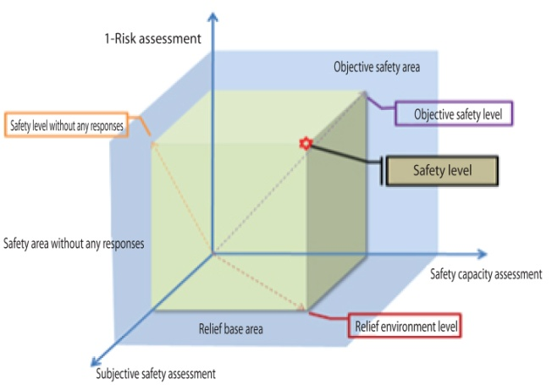
○The principles of safety assessment
- The safety assessment should be represented multi-dimensional arrays so that the factors constituting the assessment can have their own meaning.
- Both subjective and objective safety is assessed.
- The assessment allows some changes in assessment items according to the target areas’ own characteristics and situation, rather than performing unilateral assessment for subject areas.
- It provides the assessment result of each dimension which can be compared and analyzed independently as well as the final integrated result.

<Basic Framework of Disaster Safety Assessment>

○ The structure of safety assessment
- The safety assessment should separate subjective safety from objective safety and the subjects for the assessment include facility, resident, visitor and local community.
- The objective safety should evaluate risk level, response capacity and the subjective safety should assess awareness, response and seriousness.
- The assessment is performed by the Ministry of Oceans and Fisheries, which carries out various coastal disaster response projects and coastal disaster vulnerability assessments.
- The assessment is conducted in every 5 years by connecting the cycle of Integrated Coastal Management Program.
- While the assessment of city areas is conducted per the basic regional unit such as eup, myeon, and dong, that of non-city area performed as an independent village unit.

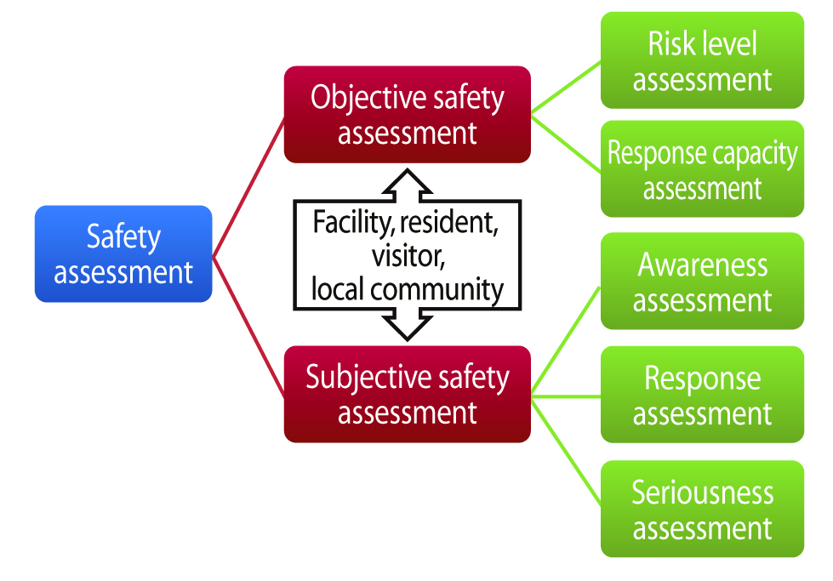
<Basic Framework of Disaster Safety Assessment>

○The utilization and application of the assessment
- Basic assessment method for establishing/implementing coastal disaster policies
- Basic data for selecting/implementing coastal disaster response projects
- Basic data for a spatial planning for prevention and proactive responses against coastal disaster
- Use for assessment and improvement of various coastal disaster response policies

2)Policy Contribution
○The study helps draw practical assessment results necessary to policy development against natural disaster. It also supports effective response utilizing the results.
- Based on the correct diagnosis on the impact of a disaster, response resources are effectively distributed.
- It develops a new concept and method for assessing the disaster impact, improving the impact of disaster response policies.

3)Expected Benefits
○ Provide trust with the people including those living in coastal areas for using safe coastal space
- Contributing to reducing public anxiety on social safety
- Improving the value of using coastal space by securing coastal safety.
○Strengthen an effective and systematic disaster response system
- Strengthening a systematic disaster response system by developing and applying comprehensive safety assessment system
- Providing basic data to establish a preventive response measure and effective foundation for using limited response resource

● Korea-China-Japan transportation logistics cooperation measures (7th round)
●A study on marine sector for the 8th basic plan for national transportation safety
●Necessity of local tax reduction to expand the international vessels registered in Korea
●The development and the commercialization of traditional fisheries processing food considering the characteristics of sea areas
●A Study on the basic plan for port logistics system in North Korea in the era of united Korean Peninsula
●A Study on the improvement measures for detailed standards for pre-feasibility study on ports
●2017 National transportation survey
●Providing human resources for entrusted operation of maritime and port logistics information system in 2017 (KMI)
●A study for the establishment of sustainable development strategy in Garorim Bay area
●A basic plan for the development of fishing villages and fishing ports of Choongchungnamdo (1st study, 2016)
●Establishment of mid-to-long term development plan for marine tourism policy at Yeongdeok
●Study on the establishment of New Fisheries Policy for making fisheries industry into a future industry
●A study on the feasibility review and the establishment of measures for integrating TOC of inner ports in Incheon
●Impact of reorganizing the alliance of the maritime market and its response measures
●Development of fishing net for aquaculture using Ultra-high-molecular-weight polyethylene (UHMWPE)_2nd
●Real-time management, international and KS standardization of the safety process and information model for bulk cargoes (agricultural and marine products)
●A study on the establishment and amendment of The Ocean Industry Development Act for control management and overseas investment promotion
●Development of Mobile rack for glass-only for effective and easy cargo handling
●A pre-feasibility study on the development of Amapala port in Honduras
● (Proposed in 2013) Korea-ASEAN cooperation project (A study on the joint development of fisheries and aquaculture in ASEAN and the establishment of cooperation system)
●Research on the introduction of Coastal Safety Index
●Establishment of a basic plan for ocean industry cluster
●2016 Yeosu project – SOI support projects by CBD
●The establishment of the 1st comprehensive plan for supporting those returning to rural and fishing villages
●Research on measures to vitalize the investment of Korean offshore aquaculture industry
●A policy study on utilization of container searcher
●Development of low carbon automation container terminal technology (4th year)
●The 2nd study on the revision of the basic plan for maritime fishery development
●The establishment of integrated management system for fishery waste polystyrene buoy in 2016 (1st phase)
●2016 Project for establishing the foundation of statistics generation on maritime and fisheries industry

■ Major Activities planned in February 2017

1. KMI-AGKN (Asian German Knowledge Network)

- Time and Place: Feb 15 (09:00~17:00) / Conference Room of KMI
- Hosted by: KMI, NeLT, Asian-German Knowledge Network(AGKN)
- Contents: Presentation and discussion on energy efficiency, climate change and urban logistics and the convergence of transportation network

2. KMI Academic Seminar on ‘Japan’s Illegal Incorporation of Dokdo and the Extinction of Dokdo Sea lions’

- Time and Place: Feb 16 (18:30~21:00)
- Hosted by KMI
- Organized by APOCC/ Busan Knowledge Service Convergence Association

3. 2017 Grand National Discussion on Maritime and Fisheries

- Time and Place: Feb 22 (13:00~18:00) / International conference hall of Sejong Convention Center
- Hosted by KMI
- Sponsored byMOF
- Participating institutions: 11 cities and provinces (Busan, Incheon, Gyeongggi, Kangwon, Chongnam, Jeonbuk, Jeonnam, Gyeongbuk, Gyeongnam, Jeju)
- Contents: Opening ceremony and keynote speech (13:00~14:30),subject presentation and discussion (14:30~17:00), comprehensive discussion (17:00~18:00)

Publisher
Yang, Chang Ho - President, Korea Maritime Institute

Editor-in-Chief
Kim, Woo Ho -Director General, Planning&Coordination Division

Editorial Board
Kim, Jong Deog -Director General, Industry Intelligence & Strategy Research Division
Mok, Jin Yong -Director General, Marine Policy Research Division
Cho, Jung Hee - Director General, Fisheries Policy Research Division
Kim, SooYeob - Director General, Maritime Industry & Safety Research Division
Lee, Sung-Woo- Director General, Port &Logistics Research Division

Secretary
Sohn, Hyozynn - Planning & Coordination Division
Lee, Yun Jung - Planning & Coordination Division

Contact Information
Address: 26, Haeyang-ro 301beon-gil, Yeongdo-gu, Busan, 49111, Korea
Tel: +82-51-797-4800
Fax: +82-51-797-4810
E-mail: neoport@kmi.re.kr, aloha0706@kmi.re.kr

