ISSN 2093-3584 January, 2012. Vol.23

- Opinion
  - The Issues faced by the Korean and Japanese Laver Industry
  - Governmental Seafood Certification: To Become Consumer Friendly and Effective

- Ocean Policy
  - An Active Cruise Industry Requires Legal and Institutional Improvement
  - The 3rd Inland Fishery Development Master Plan (2012-2016)

- Research Projects

- International Cooperation

- News & Announcements

01
Opinion

The Issues faced by the Korean and Japanese Laver Industry

Korea and Japan have a long history of laver aquaculture which amounts to more than 500 years. But the industrialization of laver came earlier in Japan than in Korea. Japan already produced about 10 billion sheets of laver in the early 1970s. Afterwards, the quantity of Japanese laver products consistently showed increasing trend and in early 1990s it reached over 11 billion sheets <Table 1>.

Although consumption of laver showed a decreasing trend from 1980s, laver farming prices remained at low level. Consequentially, this aggravated laver producers income and some of them gave up laver aquaculture eventually. That is, the number of laver producers was on rapid decrease from about 40,000 persons in 1970s to about 5,000 persons in late 2000. As a result, Japan implemented quantity control policy and the decline period of Japan laver industry began since the mid 1990s.

On the other hand, the Korean laver industry achieved rapid development due to Japanese modern laver production techniques since 1960s. Especially, Korea achieved eminent production increase by industrial specialization in raw laver production and dry laver production. So the Korean laver production had increased from 2 billion sheets in 1970s to over 10 billion sheets in mid 1990s. And also it has maintained 8~10 billion sheets of laver production since 2000
<Table 1>. The increase of laver production quantities gave rise to a falling farmer price of laver, and then gave rise to some management strains. Meanwhile, it also promoted laver production innovation and resolved deficit operation of laver production. This meant that international competitive power of the Korean laver production has improved.

12000

10000

8000

6000
millionsheets

4000

2000

0

year
Korea Japan

<Table 1> Laver production trends in Korea and Japan (1974-2010)

The high international competitive power of Korean laver production was based on more export of Korean laver products. Of course, Korean imports at Fisheries sector continued to increase due to a serious open trade policy. But
for some commodities, exports also sharply increased. Laver products are a case in point. Most of Korean laver products were exported to Japan before 2000. But after 2000, globalization policies diversified export destinations. And

1800 120

Quantities Value

1600

1400

100

1200 80

1000
million sheets
million $
60
800

600 40

400
20
200

0 0
2001 2002 2003 2004 2005 2006 2007 2008 2009 2010

<Table 2> The trends of Korean laver export (2001-2010)

70

60

50

40
%

30

20

10

0
2001 2002 2003 2004 2005 2006 2007 2008 2009 2010

seasoning laver products general laver products other laver products

<Table 3>The trend of Korean laver commodities export ratio (2001-2010)

laver export destinations were expanded to include 67 countries in 2010. Also export volume jumped from about 40 million dollars to over 100 million dollars, and is estimated to reach 160 million dollars in 2011<Table 2>.

Not only the laver export volume increased but also the laver products themselves have been diversified. For example, simple dry laver products had been mainly exported to Japan before 2000 but, after 2000, various laver products, including flavored ones, were exported to various countries. Simple dried laver products accounted for 60% of the total laver export in 2001, but the figure dropped to 30% in 2010. During the same period, the export of flavored laver has gone up from 37% to 63 % <Table 3>.

This change in the ratio of exported laver commodities implies that Korea's laver export has grown to reach the global market, beyond the Japanese market.
Korea and Japan are representative countries of laver production and consumption, respectively. Japan has controlled laver import from Korea in order to protect its domestic laver industry for a long time. Such protectionist policies have been able to protect the Japanese domestic laver aquaculture households for a long time, but the policies go against international trends of free trade. If those policies continue, the international competitiveness of the Japanese laver industry will go down in the long term.

There have been some differences in laver production style between Korea and Japan. Korea has better laver production capability but its laver quality is lower than Japan. If the two countries can complement each other, the cooperation will generate win-win results. For example, Korea should be specialized in exporting various laver products, taking advantage of its high production capability. Japan should be specialized in high quality laver

products. Then, both countries can take up two market fields, not only expanding global laver market, but also developing the high-quality laver product market. Korea has an increasing demand for high quality laver products, but the supply is short of demand due to some problems.

In conclusion, Japan should change its laver production policies into those which encourage market opening. The demand for high quality laver will increase not only in Korea but also in China, USA, Europe, etc. It requires practical plans before FTA negotiations between Korea and Japan begin.

Contact information Name: Ock, Young-Soo
- mail: ysock57@kmi.re.kr Tel: +82-2-2105-4922

Governmental Seafood Certification: To Become Consumer Friendly and Effective

Consumer interest in food is fast changing its course into a new direction. Reflecting the changes, governments around the world have implemented various certification systems on food quality and safety.

Korea also introduced a range of qualifications on semi-processed food made from fisheries, agricultural and livestock products. Starting with the Seafood Quality Guarantee System in 1992, the Korean government has launched a series of certification according to changing environment, including Eco-friendly Seafood Certification, Seafood Geographical Identification and Hazard Analysis Critical Control Point System (HACCP).

Under the governmental regulations, items which qualify standards and criteria of the Quality Control of Fishery Products Act can use the certification logo and name on their package.

Over the last 20 years since the introduction of the governmental certification system, however, similar or overlapping certifications were added up based on the claim that they considered unique characteristics of fisheries, agricultural, livestock and processed food. Consequently, governmental certifications became too much diversified and their number increased sharply, leaving consumers puzzled.

The incomplete qualification system might play a role. But this consumer confusion is mostly due to the fact that different logos or titles
are used for similar or same certifications on agricultural or livestock products by the central government or municipalities.

Therefore, if the seafood governmental certification wants to achieve its policy goal and to become useful for consumers, it should be reborn as a new system which considers agricultural and livestock certification as well as present and future changes surrounding seafood.

In a nut shell, the seafood governmental certification needs to reflect characteristics of seafood production and distribution. Moreover, the system should become geared towards future to be differentiated from agricultural, livestock and other food qualification systems.

As for the new direction, first, scientific criteria should become the basis of the system. Scientific and rational standards are prerequisite for a governmental seafood certification system to ensure equal quality and safety of seafood. The standards should reflect basic food function, such as nutrition, soundness/perfection, safety and preference.

Second, the new system should be in accordance with global standards. In this liberalization era of global food market, governmental certification system should do double functions of providing consumer with food choice in Korean market and securing domestic seafood’s global competitiveness.

Name | Logo |  | Example
Eco-friendly Agricultural Products1) |  | No antibiotic  +  Eco-friendly production | 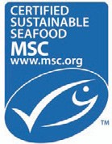
Seafood HACCP | 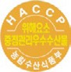 | (to be possibly changed) | 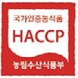
Seafood Geographical Identification |  | (to be possibly changed)
Traditional Seafood Quality Certification |  | (to be possibly changed)
Seafood and Seafood Specialty Quality Certification | 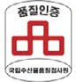
Traditional Seafood Master | - | (to be possibly changed)
Seafood Traceability System2) | 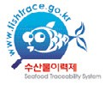 |  | 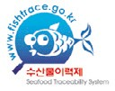
<Table> Improvement of Seafood Certification (plan)

Note: 1) The Agricultural Food Certification Integration Plan (tentative) limits the Eco- Friendly Agricultural Food Certification to agricultural food without antibiotic and excludes concept of sustainable fishery industry and eco- labeling. Therefore, a separate certification logo is required. Examples are MSC certification logos.
2) The table includes the Seafood Traceability System although it is not included in the improvement plan.

Third, the new system should ensure effectiveness and differentiation. The certification system under certain needs and purpose should be effectively applied to the field

in accordance with its original purpose. In this regard, the Agricultural Food Certification Integration Plan (tentative) should harmonize characteristics and industrial system of fisheries industry. (refer to <table>)

Fourth, the system should be easily accessible for consumers and producers. The new certification guides consumers into an important tool for consumer decision. If the governmental seafood authorization secures differentiation as well as accessibility for consumers, the demand for certified food will rise.

Fifth, the system should reflect characteristics of the fisheries industry. Seafood are different from agricultural or livestock products in industrial and biochemical distinctiveness. The certification system needs to be established and operated based on them.

Lastly, the Korean government should be open-minded to international guarantee systems in this globalized world. For example, the Marine Steward Council (MSC), an internationally well-known certification, needs to be reviewed for its domestic introduction. Basically, MSC only covers boat fisheries. However, if aquaculture production is eco- friendly and fertilizer-free, like oyster and mussel, they can be the subject for MSC.

An accurate analysis on the current status and practical short and long-term plans should be in
place to harmonize these future directions with the reality. On top of that, more efforts should follow to raise consumer awareness about the new system.

Contact information Name: Joo, Moon-Bae
  - mail: mbjoo@kmi.re.kr Tel: +82-2-2105-2844

An Active Cruise Industry Requires Legal and Institutional Improvement
02

Ocean Policy

Growing Attention to Safe Operation of Cruise Ships

More attention has been paid to regulations on cruise ship safety since the cruise ship Costa Concordia crashed into the rocks off Giglio Island of Italy, bringing casualties and vessel damages.

After the accident, some nations, including Brazil, launched an overall inspection on cruise and port operation as well as announcing plans for management system improvement. The global cruise industry has continued to grow despite the recent global economic recession. In Europe and Asia, in particular, cruise ships became larger and larger, fueled by skyrocketing demand. The cruise industry is thought to be a business with large economic ripple effects of invigorating the job market, relevant industries and local economies. Accordingly, nations with active tourism industry have cultivated the market and lured cruise ships with dedicated terminals and various incentives.

Meanwhile, Harmony Cruise, Korea’s first cruise operation company, was established last year and plans to launch the Club Harmony (Korean flagged) on the Korea- Japan route from February. The Club Harmony is equipped with 383 rooms which can accommodate 1,000 passengers. It will provide Korean and Asian passengers with tailored services. Given the mounting concerns for safety since a series of shipwrecks and other accidents, the Korean cruise liner needs to pay extra attention to ship/facility inspection and safety training for crew and passengers. In the past, the cruise industry was often defamed and the business faltered partly by criminal acts or safety or health measure violation on and off cruise vessels. Not to repeat the unfortunate past, more thorough preparation should be done.

Relevant Regulations Need to be Improved

Some of the characteristics of the cruise business include cruise ships transporting passengers as well as cargoes, going between domestic and international ports on a regular or irregular basis, and running various businesses on board. For such reasons, the business is subject to various kinds of regulations including the Marine Transport Act that needs to be kept in order. Moreover, a comprehensive legal system should be in place for effective management of cruise ships and institutional support. However, Korea has no concrete regulations even in the Marine Transport Act and the Tourism Promotion Act. The Marine Transport Act1 (amended in Oct. 2006), however, prepared the legal foundation for cruise industry by defining ‘cruise passenger transportation services’ as ‘marine passenger transportation services’ operated to provide cruise tours by sea (including calling at domestic and overseas tourist spots), using passenger ships of a size prescribed by the Presidential Decree of larger, which are equipped with convenience facilities and amenities, such as accommodation, dining and drinking, and recreational facilities. But the cruise business operator is required to obtain a license on marine passenger transportation service.

The Tourism Promotion Act has regulations on the tourism cruise business as part of the tourist-use facility business. But the Act defines cruise business as ‘the business of providing
tourists with tours using ships, operated by a person who is licensed for marine passenger transportation service’. Although cruise ships are equipped with various convenience facilities, the license standards don’t include provisions for their regulations. As a result, each facility requires separate approval from each relevant authority. Therefore, the Marine Transport Act and the Tourism Promotion Act need to be improved to vitalize the cruise business. The Marine Transport Act and Seafarers Act are mostly about cargo transportation, which requires amendment to specify regulations on seafarers or crew for cruise ships.

Legal and Institutional Improvement for an Active Cruise Industry

The Ministry of Land, Transport and Maritime Affairs and the Ministry of Strategy and Finance plan to divide cruise passenger transportation service into coastal transportation service and international transportation service and apply the tonnage system to international cruise passenger transportation service. So far, general passenger ships and cargo ships were subject to the tonnage system. Accordingly, the Restriction of Special Taxation Act will be amended based on days of operation and ship tonnage, rather than on the actual profits from business. In an effort to invigorate cruise tourism and lure tourists who transfer at Korean ports, the Ministry of Justice will streamline the immigration screening and expand the on board immigration inspection to loosen procedures,

1 http://elaw.klri.re.kr/

especially for Chinese tourists who may visit Korea on TWOV (travel without visa). Many cruise passengers are middle aged or elderly people with high income. Thus, long wait time or complex immigration procedures tend to push down disembarkation. In this regard, TWOV system needs to be introduced urgently to simplify immigration procedures for cruise passengers. All passenger ships, including cruise ships, are currently enjoying 50% discounts for entry, departure, berthing and the discount rates are expected to reach 70%. As cruise ships involve long working hours on the deck and competitive payment, employment of Korean crew is limited. Since employment of foreign crew staff is evitable, issues involving visa need to be addressed as well.

Although, via the notification by the Ministry of Culture, Sports and Tourism, Kangwon Land Casino and Jeju Duty Free Shop were opened to Korean nationals, contemporary social and institutional obstacles wouldn’t allow cruise ships to accommodate casinos or duty free shops soon. This needs to be reviewed in depth to attract foreign tourists and Korean tourists who go abroad as well as to increase profits of cruise operating companies.

As a dedicated organization, the Cruise Tourism Promotion Council composed of local municipalities, Korea Tourism Organization, private companies and relevant Ministries was launched in 2007. Due to its negligible
achievements, the Cruise Tourism Council was re-established in December last year. Its members include the Ministry of Land, Transport and Maritime Affairs, Ministry of Culture, Sports and Tourism, local municipalities, Port Authorities, Korea Tourism Organization and other relevant institutions. On top of that, major ports of calls will operate local cruise tourism committees and the knowledge information system will be built.

Various efforts have been made at relevant ministries and organizations to invigorate the cruise industry. However, a Cruise Tourism Industry Development Basic Plan is needed to set the practical future direction. A mid- and long-term plan, such as the five-year or ten-year plan, is necessary for the cultivation of Korean cruise companies and training of human resources. Other measures should be in place, such as securing of cruise ships by Korean cruise liners, financial support for construction or improvement of cruise ships as well as joint investment and operation. Along with efforts to vitalize the cruise industry, safety management, regulations and institutional problems should be reviewed for effective business operation.

Contact information Name: Choe, Young-sok E-mail: yschoe@kmi.re.kr Tel: +82-2-2105-2992

The 3rd Inland Fishery Development Master Plan (2012-2016)

The Korean government recently prepared the 3rd Inland Fishery Development Master Plan. Under the Inland Water Fisheries Act (Article 5), the master plan set a comprehensive long-term goal on the national level and presented relevant policy tools. Mayors or Governors of cities and provinces who are in charge of inland fishery will establish and implement detailed plans. The gist of the master plan is as follows: first, higher productivity of inland fishery as well as creation and protection of inland fishery resources; second, rearing of fishery foundation for inland leisure and tourism industries; third, development and distribution of technologies for inland fishery use and processing; fourth, hygiene management, management methods, aquaculture skills and other instructions.

The 3rd Inland Fishery Development Master Plan evaluated achievements of the 2nd master plan (2007-2011) and reflected changes surrounding the inland fishery to present policy directions for its sustainable development. The 3rd plan includes governmental active responses to depleting inland fishery resources and ecological changes, while boosting the development of the recreational fishing and aquarium fish industry, the new growth engines.

The basic goal of the 3rd Inland Fishery Development Master Plan is ‘inland fishery resources in harmony with ecological environment.’ The basic directions are: first, development of inland fishery resources into an industry with high added value and
competitiveness; second, creation of inland fishery resource and ecological environmental protection; third, construction of places both for fishery production and leisure industry. The corresponding core tasks are: first, concentrated development of eco-friendly and high added value aquaculture products; second, strengthened protection and management of inland fishery resources; third, vitalization of healthy inland leisure and tourism industry; fourth, safety and consumption improvement of inland fishery products; fifth, systematic and effective inland fishery management.

For more effective implementation of the 3rd master plan, a total of KRW 110.7 billion is earmarked for investment or financing. The investment will help the 3rd plan to achieve 40,000 tons in yearly inland fishery production, KRW 500 billion in production and KRW 48 million in fishery household income.

Basic Goal

Inland fishery resources in harmony with ecological environment
Basic Direction

- To develop inland fishery resources into an industry with high added value and competitiveness
- To create inland fishery resource and to protect ecological environment links for resource effectiveness
- To develop places both for fishery production and leisure industry
Core Tasks

- Concentrated development of eco-friendly and high added value aquaculture products
- Strengthened protection and management of inland fishery resources
- Vitalization of healthy inland leisure and tourism industry
- Safety and consumption improvement of inland fishery products
- Systematic and effective inland fishery management

<Diagram> Goal, Direction and Core Tasks of the 3rd Inland Fishery Development Plan

Contact information Name: Kim, Dae-Young
    - mail: mobydick@kmi.re.kr Tel: +82-2-2105-2868

03
Research Projects

•A Study on the integration of the Busan Fisheries Whole Sale Market and the Joint Fisheries Market
•A study on fairer and more transparent shipping charges
•The study on sustainable development of uninhabited islands
•Operation of the International Logistics Investment Analysis
Center (3rd)
•Master plan for salmon industry in Yangyang-gun
•A basic plan for the comprehensive development of fishing villages
•The 1st stage development of the Shipping Market Information Network
•Modernization of Vietnamese Ports: sharing of Korea's experience
•A validity study on the establishment of the Jeju shipping authority
•Systemic improvement and ship finance for domestic production of national flag carriers
•Foundation for the Solar Salt Traceability System and Pilot Projects
•Action plans for building a fisheries distribution logistics center at consumption areas
•Plans to attract the ocean plant equipment industry and relevant companies
•A basic study on the development of the seafood complex in Donghae City
•A study on the development of intelligent subsea tree
•The 1st National Basic Plan on Maritime Affairs and Safety
•Safety measures for the exploration at the 8th mining area in the East sea
•A study on cruise passengers, facility demand and business value of the Incheon Port
•A validity study on logistics facility development in Southeast Asia
•Development of guidelines for ecosystem-based management
•A study on the introduction of ship financing
•Cooperation on multi-lateral marine environment of East Asia
•Basic plan for the comprehensive development of areas nearby Busan station
•Utilization of managerial right of port facilities at the Kyungin Port
•Improvement of tax-free oil supply and management system
•Domestic commercialization of CO2 storage at the ocean underground
•A study on the designation and management of marine protected species

•Land based pollution management and total pollution loads management (2nd)
•The enactment of the Aquaculture Industry Development Act and eco-friendly aquaculture
•A validity study on Phuoc An Port in Vietnam
•A study on the marine ecosystem industry
•2011 National Transportation Survey and Database
•Comprehensive port development plan (Chungchungnamdo)
•A price analysis on imported fisheries products
•A validity study on the Pohang new port's swell improvement and its effects
•Negotiation governance for international fisheries bargaining power
•High value added fisheries development and export expansion
•Securing and management of new financial resources for Fisheries Development Fund
•Technology development for smart green container terminal
•A validity study on economic feasibility and financial analysis of port and logistics in the Philippines
•The study on the implementation of the single shipping market for ASEAN
•A study on long-term development of coastal passenger transportation industry
•Port basic plan system improvement for effective port policy implementation
•2011 port demand prediction
•Systemic response to international agreements on marine biological resources (2nd)
•An analysis on the Norwegian mackerel production and distribution system
•Demand prediction and validity study for Ganggu port development
•A validity study on Jeju-metropolitan area comprehensive logistics center
•Technology development for marine environment hazard evaluation and management
•A study on the development of mudflat fisheries
•Marine academic SOC international development and mid- and long-term development
•A study on mudflats affected by oil spill

•Cleaning methods for areas near by Busan Port
•Consigned preparation of 2012 international symposiums
•The estimation of the car ferry cargo throughput and passenger demand at Incheon international passenger terminal
•Shipping & logistics crisis management system development and K-C-J logistics information standardization
•A study on domestic shell fish production area hygiene management
•Implementation system for integrated coastal management plan
•Introduction of ITQ fisheries resource management system
•The basic plan on sea areas under environmental management and plan for each sea areas
•Establishment of integrated logistics network for advancement into ASEAN
•The impacts of small fish catch on fisheries resources and demand/supply
•An analysis on the Arctic and Antarctic Sea policies of major nations and international organizations
•Northern and Northwestern part of Sri Lanka Aquaculture Development (2011 Yeosu project 2nd year study)
•A study on the South and East-South sea of Grenada (2011 Yeosu project 2nd year study)
•A study on close cooperation between ports in Northeast Asia
•North Korean port basic plan
•Cameroon’s coastal protection/development plan scenario and master plan
•Consigned operation of 2012 shipping, port, logistics information center

03. Research Projects 15

04
International Cooperation

The Meeting for Members of UNEP-GPA and Other International Organizations

      - Time & Place: January 6, Edsa Shangri-La Hotels
      - Participants: Nam, Jung-ho (Research fellow, KMI) and others

2011 Junior Scholar Award

      - Time & Place: January 6, the Korean Society of International Law
      - Awardee: Choi, Jee-hyun (Researcher, KMI, ‘A study on Provisional Measures of the ICJ’)

The Workshop for Climate Change Experts and the International Climate Change Junior Researchers Convention

      - Time & Place: January 11, Korea University
      - Participants: Park, Young-gil (Researcher, KMI)

MOU Signed between KMI and Tokyo University of Marine Science and Technology

- The Preparatory Meeting on Pending Issues for GPA
- Time & Place: January 24, Edsa Shangri-La Hotels
- Participants: Nam, Jung-ho (Research fellow, KMI) and others

Visit by the Vietnam Administration for Seas and Islands (VASI)

- Time & Place: January 29~ February 4
- Participants: Head of VASI and others
- Purpose: Data collection on Korea’s policies and experience in marine science and technology

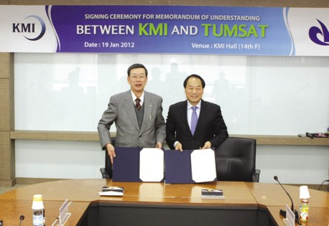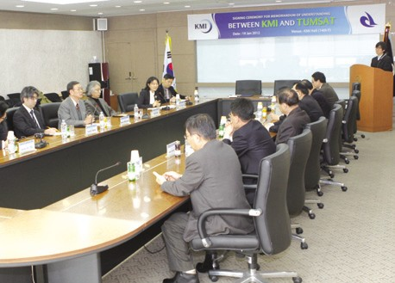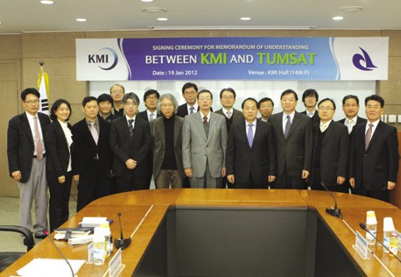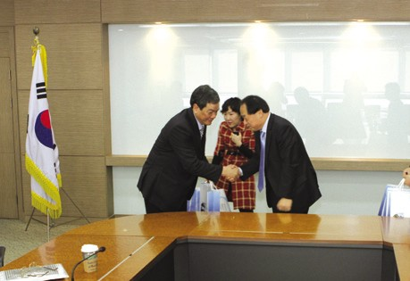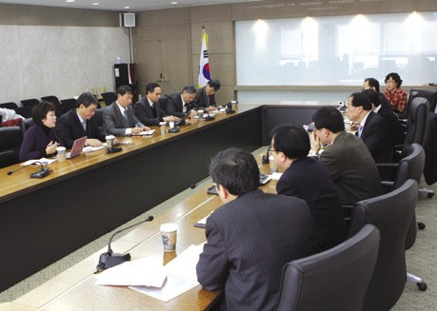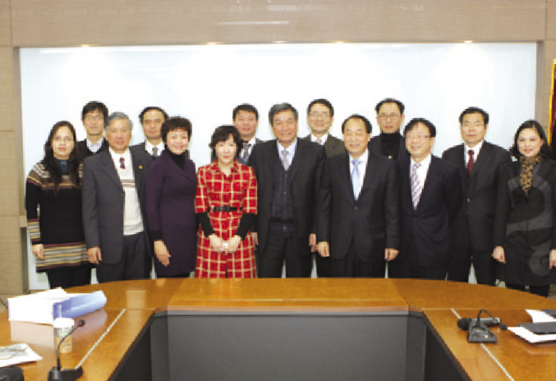
Source: KMI
Source: KMI
Source: KMI
Source: KMI
Source: KMI
Source: KMI

05
News & Announcements

Major Activities Conducted in January 2012

The 3rd Workshop on Maritime Safety Basic Plan
- Time & Place: January 3~6, the International Youth Center
- Topic: Establishment of the 1st National Maritime Safety Basic Plan

The Preparatory Meeting for the Study on Clearing of Busan Port Areas
- Time & Place: January 6, Ministry of Land, Transport and Maritime Affairs
- Topic: Basic direction and supporting measures
- Participants: Kim, Hyung-geun (Director, KMI) Lee, Jong-phil (Associate research fellow, KMI) and Lee, Sang-ho (MLTM)

The Preparatory Meeting for the Validity Study on Pohang Port Swell Improvement
- Time & Place: January 9, KMI
- Topic: Interim review and complementary measures
- Participants: Lee, Jong-phil (Associate research fellow, KMI), Ha, Tae-young (Senior researcher, KMI) and Choi, Hyuck-jin (Vice president, Daeyoung Engineering. Co., LTD)

KMI Ocean Academy (2012 January Ocean Education Job Training)
- Time & Place: January 10~14, Olympic Parktel
- 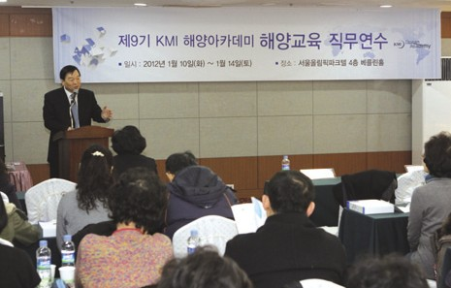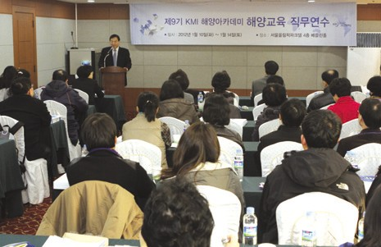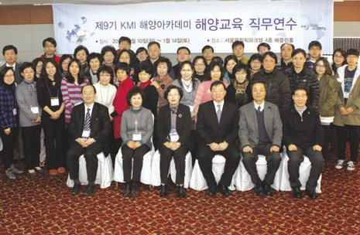Participants: 40 teachers at elementary, middle and high schools nationwide
Source: KMI
Source: KMI
Source: KMI

The Consigned Study Kick-off Meeting
- Time & Place: January 10, KORDI
- Topic: U-based sipping & logistics security system

The Consigned Study Kick-off Meeting
- Time & Place: January 10, MLTM
- Topic: Consigned operation of contents of the Shipping, Port and Logistics Information Center

The Fisheries Policy Research Division Workshop
- Time & Place: January 13~14, HEGOSLAB
- Topic: Preparation for the Fisheries Outlook Conference, 100 Fisheries pending issues, 2012 fisheries core projects

2012 MIFAFF-KMI New Year Work Conference
- Time & Place: January 18, KMI
- Participants: Kim, Jung-bong (Research fellow, KMI)

The Final Briefing on the Study on Korean Fisheries Industry Development Strategy
- Time & Place: January 17, KMI
- Participants: Kim, Jung-bong (Research fellow, KMI)

The Final Briefing on 2011 Solar Salt Traceability System and Pilot Projects
- Time & Place: January 20, aT center
- Participants: Joo, Moon-bae (Research fellow, KMI)

The Future Korea, Maritime Fisheries Development Forum
- Time & Place: January 17, Plaza Hotel
- Participants: Kim, Jung-bong (Research fellow, KMI, ‘Future and Hope of the Korean Ocean Industry’)

The Meeting for Consigned Studies
- Time & Place: January 26, MLTM
- Topic: The 1st National Maritime Safety Basic Plan

Major Activities Planned in February, 2012

•The General Study Kick-off Meeting
- Time & Place: February 3, KMI
- Topic: UNESCAP international joint research projects

•The 8th Logistics Technology Industrialization Colloquium
- Time & Place: February 3, KMI
- Topic: Seamless logistics and Social logistics

•The Seminar on ITQ Fisheries Resource Management System with Invited Scholars
- Time & Place: February 4, KMI
- Participants: Rognvaldur Hannesson (Professor, Norwegian School of Economics) and Ryu, Jong-gon (Research fellow, KMI)

•2012 Fisheries Outlook Conference
- Time & Place: February 3, Korcham
- Participants: Researchers at the Fisheries Policy Research Division
- Topic: The first year for the next generation fisheries bio-industry

•The Fisheries Knowledge Sharing Seminar
- Time & Place: February 6, KMI
- Participants: Fisheries Policy Research Div., Global& Future Research Div. and Fisheries Outlook Center

•The Preparatory Meeting for 100 Fisheries Pending Issues
- Time & Place: February 27, KMI
- Participants: All members of the T/F

•KMI-MIFAFF Policy Conference
- Time & Place: February, KMI
- Participants: Senior researchers at the Fisheries Policy Research Division
- Topic: Review on the achievements of 2011 studies and research plans for 2012

•The Eco-Shipping Expert Seminar
  - Time & Place: February, MLTM
  - Participants: Researchers at relevant organizations, including NMRI

•The Hawaii Workshop on National Strategy for the Arctic Sea
  - Time & Place: February 6~10, EWC
  - Topic: Plans for the next 5 years and Port O/D analysis on the Northern Sea Route

•Preparation for the KOSOPFF International Forum
  - Time & Place: February, place (TBD)
  - Topic: Venue and schedule
  - Participants: Joeli Veitayaki (Professor, Piji University)

•KMI Ocean Academy (4th Training Session for High Ranking Managers)
  - Time & Place: February 14~17, Kyushu, Japan
  - Participants: 20 principals/vice principals at elementary, middle and high schools nationwide

•2012 KMI Shipping, Port and Logistics Outlook Conference
  - Time & Place: February 28, Korea Federation of Bank
  - Participants: Major personnel at KMI and other organizations
  - Topic: Overcoming of global crisis and future direction

20 KMI International News Bulletin`Ocean & Futurea

Publisher
Kim, Hak So - President, Korea Maritime Institute

Editor-in-Chief
Kim, Jong Deog - Director General, Planning & Coordination Division

Editorial Board
Lim, Chin Soo - Director General, Ocean Knowledge Management Division Choi, Jae Sun - Director General, Global & Future Research Division
Rim, Jong Kwan - Director General, Maritime Industry Research Division Kim, Bum Jung - Director General, Port & Logistics Research Division Kim, Sung Gwi - Director General, Marine Policy Research Division Kim, Jung Bong - Director General, Fisheries Policy Research Division

Secretary
Kang, Myung Hee - Planning & Coordination Division Chung, Kyung Hwa - Planning & Coordination Division

Contact Information
Address: 21F KBS Media Center Bldg., #1652,
Sangam-dong, Mapo-gu, Seoul, 121-270, R.O. Korea Tel: +82-2-2105-2770, 2984
Fax: +82-2-2105-2730
Email: jdkim65@kmi.re.kr, myungheekang@kmi.re.kr

