ISSN 2093-3584 October, 2011. Vol.20

- Opinion
  - Fostering Marine Equipment Industry in Korea
  - Korea-China FTA and Maritime Transport Service
  - Developing High Value Added Ornamental Fish Industry

- Ocean Policy
  - Korea’s World Class Salt: Mudflat Solar Salt
  - Lessons from EU's Fisheries Policy Reform
  - National Management Targets for Natural Coastline

- Research Findings
  - The Response to Delegation & Devolution of Port Management to the Local Autonomous Entity

- Research Projects

- International Cooperation

- News & Announcements

01
Opinion

Fostering Marine Equipment Industry in Korea

Korea ranks first in the shipbuilding industry but it is incompetent in related industry such as marine equipment and ship repairs. Europe, the US and Japan who once enjoyed the heydays of shipbuilding industry are now falling behind but still prosper and rank top in the marine industry. Those countries manufacture mainly high-end and high value marine equipment products. Competitiveness of shipbuilding industry largely relies on marine equipment industry, and the value- adding process is concentrated on marine equipment industry than on shipbuilding industry. Currently, technical competitiveness of Korea in marine equipment industry is estimated at 85% to the industry leaders.

Korea needs to develop the marine equipment industry to prepare for the future. China chases Korea in shipbuilding industry in fast pace. China even overdoes Korea for orders received in 2009 but Korea still outperforms China in high value shipbuilding and engine manufacturing. In 5 to 10 years, it is estimated that China takes over the leading position in shipbuilding, surpassing Korea. Due to the rise in labor costs, it is inevitable to take its top position to China in volume. It is time to turn to marine equipment industry to maintain leading position and national wealth in ship related industry. Value adding of marine equipment industry is much higher than that of shipbuilding industry in case of manufacturing high-tech and high end products. For example, it costs 20% higher to manufacture LNG fuelled ship than current oil-fueled ship1. 10% additional costs from gas engine and security facilities while other 10% additional cost comes from fuel injection system. All three parts are supplied by the marine equipment industry, meaning most of benefits from building LNG fuelled ship go to ship parts manufacturing companies mostly overseas. Korean marine equipment companies are far behind market leading countries in high tech product market. Korean companies are inferior in size and funding and, therefore, lack research and development capability compared to those of EU, the US, and Japan, resulting to difficulty in developing

1 Interview with a shipbuilding company in Goeje, South Korea

 | Korea | US | Japan | EU | China
Deck and Correspondence facilities | 71.8 | 86.6 | 87.0 | 100 | 32.8
Ship material structure | 72.8 | 93.7 | 98.0 | 100 | 51.8
Propulsion system parts | 80.4 | 91.5 | 93.3 | 100 | 59.7
Offshore platform | 79.7 | 106.6 | 93.5 | 100 | 62.2
Leisure and exploration device | 64.0 | 104.2 | 94.7 | 100 | 62.5
Safety equipment | 74.6 | 93.6 | 86.5 | 100 | 52.4
Source: Korea Evaluation Institute of Industrial Technology,`Industry technical standard Analysisa(2006)

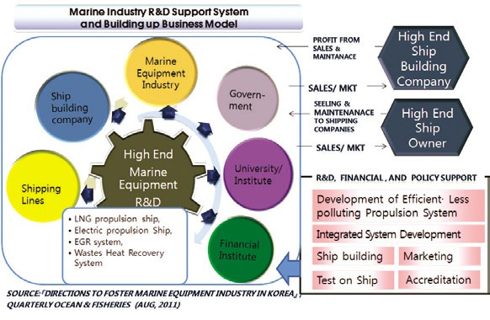
advanced products technologically. Even after developing advanced products, due to the requirement of fully tested and having application history, it is still difficult for major shipbuilding companies to adopt as its part.

Korean marine equipments industry is behind that of leading countries such as EU, Japan, and the US. High value sector such as
propulsion system and offshore platform sector are relatively not that behind but the leisure and exploration device sector is relatively lagging even more.

Marine Industry Support System

To change the situation of marine equipment industry in Korea, it should seek major solutions to reinforce the industry. Korea lacks the Pan Government system to support cooperation among the related parties of marine equipment industry. Despite its leading position in shipbuilding industry, Korea’s value added operation induced from shipbuilding is limited because the high-end ship parts are mostly imported. To resolve the problem, a support

system is needed for the related parties including the government to develop technologically advanced ship parts and to guarantee its applications. Here, I suggest to form marine industry R&D support system and to build up business model so that it develops and sells the ship parts, jointly with ship building, marine equipment, and shipping company.

Contact information Name: Jung Hyun Kim
E-mail: jh-kim@kmi.re.kr Tel: +82-2-2105-2943

Korea-China FTA and Maritime Transport Service

Geographical and Economic Links Make Greater Riffle Effects

Korea has prepared negotiations for the Korea-China FTA to tap into immense economic power of its neighbor. In addition to geographical closeness to Korea and similar industrial structure, China has huge domestic demand and has been leading the East Asian market. Although market opening of sensitive products, such as agricultural goods, will raise difficulties for negotiations, many agree that economic spillovers of the Korea-China FTA will be far greater than the Korea-US FTA. As one of major economic powers and as the largest importer and exporter, China has raised its voice over shipping and port logistics industries.

China is the world’s 4th largest in terms of vessel ownership and, 3rd, if Hong Kong is included. Since its accession to WTO, China has posted double digit economic growth rates. Rapidly rising container throughput and demand for major resources made China the key player in the global shipping market for the mid- and long- term. In fact, the global oil, coal, and iron ore transport markets (major three dry cargoes) are centered around China. Shanghai toppled Singapore to become the world largest port and other Chinese ports continued to increase their throughput. The World Top 10 ports include six Chinese ports, including Hong Kong. China is expected to expand its industrial production as the world factory, while draining out huge amounts of raw and subsidiary materials like a
black hole. Consequently, this will keep increasing China’s seaborne trade.

Rising China in the global shipping market also restructured the seaborne transportation system with itself at center. It has expanded the Asian networks through FTAs with ASEAN members and ECFA with Taiwan. China’s shipping industry has sharpened its edge based on bigger market size and higher stance in the global market. COSCO, a Chinese shipping behemoth, tried to build up its fleet size through IPOs at the Shanghai, Hong Kong and Singapore stock markets, while actively investing in overseas ports, including Greece. The Chinese shipping industry has rapidly embraced globalization and international standards and carried out ‘the Smart Shipping Industry Development’ to become the leader. For instance, Shanghai aims to simultaneously build the global financial center and the leading shipping center by 2020. The Chinese shipping market is expected to enhance both quality and quantity as intra-regional trade in East Asia remarkably increases and as complex and various shipping routes and networks are established.

Future Possibilities and New Opportunities

Korea requires a different approach for FTA negotiations with China if it wants to harmoniously grow free trade and shipping service industry for national wealth and job

creation. Gaining the upper hand at competition with an economic and shipping power, China, calls for far-sighed views on its future and potential, rather than its current status. An FTA with China, which can possibly grow into the world largest economy, may pose threats as well as opportunities. Opening of the shipping service market under the Korea-China FTA will invite more competition as shipping companies can call at ports more freely and often. In the meantime, mergers between shipping routes and shipping companies will get accelerated. Higher market share of Chinese shipping companies is expected to shift the shipping market in Northeast Asia by causing a change in ports of call and networks among shipping companies.

Meanwhile, Korea should strongly call for opening or loosening of foreign investment share limitations or management rights in the maritime transport service. It should ask for improvement of local practices or administrative procedures for license or permits at FTA negotiations. China’s specific limitations and asymmetric international standards should be addressed as well, based on Korea’s market opening level. Transparency and fairness in the shipping and relevant areas need to be ensured to minimize investment uncertainty and increase overseas market entrance and investment.

Korea and China has held Korea-China Shipping Meeting, Korea-China Seaborne, Land Intermodal Truck Transportation Cooperation Committee and other bilateral government
meetings since the 1993 Korea-China Maritime Transport Agreement. Bilateral shipping cooperation which considers shipping market of both countries should continue along with FTA negotiations for joint development. Moreover, Korea needs to strategically use the Korea- China-Japan Logistics Ministerial Conference in its preparation for market opening and economic integration under the Korea-China-Japan FTA.

Contact information Name: Choe, Yung-Sok
E-mail: yschoe@kmi.re.kr Tel: +82-2-2105-2992

Developing High Value Added Ornamental Fish Industry

Background and Current Status

The ornamental fish industry is considered as high value added industry since it can produce more value addition and create more jobs than other capture fisheries due to its broad connections with other sectors such as aquarium business and manufacturing related equipments. Therefore, MFAFF considers the ornamental fish industry as a new growth engine to shift from the red ocean of producing edible fish where fierce competition exists to the blue ocean of producing non-edible fish.
Korea imported 3.0 million USD of ornamental fish in 2004 and it increased up to
7.9 million USD in 2009. During the short period of 6 years, the import value increased by 2.6 times. However, export value of ornamental fish in 2009 was only 0.37 million USD. Therefore,
Korean ornamental fish industry still stays at an

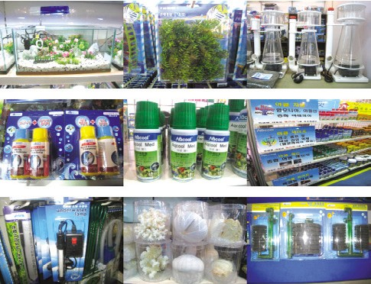
[Fig. 1] Products related to ornamental fish
infant stage and has a lot of potentials for growth considering Korea's world class aquaculture technology. The domestic ornamental fish industry including export and domestic sales was estimated to reach 230 billion KRW in 2010.

Vision and Strategies for the Ornamental Fish Industry

According to the Basic Plan on Ornamental Fish Industry Development, the government set up the vision of entering world top three exporting countries of ornamental fish by developing the ornamental fish industry as a high value added exporting industry. The government goals for the developments can be summarized as building the industrial groundwork by improving regulations and production environments, securing competitiveness by supporting and developing industrial foundation through R&D and leading the global market by expanding domestic market and developing globally competitive species.

By the year 2020, the government will set up goals of achieving 128 million USD of export value and 127 million USD of import substitution. The goal of export value is based on
11.4 percent of annual growth rate from 2000 to 2007. The goal of import substitution is based on substituting for 70 percent of import value in 2020, which were calculated by considering average import growth rate from 2004 to 2009.

[Fig. 2] Development of high value added ornamental fish industry
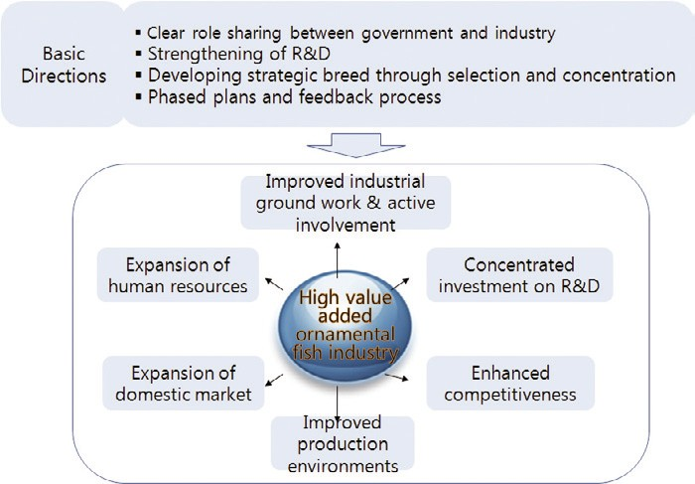

Future Directions for Developing High Value Added Ornamental Fish Industry

Basic future directions for developing high value added ornamental fish industry are as follows: role sharing between the government and the industry, strengthening R&D for industrial development, development of strategic breed and equipment (through selection and concentration), and industrial development in a short period of time through phased plans.

First, there should be clear role sharing between the government and the ornamental fish industry. The government should take a role of

building the industrial groundwork by establishing supportive policies and programs. The ornamental fish industry should take a role of enhancing competitiveness by active involvement in government policies and development of promising species.

Second, there should be strengthened R&D for industrial development. In order to achieve this, there should be expansion of human resources that can carry out concentrated R&D on the ornamental fish, thereby promoting the ornamental fish farming through establishing high technologies on breeding of the ornamental fish, low-cost high efficient farming and developing aquarium products.

Third, there should be development of strategic breed and equipment through selection and concentration. In order to expand the domestic market and lead the global market, the government and the industry should develop globally competitive species strategically through selection and concentration basis after analyzing domestic and global market for the ornamental fish.

Fourth, the development for high value ornamental fish industry should be carried out through phased plans in order to minimize trial and errors in a short period of time. Therefore, there should be concentrated investment on the development for high value ornamental fish industry in each phase and thorough review and feedback process on the achievements in each phase.

Furthermore, governmental attention and support are necessary to build the foundation for the ornamental fish industry. In this regard, policy suggestions are summarized as follows: to urgently prepare relevant policies and system, to conduct studies on the ornamental fish industry, and to build “A Ornamental Fish Industry Development Council.”
Contact information Name: Kim, Dae-young
E-mail: mobydick@kmi.re.kr Tel: +82-2-2105-2868

Korea’s World Class Salt: Mudflat Solar Salt
02

Ocean Policy

The Ministry for Food, Agriculture, Forestry and Fisheries announced “The Comprehensive Plan on Development of the Solar Salt Industry” whose goal is to foster world class solar salt competing against those from Guerande (France) and Comacchio (Italy). As Korean solar salt is produced in mudflats, it contains low amount of sodium chloride and high content of mineral and potassium, which make up its superiority. Nevertheless, salt was categorized as “mineral” until 2008 and the government lacked systemic development plan for the industry.

Three major tasks of the comprehensive plan are: first, infrastructure expansion, including improvement of underdeveloped salt farm facilities; second, competitiveness improvement based on strengthened quality and safety management; third, new market creation centered on export expansion. The Korean government plans to spend KRW 84.3 billion over the next 5 years on investment and loans. For starters, it will prepare the salt farm registry and salt farm management standards to establish a management system. It will also improve relevant facilities, salt processing complex in production areas as well as building “The Solar Salt Research & HRD Center.” For more transparent distribution, it will boost the salt traceability system and direct sales, while disclosing solar salt product prices. Quality authorization systems, such as environmental certification, will be introduced as well.

More efforts will be paid to expand research on solar salt efficacy, to converge the field with beauty products, cosmetics and medical business, to develop tour products using solar farms and to create new markets. Joint inspection with consumer groups will be regularly conducted on the hygiene, safety management and production management of salt farms.

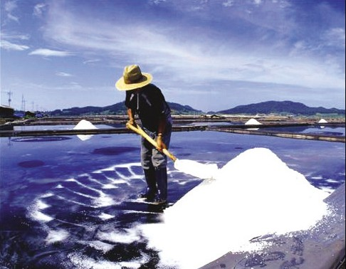
Source: Internet Shinan News

Contact information Name: Kim, Bong-tae
E-mail: btkim@kmi.re.kr Tel: +82-2-2105-2751

Lessons from EU’s Fisheries Policy Reform

This summer, the European Union Fisheries Commission has released a reform plan for its Common Fisheries Policy (CFP), which includes the Fisheries Commission's evaluations over its achievements of the existing CFP (2002~2012), and a demonstration of future course. The most critical point in the evaluations can be summarized by its failure to meet the target of reducing overfishing, and assuring sustainability of European fisheries as a whole.

Based on such evaluations, the EU’s fisheries reform plan renews and re-emphasizes the importance of major aims and goals in the EU's fisheries policy: sustainable fisheries and aquaculture, healthy marine environment, economically viable industry, and employment and opportunities for coastal communities. More than anything else, however, the crown jewel of the reform plan released in this summer seems to be the Commission's plan of adopting “transferable catch” into the CFP as the alternative to the failures of the total allowable catch (TAC).

In its 2007 annual Policy Statement on fishing opportunities, the Commission reviewed the evolution of both scientific advice and the catch limits adopted by the European Council since 2002. One of the major findings is associated with effectiveness of the TAC. According to the EU's advice, fisheries production in the EU has been in excess of 40% on average, surpassing the TAC’s annual targets. Conclusively, the TAC implemented for about
ten years proved to have resulted in failures to prevent overexploitation and/or overfishing.

According to Maria Damanaki, the EU Fisheries Commissioner in her press conference, “...the newly proposed transferable catch shares”(or “concessions”) system is scheduled to be introduced in 2014, and for vessels over 12 meters long.” This kind of quotas would be distributed to EU members in a transparent way, and operators would be allowed to lease or trade their concessions within their member country, but not between member countries, while the validity of the concessions would be a minimum of 15 years. On the other hand, the fishing rights of small-scale fisheries will be protected in the way that they would be exempted from transferable catch shares.

The transferable catch share system can be called an application of namely “Marketable Permits and Obligations Programs, MPOPs,” which was initially introduced in mitigation of pollutants emissions such as sulfur dioxides in the United States. In the fisheries sector, MPOPs was initiated in Iceland for preventing overfishing in 1979, while New Zealand was the most successful state in regards to the system (in this case, called “individual transferable quotas,” ITQs).

The ITQs presuppose the clear establishment of “property right” or “ownership,” which is pretty much difficult to be defined, and which poses, in this reason, remains as a major obstacle

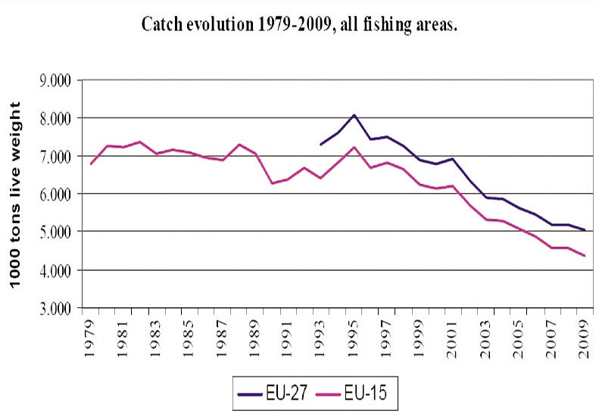
EU Catch Evolution (1979~2009)
Source: Maria Mamanaki, "Getting It Right: The Birth of a New Common Fisheries Policy," Brussels, July 13 2011.

to be expanded in the fisheries sector, at least up to this day. The EU’s proposal, however, is likely to be a turning point in global fisheries management practice, if adopted in the EU’s Parliament and its Ministers Meeting--especially when considering the EU’s share in and its influence on world fisheries stage.

The introduction of “transferable catch shares” or “individual transferable quotas” has been considered to be introduced not only in coastal fishing but also in high seas fishing, causing debates. Even in the early 2000, some experts raised the possibility that the existing participants in high seas fishing would claim their vested interests against would-be participants. It is at this point that Korean fisheries industry should be wary of negative impact of the EU’s fisheries reform on its industrial preparedness, observing its future development.
Contact information Name: Park, Sung-jun
E-mail: sjpark@kmi.re.kr Tel: +82-2-2105-2973

National Management Targets for Natural Coastline

The Korean government has implemented “The Target-based Natural Coastline Management System” this year under the Coastal Management Act. The system sets management goals for natural coastline, such as natural coastline length, for its effective management and better environmental function. One of the objectives is to reject reckless coastal development and to constantly protect the natural coast. The system also aims to preserve a certain level of natural coast by restoring damaged coast and managing development demand.
Before setting the national management target, the government has accumulated basic information so far, including costal condition maps, surveys on adjacent area development plans and natural coast management map. The information becomes the groundwork to reduce the confirmed development demand for natural coastline and set the target which takes into account future development demand. As of October 2011, the national management targets for the next 5 years (2011-2016) are being discussed by relevant administrative bodies and

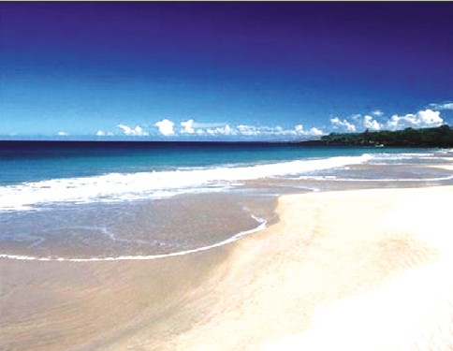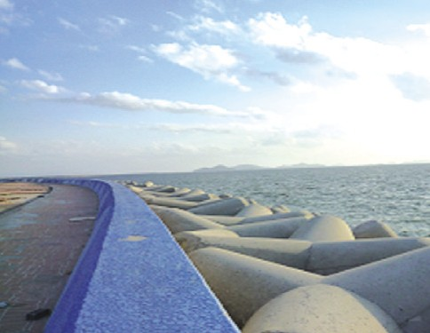
<Natural coastline> <Artificial coastline>
Source: MLTM (Ministry of Land, Transport and Maritime Affairs)

The management scope is natural coastline to the seashore (the area between high-water mark and the area registered with land registry), the intertidal zone. The government takes the following step before setting the management target. First, natural and artificial coastlines are classified (coastal condition map). Second, targets are prepared based on development and restoration demand over the next 5 years. Third, national management targets for natural coastline are confirmed after deliberation at the Central Coastal Management Council.
will be decided after being reviewed by the Central Coastal Management Council.

Contact information Name: Choi, Hee-Jung
E-mail: chj1013@kmi.re.kr Tel: +82-2-2105-2776

03
Research Findings

The Response to Delegation & Devolution of Port Management to the Local Autonomous Entity

A Survey Analysis on the Impact of Delegation and Devolution of Port Management

The results showed both positive and negative effects. High benefits are expected from the following: increasing revenue from local taxes; active efforts to attract relevant industries to the local area; rising local employment; better capability of municipalities in running their organization and human resources. However, the central government and regional maritime entity belonging to it hold negative views.

As for negative effects, the central government is concerned about the possibility of excessive competition and loose management. The biggest worry for municipalities is that the central government might give less budgetary support for local port development.

About follow-up measures after the delegation or devolution of port management, positive views were dominant in the following 5 aspects: ⅰ) enactment of standard ordinances and regulations, ⅱ) distribution of work process standards or handbooks, ⅲ) implementation monitoring, ⅳ) project result evaluation and ⅴ) regular report and agreement

All stakeholders agreed on the need for evaluating port development and management after delegation or devolution. 71.3% of respondents answered that joint evaluation by the central and local governments is necessary if an evaluation would be conducted. Evaluation criteria were divided into “planning,” “implementation,” and “achievement” which had the same level of weighing factor. Measurable indices are preferred to non-measurable ones. (58%: 42%)

Responses to Delegation or Devolution of Port Management

In order to minimize side effects, the scope and level of port management transfer should be thoroughly reviewed. The survey showed that many stake holders were still negative about the management or development transfer. They were also disapproving of differentiated types of transfers.

Along with municipalities’ own evaluation, a joint assessment with the central government should be conducted. Such evaluation will show both achievements and problems, which can be the foundation for better management onwards. After the reassignment, joint monitoring by the local and central governments needs to be conducted. The monitoring should be done on the project size, the implementation rates of original plans, project improvement efforts and funding.

After the transfer of port development and project management, the central government should provide administrative supports, such as the enactment of standard ordinances or regulations, distribution of work processing guidelines or handbooks and support for local employment of relevant human resources. After the reassignment is completed, the central government should expand its budgetary supports for municipalities, based on the evaluation of their performance in port development and project management. If port development and project management is managed as national projects as today (municipalities are commissioned for the job),
this should be partly financed by national funds. However, if those responsibilities are transferred to municipalities, they are better to be supported under “the Metropolitan / Local Development Special Accounts” for better financial autonomy of municipalities.

A Model to Evaluate Achievements of Delegation or Devolution of Port Management

The study built an evaluation model on performance after port development and project management is reassigned to local government. Although the model fell short of scoring in all indices, it established detailed factors. It presented thorough evaluation methods for each project stage, such as planning, implementation and achievement. For example, it suggested assessment methods for measurable/non- measurable items, evaluation items for each project stage and main evaluators. Port development projects are long-term projects. Thus, the evaluation is more focused on planning and implementation stages, while the analysis on achievement stage is limited. In the early phase of the transfer, weight for each stage should be
30 (planning): 30 (implementation): 40 (achievement). It is difficult to evaluate port development projects only with measurable items. So, measurable indices are limited to “achievement phase” (30%).

Non-measurable indices are based on factors, such as “being customer-oriented” and “being

- Research Findings 15

<Weight factor for evaluation: for general public and experts>

 | Reflection of opinions | Adequacy | Transparency | Consistency | Efficiency | Returning effects | Satisfaction | Total
General public | 14.0 | 15.6 | 13.0 | - | 17.4 | - | 40.0 | 100
Experts | 10.3 | 11.2 | 8.1 | 8.5 | 13.0 | 8.9 | 40.0 | 100

achievement-oriented.” They are evaluated through experts’ brain storming and the Delphi Method. Meanwhile, measurable indices can use the Policy Satisfaction Index (PSI), riffle effects on the local economy, the ratio of plans to achievements and the policy efficiency index.

Policy Suggestions

In the reviewing stage of the reassignment, a joint council of public officials, research institutes (supported by the central or local government) and the private sector explore and review potential cases systematically. “Differentiated transfer” can be desirable in some aspects. However, standards for differentiation, such as population, financial conditions and administrative conditions, are not clear. Therefore, this type of port management transfer is not viable. Financial support measures should be firstly determined before actual reassigning of responsibilities to municipalities. In the long-term, the local tax system and the intergovernmental fiscal co-ordination should be improved for port management transfer. Port management transfer should be utilized by restructuring functions of the central government. For that purpose, relevant results

need to be actively used, while functions and human resources are adequately transferred with the responsibility of port management.

“Policy evaluation results” are used as part of follow-up management of the transfer. For more effective use of those results, the following should be analyzed. The feedback system between evaluation results, policy establishment and policy implementation should be strengthened. Moreover, expertise, independence and reliability of evaluators (organization) should be improved and database on evaluation results should be built for their systemic analysis.

Contact information Name: Jun, Chan-young et al. E-mail: cyjun@kmi.re.kr
Tel: +82-2-2105-4921

04

•Fisheries policy response to climate change
•Measures for better export of strategic fisheries products -10 major strategic products
•The Korea-China FTA’s Impacts on fisheries sector (2nd year)
•Transportation policy direction for Korea-China FTA (marine transportation)
•Strategies for future green ship industry
•Environmental standards for eco-friendly fishing ground management
•A review on sites for Boryong LNG TML
•Improved project evaluation system under climate change and international market utilization
•The study on investment system of nations under shipping and logistics projects
•A consigned study on mid-and long-term development of Daesan port
•A validity study on the development of port at Solomon Islands
•A study on the restructuring of port dues
•System development for transportation policy support and analysis
•Policy direction for the participation of national flag carriers in the Japanese and Taiwanese routes
•A study on the categorization, role and future growth of the ocean industry (Research Project)
•A validity study on the development of Limbae port in Cameroon
•A study on the Korea’s logistics technology development
•A basic plan on the comprehensive fishing village development
•Utilization of managerial right of port facilities at the Kyungin Port
•A basic study on the symbolic structure of IALA
•A study on YJC future management strategies
•Development of marine ecosystem experience, leports and tour programs along with resource development facilities
•The analysis on the deep sea fishing industry
•International Marine and Environmental Policy Program (IMEPP, 2nd)
•A study on the development size and business feasibility of the 2nd port logistics complex development plan
•The study on the large size marine leisure park
•Fact-finding survey of sea, land registration and management categorization
•Responsive measures against the Korea-Turkey FTA and 2011 WTO-DDA

Research Projects

•A basic plan before the notification of “fundamental fishing ports for fishing villages”
•The study on Korea-Middle East Fisheries Cooperation (particularly Egypt and Turkey)
•A validity study on the 2014 Wando International Seaweed Expo
•Korea-China-Japan cooperation in transportation and logistics (3rd)
•Systemic improvement and ship finance for domestic production of national flag carriers
•Guidelines for the coastal planning for climate change adaptation
•Coastal management projects for better adaptation to climate change
•Implications of the Korea-Indonesia FTA on the Korean fisheries industry
•System improvement for seaweed protection
•Effective use of coastal zones
•The study on cooperation with Latin America and active fisheries investment
•The 2nd fishing ground management plan
•A basic plan to build a comprehensive fisheries support center at the Mokpo North Port
•A validity study on the establishment of the Jeju shipping authority
•The 1st National Basic Plan on Maritime Affairs and Safety
•A basic study on the development of the seafood complex in Donghae City
•Safety measures for the exploration at the 8th mining area in the East sea
•A study to select a PMC company for coastal protection and management under climate change
•A validity study on developing foreign markets for the ocean plant industry
•2012 International symposium preparation (consigned, 1st)
•PR support for the global fisheries standard education
•Development of an evaluation model on fisheries seed discharge
•Contract for 2011seafood traceability projects
•2011fisheires resource survey (joint study)
•Financing measures for port redevelopment and marina development
•Network building among professionals in the

shipping, port and logistics areas (2nd year)
•Consigned projects for the 2011 international symposiums
•2011 Consigned operation of contents for the shipping, port, logistics information center
•A Study on the integration of the Busan Fisheries Whole Sale Market and the Joint Fisheries Market
•A study on fairer and more transparent shipping charges
•The study on sustainable development of uninhabited islands
•Operation of the International Logistics Investment Analysis Center (3rd)
•Master plan for salmon industry in Yangyang-gun
•A basic plan for the comprehensive development of fishing villages
•The 1st stage development of the Shipping Market Information Network
•Modernization of Vietnamese Ports: sharing of Korea’s experience
•Foundation for the Solar Salt Traceability System and Pilot Projects
•Action plans for building a fisheries distribution logistics center at consumption areas
•Plans to attract the ocean plant equipment industry and relevant companies
•A study on the development of intelligent subsea tree
•A study on cruise passengers, facility demand and business value of the Incheon Port
•A validity study on logistics facility development in Southeast Asia
•Development of guidelines for ecosystem-based management
•A study on the introduction of ship financing
•Cooperation on multi-lateral marine environment of East Asia
•Domestic commercialization of CO2 storage at the ocean underground
•A study on the designation and management of marine protected species
•Land based pollution management and total pollution loads management (2nd)
•The enactment of the Aquaculture Industry Development Act and eco-friendly aquaculture

•A study on the marine ecosystem industry
•2011 National Transportation Survey and Database
•A price analysis on imported fisheries products
•Comprehensive port development plan (Chungchungnamdo)
•The study on the implementation of the single shipping market for ASEAN
•2011 port demand prediction
•Systemic response to international agreements on marine biological resources (2nd)
•A study on the development of mudflat fisheries
•A study on mudflats affected by oil spill
•A study on domestic shell fish production area hygiene management
•North Korean port basic plan
•A validity study on the Puok Port development in Vietnam
•The Comprehensive Development Project for fishing villages in Shinji area of Wando-gun (basic plan)
•Northern and Northwestern part of Sri Lanka Aquaculture Development (2011 Yeosu project 2nd year study)
•A study on the South and East-South sea of Grenada (2011 Yeosu project 2nd year study)
•Port basic plan system improvement for effective port policy implementation

- Research Projects 19

05
International Cooperation

The APEC Transportation Working Group Meeting

- Time & place: October 2~5, Vladivostok
- Topics: Container tracking measures based on satellite
- Presentation: Kim, Soo-yeob (director, KMI)

The Northeast Asia Port Directors’ Meeting

- Time & place: October 9~11, Hangzhou, China
- Topics: Development strategies of container transport information

KMI-Tokyo University of Marine Science and Technology Joint Seminar

- Time & place: October 17~19, Tokyo University of Marine Science &Technology
- Participants: Kim, Hak-so (president, KMI) and Kim, Jung- bong (director general, KMI)

The 1st Briefing on New Projects by the International Logistics Investment Analysis Center

- Time & place: October 17, Seoul station conference room
- Topics: New projects for domestic logistics companies’ overseas advancement (Indonesia, Vietnam, and the Astoria Port)
- Participants: Korean logistics companies and officials from MLTM

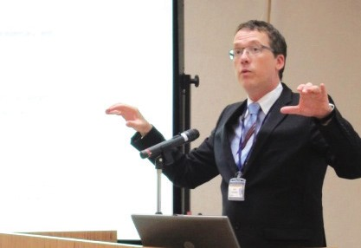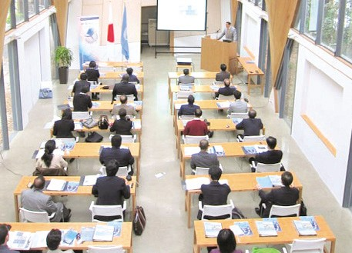
Source: KMI
Source: KMI

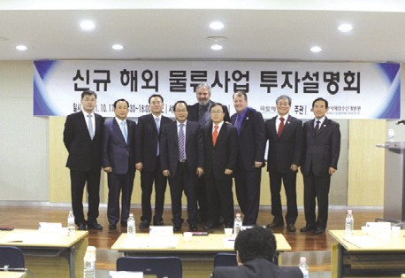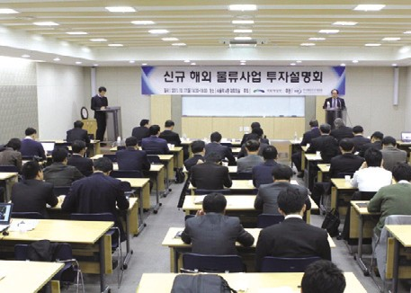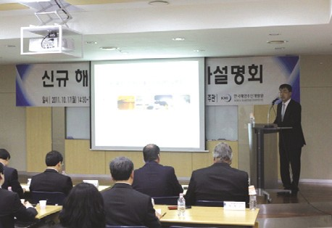2011 International Seminar on Development of GSCM & Cooperation of Northeast Pot Logistics
Source: KMI
Source: KMI
Source: KMI

- Time & place: October 21, Myungdong bank hall
- Hosted by KMI and sponsored by MLTM

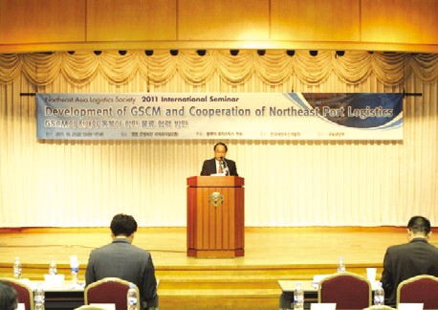Participation in the Natural Disaster Response Training & Education (by UNITAR)
Source: KMI

- Time & place: October 18~21, Tokyo, Japan
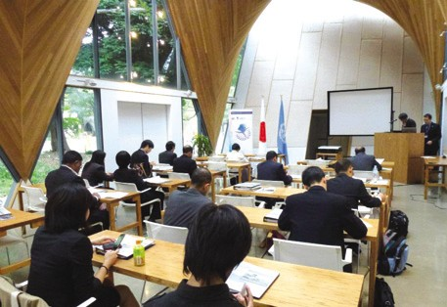
Source: KMI

- International Cooperation 21

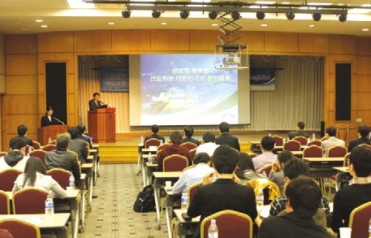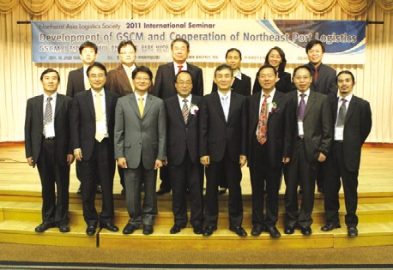2011 World Ocean Week Forum (Session IV)
Source: KMI
Source: KMI

- Time & place: November 4, Xiamen, China
- Presentation: Developing Economic Indicators of Korea's Marine Sector toward Improved Marine Planning (by Hwang, Kee-hyung)

The Workshop on the East Asia-Pacific Marine Policy Joint Research Project

- Time & place: November 4, Sea view Resort Xiamen, China

KMI-COMI Co-Workshop

The 3rd Annual Meeting of Marine Protection Zone Networks

  - Time & place: October 27~28, Suncheon, Jeonnam
  - Topics: Results of the 1st and 2nd annual meetings and operation of networks
  - Participants: YSLME, KMI and others

The World Ocean Forum: Smart Coast & Marine Environmental Industry (Session IV)

  - Time & place: October 28, BEXCO, Buan

KMI-ISL 2012 Global Shipping Outlook Conference

  - Time & place: November 2, KCCI
- Time & place: November 5, Xiamen University, China
- Topics: Benefit evaluation of integrated coastal management

Major Activities Conducted in October, 2011
06

News & Announcements

The 5th Shanghai Logistics Company Forum & Shanghai Company Briefing Session
- Time & place: October 4, China

The Final Briefing Session on Fishing Ground Standards for Eco-Friendly Management
- Time & place: October 4, National Fisheries Research Development Institute (NFRDI)
- Participants: Jung, Myong-saeng (research fellow, KMI)

The Fisheries CGE (Computable General Equilibrium) Model Seminar
- Time & place: October 7, KMI
- Participants: The Fisheries Policy Research Division

The Interim Briefing on the 2014 Wando International Seaweed Exposition
- Time & place: October 12, Wando County Office
- Participants: Lyu, Jung-gon (research fellow, KMI)

The Interim Briefing on the Effects of Fisheries Seeds Discharge
- Time & place: October 12, Novotel, Busan
- Participants: Kim, Dae-young (associate research fellow, KMI)

The Lecture on KR Education Program
- Time & place: October 14, KR conference room
- Program title: Green education-shipping industry and green growth
- Lecturer: Rim, Jong-kwan (director general, KMI)

The Interim Briefing on the Dohae Sea Food Industry Complex
- Time & place: October 17, Donghae City Hall
- Participants: Joon, Moon-bae and others (research fellow, KMI)

The Lecture at the Land & Maritime Affairs HRD Center
  - Time & place: October 17, Land & Maritime Affairs HRD Center
  - Lecturer: Hwang, Jin-hoi (shipping system) and Kim, Woo-ho (international shipping&logistics)

The Ocean & Logistics Shared Growth Seminar
  - Time & place: October 18, National Assembly Member’s Office
  - Topics: Measures for ocean & logistics industry’s shared growth

The Colloquium on Logistics Technology Commercialization Strategies
  - Time & place: October 20, KMI
  - Topics: Technology evaluation, technology prediction, case studies on technology transfer and strategies
  - Presentation: Choi, Han-rim (researcher, Korea Institute of S&T Evaluation and Planning) and Lee, Jae-il (president, Korea Technology Transfer Agents’ Association)

The 8th Ocean Policy Symposium
  - Time & place: October 25, the War Memorial of Korea
  - Topics: Development of the Korean transportation industry into a green industry
  - Presentation: Chun, Hyung-jin (associate research fellow, KMI)

2011 Jihae Maritime Scholarship Award
- Time & place: October 10 ~November
- Purpose: The scholarship was established to commemorate achievements of the late Park, Chun-ho (judge, International Tribunal for the Law of the Sea) and to encourage research in the field

Major Activities Planned in November, 2011

•The 5th term Ocean Promotion Group (operated by the Ocean Academy)
- Time & place: November 1, Zenise
- Topics: Marine exchanges in Northeast Asia
- Participants: Yun, Myung-chul (professor, Dongguk Univ.), ocean promotion group members and others

•The Policy Seminar on Fisheries Advancement and New Growth Driver Development
- Time & place: November 4, Kyoyuk Munhwa Hoekwan
- Hosted by: KMI and the Ministry for Food, Agriculture, Forestry and Fisheries
- Participants: Kim, Jung-bong (research fellow, KMI)

•The Renewal of MOU between KMI and Shanghai Maritime University
- Time & place: November 7, Shanghai Maritime University
- Participants: Kim, Hak-so (president, KMI) and Shin, Yong-tae (head, fisheries outlook center, KMI)

•2012 Yeosu Expo International Symposium
- Time & place: November 10, the ocean resort, Yeosu
- Topics: Ocean industry and vitalization of the local economy

•The Publication Commemoration of the Dokdo Dictionary
- Time & place: November 16, Seoul Plaza Hotel
- Participants: The Dokdo dictionary publication committee, relevant officials, KMI president and researchers

•The Maritime Territory International Seminar
- Time & place: November 16, Seoul Plaza Hotel
- Topics: Pending and future maritime issues of East Asia
- Presentation: Jose Luis Jesus (former president, ITLOS) and others
- Participants: Scholars at home and abroad

•2011 Busan International Seafood Exposition and Workshop (seafood traceability system)
- Time & place: November 16~18, BEXCO, Busan
- Hosted by: KMI and the Ministry for Food, Agriculture, Forestry and Fisheries
- Participants: Joo, Moon-bae (research fellow, KMI)

•The Asia-Pacific Security & Cooperation Council
- Time & place: November 20~23, Hanoi, Vietnam
- Topics: Territorial conflicts in the South China Sea and security in Asia
- Participants: Park, Young-gil and Lee, Hyun- gyung (researcher, KMI)

•The Inaugural Meeting and Seminar by the CEO Forum on Korea’s Fisheries Policies
- Time & place: November 25, Kyoyuk Munhwa Hoekwan (tentative)
- Participants: Kim, Jung-bong (research fellow, KMI)

- News & Announcements 25

Publisher
Kim, Hak So - President, Korea Maritime Institute

Editor-in-Chief
Kim, Jong Deog - Director General, Planning & Coordination Division

Editorial Board
Lim, Chin Soo - Director General, Ocean Knowledge Management Division Choi, Jae Sun - Director General, Global & Future Research Division
Rim, Jong Kwan - Director General, Maritime Industry Research Division Kim, Bum Jung - Director General, Port & Logistics Research Division Kim, Sung Gwi - Director General, Marine Policy Research Division Kim, Jung Bong - Director General, Fisheries Policy Research Division

Secretary
Kang, Myung Hee - Planning & Coordination Division Chung, Kyung Hwa - Planning & Coordination Division

Contact Information
Address: 21F KBS Media Center Bldg., #1652,
Sangam-dong, Mapo-gu, Seoul, 121-270, R.O. Korea Tel: +82-2-2105-2770, 2984
Fax: +82-2-2105-2730
Email: jdkim65@kmi.re.kr, myungheekang@kmi.re.kr

