ISSN 2093-3584

The KMI News Letter
Ocean & Future

August, 2014. Vol.53

- Opinion
  - The Growth and Future of the Arctic Council
  - Better to be Prepared: Global Big 3 are Poised to Build New Alliance
  - The Catch Document System Revision: Research is Necessary on International Trends and Responsive Measures
  - Kazakhstan Stands as an International Logistics Node, Linking Asia and Europe3

- Ocean Policy
  - The Revised Plan for Seamanguem Development aims to Boost Tourism and Leisure Industry

- Research Projects

- Research Findings
  - A Study on Policy Direction for Better Welfare of Fishermen in Super Aged Society

- KMI News & Events

The Growth and Future of the Arctic Council

In September 1989, Finland first initiated the eight Arctic countries to meet. Then the Arctic Council was established at the Ottawa Declaration (September 1996) with Arctic nations as its members. The permanent Secretariat was launched in Tromsø, Norway in January 2013 and became the organizing administrative system of the Council. The chairmanship rotates every two years among the Arctic member nations. The Council holds a ministerial level meeting every other year, a Senior Arctic Officials (SAO) meeting every six months and other various meetings for six working groups and four taskforces. Experts in each field, representatives from sectoral ministries and NGOs participate in the meetings and discuss a broad field of subjects related to the Arctic environment, including pollution, biological resources and climate change.

OPINION

As an intergovernmental forum that addresses Artic policies, the Arctic Council has increased its permanent participants and observers over the last 20 years in addition to the eight member states. There are six permanent participants, 12 permanent observer states and 20 non- governmental observers and international organizations. Observer states do not have the official right to speak or decide but may receive invitations to all council meetings. In addition, they can offer written suggestions and make discrete comments to the Chair. They have easy access to information relevant to major policies and decisions from the Arctic Council and can also indirectly express their position on them.

Based on the understanding that Arctic environmental problems are communal responsibility, the Arctic Council has discussed cooperation for environmental protection. The Council is taking new approaches from economic, social and cultural perspectives for sustainable use of Arctic natural resources and sustainable development in the Arctic. The Kiruna Declaration, the Arctic Council’s vision for the Artic, was adopted in Kiruna, Sweden, May 2013. The vision emphasized a peaceful, safe and prosperous Arctic. For that purpose, six working groups such as the Arctic Contaminants Action Program (ACAP), the Arctic Monitoring Assessment Program (AMAP), the Conservation of Arctic Flora and Fauna (CAFF), the Protection of Arctic Marine Environment (PAME), the Emergency Prevention, Preparedness and Response (EPPR) and Sustainable
Development Working Group (SDWG) share international cooperation knowledge and best practices and respond to the common problems based on mutual understanding and trust.

In addition to the Working Groups, the Arctic Council operates several Task Forces on specific issues. The current active Task Forces include the Task Force on Artic Marine Oil Pollution and Prevention (TFOPP), the Task Force on Black Carbon and Methane (TFBCM), the Task Force on Scientific Cooperation (SCTF) and the Task Force to Facilitate Circumpolar Business Forum (TFCBF). The goal of these Take Forces is to submit recommendations for the common issues and present them to the ministerial meetings. Therefore, the Task Forces draft the necessary documents for an agreement, including cooperation measures and implementation plans. Experts from the Working Groups, observer states and other organizations participate in the Task Forces and discuss operational problems involved in the implementation plans. They review local, national and international measures and address overlapping or incoherent issues through cooperation.

For example, the Arctic Council launched the Arctic Economic Council based on the Task Force to Facilitate Circumpolar Business Forum (TFCBF) last January. This is an effort to expand to new business areas for sustainable Arctic development. Its detailed role, scope and authority have yet to be decided but it will still play a role in bridging the Arctic Council and businesses as an independent organization. In close cooperation with the Arctic Council, the Arctic Economic Council will connect businesses, industries, member states and observer states and seek an economic development project for local and indigenous people in resource development, infrastructure, transportation
/logistics and tourism sectors. The first meeting of the Arctic Economic Council is slated to be held early September in Iqaluit, Canada. Canada and the US are known to have already appointed three respective representatives. Other member states are also quickly preparing their roles for the Council with high hope. As such, the Task Forces are doing the basic works necessary for the operation of the Arctic Council and building a response system for global issues. These works complete the essential projects and in particular, aid in building a paradigm on science and businesses. Establishing Task Forces are always possible,

therefore, Korea needs to review relevant Arctic issues and be prepared as a permanent observer state.

The Arctic Council became more than a forum for study or discussion and is developing itself into an organization with bigger responsibility over policies. The Council has been conducting various joint studies and projects as well as writing guidelines. The Ministerial meeting announces declarations constantly and prepares for relevant regulations for cooperative and peaceful decision making. However, the Council does not address issues that are unrelated to the Arctic environment, such as territorial claims or jurisdiction and military or security matters.

Resolutions adopted by the Arctic Council are rather symbolic and do not have binding forces. As a result, they have limited effects in managing sensitive problems. More
authority and executive force can make the Council an international organization in practice. Moreover, the Council should secure global cooperation in a genuine term if it wants to develop the Arctic into a venue for cooperation and address problems faced by mankind. Exchanges and cooperation with observer states and other relevant nations can enhance the understanding of the Arctic and mutual understanding. Based on this, the Arctic Council should exert its leadership and influence to the international society. One factor that is crystal clear: a sound future and value for humanity begins in our efforts of preserving the Arctic successfully.

Contact information Name: Choe Yung-sok
E-mail: yschoe@kmi.re.kr Tel: +82-2-2105-2992

Better to be Prepared: Global Big 3 are Poised to Build New Alliance

Global Top 3 companies in container ship market, such as Maersk, MSC and CMA-CGM once tried to establish an operational alliance. Called the P3 network, its goal is to maintain cost competitiveness over G6, CKYHE and other independent companies as well as to expand service scope. If the P3 had been launched, it would have dominated 41% of global container market and wielded its absolute dominance based on the scale of the economy. However, its 46.7% share in the European routes gave China an excuse to disprove the P3 and the project sank accordingly.

Many predicted that China’s disapproval of the P3 would relatively benefit G6 and CKYHE whose member included COSCO and Asian shipping companies. Since G6 and CKYHE constitute only 42.5% of the market share, they can enjoy their competitiveness within the antitrust law.

The disapproval sent stock prices of the Big 3 companies plunging as they became unable to cut back costs and improve profitability. In contrast, G6 and CKYHE plans to share more service offerings, sharpening their competitiveness. After the launch of the P3 was made public, G6 already expanded their alliance in the US West
coast and the Atlantic line. In similar move, CKYH included Evergreen to make their alliance bigger.

The foundering of the P3 network gave edge to G6 and CKYHE, forcing the Big 3 to seek new coalition methods within the boundary of antitrust laws. Chances are that they will re-apply for approval after constituting new service routes which do not violate antitrust regulations. This means that the Big 3 will focus on the North America- European route with the original plan. According to Drewry, they are likely to offer integrated service to Asia- North America and Asia-the Mediterranean (Sea), while providing partnership for Asia-North Europe, North Europe-the US and the Mediterranean-the US routes. In every aspect, China’s disapproval of the P3 network won’t prevent emergence of super large alliance.

After losing ways to improve their profit structure by cutting hundreds of million dollars in the short-term, the Big 3 will continue to seek different approaches for cost reduction. The Chinese disapproval of P3 service does not necessarily lead to less number of service routes or service times. Therefore, the three companies are expected to rearrange their service routes through bilateral or trilateral vessel sharing and slot exchanges on Asia-North

America route and Asia-Europe route.

In a nutshell, the P3 network of Big 3 stumbled but their new alliance is still valid. The Big 3 are likely to pursue new type of alliance which can expand and develop their partnership but elude antitrust regulations

On July 16, Maersk and MSC, the Global Big 2, sealed the Vessel Sharing Agreement for the next 10 years. This cooperation is called ‘2M.’ These 2Ms will start joint operation with 185 vessels on 21

routes, including Asia-Europe and Asia-North America. Maersk will deploy 55% or 110 vessels and MSC put in 45% or 75 vessels for the route.
With or without the P3 network, the Global Big 3 are already market leaders with strong cost competitiveness. Accordingly, their profits will be far higher than G6, CKYHE or other independent shipping companies. Although sinking of the P 3 network saved some time for national flag carriers to secure very large vessels and add service routes, they need to make their best efforts for higher cost competitiveness before the rate war begins.

Contact information Name: Chun Hyung-Jin E-mail: chun@kmi.re.kr Tel: +82-2-2105-2790

The Catch Document System Revision:
Research is Necessary on International Trends and Responsive Measures

Improvement was Agreed at the UN Fisheries Resolution.

Norway suggested that the FAO should initiate efforts to improve the catch documentation scheme and traceability including the Catch Document System of the EU1 at the 68th United Nations Informal Consultation Meeting on Sustainable Fisheries in 2013. Fisheries exporters mostly agreed with the idea and the suggestion was adopted at the meeting2. The idea is based on concerns that the Catch Document System helped to prevent IUU fishing but different catch documentation system of each region and nation rather act as unnecessary barriers in fisheries trade.

Moreover, majority of member countries agree with the Norway’s proposal at the 31st FAO COFI held from June 9 to 13, 2014. Accordingly, the FAO agreed to operate an expert workshop on the Catch Document System to develop improvement measures. This means that it shares understanding that the system can pose technical barriers against fisheries exporters thus the Catch Document
System should be standardized or shared. Norway argues for harmonization of various Catch Document Systems, taking an example of its electronic catch certificate.

Despite its large impact, preparation is not there.

However, Korea lacks both interest and responsive measures for the issue. The Korean government plans to discuss possible introduction of the electronic catch certificate but falls short of gathering necessary information, such as discussion details at EU and FAO as well as Norway’s proposal. Despite large impacts on domestic fisheries export, industry and policies, level of interest and preparation works are nascent.

To be precise, calls for better catch document system are not irrelevant to recent incidents where the EU and the US designated Korea as IUU fishing nations and asked for regulatory measures. Therefore, consultations with the FAO and Norway should come first before coming up with concreate plans or improvement measures.

1 According to the catch document system, fisheries exporters are required to reveal country of origin and fish type to import nations. 2 Refer to the 68th UN Fisheries Resolution OP 67 (A/68/L/19), p15
OP 67: Welcomes the ongoing work of the Food and Agriculture Organization of the United Nations on the development of best-practice guidelines for catch
documentation schemes and traceability, in accordance with its agreed terms of reference and framework principles;

Moreover, if the area of catch should be specified, inshore fishing activities can face difficulties in the long term. Therefore, studies need to be conducted both in the short term and long term. Since regulations on IUU fishing apply to fisheries exports and imports alike, short-run and long-run ramifications should be analyzed as well.

Urgently required: Analyses on latest trends and domestic institution and policies

On-going discussion and trends at the FAO, the EU and Norway requires constant analyses and research. Workshops with experts from those organizations are essential for systematic and accurate assessment and preparing responsive measures. At the same time, studies should highlight what kind of items will be added to the
revised catch document system, whether new catch document system will act as another kind of trade barrier or not and ramifications on domestic fisheries industry of the new system.

Domestic catch document system for fisheries exports are linked to detailed items of the EU’s catch document system. Therefore, the former is in need of revision or complementary regulations. Networks between industry, academia, research institute and government will go a long way towards preparing effective policies.

Contact Information Han, Deuk-hoon bansock1@naver.com
+82-2-2105-4957

Kazakhstan Stands as an International Logistics Node, Linking Asia and Europe3

Kazakhstan showing steady economic growth

Sharing its national boundary with China, Kirgizstan, Russia, Turkmenistan and Uzbekistan, Kazakhstan, a land locked nation with territory of 2.72 million km², functions as a transit node linking Asia and Europe. Its population has been increasing to 16 million, accompanied by continuous economic growth. Its main resources are crude oil (9th of the world, confirmed reserve of 39.8 billion bbl), natural gas (world 17th), zinc (world 3rd with 30 million ton reserve) and tungsten (world top), together with many other mineral resources such as uranium, silver, chrome, and manganese ore.

Thanks to such rich crude oil and mineral resources, Kazakhstan has achieved steady economic growth. GDP recorded US$ 196.4 billion in 2012 and per capita GDP (purchasing power parity) was estimated at US$ 14,100. Export stood at US$ 93.1 billion in 2012 and import reached US$ 47.9 billion. Major export items are oil and oil products, natural gas, mineral resources, chemical products, machinery, grains, wool, meat and coal, while
main import items include machinery and equipment, metal products and food stuff. Major export partners are China (21%), Russia (9.9%), France (9.3%), Germany (6.9%), Italy (5%), Canada (4.8%), Ukraine (4.7%), and Romania (4.1%), while major partners for import are Russia (31.6%), China (26.6%), Germany (6%) and Ukraine (4.4%).

However, Kazakhstan's economy faced economic recession due to a series of global financial crises and falling prices of raw materials in the late 2000s. Entering into 2010, its economy bounced back, showing steady growth of 7.5% largely thanks to continual price rises of raw materials. In order to reduce its dependence on natural resources, the government plans to promote other industries such as transport, pharmaceuticals, communi- cations, petro-chemicals and food. Korea established diplomatic relations with Kazakhstan in 1992 and bilateral relations have become ever closer with entering of the double tax avoidance agreement in 1997. Korea's export to Kazakhstan in 2010 was around US$ 600 million, while import was US$ 334 million. Main export

3 The title is derived from ‘the Report on Kazakstan’ in the Korea Logistics News (2013).

items of Korea are plastic products, machinery and equipment, vehicles, home electronic appliances, industrial electronics, agricultural products and steel products. Import items are non-iron metals, steel products, mineral fuel, precision chemicals, fertilizer, livestock and agricultural products (Korea Trade Association, 2012).

Kazakhstan plans to build an international multimodal transit hub

Kazakhstan's international multimodal transport channels are largely composed of railways, similar to other central Asian countries. The transport channels to North East Asian countries are divided into two, one with China and the other with Russia. These include the channel with China; a channel to Almaty from Lianyungang via Dostyk (Kazakhstan's boundary station); or another to Almaty through Alashankou (border station of China) and Dostyk from Tianjin; and lastly, the channel to Saryagash, Assake from Lianyungang via Dostyk.

The following shows operations of container trains by transit channel as of 2010. Lianyungang- Dostyk-Almaty route had 1,237 schedules, two times higher than 576 of 2007. A newly scheduled route of Lianyungang-Dostyk- Astana operated 104 schedules (Korea Trade Association 2011). On the other hand, an international multimodal transport channel, Lianyungang-Dostyk-Astana-Ozinki- Moscow increased remarkably to 52 schedules from 3 in 2007. Another channel, Lianyungang-Dostyk-Asaka (Uzbekistan) operated 13 schedules.

The border station Dostyk is directly connected to the trading partner's railways as a gateway to facilitate transshipment between trains of central Asian railways and Chinese railways. The transit channel Kartaly (border station of Russia)-Tobol (border station of Kazakhstan) is used between Kazakhstan and Europe, and also used as a transit channel between East Asian countries including China and Europe. Railways of Kazakhstan are operated by Keden Trans Service, Kaz Trans Service, Trans System, East Com Trans and Kaz Inter Freight. Main railways network promoted by the government of Kazakhstan are, above all, to improve the logistics network system with Russia through the railways lines, such as Petropavlovsk - Kokshetau - Astana - Mointy - Actogai – Dostyk. Other
plans to improve logistics efficiency with neighboring countries are 1) Shengeldy - Arya - Lugovya - Shu - Almaty - Aktogai - Dostyk, 2) Ozinki - Uralska - Aktobe - Kandyagash - Arys - Shengeldy, 3) Aksaraiskaya - Aryau - Makat - Beyneu - Aktau- boundary station of Turkmenistan,
- Omsk (Russia) - Pavlodar - Semipalatinsk – Maikapchagai (boundary station of China), 5) Astana - Kostanai – Chelyabinsk (Russia) – Ekaterinburg (Russia).

Implications

Strategic efforts to build an international multimodal transit hub will help Kazakhstan play a role as a logistics hub linking China and Europe via central Asian countries, bringing about trade boost to the country. Expansion plans of railways network and roads now to be implemented by the government of Kazakhstan will contribute significantly to its functioning as an international logistics hub among central Asian countries, while providing stimulus to trade between Asia and Europe.

Contact information Name: Park, Yong-An
E-mail: yapark@kmi.re.kr Tel: +82-2-2105-2789

The Revised Plan for Seamanguem Development aims to Boost Tourism and Leisure Industry

A public hearing on the revised ‘master plan’ for the Seamanguem development project was held on July 22, 2014. Aiming to attract investment for pilot development projects on borderless economic cooperation, the revised plan focuses on establishing tourist destinations and leisure cities as well as economic special zones. In particular, flexible use of lands is highlighted, which suggests basic directions for six divisions, including Tourism-Leisure Lands, without specific locations and sizes for each division.

Under the current land use policy in Korea, it is hard to change purpose and size of land once they are set. In this regard, the revised plan intends to offer incentives for businesses when they attract private and foreign investment. The revised bill known as ‘the Implementation Ordinance of the Special Law on the Saemanguem Project’ was pre- announced on July 3. The bill underscores two aspects. First, it expands the scope of project operators to include private companies at home and abroad. So far, the scope was limited to local governments and domestic investors. Second, repealing the current principles on land supply regulations, it allows the project operator to resell up to 50% of the developed part of raw land to others.

Such a move will be accelerated by the development plan of a Joint Korea-China Economic Zone in Seamanguem, which was agreed at the Korea-China Leaders’ Summit held on July 3, 2014 in Seoul. The Joint Economic Zone (tentatively named the Saemanguem China Valley) was initially drafted at the Leaders’ Summit in June 2013 in China and its co-development reached a consensus at the Korea-China Finance Ministers’ Meeting in December 2013. Both sides had director-general level discussions on detailed policies to support this project last June. The Saemanguem Development Agency will continue such discussions with the Chinese government until December of this year.

Meanwhile, the Korean government plans to develop marine tourism sector within the Saemanguem China Valley, targeting Chinese visitors. This is in accordance with a policy objective that utilizes marine resources more pro-actively and activates international economic
cooperation based on maritime sector.

In correspondence to such policy objective, the Saemangeum area has been arranging advantageous conditions for marine leisure activities. For instance, the Gogunsan islands area which features its superb natural landscape and close proximity to China was selected for development as one of six marinas capable of handling at least 300 boats by 2017 under the Marina Basic Plan of the Ministry of Oceans and Fisheries. The Ministry had accepted project applications by private companies until July 18. The chosen private developer will be announced in September and begin construction next year. ‘Fosterage of marina industry’ is one of the 140 tasks of the Park Guen-hye administration. Amid growing demands for maritime leisure activities and corresponding measures of the government, development of the Saemanguem area is now in sight.

Contact Information
Yoon In-Joo mouthpiece@kmi.re.kr
+82-01-2105-2929

  - 2013 increase and restoration of marine life under
protection
  - Results of 2014 Wando International Seaweed Expo
  - Management plan per waters for environmental
management
  - A study on 2nd costal development plan (revised)
  - A study on maritime and fisheries ODA intl.conference
  - A study on conservation of 2013 marine life under
protection
  - A validity study on 7 terminal development (74 berths)
at Gunsan port
  - Port redevelopment at dredged soil landfill at Myodo,
Gwangyang port
  - Case studies on city planning against coastal erosion
and maintenance direction
  - Development of unified cargo handling equipment for
less time consumption of cargo vehicles
  - Functional relocation of Incheon port and employment
of dock workers
  - 3-1 stage project on shipping market network construction
  - A validity study on North Sea Wall construction
(Donghae port 3 stage project)
  - Strategies and tasks for Ulju ocean industry development
  - Basic design for marina port base: utilization of marina
port for marine tourism
  - Impacts of Korea-Australia, Korea-Canada and Korea-
New Zealand FTAs
  - Coastal water in-depth investigation (basic research for
systematic management of coastal line)
  - Improvement measures for port modernization fund
operation system
  - Domestic supplementary measures for fisheries FTAs
  - Institutional improvements to vitalize marine leisure
activities
  - Estimation of adequate investment in port infrastructure
and policy direction
  - Comprehensive plan on marina port development in
Choongchungnamdo
  - A study on improvement and promotion of towage system
  - A study on maritime and fisheries future vision establish-
ment
  - A study to promote cooperative relation among Northeast
Asian ports
  - An estimation of social costs of maritime accidents
  - Development of EBSA national report on biodiversity
convention
  - Impacts of radioactivity on fisheries and radio activity
pollution cases
- A survey on promising fisheries export items to China
- Implementation plans for 'Beautiful Busan Port'
- Pilot supply and demand forecast under changing
environment and institutional improvements
- An In-depth analysis on responsive measures prepared
for TPP participation
- Strategies to enter logistics market in Northeast China:
based on China-North Korea cooperation
- A study on definition and scope of fishing villages for
comprehensive fishing village development
- Global network building to strengthen maritime
territory, incl continental shelf
- Improvement on strategic environmental effect
evaluation system
- Polar sea utilization measures through analyses on
major nations' arctic policies
- Special categorization of fisheries industry and statistics
analysis
- A study on Eurasia intermodal transportation/logistics
networks building
- Follow-up measures for Arctic Policy Master Plan
- A study on environmental standard establishment for
each water
- 2014 analysis on actual condition of beaches and manage-
ment types
- 2014 implementation of total pollution load management
system on the Masan Bay special management water
- 2014 Yeosu International Academy Project
- A validity analysis on Boryong multifunctional develop-
ment and basic plan
- Pilot projects on fisheries observation
- Fisheries export market development before Korea-
China FTA
- Regional model development for access to biological
resources and benefit sharing
- A study on abalone processing industry and processed
products
- 2014 operation of international logistics analysis center
- Preparation for bilateral and multilateral shipping
service negotiation, incl. Korea-China FTA
- A consulting project on 2014 Ongjin-gun Fisheries
Mutual Logistics
- Development of marine safety index and validity of
hands-on experience facilities
- National contest on knowledge sharing for fishermen
- A validity study on international cruise tourism and
master plan establishment

  - Operation of private-government-industry-university
conference at Ulsan coast and the Gwangyang Bay
  - Provision of the Regional Study on Efficient and Effective
Logistics Information System for the UNESCAP
  - 2014 Entrusted operation of shipping demand prediction
center
  - The 1st study on unification preparation (shipping industry)
  - Certification of good logistics warehouses in port area
  - 2014 national transportation surveys and DB establishment
  - 2014 consigned operation of shipping, port logistics
information center homepage
  - Development of national fishing ground usage models
and present condition investigation
  - Integrated export certification and national brand
development
  - Coastal basic analysis
  - Impacts of Korea-China-Japan FTAs on fisheries sector
and responsive measures
  - Strategies for Arctic Ocean and Fareast Russia logistics
linkage
  - An analysis on SOI of convention on biological diversity
  - A review on total port load system and economic
validity of new target ports
  - A review on economic validity and financial soundness
of port logistics (Philippines port development)
  - Exploration of 2014 maritime and fisheries ODA projects
  - A study on international cooperation and overseas
advancement to address coastal disasters
- Designation and management of coastal erosion
management zone
- Technology development for low carbon automation
container terminals
- Policy development to utilize offshore geological storage
of CO2
- Measures for the 4th fisheries development comprehensive
plans
- Technology development prepared for coastal erosion
(2nd year)
- Advancement into shipping and logistics market in the
Black Sea
- Operation measures for changes rates for container
cargo handling
- Korea-China FTA domestic supplementary measures
- Development of fishing villages into the 6th industry
(direction and models)
- Entrance plan into shipping and logistics market of
Russia Fareast
- Follow-up measures for coastal passenger ship safety
management innovation
- LNG bunkering supportive ports development measures
- A study on more distribution of small and medium-
sized LNG ships
- A basic Plan on Myanmar port development and its
validity
- A study on expansion of aquaculture insurance items
- Competitiveness analyses of individual fish stock
prepared for Korea-China FTA concession plans

RESEARCH FINDINGS

A Study on Policy Direction for Better Welfare of Fishermen in
Super Aged Society
1. Purpose
tailored welfare for the benefit of fishermen and fishing
community.
- The study examined welfare state of those in fishing
community as society becomes super aged society. – In line with national welfare policies, the study After analyses on problems of the current system and aimed to address welfare grey areas by implementing improvement measures, it presented policy direction for welfare policies customized for fishermen and fishing

community.
– Welfare demand has increased due to market opening, aging, depopulation, deepening income disparity, increasing poor class and other socio-economic changes at home and abroad. The study also intended to set up direction of customized welfare policies of the Ministry of Oceans and Fisheries.

Methodologies and Feature

Methodologies

  - To analyze actual condition of vulnerability of fishermen and fishing community such as old-age quotient, income inequality and poverty rates.

  - To examine cases of Korean farmers, farming community, Japanese projects of fishermen and fishing community welfare policy division

  - To conduct surveys and interviews on fishermen welfare,
and hold expert advisory meetings

Feature

  - The study analyzed demographical aspects of fishing community to prepare tailored welfare policy direction. It firstly scrutinized aging and depopulation, income inequality and poverty status and revealed serious weakness of fishing community.

Moreover, it conducted analyses on fishermen’s welfare according to 7 sectors and suggested welfare policies suited for fishermen and fishing community based on the results.

Results

Summary

  - Fishing community already entered super-aged society and showed big income disparities compared to cities. Income inequality level stood higher than the national average, implying serious gap between the rich and poor. The number of poor people who live below the minimum cost of living has continued to increase.
- Problems in welfare delivery system created welfare grey areas. Legal plans which reflect welfare of fishermen and fishing community are not in place while current welfare system and policies have their own problems.

- According to the firstly conducted survey on welfare of fishermen and fishing community, overall satisfaction level of welfare remained very low. In particular, women and infant/toddler welfare area registered low satisfaction, while those aged below 50 and island areas showed higher dissatisfaction level.

- The four policy directions for better welfare of fishermen and fishing community are; tailored welfare, welfare for everyday life, resolution of welfare grey areas and good welfare administration system.

Policy contribution

- The study can be used as basic materials in setting policy direction for welfare and quality of life for fishermen and fishing community.

Expected benefits

- The study will practically contribute to improving
quality of life of fishermen and fishing community.

– Tailored welfare policies will address welfare grey areas. But the vulnerable, such as the aged, women, multicultural families and those in island areas, require more careful welfare policies.

- The study will help to improve the welfare delivery
system and to establish effective welfare governance.

– The study will help to build effective delivery system based on cooperation with other ministries and other relevant organizations. It will also contribute to building welfare and administrative system of the newly launched Ministry of Oceans and Fisheries.

Contact Information
Choi Sung-ae sachoe@kmi.re.kr
+82-01-2105-2865

Major Activities conducted in June, 2014 Major Activities conducted in July, 2014

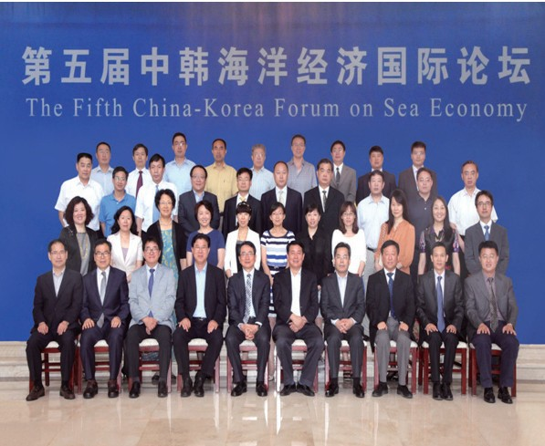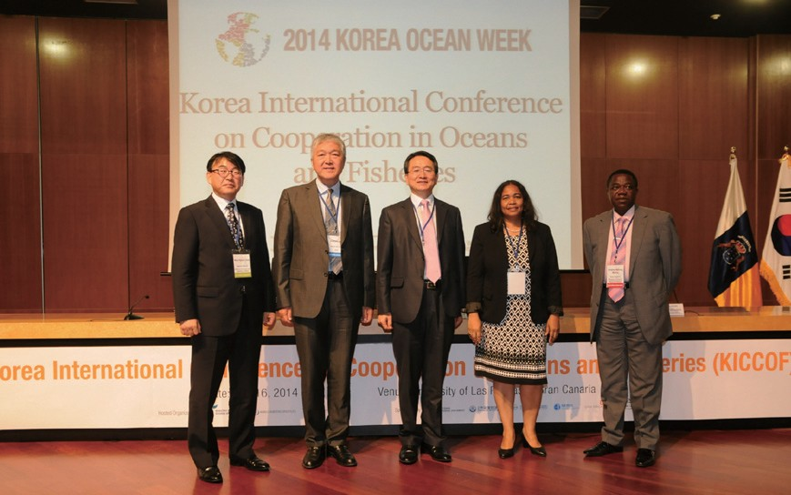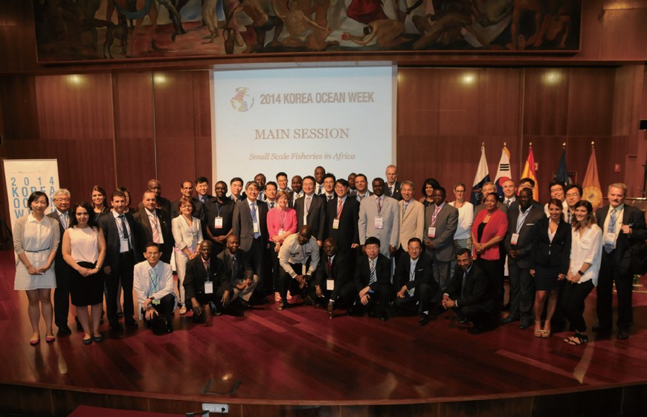2014 China Logistics Forum

- Time & Place: June 22, Dandong, China
- Topics: New economic and logistics network building in the East Sea Rim, based on cooperation of Northeast Asia

The 5th Korea-China International Forum on Maritime Economics
- Time & Place: June 12, Sandong Academy of Social Sciences, China
- Topics: Korea-China cooperation measures for mutual growth of maritime economics

2014 Bergen Conference

- Time & Place: June 25~28, Bergen, Norway
- Topics: An annual international conference on maritime law held by the Centers for Oceans Law and Policy (University of Virginia)

2014 KOREA OCEAN WEEK

- Time & Place: July 16~17, University of Las Palmas, Casa Africa

Global Ocean Leaders Forum
  - Topic: Cooperation to follow the international fisheries norms (IUU and aquaculture)

The launch of the Borderless Fish Farm

- KICCOF
  - Topic: Sustainable development of marine and fisheries sector in West Africa

KORAFF
  - Topic: Small scale fishing activities in Africa

The 1stKorea-Spain Ocean Forum
  - Topic: Maritime and fisheries cooperation measures between Korea and Spain

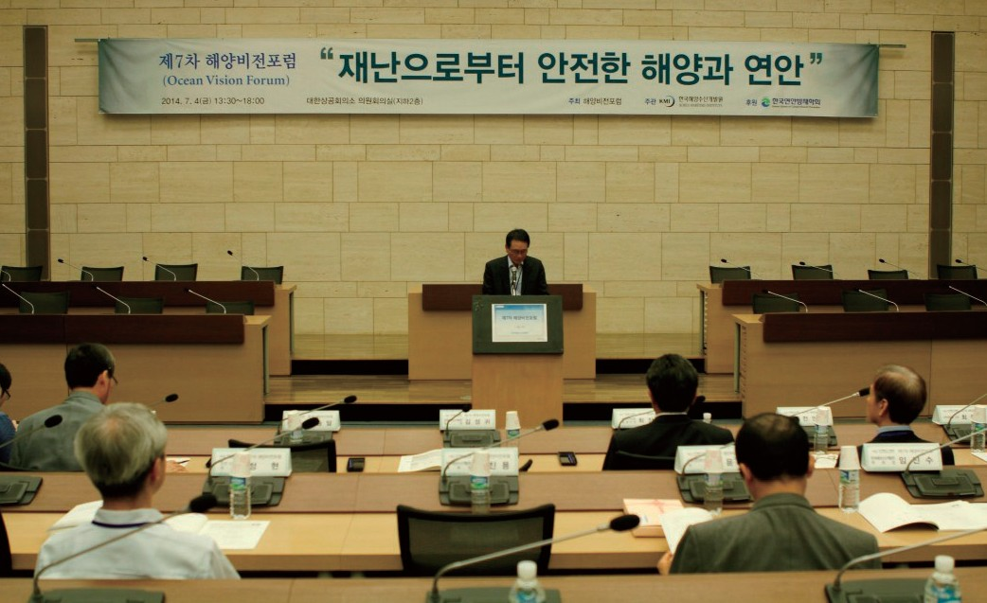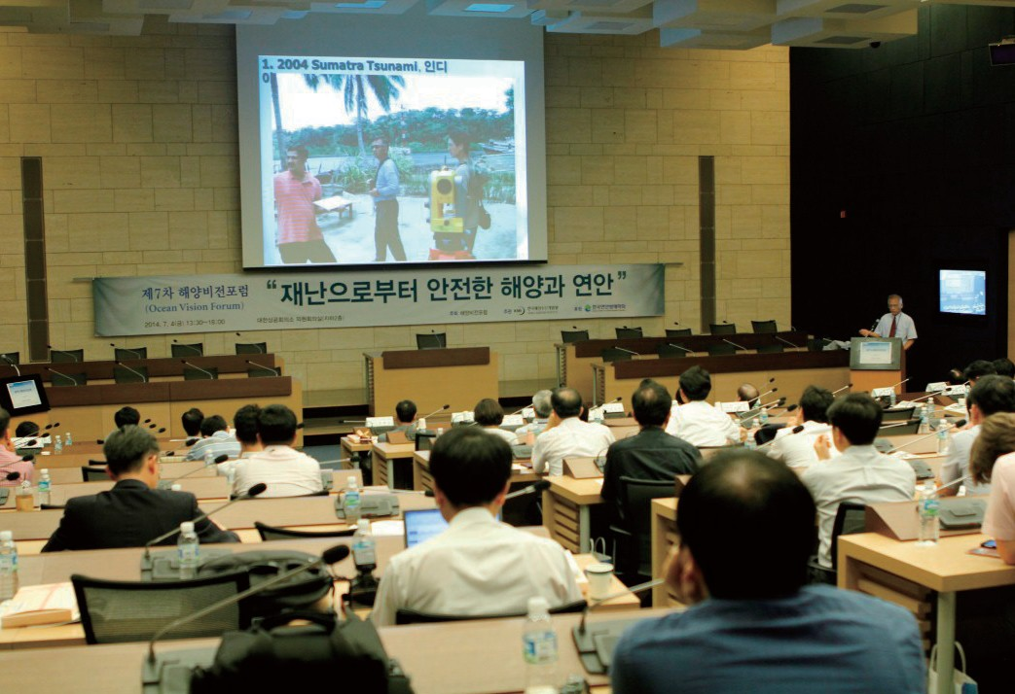

The 7th Ocean Vision Forum

    - Time & Place: July 4, Korcham
    - Topics: Ocean and coast safe from disasters

Major Activities planned in August, 2014

Lecture at the Asia-Africa Female College Students Training
    - Time & Place: July 4, Korcham

The North Pacific Arctic Conference (NPAC)

    - Time & Place: August 20~22, Honolulu, Hawaii
    - Topics: Cooperation measures to be discussed among North Pacific coastal states
    - Participants: Kim Sung-gwi (president, KMI), Kim Jong-Deog (director general, Strategy Research Div.), Lee Sung-woo (director, KMI) and Choi Anna Jane (KMI)

Korea-Kenya-ITLOS Joint Seminar on the Law of the Sea

- Time & Place: August 7~8, Nairobi, Kenya
- Jointly hosted by: Embassy of the Republic of Korea in the Republic of Kenya, Keyan Ministry for Foreign Affairs, the International Tribunal on the Law of the Sea (ITLOS) and the Korea Maritime Institute (KMI)
- Topics: “Enhancing Mutual Understanding and Cooperation through the Law of the Sea Convention”
- Participants: Mr. Philippe Gautier (Registrar of the ITLOS), Judges of the ITLOS, Professor Lee Geun- gwan (Seoul National University), Lee Seok-woo (Inha University), Professor Ronan Long (School of Law, National University of Ireland Galway) and Professor Aref Fakhry (World Maritime University)

Publisher
Kim, Sung Gwi - President, Korea Maritime Institute

Editor-in-Chief
Choi, Jae Sun - Director General, Planning & Coordination Division

Editorial Board
Mok, Jin Yong - Director General, Marine Policy Research Division
Joung, Myung Saeng - Director General, Fisheries Policy Research Division Kim, Woo Ho - Director General, Maritime Industry & Safety Research Division Jun, Chan Young - Director General, Port Research Division
Kim, Jong Deog - Director General, Strategy Research Division

Secretary
Song, Wonkeun - Planning & Coordination Division Chung, Kyung Hwa - Planning & Coordination Division

Contact Information
Address: 21F KBS Media Center Bldg., #45, Maebongsanro, Mapo-gu, Seoul, 121-915, Korea
Tel: +82-2-2105-2700
Fax: +82-2-2105-2800
Email: jschoi@kmi.re.kr, wksong7@kmi.re.kr

