ISSN 2093-3584

The KMI News Letter
Ocean & Future

MAY-JUNE 2015. Vol.62

- Opinion

The Need to Establish Life Cycle Management System for Waste Styrofoam buoys
  - Future Vision of Maritime and Fisheries Sector and Public Diplomacy

- Ocean Policy

Promotion of Maritime Special Economic Zone and Ocean industry

- Research Findings

Measures to vitalize shipping finance by improving the role of the capital market

- Research Projects

- KMI News & Events

The Need to Establish Life Cycle Management System for Waste Styrofoam buoys

The discovery of Great pacific Garbage Patch has made the plastic waste entering into the ocean emerge as a serious global concern. The plastic waste traveling on ocean cur- rents and winds are accumulated at the sea around Hawaii, Pacific Ocean, having a significant impact on marine ecosystem. The United Nations announced that the esti- mated damage on marine ecosystem reached to US 13 bil- lion in 2014, strongly calling for international collaboration against this challenge. In a global eﬀort to prevent plastic waste from entering into the ocean, the UN Environment Assembly held in July last year suggested introducing ‘Plas- tic Footprint’ system. As such, the attention and concerned voices over plastic waste is increasing on the global scale.
South Korea produced 77,880 tons of plastic waste as of 2013 which accounted for 85.4% of the total waste en- tering into the ocean (91,195 tons). From this number, the plastic waste generated in the ocean such as derelict fishing gear, waste ropes and waste Styrofoam is estimated to reach 80% of the total marine waste (58,370 tons). All the plastic waste flown into the ocean via rivers and streams are man- aged through extended producer responsibility (ERP) car- ried out by the Ministry of Environment. The ERP is a waste management policy aimed at reducing the amount of plas- tic waste in the first place. Under the system, manufacturers are responsible for taking back 80% of their plastic products including packing materials from end users and recycling. On the other hand, derelict fishing gear, fishing nets and aquaculture waste Styrofoam are left in the ocean and col- lected after the use. While abandoned fishing gear and fish- ing nets are properly managed by the existing marine waste collection system, management of the waste Styrofoam is left in the blind spot.
It is relatively easy to collect derelict fishing gear and fishing nets after the use since they are piled up under the ocean. However, the same approach is not eﬀective to waste Styrofoam buoys because they are left unattended on land or broken into pieces and stacked up on the beach after traveling long distances. The neglected waste Styrofoam has negative impacts on local tourism industry, navigation safety and fishing industry. In addition, there have been many reliable reports of environmental damage and human health impacts when micro plastics have been ingested by the fish and transmitted by food chain. Considering these issues, policy direction for managing waste Styrofoam
buoys should be a preventive strategy by collecting the waste in advance before entering into the ocean
In order to resolve various issues arising from the waste Styrofoam buoys, it is necessary to establish a life cycle management system for Styrofoam covering from produc- tion, use, collection and recycling. Above all, investment on developing environmentally friendly buoys should be con- tinued to replace Styrofoam buoys which can be easily bro- ken into pieces. Environmentally friendly buoys have high unit cost. Therefore, it is necessary to implement the strat- egy of phasing out the existing Styrofoam buoys and in- creasing the use of eco-friendly buoys. At the same time, we need to come up with measures that can attract the co- operation of fishermen, the user of the buoys. Also, it is im- portant to prepare measures to collect the estimated 52 million Styrofoam buoys currently in use before the use of environmentally friendly buoys becomes mandatory. Si- multaneously, the measure to collect wasted environmen- tally friendly buoys should be established after the products are distributed. Relevant authorities should build a life cycle management system for Styrofoam, establishing an organic cooperation system. In this way, the distribution of envi- ronmentally friendly buoys, collection of existing Styro- foam ones and recycling of waste Styrofoam are actively carried out in the field.
The Korean government should actively respond to the marine plastic waste issue which has recently emerged as a global concern. While the government needs to continu- ously manage the plastic waste flown from the land to the ocean, it should concentrate its capacity to resolve marine waste Styrofoam which has not been properly managed so far. Since the government has started to distribute environ- mentally friendly buoys from this year, a follow-up measure to link the existing waste Styrofoam to the collection and recycling business needs be established. As the issue of Sty- rofoam buoys should be resolved from the perspective of marine environment management, it is a prerequisite to es- tablish a comprehensive response system covering from production, use, collection and recycling of the Styrofoam buoys.

Contact Information Kim, Kyung-Shin et al. kskim@kmi.re.kr

Future Vision of Maritime and Fisheries Sector and Public Diplomacy

Marking the 20th Ocean Day, the Ministry of Oceans and Fisheries (MOF) held a ceremony on May 29 to raise public awareness on the importance of ocean and maritime industry and bolster the pride of those engaging in the sector. At the cer- emony, Minister Yoo Ki-June announced ‘2030 Future Vision of Maritime and Fisheries’ which encapsulates the future direc- tion of maritime and fisheries policies. Under the vision of ‘cre- ating ocean beyond imagination’, the government aims to increase maritime and fisheries GDP ratio to 10% in 2030 from the current 6%. With rapidly changing global environment, the MOF is paying an attention to the value and potential of the ocean, presenting a new vision to maximize its use. As part of the plan to make Korea a maritime power, the MOF announced action plans to turn traditional industries such as shipbuilding, shipping and ports and fisheries into high value added indus- tries and to strategically develop new ocean industries like ocean energy, biotechnology and marine tourism.

The purpose of ‘2030 Future Vision’ is to achieve ocean of happiness and prosperity, ocean with challenge and creativity and ocean of peace and co-existence. As Korea needs to coop- erate in the global society, such eﬀorts will help the country take a leading role in addressing international maritime issues and pass down safer ocean to next generations. As the competition surrounding maritime territory and resource becomes fierce, close partnership with neighboring countries is essential to de- liver joint development and benefits through ocean. As a re- sponsible leader, Korea needs to concentrate on laying the groundwork for stability and mutual prosperity and minimiz- ing negative impact and damage from maritime conflicts. In this respect, mutual understanding, personnel exchange and education are essential to raise public awareness on territorial conflicts, illegal fishing and marine environmental pollution and to build a cooperation system with related countries.

Korea should use public diplomacy for taking a leading role in addressing international maritime issues, contributing to the peace in East Asia and developing maritime regime in the fu- ture. Through public diplomacy, Korea can resolve potential maritime issues and prevent conflicts by directly communicat- ing with neighboring countries and the international commu- nity. For Korea, it is important to raise mutual understanding and broaden the consensus to jointly response to new chal- lenges on marine environment and help establish peace in Northeast Asia. These eﬀorts require changes in attitudes and
knowledge sharing on maritime issues and environmental changes. Raising public awareness on maritime issues and un- derstanding them can be achieved based on a systematic mar- itime education and policy programs. Public diplomacy represents a various kind of foreign exchanges other than gov- ernment diplomacy. It includes a wide range of private sectors such as NGO, media, university, research institute and business. With private diplomacy playing a central role, the public diplo- macy can be used through exchanges with foreign opinion leaders, expert groups and social media. Moreover, the public diplomacy includes education and PR activities on nationals, being considered as a strong tool for soft power.

Also, the communication between the public and the gov- ernment should be strengthened regarding maritime conflicts and related issues to enhance the status and role of Korea as a middle power. Such eﬀorts will also draw understanding and support from the international society and expand the role in the maritime sector. With the right knowledge and understand- ing, we should attract cooperation and interest. In this regard, it is important to contribute to maritime development and mu- tual benefits with developing countries based on exchange of human resources and oﬃcial development assistance (ODA) and organically respond to trans-boundary maritime issues. Korea should implement regional cooperation projects in order to secure leadership of maritime and fisheries sector in East Asia. By playing a central role in regional cooperation, we should achieve ‘2030 Future Vision of Maritime and Fisheries’ and improve the capability in ‘maritime soft power’. At the same time, Korea should use public diplomacy related to interna- tional maritime issues. Continuous eﬀorts should also be made to promote mutual development on maritime issues and build eﬃcient and systematic measures to implement multilateral public diplomacy on maritime sector. In addition, it is necessary to pay a consistent attention to the governance and policy struc- ture related to maritime public diplomacy. By doing so, Korea will be able to draw a strategy with improved practicality and eﬀectiveness and achieve the 2030 future vision based on a bet- ter cooperation. These eﬀorts will be a stepping stone to estab- lish a future oriented global consensus and to attract joint eﬀorts on maritime issues.

Contact information Yungsok Choe yschoe@kmi.re.kr

Promotion of Maritime Special Economic Zone and Ocean industry

Maritime Special Economic Zone and Ocean Industry

‘Maritime Special Economic Zone’ is areas in which ocean industries are attracted to idle port facilities to build and activate industrial clusters. By doing so, it aims to fa- cilitate aggregation, integration and convergence of ocean industries and support technological development to vi- talize regional economy and further strengthen national competitiveness. Currently, the act related to maritime spe- cial economic zone is in the process of legislation at the National Assembly. In order to understand the maritime special economic zone and diﬀerentiate it from other spe- cial zones, it is a prerequisite to understand the meaning of the ocean industry. However, defining the ocean indus- try is challenging. This is particularly true for the ocean industry since it is a specialized industry in which all in- dustries are integrated and converged. In South Korea, Framework Act on Marine Fishery Development stipulates the ocean industry in article 3, subparagraph 3 as follows: The term ‘ocean industry’ means the industries related to the maritime transportation, harbor, fishery, development of marine science and technology, marine environment, marine tourism, and marine information, and other indus- tries related to the management, preservation, develop- ment or utilization of the sea and marine resources. Overseas countries take a comprehensive perspective on the term by defining it as industries carrying out ocean re- lated activities. For instance, the ocean industry is defined as the portion of the economy which relies on the ocean as an input to the production processes (NOEP, USA) or activities that create added values from marine environ- ment (Allen Consulting Group, Australia). In other words, the definition of ocean industry is a combination of spatial concept of ‘ocean’ and general concept of ‘industry’. Based on the definitions and categorization of foreign countries (the United States, Britain, France and the EU etc.), Korea’s ocean industry can be divided into 9 categories and 42 sub- industries. Those 9 categories include ocean construction, fishery, ocean mining, shipbuilding, ocean tourism, ocean transportation, ocean equipment, R&D and new renewable energy.

The necessity of clustering the ocean industry

Korea’s ocean industry is not generating high ratio of added value due to the depression of traditional industry such as shipping, ports and shipbuilding and lack of key technologies to strengthen ocean equipment industry. Moreover, KRW 18 trillion of the revenue created from oﬀ- shore industry has been flowing into overseas. On the other hand, comparable countries with Korea such as Norway, Netherland, Britain and Ireland are striving to enhance the competitiveness of the ocean industry. Those countries are selecting and concentrating a specific sector, building var- ious types of clusters and improving added value ratio of the ocean industry. For example, Norway started to estab- lish clusters for ocean industry in 2004, leading to raise added value ratio (33.0% in 2004 ⇒ 35.1% in 2012). While the country has expanded the size of the ocean industry, the clusters have developed centering on ocean equipment industry. Britain aims to grow the ocean industry from GBP 17 billion in 2003 to GBP 25 billion in 2020. Under this tar- get, the country has built industrial clusters in 3 sectors; maritime, recreation and tourism, and fisheries. The gov- ernment and related organizations are discussing develop- ment measures and regulation improvements.1)

Ireland is also planning to establish a maritime cluster at Cork harbor as a way to develop marine and energy economy and create more jobs.2)
Changes in Added Value Ratio of Ocean Economy
36%
35%
35%
34%
35.1%

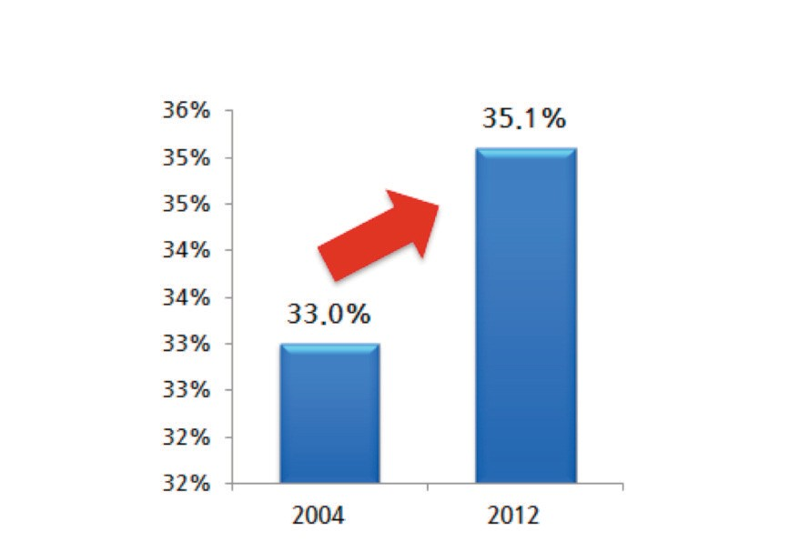
- Policy Research Corporation, “The role of Maritime Clusters to enhance the strength and development of maritime sectors, Country Report-UK”, 2008; Patrick Carnie, “UK Marine Industries Alliance, A strategy for growth for the UK Marine Industries”, 2011; UK Marine Industries Alliance, “UK Marine Industries Growth”, 2014
34%
33.0%
33%
33%
32%
32%
2004 2012
- UCC, CIT, Naval Service, “IMERC Strategy 2011~2016”, 2011

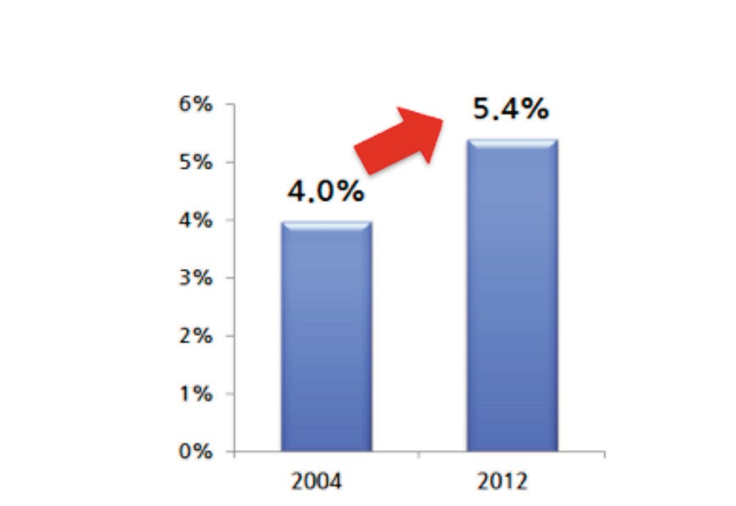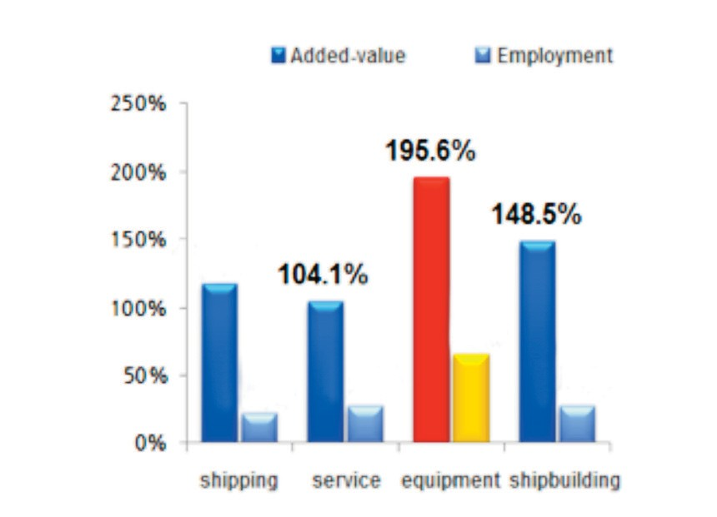
culture and marine biotechnology. Furthermore, the eco- nomic implication of ocean industry is much larger than that of other industries. In the United States, the employ- ment to GDP ratio of the ocean industry is 1.93, which is higher than tourism (1.86) and semiconductor (1.04). Also, value added inducement coeﬃcient of the ocean industry is 2.48, larger than manufacturing (1.47) and tourism (1.6). The employment to GDP ratio of Britain’s ocean industry also shows 2.58, which is higher than manufacturing (1.62) and tourism (1.61). As a result, the ocean industry has a huge growth potential in the future with larger implication to the economy. Therefore, it is necessary for the govern- ment to drive the development of the ocean industry in order to create jobs and secure next growth engine for the economy. The government should lay the groundwork for securing key technologies with high added value. Since Korea is a second mover, the government also needs to es- tablish a systematic framework to provide incentives cus- tomized to our environment.
148.5%
Changes in GDP Proportion of Ocean Economy
6%
5.4%
5%
4.0%
4%

3%

2%

1%

0%
2004
2012
Growth Pattern of Ocean Economy
Added-value
Empoloyment
250%
195.6%
200%
150%
Contact information
Kiyoul Lee kylee@kmi.re.kr
50%
21.7%
27.4%
27.4%
0%
117.5% 104.1%
100%
65.6%

shipping service equipment shipbuilding

<Impact of ocean industry cluster in Norway>3)

Establishing measures for developing ocean industry

Most foreign countries with high ratio of added value in ocean industry are strengthening technological capability by integrating related businesses supported by the govern- ment. However, Korea’s ocean industry, despite similar size, has ended up generating low ratio of added value due to lackluster traditional ocean industries and lack of techno- logical capabilities. The EU carried out a research4) for se- lecting 7 new emerging industries as part of the policy to build a world-class cluster within the union. In the result, the ocean industry was selected as a new emerging industry along with oﬀshore plant, ocean tourism‧recreation, aqua-

- Statistics Norway, Maritimt forum,“Maritim Verdiskapingsbok”, 2014
- PwC, “Emerging industries”: report on the methodology for their classification and on the most active, significant and relevant new emerging industrial sectors(Version 1.3), July 2012

Measures to vitalize shipping finance by improving the role of the capital market

Purposes

- This study aims to strengthen the role of the shipping fi- nance as a capital source for national shipping companies. To achieve this goal, it is important to improve the shipping finance in private sector which has not been fully utilized, to an eﬃcient system.
  - The study strives to find systematical improvements to vitalize the shipping finance market in private sector, contributing to the development of Korea’s shipping and shipping finance industries
  - It also aims to lay the foundation for policy-based fi- nancing to expand various functions leading to improve the private capital market.

Methodologies and Features

- Methodologies
- Features

- It examines direct and indirect financing markets as well as policy-based financing related to shipping finance. Based on the examination, it suggests eﬀective measures applica- ble as a policy instead of the ones simply improving the function of the capital market.
  - While the examination of indirect financing market focuses on loan and fund markets, equity and bond markets are major targets for direct financing market. In this study, the fund market primarily narrows down to Ship Invest- ment Company to which Korea first introduced in Asia.
  - The study suggests improvement measures on Free Trade Zone by reviewing foreign cases and holding small- scale seminars with experts to exchange information and opinions.

- The analysis on policy-based financing mainly focuses on vitalizing private financing. Since Shipping Industry

Methodology | Applying Areas | Characteristics of the Methodology and Details
Related literature and case study | - Relationship between capital market and ship- ping finance  - Current status of domestic shipping finance  - Shipping finance in major countries | - Collect and analyze related literature and reported cases  - Describe the Analysis on basic research of shipping finance and current status and system of domestic shipping finance. Analyze global shipping finance status focusing Europe
Analysis on statistics and fi- nances | - Current status of domestic shipping fi- nance  - Analysis on financing structure of shipping companies | - Analyze financial statements of domestic shipping companies to identify financing structure and its characteristics  - Investigate and analyze related statistics to find out the size and cur- rent status of shipping finance market both home and abroad
Expert Consultation and Interview | - Analysis on shipping finance structure  - Measures to utilize shipping finance in the capital market | - Consult with experts in banks, securities industries and academy  - Invite experts handling shipping finance and listen to problems, dif- ficulties , structures and characteristics of domestic shipping finance  - Discuss policy directions required to encourage the capital market to participate in domestic shipping finance and come up with re- lated systems and improvements measures
Survey | - Awareness survey of credit providers | - Survey of those in charge of shipping finance in domestic institu- tions (banks, non-banks, operators) to investigate the size and mar- ket prospects of the shipping finance industry  - Survey on awareness and competitiveness of domestic shipping fi- nance market
Consultation with foreign experts | - Shipping finance cases in Japan  - Shipping finance cases in China | - Commission manuscripts to experts of Asian shipping finance in- dustry

Guarantee Fund is expected to launch, operational meas- ures of the fund to vitalize the financial market are included in the analysis.

- The study intends to present policy measures combining direct and indirect financing because shipping finance fea- tures strong characteristics of merchant banks providing these two financings.

Results

- Summary

- The financial market serves a role of enabling a series of financial activities that make investments in vessels. To achieve this, the financial market provides various sources from stake investment, mezzanine financing, senior loan to lease.
  - While stake investment categorizes into stake holding in shipping companies, private companies, shipping invest- ment funds and public oﬀering, mezzanine financing is fi- nancing from private equity fund. And senior loan classifies as financing with bond issue, bank loan, credit oﬀering in shipyard and private equity fund. Financing lease is classi- fied into finance lease and operating lease.

- In global shipping companies, bank loans take up the largest share with more than 50% of their shipping finance. Starting from the financial crisis in 2008, however, global companies significantly increase the financing from the capital market.
  - According to Petrofin Research, 75% of 40 major Eu- ropean shipping companies predicted that shipping finance from non-bank sources will dramatically increase in 2~3 years.

- Korea’s shipping finance market accounts for 18~38% of global new ship orders, most of which financing from ECA (Export Credit Agencies) and overseas financial institu- tions.
  - The domestic shipping finance market is an ECA- dominated market and in its transition from loan to invest- ment-intensive market. Also, the investment is concentrated on non-regular liners with freight contracts on collateral.

- European countries have driven the global shipping fi-
nance market until 2008, boosted by exceptional tax breaks. However, Asian shipping market is on the rise based on the strong support of policy-based financing.

- Major deterrents to the domestic shipping finance market
are as follows;
  - Credit risks spreading the overall shipping companies
  - The financial market’s reluctance to oﬀer loans due to high debt ratio of shipping companies
  - Loan conditions of shipping companies have deterio- rated; banks significantly increased interest rates for han- dling shipping finance; loan maturity was shortened from more than 10 years to 5~7 years; leverage ratio has cut from around 80% to 50~60%.
  - Korea’s shipping finance market shows high depend- ency on foreign capital since foreign financial institutions account for 61.2% of total market.
  - The shipping finance market is primarily a dollar-ori- ented market, being exposed to currency risk which is an- other stumbling block for developing a competitive shipping finance product.

- The current status and awareness survey of domestic shipping finance institutions are as follows.
  - The domestic market strongly indicates government- led shipping finance market. While 36.4% of shipping fi- nance handled by domestic financial institutions were less than 500 million dollars with 45.5% less than 1 billion dol- lars, ECA institutions mandated more than 3 billion dollars as of the end of 2013.
  - Also, senior loans (62%) were the most frequently used type of shipping finance, followed by subordinated bonds (18%) and capital investment and others (insurance etc.) (10%) The average margin is 130 bps ranging largely from 40 ~ 310.
  - The awareness survey on shipping finance was con- ducted to domestic financial institutions based on its ex- pertise, market value, accessibility with reference to service quality. The competitiveness of Korea’s shipping finance scores 2.3, indicating that the service quality is not high.
  - Therefore, improving the competitiveness of the ship- ping finance market requires eﬀorts to strengthen respon- siveness by expanding physical infrastructure and encouraging the participation of the private sector. In se- quence, banks need to suspend job rotation for shipping fi- nance business in order to nurture skilled workers.

- Based on the analysis of the shipping finance market both

home and abroad, the study suggests 1) short-term strate- gies to secure liquidity for shipping investment 2) mid- and long- term measures.
  - Short-term strategies are as follows; ① improve the role of the capital market by utilizing Shipping Investment Guarantee Fund ② strengthen the role of Ministry of Oceans and Fisheries(MOF) to manage funds and develop securitization structure of shipping funds ③ expand invest- ment to shipping finance by using national pension ④ se- cure financing through IPO
  - As for mid- and long- term strategies, ① strengthen the investment role of private financial investment compa- nies ② nurture workforce in the shipping finance market
③ establish pro-cyclical shipping finance system ④ come up with incentives for private investors.

- Policy contribution

- Consider the development of mid- and long- term com- prehensive development plans on shipping finance indus- try

- Introduce a shipping finance system connecting policy- based financing and the capital market
- Conduct short-term researches and taskforce activi- ties among relevant organizations (Tentative name, Ship- ping Finance Vitalization TF)

- Review on developing a securitization structure for ship-
ping funds

- Come up with incentives to boost investments in ship-
ping finance as an alternative to pension funds

- Build a system to identify financing structures of domes- tic shipping companies

- Establish university departments to nurture shipping fi- nance experts and develop various curriculums

- Improve credit assessment system of shipping companies
which reflects industry trends

- Expand exchanges among experts in shipping, shipbuild-
ing and financial industries and pursue public awareness programs

- Expected benefits

- Establish a system to nurture professional workforce and discover new industry issues for conducting policy research on a yearly basis

- Constantly secure channels of shipping companies and financial companies

- Hold academic and industry policy forums co-hosted by the industry, government, academy and research

Contact information
Kim, tae il ktizorro@kmi.re.kr

- A study on expansion of aquaculture insurance items
- A comprehensive development plan of fisheries industry in Wando-gun
- The 3rd nationwide costal port master plan revision (prospects for development condition)
- A study on port development condition prospects and reestablishment of development direction for the 3rd basic plan (revised) on national trade ports
- A mid and long term study of eﬀective preservation and smart usage of Suncheon bay
- Yeosu project - SOI support project for CBD
- R&D Technology development for low carbon automa- tion container terminals (2015)
- A Study on developing Korean port security risk assess- ment system
- The 2nd port redevelopment basic planning (academic re- search)
- Changes to the 2nd integrated coastal management plan
- R&D on marine environment and ecosystem manage- ment nearby Saemanguem
- 2015 Entrusted operation of Port demand prediction cen- ter
- Improvement on fishing management system
- Improvement of neighboring roads to secure competitive- ness of port logistics
- Study on preparing technology standards for safety man- agement of ports maritime construction equipment
- Analysis on demand and ripple eﬀects while setting up the master plan of special economic zone in Bitung, In- donesia
- A Study to promote cooperative relation among Northeast Asian ports
- Consigned operation of 2015 shipping, port and logistics information center homepage
- 2015 National transportation surveys and DB establish- ment
- 2015 follow-up study on the basic plan of the Arctic pol- icy
- Certification of good logistics warehouses in port area
- 2015 Maritime and fisheries ODA international confer- ence
- A Study on 2015 IMO strategic responses
- A Study on system improvement of non-administrative port construction
- Survey on fisheries equipment industry and promotion measures
- A validity study on master planning of Russia Far East Port
- A validity study and revised plan (draft) on public water reclamation
- Operation of International Logistics Investment Analysis Center (2015)
- Comprehensive report on Sewol ferry sinking
- Development of evaluation method on climate change impacts and its vulnerability on Fisheries industry
- A basic Plan on Myanmar port development and its va- lidity
- A Comprehensive plan on maritime and fisheries sector in response to climate change
- A Study on measures to activate ship supplier business
- A Study on building a global network of marine territory expert
- A study on establishing long-term development plan for shipping industry (4th)
- 2015 analysis on actual conditions of beaches and man- agement types
- Impact of radioactive substance concentration on fisheries products and case study (3rd)
- A study on biz model development and luring of business in Pyongtaek-Dangjin Port
- A study on establishment of mid and long term develop- ment strategy for cruise industry (co-work)
- Korea-China-Japan transportation and logistics cooper- ation measures (6th)
- A study on international agreements related to marine life resources
- A policy study on developing GTO customized to Korea
- Actual condition survey of beaches and establishment of basic plan
- 3-2 stage project for building shipping market informa- tion networks
- A study on pricing systems of Terminal Operating Com- panies (TOC)
- Performance evaluation of unified cargo handling equip- ment and design development of loading/unloading work area (2nd year)
- Consigned host of business forum on Korea-Russia Lo- gistics Cooperation Promotion
- A Study on impact analysis and responsive measures for TPP fisheries sector
- System improvements for attracting overseas fisheries in- vestment in Fareast Russia
- Foundation establishment for undersea tests of ocean drilling equipment
- Manual of coastal development plans and follow-up measures for equipment management

  - A study on operation, maintenance and management of floodgate facilities
  - A study on advancement into special logistics market (centering on joint logistics, cold chain and project logis- tics)
  - Measures for Establishing FTZ cold chain hub and net- works
  - Survey on distribution channel of renewable energy car- goes at hinterlands in metropolitan area
  - The 9th Seoul International Maritime Forum
  - Conference on fisheries cooperation of coastal countries in the Arctic Ocean
  - A study on fisheries related industry of coastal countries in the Arctic Ocean
  - Measures to improve structure of fisheries industry
  - A policy analysis on polar Arctic/Antarctic policies of major nations and international organizations (2015)
  - A validity study on introduction of maritime economic special zone
  - A study on sea areas under environmental management and environmental management system of beaches
  - Measures to transport daily necessities to islands
  - A study on standard synchronization of port cargo han- dling equipment
  - A study on improvement measures for rationalizing pub-
lic water management
- LNG bunkering supportive ports development measures
- A study on more distribution of small and medium-sized LNG ships
- Follow-up measures for coastal passenger ship safety management innovation
- Entrance plan into shipping and logistics market of Russia Fareast
- A policy study on utilization of container searcher
- Measures to support leisure boat manufacturers
- System improvements of public vessel orders
- A study on preservation and development of Jeju Inter- national ship register system
- Development of fishing villages into the 6th industry (di- rection and models)
- Korea-China FTA domestic supplementary measures
- 2014 information provider on overseas market for ocean plant service industry
- A basic study on introduction of total coastal pollution load management to Ulsan waters under special manage- ment
- Operation measures for changes rates for container cargo handling
- Advancement into shipping and logistics market in the Black Sea

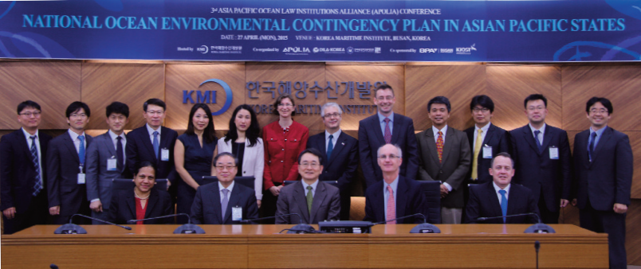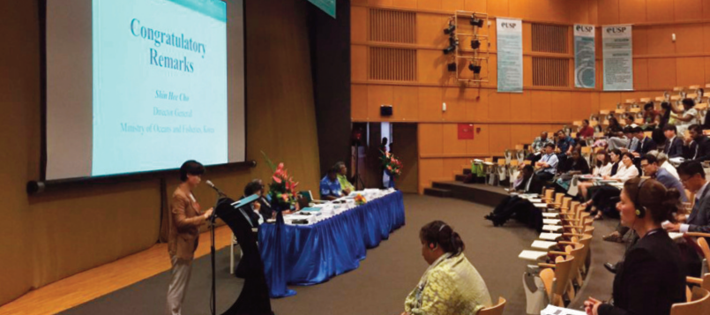Major Activities conducted in April, May 2015

Expert Seminar on Advancing into Eurasian Lo- gistics Market
    - Time/Place: April 21 (Tue) / KMI meeting room
    - Participants: CEO Im Oh-Kyu of Eusu Holdings HJLK, Professor Min Jung-Ung of Inha University, CEO Kim Ik-Jun of Ecovice Logistics, Executive director Son Byung-Il of Samil PwC and others
    - Contents: An expert seminar on setting up a strategy for advancing into Eurasian logistics market including Russia, Mongolia and CIS countries

APOLIA International Academic Conference
    - Time/ lace: April 26 (Sun) ~ 28 (Tue), KMI Busan Oﬃce
    - Participants: Foreign guests including Anastasia Tele- setsky, Ted Mcdorman, Clive Schofield, Alfonso Ascen- cio Herrera and KMI researchers
    - Contents : Holding APOLIA(Asia Pacific Ocean Law institutions Alliance) international academic confer- ence to discuss the following issues; establishing mar- itime order in Asia Pacific region, addressing marine environmental issues and latest trend and policy issues related to maritime boundary delimitation

Ocean Knowledge Forum – Busan ‘The 1st Policy Meeting’ (Co-hosted by Busan Port Development Association)
    - Time/Place: May 13 (Wed) 14:00 / KMI International Conference Hall
    - Subject: Discussion on development measures of Busan’s maritime and fisheries sector
- Presenters: Co-Chairman Park In-ho of civic group who loves Busan port, Executive director An Nam- Soon of Korea Oﬀshore Plant Ship Repair Cooperative, Chairman Choi Sung-Ho of Busan Port Logistics As- sociation

Korea-South Pacific Fisheries Forum 2015 Fiji Symposium
- Time/Place: May 20 (Wed) 10:30 / USP University, ICT center at Suva, Fiji
- Subject: Community-based Fisheries in South Pacific Islands
- Attendees: Vice-chancellor Rajesh Chandra of USP University, Ian Bertram (SPC), Lora Noella Lini (MSG), Aisake Batibasaga (Principal Research Oﬃcer at Fiji Fisheries Department) ad fisheries related oﬃ- cers from Korea and South Pacific Islands and KOSOPFF members

Major Activities planned in June 2015

Academic seminar ‘China’s New Silk Road (One belt, one road) Strategy and Korea’s Choice’
  - Time/Place: June 9 (Tue) 15:00 / Conference room at Korea Chamber of Commerce and Industry
  - Subject: China’s One Belt One Road Strategy and Fu- ture Direction
  - Participants: Experts including professor Shu Jian- zhong of Institute of International Relations of Nanjing University, professor Choi Pil-Soo of Sejong University, President Eoh Hae-Hyuk of CJ Korea Express General Logistics Research Institute.

Publisher
Kim Sung Gwi - President, Korea Maritime Institute

Editor-in-Chief
Choi Jae Sun - Director General, Planning & Coordination Division

Editorial Board
Mok Jin Yong - Director General, Marine Policy Research Division
Joung Myung Saeng - Director General, Fisheries Policy Research Division Kim Woo Ho - Director General, Maritime Industry & Safety Research Division Jun Chan Young - Director General, Port Research Division
Kim Jong Deog - Director General, Strategy Research Division

Secretary
Kim Sangmi - Planning & Coordination Division Lee Yun Jung - Planning & Coordination Division

Contact Information
Address: 26, Haeyang-ro 301beon-gil, Yeongdo-gu, Busan, 606-080, Korea Tel: +82-51-797-4800
Fax: +82-51-797-4810
Email: jschoi@kmi.re.kr, smk32@kmi.re.kr

