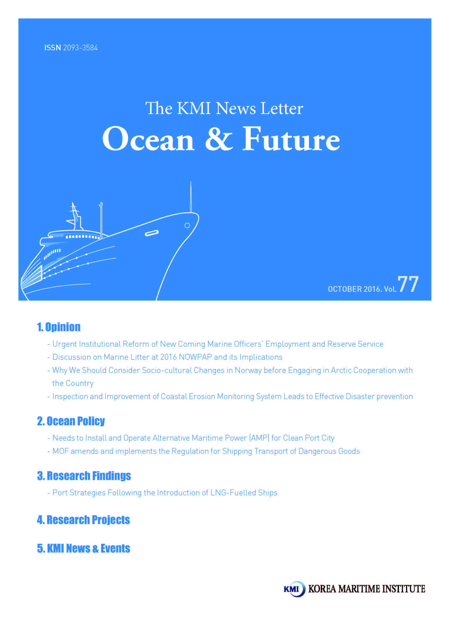

Urgent Institutional Reform of New Coming Marine Officers’ Employment and Reserve Service

I. Introduction
Maritime businesses have been suffering from long-term recession due to the structural over-supply and demand decline. Main indicators of the shipping market have shown the floor level since the financial crisis of 2008. Global shipping recession has become a new challenging factor to Korean seafarers’ employment and their future career development.
If such a new challenge is not dealt with immediately, it may become a bottleneck to proper and timely training of seafarers, the essential factor for sustainable ocean industries. In this context, it is urgently needed for the government to implement a fresh seafarers' policy to find and solve new coming marine officers’ future career and obstacles.

II. Employment Status and Problems of New Coming Officers
Korea’s international shipping companies employed 21,444 seafarers, consisting of 9,308 Korean seafarers and 12,136 foreign seafarers as of the end of 2105. The average annual wages of these seafarers were 37.56 million won and total wages, 803.3 billion won. Annual number of newly trained officers have been around 1,100 since 2000 and 1,058 officers were trained in 2015.
The careers of new coming 1,058 marine officers’ are as follows: employment: 603, reserved seafarers: 289 and separation: 166. The combined number of officers in the status of employment and reserved are 892, reaching up to 84.3%. However, considering the previous reserve rate 23%, 27.3% of 2015 sends a new red signal to the employment market of seafarers.
Beside this red signal, problems of new coming seafarers are as follows. First, the seafarers who have been employed by Hanjin Shipping are entering into seafarers' employment market due to sales of ships and this additional supply works as a distorting factor. The existing shipping companies tend to prefer and employ them, whose maritime skills are useful to them.
Second, about 180 officers, 25% of 718 seafarers of Hanjin Shipping may not complete the duty service period because of shipping recession, which is imperative to complete the duty of national defense. This may give a bad impact on new officers who are coming into the market after graduation. Third, increased reserve seafarers may find their jobs, but new coming officers who have not found their jobs may become a potential element of unemployment.
< Trainees at the Ceremony of On-board Training >
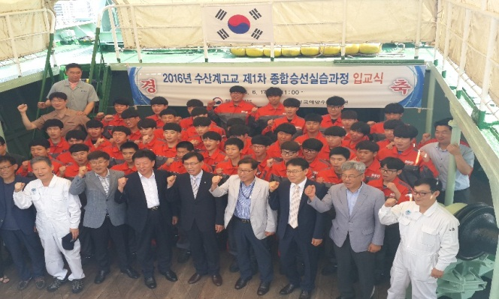

III. Policy Recommendations
In order to secure effective maritime skill transfer and stable supply and demand of seafarer market, it is necessary for the government to consider and introduce the following policy recommendations. Above all, it is useful to allocate proper ratio of employment of newly coming seafarers and marine officers. Second, it is needed to find a new demand of seafarers and development of new maritime businesses in a way to deal with long-term shipping depression. Operation of offshore structures and global logistics businesses may be good opportunities. Third, it is demanded for the Office of Military Manpower Administration of Korea to implement flexibly the duty service scheme for the duty of national defense. In case of inevitable service nonfulfillment within the set time, alternative service opportunities should be provided. Fourth, when Korean seafarers are to be employed in order to replace foreign seafarers, it is positively suggested for the government including the Ministry of Oceans and Fisheries to consider a support measure of employment incentives.
New government measures for seafarers' employment should be established and implemented from fresh perspectives in order to defeat the long-term global shipping depression. KMI

Contact information
Name: Park, Yong-An
E-mail: yapark@kmi.re.kr
Tel: +82-51-797-4612
Discussion on Marine Litter at 2016 NOWPAP and its Implications

The Northwest Pacific Action Plan (NOWPAP) is one of 13 regional seas programs to which the United Nations Environment Program (UNEP) has implemented since 1974, in accordance with the resolution of the United Nations Conference on Human Environment held in Stockholm in 1972.
NOWPAP was officially launched in September 1994 with the participation of 5 countries including the Republic of Korea, the Democratic People’s Republic of Korea, Japan, China and Russia. It aims to strengthen the cooperation among neighboring countries in protecting the marine environment at the Northwest Pacific Ocean. For this purpose, NOWPAP carries out various tasks including hosting inter-governmental meetings, sharing information between member countries and joint response against marine pollution. Since its establishment in 1994, NOWPAP has held an annual seminar, inviting governments, civic groups and experts from 4 countries including South Korea. Since 2005, it has started to take the issue of marine litter of NOWPAP regions as a major agenda. Since 2008, NOWPAP has carried out systematic activities in dealing with marine litter by establishing NOWPAP Regional Action Plan on Marine Litter. In particular, its annual seminar serves as a platform to make presentations on the achievements and experience about each member countries’ ongoing projects and share information.
< Presentation Subjects for NOWPAP International Joint Seminar >
• Results of marine litter(including microplastics) monitoring around japan
• Rapid assessment of anthropogenic debris by visual scoring along the coast in Korea
• Mandatory garbage classification management in China
• Results of microplastics research in Primorsky Kray of Russia
• A study on management of waste Styrofoam buoys from aquaculture in Korea
• Joint Japan-Russia-China expedition aboard Japanese research vessel to monitor marine litter around Japan
• Results of ICC campaigns in the Russian Far East
• Marine litter monitoring report by Chinese marine NPOs
• NGOs efforts to address marine litter issues in Chungnam Province, Korea
• NGO efforts to address marine litter in Japan
• Enhancement of the NW Pacific regional node of the Global Partnership on Marine Litter

The 2016 NOWPAP Joint Workshop, held in Slavyanka, Primorsky Kray on September 2016, provides presentations and discussions on 11 subjects regarding marine litter such as microplastic research method.
So far, Japan used to collect the marine wastes at beach which are flown from rivers or sea. After 2015, however, the areas subject for waste collection has been expanded that the wastes which are floating on the ocean or settled under the sea floor should be collected. In 2016, the Japanese government set 30 million USD as a budget on addressing marine litter to collect and prevent it. According to the analysis conducted by Arakawa Clean-aid Forum based on the collection activities in 2013, plastic constitutes 62% of all the marine litter.
Centering on the Russia Academy of Science, Russia has conducted monitoring research on marine plastic since 2014. After carrying out monitoring research at Posyet Bay to which is adjacent to the national border of North Korea, most of the marine litter found in Russia is plastics, accounting for nearly 57% of the total wastes. Among micro marine plastic litter larger than 25mm, EPS buoy takes up the largest proportion, accounting for 29% (130 units), followed by plastic bottles (19%) and ropes and fishing nets (13%).
China has started monitoring projects for marine litter since 2014. The monitoring takes place 6 times a year in 12 coastal regions including Qingdao, Shanghai and Shenzhen. The monitoring result shows that glass pieces and foam plastics are generated the most by the number of units.
South Korea announced a research result on a method to promptly investigate and evaluate the marine waste at beach by utilizing mobile application, as well as the system for collecting aquaculture buoys before being disposed at sea.
< Chinese Regions under the Monitoring of Marine Litter and Its Result >

Research results are announced one after another in which marine plastic wastes and microplastics have negative impacts to the marine environment and ecosystem. As a result, the voice calling for a joint response against marine plastic wastes at the global level is gaining a strong momentum. This year’s NOWPAP International Joint Workshop also provided abundant discussions on the issue of marine plastic wastes including microplastics. Joining hands with China and Russia, Japan dispatched research vessels for a joint research on microplastics. At this year’s NOWPAP International Joint Workshop, Japan made a suggestion to compare research results of 4 member countries. For this, it is necessary to carry out discussion on the standardization of research first, such as establishing research methods on microplastics. KMI

Contact Information
Name: Kim, Kyung-Shin et al.
E-mail: kskim@kmi.re.kr
Tel: +82-51-797-4714

Why We Should Consider Socio-cultural Changes in Norway before Engaging in Arctic Cooperation with the Country

Is Norway a Peaceful Mono-cultural Society?
Back in July in 2011, a terrible terrorist attack took place in Norway, killing 77 civilians. This took the world by surprise, mainly because it was simply unimaginable in a country widely known as a ‘welfare paradise’. In fact, Norway had always remained within top five countries both in terms of GDP per capita and happiness index. However, since the motivation of the attack turned out to be the perpetrator’s hostility against multiculturalism, there has been a growing interest on both demographic and socio-economic situation in Norway. To cut to the point straightaway, Norway is no longer a country exclusively owned by descendants of Vikings: Rather, it is where different groups with different cultural and ethnic backgrounds co-exist.

The Sami, Indigenous People of the Arctic
The Sami are an indigenous people of the region near the North Pole to the north of Norway. The first historical evidence of their existence dates back to AD 98 in a manuscript written by Tacitus, a famous historian of the Roman Empire. He described the Sami as people who wear fur, hunt reindeers, and ride ski. Today, they mostly live in the Nordic states including Norway, Sweden, and Finland. And it is presumed that 60,000 to 100,000 Sami people live in Norway alone. The Sami in Norway mainly make their living by grazing reindeers, preserving their own traditions.

Jews, People Chosen by God
It is unclear since when Jews began to reside in Norway. However, the Norwegian constitution had officially prohibited the entry of the Jew until 1951. And some of these people barely managed to settle in Norway, only suffering another misery in different ways during the World War II. In particular, many Jews had to escape to countries like Sweden while the rest were arrested and sent to concentration camps when the Norwegian government began to collaborate with the Nazi led by Hitler. Today, there are approximately 1,000 Jews across the country. Many of them remain religious and follow the traditions of Judaism. In fact, they strictly observe the Sabbath-a day of religious observance and abstinence from work, kept by Jews from when the sun goes down on Friday to Saturday evening. They do so even during the period of nights with the midnight sun, when it doesn’t really get dark all day long, by beginning their rituals on Friday at 5:30 PM.

Muslims, Descendants of the Saracens
Over the latter part of 20th century, the Norwegian government pushed ahead with multicultural policies, allowing numerous immigrants to settle in the country. This resulted in a rapid growth in the number of immigrants, especially those who came from various countries in the Islamic world—Muslims. These immigrant Muslims mainly live in their enclaves in bigger cities. There are now approximately 200,000 Muslims living in Norway. Muslim immigrants are most passionate in their religious activities in Norway, to the extent that some of them force every woman around them to wear hijab according to Islamic Sharia (law). Such behaviors of Muslims eventually led to serious conflicts with Norwegian natives and others in the society. Against this backdrop, immigrant Muslims in Norway have a much higher birthrate than Norwegian natives, which prompted some in the Norwegian society to voice their concerns over the potential consequences.

Socio-cultural Situation Should be Considered in Cooperating with Norway
As described above, the socio-cultural composition of Norway is much different from what people generally expect. That is why South Korea, which seeks to strengthen the cooperation with Norway regarding the Arctic policy, should deeply understand these socio-cultural changes and quickly respond to them. As Muslim immigrants are increasing their voices, it is noteworthy to take a closer look at the policy changes in the Norwegian government regarding minority groups. In this respect, if South Korea intends to carry out cooperation projects with the Sami, these changes would provide a good reference during the process. KMI

Contact information
Name: Shin, Su-hwan
E-mail: shshin@kmi.re.kr
Tel: +82-51-797-4764

Inspection and Improvement of Coastal Erosion Monitoring System Leads to Effective Disaster prevention

Seriousness and Damage of Coastal Erosion
People witness the phenomenon of coastal erosion broadcasted by the media and often stress the urgency of its risks and causes, while calling to come up with countermeasures. Coastal erosion is the wearing away of land and the removal of beach, resulting the loss of national territory and endangering the safety of those who use coastal spaces. Although South Korea has not conducted a complete enumeration survey on the damage of coastal erosion, the Ministry of Oceans and Fisheries (MOF) has conducted coastal erosion monitoring projects. According the result of the projects, the areas at the risk of erosion or being seriously eroded account for 73% (250 sites) of the total subject areas, representing the seriousness of the issue.
Coastal erosion is categorized as natural disaster, and is the product of natural cause such as the rise of sea level and ocean wave. However, some point out that artificial causes far outweigh the natural causes since various coastal development projects have been carried out without proper impact assessments or countermeasures. People have no choice but to adapt to natural disasters. As for the disasters caused by artificial reasons, however, the basic principal for disaster response is to prevent before it is happening. The Statistical Yearbook of Natural Disaster shows that natural disaster recovery costs twice as much as damage cost¹⁾. Given this, disaster prevention is more effective way than disaster recovery.
There is a somewhat exaggerated concern that coastal erosion may reduce the size of territorial waters resulting from shoreline retreat which leads to receding baseline of territorial sea. However, it is true that coastal erosion can lead to loss of land and damage to land property owners. In addition, coastal erosion can bring about anxiety among coastal residents or users while it may contract economic activities.

Problems of Coastal Erosion Response
Over the last 15 years, several policies and projects have been carried out to respond to coastal erosion and prevent its damages. However, the damages caused by coastal erosion are still lasting, increasing concern among the public. The most representative measure against coastal erosion is the Coastal Maintenance Project which has been conducted by MOF since 2000. Currently, the government is planning or already implementing 296 projects (worth 1,583.9 billion KRW) based on the 2nd Coastal Maintenance Basic Plan. Besides, the Korea Forest Service is carrying out the beach erosion prevention project covering 54 km of shoreline, while the Ministry of Public Safety and Security is regularly implementing erosion recovery projects.
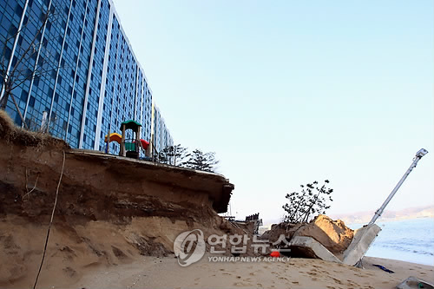  < Article of Yonhap News Feb 4, 2009 > | 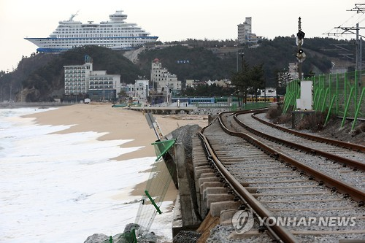  < Article of Yonhap News Jan 1, 2016 >
1) According to the Statistical Yearbook of Natural Disaster (MPSS 2015), the damage cost caused by natural disaster amounts to 547,741 million KRW while recovery cost is estimated to reach 1,083,477 million KRW over a decade from 2006 to 2015
However, these erosion response projects have not produced expected results, since they have been planned and implemented by each governmental department, causing repetitive investment or decisions made by non-experts. Furthermore, the government is undertaking relevant projects, albeit not referred to as coastal erosion response projects, such as coastal erosion monitoring, vulnerability assessment on coastal disaster, and sea area utilization impact assessment. However, these projects are lack of interconnectedness, falling behind a complete response system. If this situation continues, the public distrust toward the impact of various policies and projects for coastal erosion response would increase, and the trustworthiness of national administration would be reduced.

Inspection on Coastal Erosion Response System and Comprehensive Operation of Resources are Required
Effective response against coastal erosion requires analyzing the implementation status of various policy measures and assessing the result of projects. Therefore, it is necessary to identify the current status and problems of projects per each stage, such as planning, implementation and management. Based on this, it is important to seek improvement measures i.e. comprehensive operation among each policy measures. Since the resources available for erosion response are limited, effective management of those resources will be a step in the right direction towards solving the erosion problem. Along with comprehensive operation of erosion response functions scattered across each governmental department, it is imminent to integrate the operation of following tasks; sea area utilization impact assessment seeking to forecast the impact of erosion in advance and find reduction measures; monitoring to scientifically analyze the cause of erosion; costal maintenance to reinforce concerned areas at the risk of erosion; and prediction of the impact of coastal erosion and technological development of response measures. These improvement efforts are going to effectively increase the impact of coastal erosion response. If these efforts lead to increasing the capacity of coastal erosion response and reduce its damages, it will contribute to the preservation of national territory by providing the public with safer place for living and addressing their concern over safety. KMI

Contact information
Name: Sungsoon Yoon
E-Mail: ssyoon@kmi.re.kr
Tel: + 82-51-797-4711

Needs to Install and Operate Alternative Maritime Power (AMP) for Clean Port City

Needs to Install AMP
< Relationship between ECA and the Installment of AMPs >
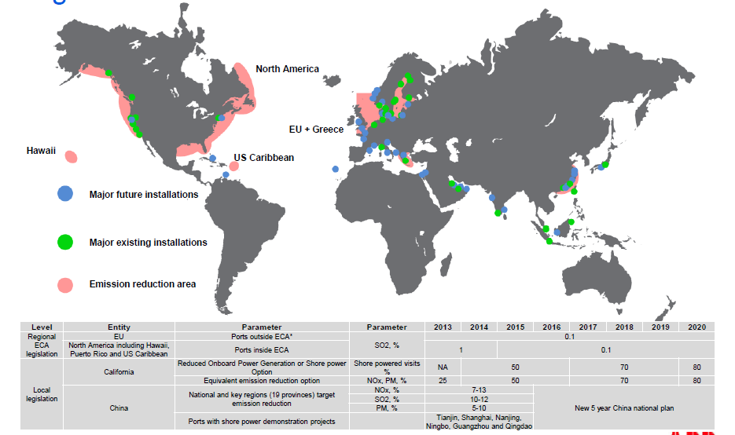
Source: Christian B. Petersen, “Clean air in ports and port cities Danish Parliament”, April 6 2014

1) By 2020, 80% of the vessels entering Californian ports will have to use AMP. Led by the government, China designates ECA and has implemented pilot projects for 7 ports after establishing a roadmap to prepare AMP national standards and support measures. The EU mandates to install AMP at ports from 2025. While Germany and Sweden are implementing tax breaks on electricity bill, Belgium and the Netherlands are providing financial support system for activating and installing AMPs respectively.
The Natural Resources Defense Council (NDRC) of the United States conducted research that estimated the amount of emissions emitted from each source of air pollution at marine ports. According to the result, major causes of air pollution at ports were found to be exhaust gas coming from trailers, vessels and port equipment. In addition, the same research discovered that those working or living port areas with heavy air pollution are 50~300% more likely to suffer from lung cancer. In the US and Canada, vessel emissions will lead to 12,000 premature deaths by 2020, and cause the death of 1.2 million every year in China. Understanding the hazardous impact of vessel emissions to human, IMO has applied more stringent standards starting from 2015. Therefore, ships operating in emission control area (ECA) are subject to 0.1% m/m sulfur limit, while China voluntarily introduces a measure in which vessels use fuel oil with sulfur content of no more than 0.5% m/m. With more stringent regulation on emissions coming from vessels, major ports are increasingly installing alternative maritime powers (AMP) along the ECAs. Also, countries are preparing national standards and providing tax benefits¹⁾ in regards to the installment of AMPs. Recently, the Ministry of Environment (MOE) and local governments are consistently calling for a solution to reduce air pollutants by i.e. installing AMPs at ports.

Problems of Installing AMPs
Recognizing the necessity of installing AMPs, South Korea set up a basic plan for the installment. However, AMPs installed in domestic ports are low-voltage with small capacity that fall short of meeting the international standards. Also, AMPs have not been introduced in container ports so far. There are largely 4 reasons for which the installment of AMPs at Korean ports falls far short of the basic plan.
First, Korean ports which secure public pipelines fitted to install AMPs are only Busan New Port and Incheon New Port. However, the number of public pipelines in those ports lack for handling the vessels larger than 18,000 TEU. Second, existing terminals will face interference in their operation when AMP-related construction starts. Therefore, shore power outlets should be embedded in the process of construction in order to prevent the interference of port operation such as quay cranes. However, SPOs are difficult to be embedded within the quay walls of existing terminals due to the current structure of civil engineering. In addition, the construction will cause operating loss since the quay walls and yards subject to the construction of pipelines will not allow port operational works. Third, shipping liners are reluctant to use AMPs at Korean ports since there are no benefits under the current electricity billing system (basic fee + usage fee). Under the current system, there are three additional fees that shipping liners have to burden; labor cost of safety guards working at terminals, cost difference between fuel cost and electricity cost (44.5 KRW per kWh + basic fee), and loss cost stemming from about 2 hour increase for time in port. Fourth, most Korean ports handle transshipment cargoes as opposed to import-export cargoes like ports in China and the US. Therefore, it is difficult to mandate the installment of AMPs at the national level due to shipping liners’ lack of benefits.

Policy Suggestions for AMP Pilot Port
Since installing AMPs is the needs of our times for clean port city, major ports in China, Europe and the US are actively installing AMPs. However, Korean ports have no experience in installing, let alone operating, AMPs which meet the international standards. For Korean ports successfully installing and operating AMPs like global major ports, it is necessary to designate a pilot port for installing AMPs. After the installation and operation, it is important to prepare Korean standards for AMP. For this purpose, four policies will be required as follow.
First, Korean standards for AMP should be established by organizing a promotion committee (consisting of the Ministry of Ocean and Fisheries, the Ministry of Environment, local governments, Korea Electric Power Corporation, Port Authorities, terminal operators and equipment companies etc.) for AMP pilot project. Second, it is necessary to legislate for the emission control of SOx and particulate matter (PM) as well as that of NOx under the Marine Environment Management Act and International Convention for the Prevention of Pollution by Ships. Third, it is necessary to assess air pollutants emitted from vessels at port cities in collaboration with MOF, MOE and local governments. In addition, epidemiologic survey on human impact and the research on the impact of AMP installation should be carried out. Forth, it is important to come up with measure for shipping liners to expand the use of AMPs. That is, the current electricity billing system of ‘basic fee + usage fee’ implemented by KEPCO should be revised. Also, the government should devise measures to finance the installation of AMPs and provide tax benefits for using electricity. Furthermore, it is critical to increase port incentives to shipping liners for installing and operating AMPs, after inspecting currently implemented ESI (Environmental Ship Index) system. KMI

Contact information
Name: Eon-Kyung Lee
E-mail: eklee@kmi.re.kr
Tel: + 82-51-797-4682

MOF amends and implements the Regulation for Shipping Transport of Dangerous Goods

IMO Amends and Implements the IMDG Code
The International Maritime Organization (IMO) amended and implemented the International Maritime Dangerous Goods Code (IMDG Code) on January 1, 2016 for the safe transportation of dangerous goods or hazardous materials by water on vessel. As a mandatory regulation, this code is updated and revised by the representatives of the member countries and experts every 2 years.
MOF Undertakes a Strict Management by Revising the Regulation for Shipping Transport of Dangerous Goods
As IMO amended and implemented the IMDG Code for safe maritime transportation, the Korean government followed suit by amending and implementing the Regulation for Shipping Transport of Dangerous Goods on September 1 to meet the international standards.
The amendment of domestic regulation stipulates that the limit of the amount of poisonous gas or steam should be 50% lower than the exposure standard for preventing the entry of closed zones of oil tankers (Article 19 paragraph 2). In doing so, seafarers are able to secure safety when entering closed zones.
In addition, drivers of vehicles loaded with dangerous goods have newly added as a subject for the training of safe transport of dangerous goods (Article 27). By doing so, the amended regulation aims to strengthen the drivers’ capacity to respond in case of accident. The training for drivers of vehicles loaded with dangerous goods will begin on January 2017. Those intending to drive the vehicles loaded with dangerous goods must complete the training by June 30, 2018.
Also, 30 substances are newly assigned to the list of dangerous goods for transportation including mercury (UN2809) embedded in products. In addition, the amendment stipulates stricter requirements for quarantine so that hazardous substances do not generate chemical response when being close together. Furthermore, it strengthens the installation standards of fire prevention equipment per cargo areas, which should be established in vessels for dangerous goods.
While LNG fuels for propelling LNG carriers are added to the list of common dangerous goods, a new standard is established for tanks storing LNG. Therefore, LNG fuels should be stored in fuel tanks made by cryogenic substances (nickel steel, aluminum alloy, and high manganese steel etc.)

Safe Transport of Dangerous Goods will Increase the Prevention of Accidents
The amendment of the Regulation for Shipping Transport of Dangerous Goods is a reflection of international standards which was revised earlier this year into domestic laws. In doing so, it aims to make sure to prevent safety related accidents in case of transporting dangerous goods. Through this effort, the Korean government expects that the amendment will contribute to the safe transportation of dangerous goods, prevention of safety accidents and improvement of shipping safety.

Contact information
Name: Woohyeon Jeon
E-mail: jwh0321@kmi.re.kr
Tel: +82-51-797-4615

Port Strategies Following the Introduction of LNG-Fuelled Ships

1. Purpose
○ This study aims to estimate affordable LNG price with which Korea’s main ports including Busan can secure competitiveness over other ports in competition. Based on the estimation, it intends to draw appropriate levels of demand and infrastructures.
○ The study analyzed the supply system of LNG bunkering terminals in foreign countries, the designation of potential ports in competition, the estimation of affordable LNG prices for supply, and measures to secure price competitiveness. Also it made policy suggestions to attract elements for LNG bunkering hub.

2. Methodologies and Feature
1) Methodologies
< Features of Methodologies >
Features | Major contents | Data collection | Reasons for selection
Basic  Analysis | - Global status of regulating emissions from ships  - Systemization of the supply systems of foreign LNG bunkering  - LNG price trend and LNG price comparison with ports in competition | - Related literature review  - Domestic and overseas case study | - Various contents related to LNG bunkering are published in Korea. However, the study regarding its supply system and price is insufficient, which requires basic data analysis.
Expert  Consultation | - Development and operation trend of foreign LNG bunkering terminals  - Business structure of LNG bunkering  - Measures to secure price competitiveness of LNG bunkering | - Expert consultation and hearing of opinion | - Korea’s LNG bunkering related business is at initial stage, which requires expert consultation
International Seminar | - Various issues discussed with domestic and foreign LNG bunkering experts  - Trend, technology, safety, demand, commercialization etc. | - Expert presentation | - Need to secure the possibility of attracting competitiveness as well as the development measures of Korea’s LNG bunkering terminals from global leading LNG suppliers, classification society and LNG operators.
2) Feature
○ It conducted general analysis on price, which should be considered for introducing LNG bunkering terminal to Korean ports. In addition, the study suggested development method and policy support measures of LNG bunkering terminals to secure price competitiveness centering on Busan Port.
○ The study carried out the analysis on the operation system of global leading LNG bunkering terminals, the price structure of LNG bunkering and estimated Korea’s LNG price compared to foreign ports.
- It suggested a supply system for securing price competitiveness in developing LNG bunkering terminals. Also, the study provides a standard for site selection and bunkering methods

3. Results
1) Summary
○ Globally, regulations for emission from ships have strengthened
- Staring 2015, every ship operating within the Emission Control Area (ECA) must use higher quality fuels with a sulfur content of no more than 0.1%
- In 2018, the decision will be made on when to introduce the regulation of bunker fuel with a sulfur content of less than 0.5% to all vessels in either 2020 or 2025.
- The US, Hong Kong and the EU designate their own ECA, implementing the regulation for air pollution caused by ships
○ LNG-fuelled ships are an optimum alternative for reducing gas emission from ships
- According to the result of analyzing the operating cost of LNG-fuelled and LSFP-fuelled containerships, LNG has a saving effect in fuel cost over LSFO, amounting to USD 4.50~5.80 million annually.
- The demand of LNG-fuelled ships will continue to rise depending on the competitiveness of LNG.
○ The prospect of increasing global LNG bunkering demand and high uncertainty
- With increasing potential and competitiveness of LNG as an alternative for existing fuel oil, the global demand for LNG bunkering is expected to witness explosive growth.
- The global demand of LNG bunkering basically depends on the prospect of introducing LNG-fuelled ships. This prospect significantly varies on whether to expand ECA and the timing when IMO introduces the regulation for reducing emissions to all ocean areas.
- Nevertheless, global major ports are adopting policies to aggressively develop infrastructures and strengthen stability for entering into the LNG bunkering market in advance.
○ The LNG bunkering demand of Busan Port is flexible depending on external variables
○ As of 2030, the LNG bunkering demand of Busan Port is estimated to rise from 0.64 million tons in the beginning to 4.28 million tons to the max.
- Korea’s LNG import price is estimated more than USD 50 per ton higher than that of Singapore due to high premium.
- Therefore, Busan Port needs to have price competitiveness to invigorate the LNG bunkering terminal.
○ Securing price competitiveness is the top priority for making an early move into the market
○ Providing bunkering service using pipelines, adopting brokerage system for operational strategy and selecting an optimal site to minimize the cost etc.
○ Policy Suggestion
○ Continuous monitoring for LNG bunkering discussion, implementing LNG bunkering pilot projects, laying the foundation for pushing ahead LNG bunkering terminal projects, improving related laws and regulations, establishing an incentive system, expanding LNG bunkering related R&D and etc.

2) Policy Contribution
○ The demand, which is estimated based on the estimation of LNG bunkering prices, can be used as a policy base when LNG bunkering terminal projects are implemented in the future.
○ It can be used as a source material when private operators request the development of bunkering business for LNG-fuelled ships.

3) Expected Benefits
○ It improves added values of ports following the introduction of port related service industry when LNG bunkering is established in Korea.
○ Also, it creates a development opportunity in connection with shipbuilding industry, ship equipment industry and energy supply sector. . KMI

● Korea-China-Japan transportation logistics cooperation measures (7th round)
● A study on marine sector for the 8th basic plan for national transportation safety
● Necessity of local tax reduction to expand the international vessels registered in Korea
● A study for the establishment of sustainable development strategy in Garorim Bay area
● A basic plan for the development of fishing villages and fishing ports of Choongchungnamdo (1st study, 2016)
● Establishment of mid-to-long term development plan for marine tourism policy at Yeongdeok
● A study on the feasibility review and the establishment of measures for integrating TOC of inner ports in Incheon
● Impact of reorganizing the alliance of the maritime market and its response measures
● Development of fishing net for aquaculture using Ultra-high-molecular-weight polyethylene (UHMWPE)_2nd
● Real-time management, international and KS standardization of the safety process and information model for bulk cargoes (agricultural and marine products)
● A study on the establishment and amendment of The Ocean Industry Development Act for control management and overseas investment promotion
● Development of Mobile rack for glass-only for effective and easy cargo handling
● A pre-feasibility study on the development of Amapala port in Honduras
● (Proposed in 2013) Korea-ASEAN cooperation project (A study on the joint development of fisheries and aquaculture in ASEAN and the establishment of cooperation system)
● Research on the introduction of Coastal Safety Index
● Establishment of a basic plan for ocean industry cluster
● 2016 Yeosu project – SOI support projects by CBD
● The establishment of the 1st comprehensive plan for supporting those returning to rural and fishing villages
● Research on measures to vitalize the investment of Korean offshore aquaculture industry
● A policy study on utilization of container searcher
● Development of low carbon automation container terminal technology (4th year)
● The 2nd study on the revision of the basic plan for maritime fishery development
● The establishment of integrated management system for fishery waste polystyrene buoy in 2016 (1st phase)
● 2016 Project for establishing the foundation of statistics generation on maritime and fisheries industry
● The 6th support for the industrialization of fishing villages_subsidiary
● R&D on marine environment and ecosystem management nearby Saemanguem
● A study on the foundation for upgrading comprehensive management for coastal areas
● Development of statistics index on underwater leisure industry and establishment of subordinated ordinance of Underwater Leisure Act
● 2016 Entrusted operation of shipping and ports logistics information system
● 2016 National transportation survey and DB establishment
● A study on activation measures of mudflat ecology resources
● A validity study on the lands applying for changed plan on public water reclamation
● 2016 MOF cost benefit analysis on ‘cost-in, cost-out’
● A study on impact analysis and response measures of WTO and TPP on fishery sector
● The establishment of advanced operation system for large purse seine
● A Study on the basic plan for the recovery of mud flats in Suncheon bay
● A study on the impact analysis of RCEP to fisheries sector and its response measures
● A study on feasibility study and advancement plan for Iranian aquaculture investment
● A study on the establishment measures for building feeder and artery network for coastal passenger ships
● A study on the establishment of IMO Korea Committee
● IMO international standardization and the development of specific technological standards of its guidelines
● A study to promote cooperative relation among Northeast Asian ports
● A study on the expansion of integrated cargo vehicle for sea and land transportation among Korea-China-Japan
● Act as deputy for evaluating certification system of excellent logistics companies in 2016
● 2016 information provider on overseas market for offshore service industry
● The operation of international logistics investment analysis center in 2016
● Research on the development of Korean Ocean Health Index and policy application measures
● A study on the introduction of quality certification for fishery equipment
● 2016 Entrusted operation of shipping demand prediction center
● A study on the establishment of international cooperation and institutional foundation for Arctic policy
● 2015 Evaluation study on implementing environmental management plan for each sea
● 2016 Yeosu International Academy Project
● 2015 Analysis on the current status of beaches
● A study on the establishment of basic plan for building export complex of fishery products and its feasibility study
● A study on the agenda analysis and response measures of BBNJ and Nagoya Protocol
● The 3rd study on the establishment of basic plan and institutional improvement for fishing ground management
● A study on active implementation of special management water system and the expansion of total pollution load management system
● 2016 Implementation of total pollution load management system on the Masan Bay special management water
● The establishment of marine spatial planning system_2016 demonstration research project
● The development of evaluation methods for climate change impact and vulnerability in fishery industry
● A study on the performance analysis and improvement measures for fishery resources recovery project
● The establishment of the master plan for increasing productivity of fishery products in Algeria (2nd year)
● A study on the establishment of the 4th basic plan of promoting inland fishery and current status survey
● Establishment of a size management system for national maritime jurisdiction
● Establishment of selection standard (draft) of carrying out marine organism resources to overseas
● A study for the establishment of a strategy for national marine basic study
● A study on the conservation and management of marine protected species in 2016
● Demand analysis of technologies for the convergence of aquaculture industry and the operation of convergence technology investment forum
● The improvement measures and mid-to-long term development strategy for managing coastal wetlands in 2016
● The establishment of a global network of ocean territory experts
● Mid-to long-term development measures for government reserve of fishery products
● The 2nd National Basic Plan on Maritime Affairs and Safety (2017~2022)
● A case study on maritime boundary delimitation for negotiating countries
● A study on the estimation of national sea power (centering on the establishment of national sea power index)
● Analysis of the settlement process of public conflicts and its implications
● Response measures for China’s13th Five-Year Plan – focusing on logistics area
● Negotiation on the redevelopment project (building concert hall) at Busan Port (North)
● A study on the establishment of basic plan for building marine healthcare complex
● A study on improving cooperation for the investigation of maritime accidents
● A study on the feasibility study of establishing a Maritime Museum in Incheon
● A study on the estimation of carrying capacity for tug boat station per ports
● A feasibility study of non-administrative port construction on new Nakpo coal port at Gwangyang (Yeocheon) Port
● A study on improvement measures for cooperation charge on the conservation of marine ecosystem
● The feasibility study and the establishment of plans for building sea fishing complex town
● A study on the acceleration measures of enlargement and integration of TOC ports
● The publication of MOF history

Major Activities planned in September 2016

1. Signing of MOU on Exchange Cooperation between Government-funded Research Institutes and Korea University
- Time and Place: September 5. (Mon) 15:00~, Korea University
- Participants: KMI President Yang Chang-ho and Director Kim Chang-ha of International Cooperation and PR relations department

2. Forum for Port Logistics Information System
- Time and Place: September 21. (Wed) / Tmark Hotel, Seoul
- Contents: Discussion on measures to share information among port logistics information systems
- Participants: KMI researchers including Director Kim Su-yeob, domestic and international expert and relevant officials

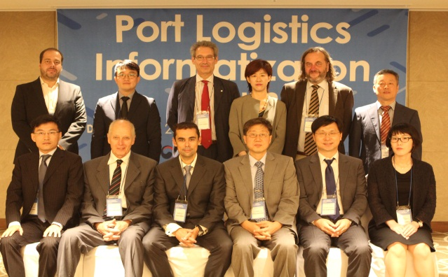

3. Signing of MOU among KMI-Hallym Logistics-Korea Maritime and Ocean University
- Time and Place: October 11 (Tue)
- Major contents: Agreement on MOU to vitalize offshore plant service industry
- Participants: KMI President, President of KMOU, CEO of Hallym Logistics etc.
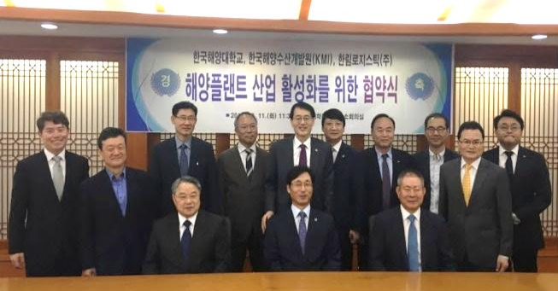

Major Activities planned in October 2016

1. Seminar by Invited CEOs
- Time and Place: Oct 19 (Wed) / Seoul Press Center
- Major Contents: Assessment of shipping industry restructuring and development direction of Korea’s shipping industry
- Participants: KMI President, KMI researchers including Jeon Hyeong-jin, executive member of major shipping companies etc.

2. China Logistics Workshop: Shanghai
- Time and Place: October 18 (Tue) / KMI China Research Center
- Major contents: China’s environmental changes of shipping, ports and logistics during the period of China’s 13th five-year plan and Korea-China cooperation measures
- Participants: KMI researchers, Shanghai Maritime University, Shanghai International Shipping Institute (SISI), Chinese shipping·logistics companies etc.
(* KMI participants: Director Lee Joo-ho, Director Kim Geun-sub, Senior researcher Kim Eun-soo)

3. International Fisheries Forum: building foundation to promote foreign cooperation in fisheries sector
- Time and Place: October 20 (Thu) / Bexco 2nd Exhibition hall #121
- Contents: Roundtable discussion with international fisheries forum experts
- Participants: Director General Cho Jung-hee and KMI researchers

Publisher
Yang, Chang Ho - President, Korea Maritime Institute

Editor-in-Chief
Kim, Woo Ho - Director General, Planning & Coordination Division

Editorial Board
Kim, Jong Deog - Director General, Industry Intelligence & Strategy Research Division
Mok, Jin Yong - Director General, Marine Policy Research Division
Cho, Jung Hee - Director General, Fisheries Policy Research Division
Kim, Soo Yeob - Director General, Maritime Industry & Safety Research Division
Lee, Sung-Woo - Director General, Port & Logistics Research Division

Secretary
Hwang, Hyeon Ji - Planning & Coordination Division
Lee, Yun Jung - Planning & Coordination Division

Contact Information
Address: 26, Haeyang-ro 301beon-gil, Yeongdo-gu, Busan, 49111, Korea
Tel: +82-51-797-4800
Fax: +82-51-797-4810
E-mail: neoport@kmi.re.kr, anhelo@kmi.re.kr

