ISSN 2093-3584 March, 2013. Vol.37

- Opinion
  - Multimodal Tickets for Domestic Marine Tourism
  - The Rising Resource-Centered Northern Logistics

- Ocean Policy
  - Policy Direction for the National Marine Scientific Research Infrastructure
  - Efforts to Lay Out the 2nd Basic Plan for Management of Marine Litter Jumpstarted

- Research Findings
  - Stable Securing of Fish Meals for Higher Competitiveness of Fish Farming

- Research Projects

- International Cooperation

- News & Announcements

01
Opinion

Multimodal Tickets for Domestic Marine Tourism

Emerging New Service Patterns and Single Multimodal Ticket

In Korea, a new tourism pattern has emerged in the marine tourism sector. With increasing national income, demand for marine tourism has been growing continually. Interests in health and happiness are also considered to be important factors for an increase in demand for tourism, especially marine tourism which may bring about better standards of life.

In addition to the existing tourism pattern, new tourism products such as animal watching and walks in the wild, visits to historic places are introduced along with marine tourism. New tourist products, which combined Cheju Olleh trekking routes and new passenger transportation routes between Jeju Island and Chonnam Jang-Heung, have attracted lots of tourists whose number grew by 22% in 2010 compared to the previous year.

Rising demand for marine tourism and coastal passenger transportation is a consequence of better shipping service quality and accessibility, and connectivity between the main land and remote islands. For the convenience of tourists, new types of service are necessary, such as a single multimodal ticket which covers different transportation modes. Coastal shipping service providers need to prepare for the increasing demand for marine tourism with new service patterns and passenger shipping routes.

Examples of Combined Transport Service

There are some cases of providing combined transport service. For example, Korail has introduced the Naeillo Pass, the Korea-Japan Common Pass for rail service and shipping,

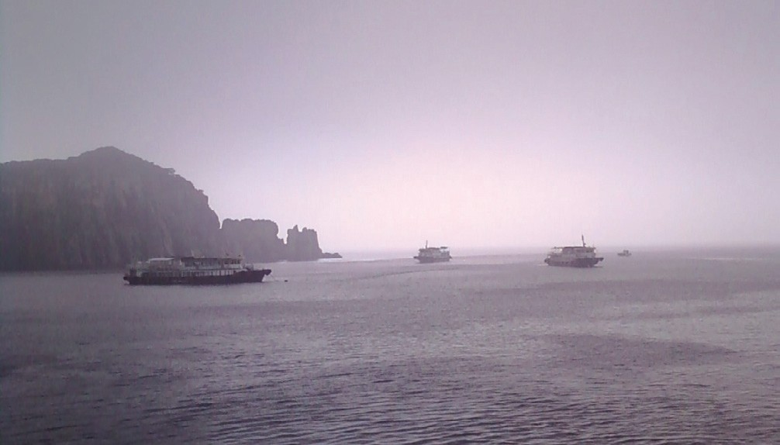
<Figure 1> The Hong-do Island at Chonnam Province

the Japan Rail Pass and the Eurorail Pass. The Korail Pass, priced at KRW 55,000, provides unlimited mileage below the Saemaul Class (7 days) and KTX train service at 50% discount (two times). This rail service product was introduced to promote land travel for youngsters during vacation.

The Korea-Japan Common Ticket provides rail services both in Korea and Japan and shipping service on the Korea-Japan route. This ticket is to provide tourists with convenient multimodal service by connecting Busan and Kyushu of Japan. The Eurorail Pass is a combined pass for rail service and other transport service, including some shipping service in European countries.

A combined transport ticket system is a better way to provide connectivity and accessibility for tourists, thereby giving a fresh stimulus for
tourism demand and new tourism trends. Coastal shipping industry has tried a combined ticket with other transport modes. The KTX Cruise mixed rail service and shipping transport and offered it at 30-50 % cheaper price than airline tickets on weekdays and weekends.

Now it is possible to provide a multimodal ticket which puts rail service, bus and shipping service together, with certain strings such as time limit and bundle purchase of tickets. Such new ticket service will offer tourist attractions, marine tourism and better connectivity between islands. These approaches will provide tourists with new marine tourist attractions in remote islands. By adopting such multimodal approaches, marine tourist attractions will become the tourist hubs beyond being simple tourism points at present. In this regard, new tourist service products are a prerequisite for promoting marine tourism and for boosting the coastal shipping industry.

Conclusion

Coastal shipping providers have been operating their shipping businesses under the coastal shipping license system according to shipping routes, while setting passenger shipping fares. This license system has merits in terms of service stability and protecting coastal shipping operators, but also has demerits, such as limited development of new service and passivity for the industry in general. So far, marine tourism has been disconnected from tourist attractions in main land like natural sightseeing and cultural traditions as well as from tourist products between the main land and islands. Therefore, it is imperative for marine tourism to introduce multimodal tickets in order to broaden its demand.

Contact Information Name: Park, Yong-An
E-mail: yapark@kmi.re.kr Tel: +82-2-2105-2789

The Rising Resource-Centered Northern Logistics

The recent logistics cooperation between China and Russia has been spurring resource development in the Arctic coastal areas of East Siberia, which requires cautious attention from the Korean government and companies.

Development of Northeast 3 provinces in China lagged behind coastal areas. This is the reason why the Chinese government has tried to build the Northeast Asia Logistics New Route through economic cooperation with North Korea and Russia. Coastal area focused-development policies generated gap between coastal areas and inland as well as between the rich and the poor. Dealing with these problems, the Chinese government is concentrating its efforts for the development of the Northeast 3 provinces.

For example, it designated front runner areas for ‘Changchun-Jilin-Tumen Development’ (Chang-Ji-Tu Development), accelerated ‘Liaoning Coastal Area Economic Belt Development,’ approved the Shenyang Economic Zone as the pilot area for ‘the National New Industrialization Plan’ and prepared ‘the Harbin-Daqing-Qiqihar Industrial Belt Development (Har-da-Qi Industrial Belt Development).’ The Chinese government has also sought economic cooperation with North Korea by relating Chiang-Ji-Tu Development with that of Naseon Special Zone.
‘The Chiang-Ji-Tu Development,’ the core of Northeast 3 province development, is providing opportunities for international cooperation for the development of the Tumen River area as well as Julin area. For international cooperation, China brought together ‘the Chiang-Ji-Tu Development’ and ‘the Naseon Special Zone Development,’ strengthening economic collaboration with North Korea. The ultimate goal is the joint development of the Tumen River area1 and cooperation among Northeast Asian nations. Moreover, China will use ‘the Chiang-Ji-Tu Development’ to establish logistics networks between Jilin and its neighboring countries, while carrying out construction projects on roads, railroads and ports which spread to Mongolia, Russia and North Korea.

Currently, Dalian Port and Yingkou Port (Liaoning) are handling more than 80% of international logistics in Northern Part of China but they already reached saturation level. Thus, new logistics passage should be secured for Jilin and Heilongjiang. The rising candidates are downstream areas of the Tumen River, in other words, Najin Port (North Korea) or Zarubino Port (Russia).

In the early 2011, China test transported coal through Najin Port, which reduced transportation costs per ton by 40~60 Yuan and 5~7 days from

1 Targets for Tumen River Area Development include Northeast 3 province, Eastern part of Mongolia, Russian Far East and East coast of South Korea and North Korea in a large sense, while including Hasan, Zarubino (Southern part of maritime province of Siberia), Hunchun (China), Naseon (Najin-Soenbon, North Korea) in a narrow sense.

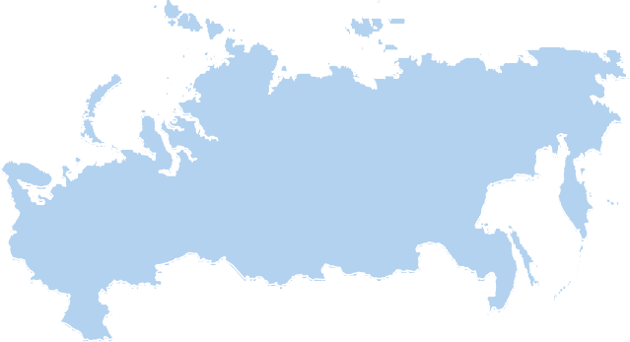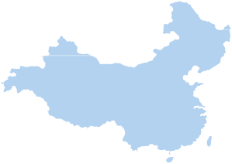<Figure 1> NSR and Inland Multimodal Transportation Route
Source: Lee Sung-woo, Choi Eun-hye & Park Hanna, “The Rising Northern Logistics Market in Northeast Aisa and its Changes,” KMI Pending Issue Analysis, March 2013.

Hunchun (Jilin) to Shanghai. If Najin port is connected to the West coast of North America, logistics distance can be shorten by 2,600 km, compared to the route through Dalian Port. The distance from Huchun to Najin Port is about 50 km. In September, 2012, China expanded the highway spanning from Hunchun (China), Wonjeonri (North Korea) to Najin Port, increasing cargo transportation capacity. It is now constructing the New Tumen River Bridge2 between Hunchun and Wonjeonri. Moreover, the High Speed Railway linking Hunchun, Najin port and Naseon Economic Zone will open in 2014.

If China uses Najin Port and Zarubino Port, it can largely cut logistics costs3 in and out of

Northeast Asian region. The distance from Hunchun to Zarubino Port is 62 km and multimodal transportation will become possible at this route connecting Korea-China and Russia. The Baekdusan route between Sokcho City, Zarubino and Hunchun will open again in May 19, 2013 and the transportation time in the route will be 16~18 hours.4 Eastern part of Suifenhe Shi (Heilongjiang, China) shares borders with Russia and Vladivostok is 210 km away and Nakhodka, the largest economic zone in the Far East, is 270 km away. Compared to the distance from Busan to Harbin through Dalian, the distance through Suifenhe Shi and Vladivostok is 1,000 km shorter with much less logistics costs.

2 Yonhapnews, Feb 16, 2013.
3 CHINDIA Journal, Vol.77, pp.12-15, POSCO Research Institute.
4 Kangwonilbo, 2013.2.19.

Meanwhile, by linking Northeast 3 provinces in China with logistics infrastructure of Russia, China is closely cooperating with Russia for the development of inland multimodal transportation route which can replace the emerging the Northern Sea Route (NSR). The NSR is only operable for 40~50 days per year and requires an ice-breaker to sail through the Arctic Sea and ice-strengthened vessels to transport cargoes. All these requirements raise operation costs significantly. Commercial operation becomes possible only when sea routes in the Arctic Sea are available more than 100 days. If the current environmental trends continue, the NSR will be operable starting from 2020 to 2030. The NSR can be replaced by the inland multimodal transportation route which is under construction by Russia and China. The route goes through the Amur River Bridge along Siberia Yakutsk and the Lena River up to the Arctic Sea. This cross- Siberia route will be completed by 2025.

The Arctic Sea is emerging as the reservoir of new resources. Moreover, global warming improved its accessibility with higher possibility of using resources. In September last year, ice in the Arctic Sea in the vicinity of Russia completely melted, letting a ship sail through the Arctic Sea without an ice-breaker for the first time in history. This heralds an accelerated resource war. These changes are being carried out both inland and offshore. The aforementioned China-Russia Logistics Infrastructure Development Project is building an inland multimodal logistics system which links roads, railways, rivers and the Arctic Sea cross East Siberia. The project will transform the Northern logistics environment in East Asia, creating new logistics market.
Contact Information Name: Lee, Sung-Woo
E-mail: waterfront@kmi.re.kr Tel: +82-2-2105-2830

02
Ocean Policy

Policy Direction for the National Marine Scientific Research Infrastructure

The development of marine science has always depended heavily on research infrastructure of which the most notable example is the research vessel. The ocean and various natural phenomena within the ocean are so vast and complicated that it is beyond human capacity to observe, experiment and manipulate them without the use of large-scale ships, equipments, devices, systems, etc. In most cases, expensive marine scientific research infrastructure can be built or made only by governments and, therefore, ocean sciences have often been called “big science.”

Today marine science is becoming more and more important as we seek solutions to such problems as the global climate change, the near depletion of traditional energy and mineral resources, and the shortage of food sources. In the midst of keen international competition for the initiative in marine science and technology, national governments of advanced countries are reviewing the current state of their ocean research infrastructure. They find deficiencies in quantity, function and capacity of their national marine research infrastructure and try to present ways to overcome those problems. Also, they estimate future needs and demands of marine scientific research infrastructure in order to establish national long-term plans.

In the United States, for instance, the National Research Council organized the ‘Committee on an Ocean Infrastructure Strategy for U.S. Ocean Research in 2030’ which published a report titled “Critical Infrastructure for Ocean Research and Societal Needs in 2030”(2011). The ‘Draft National Ocean Policy Implementation Plan’(2012) produced by the National Ocean Council also emphasized the importance of the marine scientific infrastructure by including ‘Observation, Mapping,

and Infrastructure’ among the nine National Priority Objectives.

The Korean government, likewise, has plans for building critically-important large-scale marine research infrastructure. Yet, what is still wanting is an overall perspective in reviewing the present state of national marine scientific infrastructure and preparing for the future by making long-term plans. It is not enough to have a separate investment plan for each research facility, equipment, system, or ship to meet the world-wide challenge. The national policy for marine scientific research infrastructure has to be comprehensive and consistent.

There are several things that should be considered in implementing the national policy. It is no less important to utilize the infrastructure effectively than to build it. The right to use the research infrastructure built with government funding has to be open to everyone. Yet, the reality is that many such research vessels, devices, equipments and systems are exclusively used by the members of the institution that led the project of making them in the past and have them in their possession now. Therefore, it is important for the national policy to address this problem and find ways to resolve it.

In order to implement the policy consistently, it is needed for the government to set up its organizational and legal-institutional system. A
division of the Ministry of Maritime Affairs and Fisheries, and/or a special public institution devoted to operating and maintaining national marine research infrastructure will be more than useful. Also, the government has to improve its national laws and rules regarding the marine scientific research infrastructure. By making such all-round efforts, we will have better chances in the global competition for the initiative in marine science and technology, and for the various oceanic resources.

Contact Information Name: Han, Ki Won
E-mail: kwhan@kmi.re.kr Tel: +82-2-2105-2894

Efforts to Lay Out the 2nd Basic Plan for Management of Marine Litter Jumpstarted

Efforts to lay out the 2nd Basic Plan for Management of Marine Litter (2014-2018, hereinafter, referred to as “the Basic Plan”) was recently jumpstarted with the scheduled completion of the 1st Basic Plan by the end of this year.

The Basic Plan-for the first time, formulated in 2008, as one of marine environmental policy tools, and on the basis of the Marine Environment Management Act-aims to cope effectively with the threats and risks of marine litter, or widely known as marine “solid waste,” which includes all forms of plastics, general garbage, marine debris, and Lost and Abandoned Fishing Gear (LAFG).

Traditionally, marine litter has been widely represented by two categories according to its origins. One is called the “land-based,” which includes manufactured or solid waste discarded, moved, and/or created by urban runoff and riverine inputs. The other, called “sea-based” litter, is, on the other hand, created typically from vessels including illegal dumping, and/or from varieties of human activities on the sea such as oil exploitation. The combats against marine litter in global scale witnessed a breakthrough around the late 2000s and early 2010s when many international environmental organizations such as UNEP launched renewed initiatives fighting marine litter, defining it as one of the major global challenges to the marine environment, and listing a number of its impacts and costs-ranging from entanglements and ghost
fishing, ingestion to blockage of filter feeding mechanisms, loss of aesthetics, cost to tourism, and to navigational hazards. In other words, marine litter was stigmatized as a serious anthropogenic threat to sustainable development.

The 1st Basic Plan (2009-2013) of the ROK established four major targets as strategic pillars: minimizing marine litter’s discard, enhancing disposal capacity at national- and local level, building up management foundation, and encouraging private sector’s participation and international cooperation. Although it produced several successful outcomes-for example, the first suggestion of annual amounts of marine litter disposal by 159,800 tons (the land-based and sea-based combined), there still remain some limits in overall outcome of the 1st Basic Plan.

In the 1st five-year Basic Plan period, there has been a scientific survey and monitoring for estimating annual amounts of marine litter, which focused mainly on the estuary of the Han River. Despite the risk of oversimplification, the case was applied to the estimation of total marine litter nation-wide. The lack of evidence for coastal inflow and collection rate of marine litter from Typhoon are other drawbacks included in the outcomes of the 1st Basic Plan.

Based on the lessons from loop holes of the predecessor plan, one of the main objectives of the 2nd Basic Plan will be placed on enhancing credibility of relevant data and information, the most fundamental requirement for the effective

10 KMI International News Bulletin`Ocean & Futurea

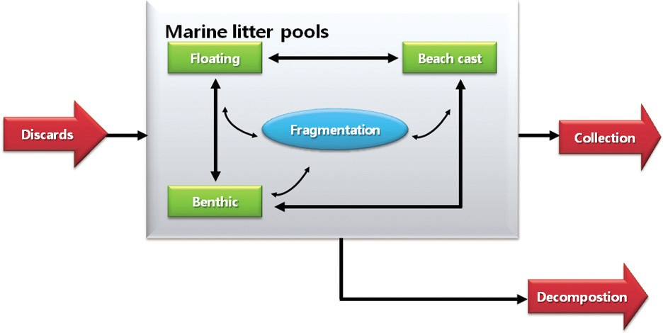<Figure 1> Schema Representing the Lifecycle of Marine Litter
Source: UNEP/IOC Guidelines on Survey and Monitoring of Marine Litter, 2009.

strategy of the management, by improving survey and data collection skills needed for precise estimation of annual amounts of marine litter such as the analysis of hyperspectral images gained from air photos, and expansion of survey locations. The 2nd Basic Plan, at the same time, will contain more refined schemes and roadmaps needed for effective implementation of the Basic Plan in various sub-areas-for instance, effective labor-division among governmental organizations and agencies, and implementation roadmap at stage and/or by year.
Contact Information Name: Park Sung-jun
- mail: sjpark@kmi.re.kr Tel: +82-2-2105-2973

03
Research Findings

Stable Securing of Fish Meals for Higher Competitiveness of Fish Farming

Purpose

•The global demand and supply imbalance on fish meals for fish farming have aggravated. However, Korea heavily relies on imported ones and has faced difficulties in securing fish meals, which raised urgent need for countermeasures.
•The goal of the study is to present measures for stable supply of fish meals, the raw material for feeds. Moreover, it aims to develop fish farming into a food industry and an export industry.
- For that purpose, the study analyzed global fish farming industry; its future prospects; the current and future fish meals supply and demand at home and abroad; case studies on global fish meals producers and consumers; pending issues for the supply and demand; and measures for stable securing of fish meals.

Methodologies and Feature

    - Methodologies
•The study analyzed domestic and international literature to evaluate the global fish farming industry and its prospects, domestic and international supply and demand for fish meals and fish meals producer and consumer nations.
•For the long-term prospects for domestic supply and demand of fish meals, the study conducted a quantitative study by scenario based on relevant statistics and expert surveys.
•It interviewed and surveyed experts to analyze supply and demand prospects, problems of fish meals and compound feed as well as to explore improvement measures.
•The study conducted domestic field visits for expert opinion and visited global fish meals exporters, such as

Peru and Chile, for an assessment on the local condition and policies.

Foundation for Stable Fish Meals Import

Higher Self-sufficiency of Domestic Fish Meals
Goal

Stable Securing of Fish Meals for Fish Farming

(43,000 tons (2011)-> 122,000 tons (2016)-> 200,000 tons (2020))
Strategies
•As for fish meals use and relevant policies of Japan, a fish importer, the study conducted a joint study with Professor Sato Shuichi at Tokyo University of Marine Science and Technology.

    - Feature
•The study put focus on stable securing of fish meals, kind of raw materials which determine growth of fish in fish farming.
•It employed various research methodologies to analyze pending issues and effective measures, including current domestic and international supply and demand, quantitative analyses on fish meals supply and awareness investigations.

Results

    - Summary
•The pending issues of domestic fish meals supply and demand are as follows;
- First, reduction of fish for fish meals production; second, strengthened resource management at fish meals producer nations; third, increased dominance of fish meals importers over international fish meals market; fourth, import structure vulnerable to domestic and international conditions; fifth, weak bargaining power against fish meals export nations; sixth, low quality and low production of domestic fish meals; seventh, fish farming practice dependant on live feeds
•The study presented the goal and strategies to stably secure fish meals for fish farming as follows;

•The basic direction and short-term/long-term measures for stable securing of fish meals are as follows;

Stabilization of fish meals supply
Expansion of fish meals use foundation
R&D expansion on fish meals
●Stronger cooperation with fish meals producers and local market entrance
●Diversification of fish meals trading nations
●Collection and supply of domestic and international fish meals supply and demand
●Connected to policies for more use of compound feeds
●System improvement for fish meals and feed
●Organization of compound feed companies for fish farming
●Higher use of domestic fish meals
●Development of fish meal alternatives, low fish meals or non-fish meals
●Development of green fish or breeding technology
Basic Direction

●Stable securing of fish meals importers and establishment of the supply and demand monitoring system
●Policies to boost using of compound feeds and expansion of relevant fish meals use
●Higher competitiveness of fish meals and compound feeds through selective and intensive R&D
Implementation Measures

•The following are policy measures to implement the aforementioned measures on policies.
- First, strengthening of fish meal supply and management system; second, establishment of the fish farming feed association (tentatively named); third, establishment of the fish farming feed purchase fund; fourth,

03. Research Findings 13

improvement of the Feed Management Act; fifth, R&D in alternative feeds and cooperation expansion

    - Policy contribution
•By encouraging the use of compound feed for fish farming, the study will contribute to stabilizing seafood supply.
•The study results, such as stable supply of fish meals, more use of fish meals, R&D in fish meals, can be used to prepare feasible policies to secure fish meal.

    - Expected benefits
•Stronger competitiveness of the fish farming industry through stable management of fish farming and facilitation of feed companies
•Securing the stable supply foundation for domestic seafood
•More export of the Major 10 Strategic Items

Contact Information Name: Kim, Dae-Young et al. E-mail: mobydick@kmi.re.kr Tel: +82-2-2105-2868

04

•An economic feasibility analysis on the Jukbyun and Gyojin port high utilization
•A study on the development of a yacht marine silk road
•A roadmap for port private projects in the long term
•A validity study on car-only terminals at Pyeongtaek-Dangjin Port
•Detailed planning for species development of halibut for export
•2012 economic development experience sharing: policy advice to Equatorial Guinea
•A validity study on Gunsan port 7 terminal (75 berths) development
•A validity study on the Banguhjin, Gusipo port high utilization
•A study on improvement of regulations and guidelines for uninhabited islands
•A study on foundation establishment for CO2 capture and marine storage
•Overhaul of passenger boat charge support system for island inhabitants
•A study on the Hadong port basic plan
•Northeast Asian port competition and cooperation preparing for international changes
•Hwasung coastal management local plan
•The study on fisheries basic system improvement
•A study on system improvement for the marina industry development
•Direction for national maritime policies for the era of per capita income 40,000 dollars
•A validity study on the port logistics and economic feasibility of Cambodia port development
•A validity study on the design of Jeju port (coast guard)
•A basic plan for modernization of cargo handling equipment at port
•Feasibility analysis on port private investment and management measures
•The 2nd stage project for the establishment of shipping market information networks
•The study on establishment of Korea-Asia inland integrated logistics system
•A study on effective management of Busan passenger terminal and other public facilities
•A study on effective public facility management such as Busan passenger terminal
•A study on mid-and long-term development strategy establishment

Research Projects

•2012 conservation study of marine species under protection
•Standard manual and guidelines for marine port establishment and management
•Impact of radioactive substance concentration on fisheries products and case study
•Systematic response to international conventions for overseas biological resource cooperation
•Fundamental technology research for u-shaped shipping, logistics system
•A study on the pacific oyster seed production technology development
•A validity study on establishment of offshore plant support stations
•A validity study on offshore plant supporting bases
•Establishment of maritime environment standards and improvement (6th)
•A study to facilitate marine tourism and leisure activities
•Development of eco-friendly aquaculture of river puffer
•A guide book for human resources in maritime affairs and fisheries
•A study on improvement of port and fisheries damage compensation
•Core technology development for national marine ecosystem comprehensive management
•Establishment of Dokdo Digital Archive (DDA)
•Land based pollution management and total pollution loads management in Masan Bay special management waters
•An analysis on polar policies of major nations and international organizations
•A policy analysis on polar Arctic/Antarctic policies of major nations and international organizations
•Climate change impact analysis model-fisheries sector (1st year)
•Ulneungdo and Dokdo maritime and fisheries long-term development plan
•Local model development for profit sharing and approach for biological resources
•Information on overseas market for offshore plant and service industry

•Technology development to deal with jelly fish
•An analysis on the mudflat fisheries damaged by oil spill
•2013 international logistics investment analysis center
•Operation of the International Logistics Investment Analysis Center (2013)
•The 2nd master plan on ocean waste management
•Consigned operation of 2013 Shipping, Port, Logistics Information Center homepage
•2013 National Transportation Survey and Database
•The seashore cadastral survey and management type categorization

International Cooperation
05

2013 KMI-FIO Marine Cooperation Seminar
- Time & Place: March 12, Xiamen, China
- Topics: Island development, coastal management policy and Korea-China cooperation measures
- Participants: FIO, TIO (the 3rd Ocean Research Center), Mokpo Univ., Xiamen Univ. and Mok Jin-yong (research fellow, KMI)

Neal-Net Technical Meeting
- Time & Place: March 19 ~20, KMI
- Topics: Technical issues on NEAL-NET unified user authentification and management
- Participants: Kim Soo-yeob (director, shipping policy research div.) and logistics experts from Korea, China and Japan
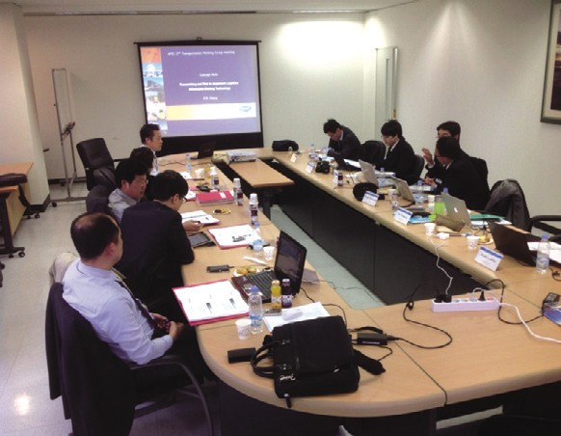
Source: KMI

Presentation at the 1st International Clean Port & Green Growth Conference
- Time & Place: March 20, press center
- Presentation: ‘Effect of building a green port and its development strategy’ (by Kim Woo-sun, senior researcher, KMI)

Seminar on Development of a Comprehensive Transport and Logistics Network in North-East Asia Subregion
  - Time & Place: March 21~22, KITA
  - Purpose: Case presentation and discussion on multimodal transportation networks
  - Topics: Seminar on development of a comprehensive transport and logistics network in
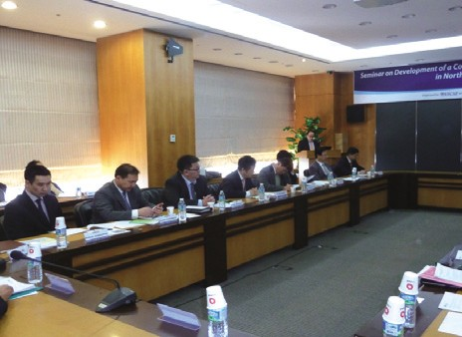N.E. Asia subregion
Source: KMI

Visit by Officials of Chulalongkorn University (Thailand)
  - Time & Place: March 27, KMI
  - Topics: Cooperation between KMI and Chulalongkorn Univ. in maritime affairs

The International Seminar on the Pan Yellow Sea Port & Logistics Cooperation
- Time & Place: March 28, Tianjin, China
- Purpose: Case presentation and discussion on multimodal transportation networks
- Topics: Port and logistics development in Pan- Balhae area and Korea-China cooperation measures
- Participants: Tianjin government, logistics purchasing association, Nankai Univ. logistics companies, KOTRA, KITA and manufacturing companies

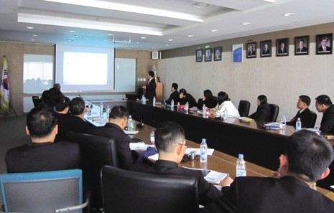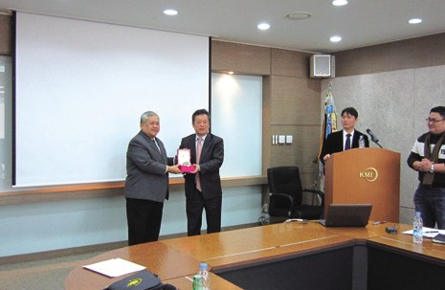
Source: KMI
Source: KMI

Major Activities Conducted in March, 2013

News & Announcements
06

The 11th KMI Special Lecture (3rd, 2013)
- Time & Place: March 4, KMI
- Topics: “See your mind- laws of communication” (by Kim Chang-oak, Seoul Womens Univ.)
- Participants: All employees of KMI and others
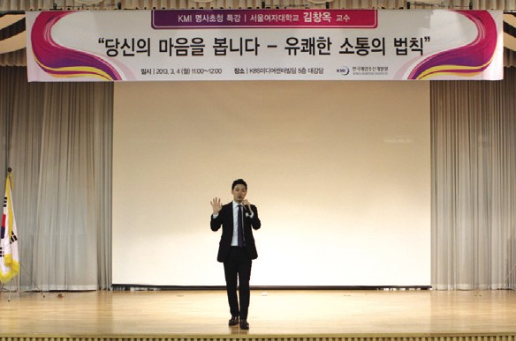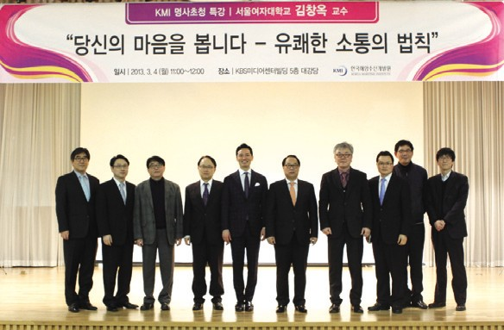
Source: KMI
Source: KMI

The Colloquium by Dokdo-Marine Territory Research Center
- Time & Place: March 8, KMI
- Topics: Expansion of marine economic territory
- Presentation: Yang Hee-chul (KIOST)

A Seminar on Marine Ecosystem under Climate Change
  - Time & Place: March 19, KMI
  - Presentation: Dr. Kim Tae-won (Monterey Bay Aquarium Research Institute, US)
  - Participants: Nam Jung-ho (research fellow, KMI), members of Korean Society of Oceanography and Korean Society of Marine Environment Energy

MOU Signed between KMI and Korea Transportation Safety Authority (TS)
  - Time & Place: March 19, KMI
  - Topics: MOU on transportation safety and maritime and fisheries development
  - Participants: Kim Hak-so (president, KMI) and Chung Il-young (president, TS)
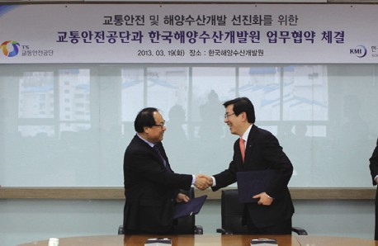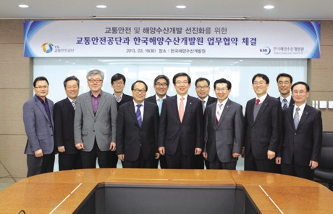
Source: KMI
Source: KMI

The 4th Anniversary Symposium of Gwangyang Bay Area Free Economic Zone Authority
- Time & Place: March 21, Gwangyang
- Topics: Ways to invigorate Gwangyang Port

MOU Signed between KMI and Busan Development Institute (BDI)
- Time & Place: March 22, Busan Lotte hotel
- Topics: Research exchange and cooperation
- 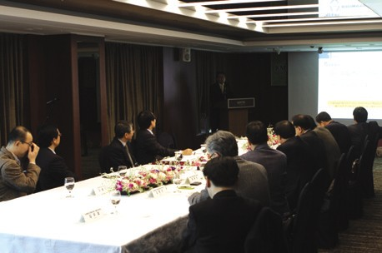Participants: Kim Hak-so (president, KMI) and Lee Eon-oh (president, BDI)
Source: KMI
Source: KMI

The Commemorative Seminar on the Reviving of the Ministry of Oceans and Fisheries
-Time & Place: March 22, Busan Lotte hotel
- Topics: ‘5 Major strategies for the development of Busan’s ocean economy’
- Participants: Kim Moo-sung (former assemblyman), Oh Guh-don (president, Sea Power League of the Republic of Korea), Lee Younh-hwal (economy vice major, Busan city), Lee Jeong- hwan (president, Korea Coastal Management Association), Kim Hak-so (president, KMI), Lee Jong-gu (president, National Federation of Fisheries Cooperatives), Woo Yeh-jong (president, Busan Regional Maritime Affairs and Fisheries), Kang, Shin-gil (president, Port Industry CEO Forum), Park In-ho (Co-chair, National Movement Headquarters for Revival of Ministry of Maritime Affair and Fisheries) and Lee Eon-oh (president, BDI)

The 3rd Shipping Logistics Company Conference
- Time & Place: March 27, KMI
- Topics: Logistics companies’ foreign market entry and joint entrance into ambatovy mineral development
- Participants: MLTM, KMI, major shipping and logistics companies

MOU Signed between KMI and Korea Maritime Foundation (KMF)
- Time & Place: March 28, KMI
- Topics: Cooperation in maritime affairs
- Participants: Kim Hak-so (president, KMI) and Lee Bu-sik (president, KMF)
Source: KMI

Source: KMI
Source: KMI
Source: KMI

06. News & Announcements 21

Major Activities Planned in April, 2013

Lecture on Maritime and Fisheries Policies of the New Government
- Time & Place: April 2, East Sea Rim Headquarters, Kangwon
- Lecturer: Kim Sung-gui (senior research fellow, KMI)

2013 2nd Korea-Myanmar Ocean Forum and Opening of Korea-Myanmar Ocean Research Center
- Time & Place: April 3, Myanmar Maritime Univ. Chatrium Hotel
- Topics: Sustainable ocean cooperation and ocean alliance in the Asia Pacific
- Participants: Kim Hak-so (president, KMI), Kim Sung-jin (president, Hankyung Univ.), U Han Sein (vice minister, Ministry of Transportation) and Myat Lwin (president, Myanmar Maritime Univ)

The 12th KMI Special Lecture (4th, 2013)
- Time & Place: April 8, KMI
- Topics: “Unpredictable harmony of Physical strength, Generosity, Knowledge” (by Yoo Young-man, Hanyang Univ.)
-Participants: All employees of KMI and others

The Workshop on Philippines-China Arbitration Trial
- Time & Place: April 11, Seoul station
- Participants: Lee Geun-gwan (professor, Seoul National Univ.), Park Young-gil (senior researcher, KMI) and others

The 3rd Anniversary Commemorative Seminar by KMI-KMU International Logistics Joint Research Center (publication of a series of international logistics)
-Time & Place: April 12, Busan Comodo Hotel

The Seminar on Shipping, Shipbuilding and Steel
- Time & Place: April 16, TBD
- Presentation: ‘Global shipping market forecast and cooperation among relevant industries’ (by Hwang Jin-hoi, director, KMI)

The 29th Anniversary of KMI Foundation
- Time & Place: April 17, KMI
- Presentation: All employees of KMI

The Special Lecture at KITA
- Time & Place: April 24, KITA Busan Headquarters
- Lecture: ‘Korea’s logistics industry and policies’ (by Kim Hong-mae, senior researcher, KMI)

MOU with Gwangyang Free Economic Zone Authority (GFEZ)
- Time & Place: April 25, GFEZ
- Topics: Overseas joint marketing, direction to facilitate Gwangyang Port
- Participants: KMI, GFEZ, Gwangyang city and YGPA

Publisher
Kim, Hak So - President, Korea Maritime Institute

Editor-in-Chief
Choi, Jae Sun - Director General, International Cooperation & Public Relations Division

Editorial Board
Kim, Woo Ho - Director General, Maritime Industry & Logistics Division Kim, Hyoung Geun - Director General, Port Research Division
Mok, Jin Yong - Director General, Marine Policy Research Division
Joung, Myung Saeng - Director General, Fisheries Policy Research Division

Secretary
Kwon, Hye Jin - International Cooperation & Public Relations Division Chung, Kyung Hwa - Planning & Coordination Division

Contact Information
Address: 21F KBS Media Center Bldg., #45, Maebongsanro, Mapo-gu, Seoul, 121-915, Korea
Tel: +82-2-2105-2733, 4901
Fax: +82-2-2105-4990
Email: jschoi@kmi.re.kr, kwonhj@kmi.re.kr

