ISSN 2093-3584

The KMI News Letter
Ocean & Future

January, 2014. Vol.46

- Opinion
  - Coastwise Passenger Transport Services and an Aging Society

- Ocean Policy
  - The Arctic Policy Master Plan of Korea
  - The Informal Consultation Meeting of the 68th UN Sustainable Fisheries Resolution in 2013 and Its Implications

- Research Findings
  - A Study on the Establishment of Greenhouse Gas Inventory for Coastal Transportation Mode
  - A Study on Policy Measures to Facilitate Marine Leisure Activities

- Research Projects

- KMI News & Events

Coastwise Passenger Transport Services and an Aging Society

Introduction

Korea is fast aging, with an increasing share of those aged 65 years or older in population. Accordingly, Korean government implemented a variety of policies for their better connectivity and accessibility to public passenger transport services in land. It enacted the Act on the Support and Promotion of Utilization of Mass Transit System and other regulations which aimed to help the senior to easily use public transport services. Even though demographic structure at archipelagic areas such as Shin-An of Chonnam Province in Korea showed severer tendency of aging than other areas (Figure 1), coastwise passenger transport services have been rarely approached from the view of accessibility by ‘the mobility disadvantaged persons’ such as senior citizens and pregnant women.
Persons and the Act on the Support and Promotion and Utilization of Mass Transit System. The former aimed to help ‘mobility disadvantaged persons’ to freely move and use transportation by expanding convenient transportation equipment and passenger facilities. In particular, the act defined ‘mobility disadvantaged persons’ and held the state and local governments responsible for providing more convenient and easier transportation service for them. Under the Act, passenger transport service providers could offer service such as low deck buses.

The latter defined public passenger transport services and introduced the Basic Plan on Public Passenger Transport Services, nationwide transport card and other policies. It tried to improve connectivity and transit transfer process of public passenger

<Figure 1> Assistance Center of Shin-An District at Mokpo Passenger Terminal

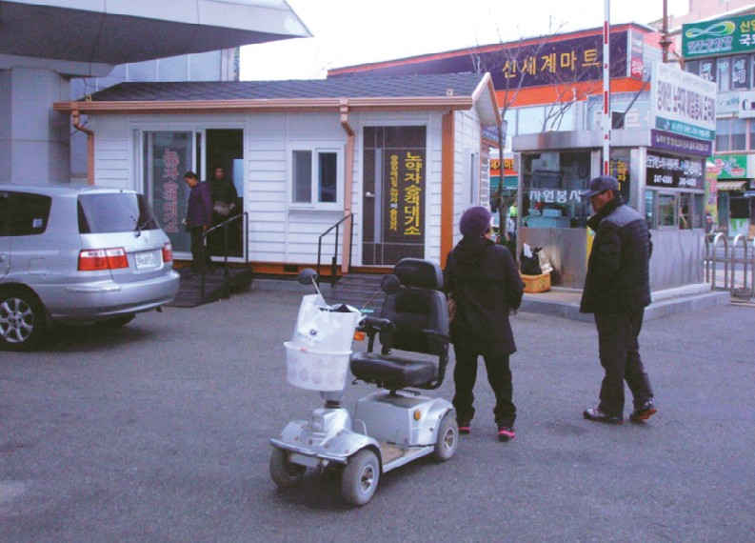

Case study-Land transportation services and Japanese cases

In land passenger transportation services, two major acts were enacted in 2005 for ‘mobility disadvantaged persons’ and the public; The Act on Promotion of Transportation Convenience of Mobility Disadvantaged

transport services by enhancing the quality and frequency of transportation. However, under the Act, public passenger transport service did not include coastwise passenger transport service.

Japan has various programs for ‘mobility disadvantaged persons’ in every transportation mode,

<Table 1> Financial Aids for Vessel Structure Change

Shipping route or port facility Portion of Financial aids

Aided route | Below 70% of vessel price
General route | Below 60% of vessel price
Passenger terminal | Below 50% of costs
Source: Foundation for Promoting Personal Mobility and Ecological Transportation of Japan (2013), KMI (2013)

including coastwise passenger transport service. Those aged 65 and over in Japan will account for least 25% by 2015. In preparation for aging society, Japan enacted the Act on Assistance and Promotion of Mobility for the Aged, the Disabled and Others, so-called the Barrier Free Act in 2001. According the Barrier Free Act, the Japanese government built policy targets and implemented policies for normalizing the mobility for marginalized people as for transportation service. In contrast to legislative scheme in Korea, such as the Act on the Support and Promotion and Utilization of Mass Transit System which did not include the coastwise passenger transport services as part of public passenger transport service, the Japanese Acts included many policy agendas on coastwise passenger transport services. Moreover, Japanese government provided financial and tax aids for coastwise passenger transport service providers which change vessel structure for ‘mobility disadvantaged persons’ (Table 1).

Draft of the Act on Encouragement of Coastwise Public Passenger Transport Services

The National Assembly in Korea made and discussed a draft of the Act on Encouragement of Coastwise Public Passenger Transport Services in 2013. The draft included the Basic Plan on Coastwise Public Passenger Transport Services, duty of the government and municipalities, construction of port facilities such as berths and terminals, ticketing system, and others. Although the draft is a first trial to approach coastwise public passenger transport services in view of public transport services, it underestimates fast aging population in archipelagic areas. The draft mainly describes better accessibility of ‘mobility disadvantaged persons’ to vessels. It is important to improve accessibility in multimodal transport modes and transportation junctions such as passenger terminals
and berths. But it is as much important to renovate passenger vessels.

Conclusion

Archipelagic areas in Korea have larger share of aging population than lands or urban areas. Therefore, we should develop more integrated plans and implementation programs for aging population in communities. The draft of the Act on Encouragement of Coastwise Public Passenger Transport Services in 2013 needs more detailed implementation programs which target the aged and disabled.

Park, Yong-An
Research Fellow at Maritime Industry & Safety Research Division

The Arctic Policy Master Plan of Korea

On December 10, 2013, the Korean government announced its framework of Arctic policies titled ‘The Arctic Policy Master Plan.’ The master plan detailed about sectoral Arctic policies until 2017 since Korea was given permanent observer status at the Arctic Council on May 15 last year. As opening of Arctic routes gains momentum, Korea, a non-Arctic nation, emphasized contribution to international society and international cooperation. The master plan includes 31 tasks, such as ① 8 tasks in international cooperation,
② 11 tasks in scientific research and study, ③ 10 tasks in Arctic business and ④ 2 tasks in rules and regulations.

The Arctic requires joint protection by the humanity before being a place with enormous economic values. Therefore, Arctic policies highlight responsibilities of an observer nation, such as scientific research for environmental protection and support for indigenous community. Under tasks in international cooperation, participation of private and public experts in the six Working Groups under the Arctic Council will be planned. ‘Arctic policy consortium’ will be proposed to other Asian observer nations, such as China and Japan and other cooperation measures in common interest areas will be prepared. For scientific research and study activities in the Arctic, the Korean government is reviewing possible building of a 2nd ice breaker as a follow up to the Araon which was built in November 2009. ‘The Korea Arctic Research Consortium (tentatively named)’ is scheduled to be
launched in mid 2014 with participation from relevant research institutes and private companies. The consortium will boost information sharing, international joint research and cooperation in the Arctic. Tasks in Arctic business are about creating new opportunities prepared for commercialization of Arctic routes. In order to lure more ships and cargoes coming in and out of Korean ports via Arctic routes, port charges will be cut down and volume incentive system will be introduced from next year. Cooperation with Russia, the key player in Arctic routes, will be strengthened for major port development. Resource development and research cooperation with Denmark, Greenland and so forth will be emphasized as well. In fisheries sector, cooperation with Arctic coastal states is to be given a boost and Industry-University-Institute joint research will be planned.

The Arctic Policy Mater Plan will become a ‘legal plan’ from next year, as a backbone for Arctic policies. Strategic cooperation among relevant nations for Arctic resource development and securing routes will help Korea to lead discovering of Blue Ocean in maritime and fisheries sector. Moreover, synergy effects in new ocean industry can be maximized when it has strong support from research, exploration and technology development in polar and deep seas.

Choe Yung-sok
Senior Researcher at Strategy Research Division

The Informal Consultation Meeting of the 68th UN Sustainable Fisheries Resolution in 2013 and Its Implications

Introduction

An informal consultation meeting was held at the UN headquarters in New York from November 12 to 19, 2013 to review proposed fisheries resolution for the 68th UN General Assembly. Member nations discussed various fisheries issues at this review meeting which
was regarded as an important leader in international fisheries order. I participated in the meeting as a member of the Korean governmental delegation, providing consultation in international laws and negotiation. The following analyzes the major discussions along with their implications and proposes domestic responsive measures. 1)

Summary of Discussions

The gist of fisheries resolutions adopted at the 68th UN General Assembly in 2013 is as follows;

First, the UN General Assembly understood that climate change and global financial crisis will adversely affect sustainability of global fisheries and food safety and called for effective use of natural resources. Second, although some advanced nations tried to add provisions on eradication of organized crime, murder, human trafficking and drug trade possibly generated from IUU fishing activities through the INTERPOL, the efforts failed this time as in 2012 due to strong opposition from some countries. However, such efforts will continue in the future. Third, as for shark finning, a hotly debated issue internationally, the EU argued that sharks should be brought back to port naturally with the fin attached and this was right for marine resources conservation measure. However, the argument was strongly opposed by shark fishing nations. However, the EU made it clear that it would continue with its efforts. Fourth, as for regulations on bottom fisheries, a review meeting on implementation evaluation is scheduled in 2015, the same as under the 67th fisheries resolution in 2012. Therefore, it is important to faithfully carry out international and domestic regulations on bottom fisheries before the coming evaluation.

Implications

The launch of Project SCALE on IUU by the INTERPOL implies that international governance and regime on IUU activities are changing greatly. In other words, trends seem to shift to stronger crack down on IUU activities through international coordination in criminal matters, away from counter measures through cooperation with flag states and coastal states, port state measures or efforts by regional fisheries organizations or international organizations such as FAO.

Although market is a very effective and desirable tool to regulate IUU activities, international society seems to think that it is not enough to address IUU

activities. This explains why international society has changed to prepare IUU control system at its production level. As involvement of the INTERPOL comes true, detailed research on domestic implications by such move is required. It is also desirable that domestic responsive measures are prepared based on the research.

As for shark fining, Korea prepared the National plan of Action (NPOA)-Shark according to the International Plan of Action (IPOA)-Shark for its protection and management. However, the Korea’s current Deep Sea Industry Development Act does not stipulate details on its resource conservation measures or regulation of catching methods. Relevant regulations should be prepared and implemented to prevent finless bodies of sharks from being discarded into the sea and eventually for protection of the environment and marine biological resources. At the same time, constant policy efforts should be made to address other problems involving shark fishing, such as safety of ship crews or storage issues within the fishing boats.

The UN working group on Biodiversity Beyond areas of National Jurisdiction (BBNJ) will decide details of international instrument. For that reason, some of its regulations can affect domestic ocean industry. For instance, ‘no fishing zones’ can be established according to stages of marine protection zones. Therefore, it is necessary to comprehend discussions and actively participate in international debate to protect national interests. Although the discussions cover various areas, including diplomatic and maritime affairs, their implications can reach Korean deep sea industry. Accordingly, responsive measures are urgently needed for domestic fisheries sector. Since the meeting aims to establish international legal regime, it is important to conduct relevant research with experts in international laws as well as those in maritime and fisheries field.

Meanwhile, other governmental delegations to the fisheries resolution consultation meeting had regular expert participants who grasped background and discussion contents over years. They accumulated know-how and experience from continuing

- For details, please refer to “A Study on the Analysis of Informal Consultation Meeting of the 68th UN Sustainable Fisheries Resolution in 2013 and Related Domestic Policy Countermeasures” (by Han, Deuk-hoon) The Journal of Maritime Business, 2013.12.30.

participation in the same meeting and built broad fellowship. Based on this, they prepared bilateral and multilateral negotiations, trying to maximize interests of their countries, which provided implications to Korea. Korea should not save efforts in cultivating international negotiators who would represent national interests at international meetings in fisheries sector, including the informal consultation meeting on UN fisheries resolution.

Conclusion

Given its impacts on international fisheries order, the consultation meeting on UN fisheries resolution is one of the most important meetings in the field. Preparations for the meeting, analyses on the agendas, participation and the results should be effectively

shared and spread between the private and the public so that academia, private sector as well as government get a hold of trends in international maritime and fisheries order. For that purpose, human resources for international negotiations should receive lots of support and cultivation. In order to help domestic fisheries order go abreast with international trends, those studies need to produce tangible achievements which will become the basis for responsive policies. If intensified regulations under international fisheries order are one pillar, other pillars should be about restructuring of private sector and other improvement measures for sustainable development of the industry.

Han, Deuk-hoon
Senior Researcher at Fisheries Policy Research Division

RESEARCH FINDINGS
A Study on the Establishment of Greenhouse Gas Inventory for Coastal
Transportation Mode
1. Purpose
measures for green house gas reduction.
•The study aims to present measures to build a
greenhouse inventory suitable for coastal transportation by considering characteristics of coastal transportation, greenhouse gas emitting activities, emission amount and greenhouse gas reduction plans.
2. Methodologies and Feature
1) Methodologies

•To use methodologies of other industries or transportation modes for their greenhouse gas inventory establishment
•It proposes effective management measures for greenhouse gas inventory, such as inventory certification, its support and human resource training along with the inventory establishment.
•To analyze the inventory of Japanese coastal
transportation modes and management policies
•To hold advisory meetings and seminars with
•The study seeks usage measures of the inventory experts and managers of greenhouse gas since it can be used in preparing various policy

Feature

•The study is focused on developing a greenhouse gas inventory adequate for coastal transportation mode and seeking its use strategies for greenhouse gas reduction.

3. Results

Summary

•A greenhouse gas inventory indentifies, records, maintains and reports all types of greenhouse gases according to their emission sources. Therefore, the inventory is the basic for greenhouse gas reduction.

•The greenhouse gas management target is carried out on the premise that the inventory already exists. Thus, the Korean government mandatorily requires all target companies to build their own greenhouse gas inventories.

  - Since there are no guidelines for greenhouse gas inventory of coastal shipping, it is important to prepare guidelines and inventory specifications for coastal shipping.

•Governmental supports should be prepared for inventory manuals, verification or certification of the inventory, employment of those who manage the inventory and other activities.

  - Moreover, separate supports should be provided for shipping companies which build their inventories.

•Only five companies are participating in the green house management target, which puts limit on greenhouse gas reduction. Therefore, greenhouse gas reduction plans should be practical.

  - Participation in the target system firstly requires establishment of inventories. Therefore, companies with many vessels should receive support for inventory establishment and be encouraged to join the management target system.

•The following policy support are necessary to

increase participation of companies in inventory establishment and the management target system.

- Statistics on sailing distance of coastal ships should be developed for exact estimation of their greenhouse gas emissions.
- The modules can be divided into the Fleet Module for ship data management, the Transport Activity Module for sailing characteristics management, and the Emission Module for energy consumption and emission coefficient management.
- Firstly, an inventory for costal shipping companies should be developed with support, and then a certification system for the inventory needs to be introduced. Companies which are certified should receive support as well.
- The Korea Shipping Association should be equipped with and operate a center for greenhouse gas inventory. And the necessary money needs to be provided.

Policy contribution

•The study will help the government to prepare policies for inventory establishment and greenhouse gas management of coastal transportation mode.

Expected benefits

•The study can be used as the basic material for greenhouse gas reduction policies of the government. Its emission estimation methods according to green emission activities will help to prepare greenhouse gas reduction measures for coastal transportation modes.

- In particular, the measures for greenhouse gas inventory management will be a great help to meet governmental reduction targets, including the management target.

•The study categorized greenhouse gas emission activities of the shipping sector (Tier 1, Tier 2 and Tier 3), proposed methodologies to analyze or use data of emission activities and presented ways to estimate greenhouse gas emissions. In this regard, the study is of value as the basic research for greenhouse management.

•The guidelines of the study will help coastal shipping companies to voluntarily build their greenhouse gas inventory and manage their greenhouse gas emissions.

Chun Hyung-Jin
Associate Research Fellow at Maritime Industry &
Safety Research Division

A Study on Policy Measures to Facilitate Marine Leisure Activities

Purpose

- The study analyzed basic conditions of domestic marine leisure activities including obstacles against them and evaluated foreign cases. Based on the result, it presented policy direction and institutional improvements to invigorate marine leisure activities, particularly skin scuba diving.

  - Based on an analysis on basic environment for marine leisure policies and the current status, the study suggested policy measures to facilitate marine leisure activities.
  - It suggested establishing a tourism business model for fishing villages by proposing transportation modes for marine leisure activities, safe leisure space, sound diving culture and measures to resolve conflict with fishermen.

Methodologies and Feature

Methodologies

•A basic environment analysis using a literature review on national policies for marine leisure activities and statistics collection

•A case study using an analysis on foreign cases, such as relevant system and its operation in Japan, Australia and the US

•Surveys and interviews with domestic marine leisure businesses, general public and other marine leisure participants as well as expert consulting

Feature

•The study focused on preparing institutional improvement measures for active tourism activities
on the sea, particularly for skin scuba diving. Moreover, it prepared business models for marine leisure businesses at fishing villages to create additional income sources and to expand exchanges with cities.

•The study proposed policy improvements after analyzing basic condition and domestic and foreign cases as well as conducting surveys with businesses and the general public.

Results

Summary

•The result showed that the basic condition is so weak to induce public participation in marine leisure activities, including skin-scuba diving.

  - Negative images about skin scuba diving at domestic seas, such as limited space, high costs along with concerns for safety accidents discouraged public participation.
  - Healthy and sound diving culture was not established due to conflict with fishermen, resource degradation and limited transportation modes.

•The study encouraged popularization of marine leisure activities through better public awareness and spaces for activities. The institutional improvement and infrastructure for skin-scuba diving can contribute to developing a new kind of tourism business model.

  - Scuba diving caused tension with fishermen as divers trespassed fishing grounds or stole fishery products. As a way to resolve conflicts with fishermen, the study proposed scuba diving

focused on sight-seeing and a tourism business model linked with fishing villages.

•The study suggested improvements and policy measures for popularization of marine leisure activities.

    - Improvement measures: PR projects for healthy and sound diving culture, designation of recreational fishing grounds for leisure activities and guidelines for user safety
    - Policy measures: Building up basic statistics on marine leisure activities, transportation modes (Water-related Leisure Activities Safety Act), user safety rules and designation of marine leisure activity grounds

Policy contribution

•The study can be used as the basic material in setting policy direction for active tourism at fishing villages and marine leisure activities.

Expected effects

•The study helps to expand the base marine tourism by improving convenience of marine leisure participants.

  - It will improve public awareness and interest in marine leisure activities, contributing to facilitating marine tourism.

•It helps to build a new tourism business model and promotes mutually constructive growth with marine leisure participants.

  - The study contributes to fostering relevant service businesses through its marine leisure development measures and improving income of fishermen.

Hong Jang-Won
Associate Research Fellow at Marine Policy Research Division

RESEARCH PROJECTS

•Responses to the UN Fisheries Resolution
•A study on FTA direct damage relief system improvement
•Responsive measures to Korea-China FTA (coastal fishing)
•Ulneungdo and Dokdo maritime and fisheries long- term development plan
•A validity study on building type aquaculture project
•A study on inland public water management system
•A study on WTO/SPA shipping service negotiation
•A study on response to WTO/SPA negotiations
•A study on Bukhang rent system improvement and normalized operation
•Local model development for profit sharing and approach for biological resources
•A white paper on pilot sea ranching projects
•A study on economic validity of pilot sea ranching projects in Taean, Uljin and Jeju
•Information on overseas market for offshore plant and service industry
•A review on the 1st national port security plan
•HS-code matching and implications with regards to Korea-China Fisheries FTA negotiations
•Technology development to deal with jelly fish
•A study on the establishment of national seaborne highway networks
•An analysis on the mudflat fisheries damaged by oil spill
•Development of biz models according to FTZ
•Operation of the International Logistics Investment Analysis Center (2013)

•A study on foreign markets for aqua-pet
•Measures for ocean accident statistics advancement
•Measures for better maritime accident statistics
•A study on better fishing ground management and institutional improvement measures
•A study on management of designated waters for fisheries resource and fishing ground purification
•Strategies for active export of Korean halibut
•A study on offshore plan professional development
•An analysis on investment candidate cities such as joint investment into west Africa
•The 2nd master plan on ocean waste management
•A study on strategic cooperation measures among Arctic coastal states
•A study on the 2nd maritime tourism promotion basic plan
•Consigned operation of 2013 Shipping, Port, Logistics Information Center homepage
•2013 National Transportation Survey and Database
•Global network to strengthen maritime territory including continental shelf
•Global networks to strengthen maritime territory, including continental shelf
•Cargo Preference and Restriction Applying to Specific Trades
•2013 Korea-Georgia Invitation Training (Black sea)
•A study on locational validity of marine leisure facilities
•Shipping tax improvement to sharpen competitiveness of the shipping industry
•Operation of fishing boat trade system and introduction of fishing boat lease
•The seashore cadastral survey and management type categorization
•A study on preparation of the 2nd ocean going industry development plan
•A study on tailored support for fisheries income and welfare increase
•Sectoral advancement measures for mutual growth of deep ocean industry
•System improvement to eradicate illegal fishing in deep ocean
•Negotiations for Gohyun port redevelopment
•A study on basic statistics supplementation of shipping, port and logistics industries
•A study on marine and fisheries 3.0 development model
•A study on better rate system and calculation of POSCO special cargo handling

•2013 entrusted operation of port demand prediction center
•The 2nd fishing village and fishing port development plan
•Mid-and long-term plan on maritime safety future technology
•A study on domestic commercialization of CO2 ocean storage
•A study on policies for domestic commercialization of CO2 ocean capture/storage
•TPP study in depth: fisheries sector
•R&D planning for integrated coastal management
•Measures to enter the shipping and logistics market in the Far East Siberia
•Support for private-government-industry-academia committee at Ulsan & Gwangyang coast
•A study on the basic planning of maritime territory management
•Analysis on Korea-Thailand, Korea-Malaysia FTA (fisheries sector)
•Development of coastal erosion response technology
•A study on fisheries distribution system improvement
•Measures to use waterside of Incheon Port
•Korea’s experience sharing with Saudi Arabia for its land or coastal aquaculture
•Policy measures for modernization of offshore fishing boats
•A study on fisheries entrance into the Arctic Ocean
•Introduction of total pollution load management system on Busan special management waters
•A study on overseas port development cooperation
•Issue development for response to international organizations in shipbuilding and ocean sector
•Foundation technology for the U-based shipping and logistics system-policies for container searcher use
•A validity study on small fishing grounds for fishing villages (Mayhyang 2)
•The basic plan on the operation of marine economic special zone
•Development of low carbon automation container terminal technology
•Korea-China-Japan transportation and logistics cooperation measures
•Foundation for self management fisheries cultivation and support
•A study on Busan Port Comprehensive Development Plan
•Tasks and direction for reciprocal fisheries relationship between Korea and Japan

Major Activities conducted in December, 2013

2013 KMI-SISI International Shipping Forum
- Time & Place: Dec 5, Renaissance hotel, Shanghai, China
- Topics: Feature of and prospects for world shipping economy

2013 Comprehensive Future Logistics Technology Forum
- Time & Place: Dec 12, Korcham
- Topics: Value of future logistics technology and future policy direction

Source: KMI

Source: KMI

The Policy Briefing for Reporters at the Ministry of Oceans and Fisheries
- Time & Place: Dec 23, MOF office
- Topics: 2014 global shipping outlook and major work plans of KMI

Source: KMI

SLOC Study Group (Korea)-KIMS-KMI Joint Conference
  - Time & Place: Dec 6, KIMS

The 20th KMI Special Lecture
  - Time & Place: Dec 9, KMI
  - Topics: Sultan and Emperor- A guy who dragged a boat to mountain
Source: KMI

Major Activities Planned in January, 2014

2014 15th Teachers Training
- Time & Place: Jan 6~10, 2014 (4 nights and 5 days), Yeosu EXPO marine park
- Trainees: 40 teachers from elementary, middle and high schools nationwide
- Contents: 10 lecture (20 hrs) and hands-on activities (10 hrs) in the Sucheon Bay, Yeosu-Gwangyang Port and EXPO marine park

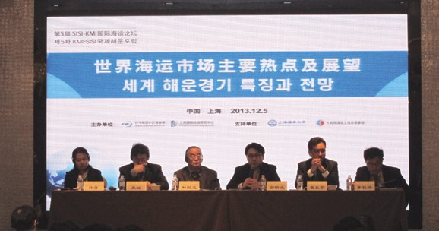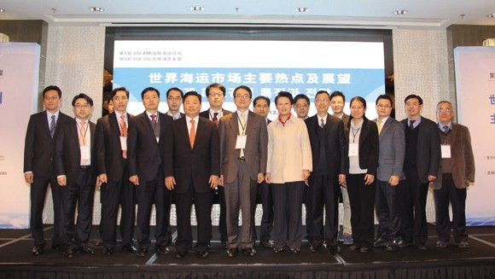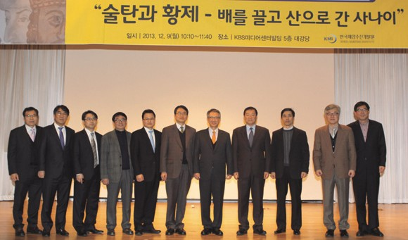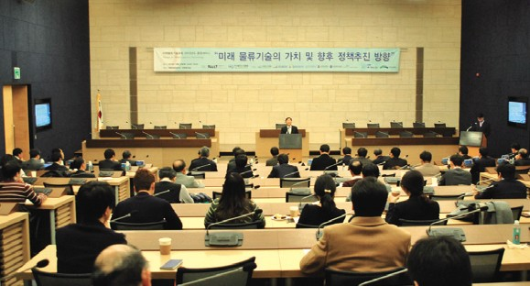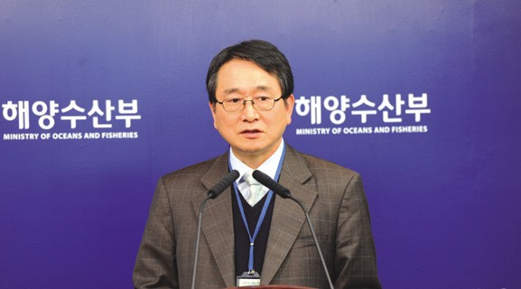

2013 KMI-UW Joint Research Workshop
  - Time & Place: Dec 10, UW, Seattle, the US
Source: KMI

2014 KMI Maritime and Fisheries Forecast Conference
- Time & Place: Jan 10, 2014, Korcham
- Topics: 2014 global maritime and fisheries trends and outlook

Publisher
Kim, Sung Gwi - President, Korea Maritime Institute

Editor-in-Chief
Choi, Jae Sun - Director General, Planning & Coordination Division

Editorial Board
Mok, Jin Yong - Director General, Marine Policy Research Division
Joung, Myung Saeng - Director General, Fisheries Policy Research Division Kim, Woo Ho - Director General, Maritime Industry & Safety Research Division Jun, Chan Young - Director General, Port Policy Research Division
Kim, Jong Deog - Director General, Strategy Research Division

Secretary
Kwon, Hye Jin - Planning & Coordination Division Chung, Kyung Hwa - Planning & Coordination Division

Contact Information
Address: 21F KBS Media Center Bldg., #45, Maebongsanro, Mapo-gu, Seoul, 121-915, Korea
Tel: +82-2-2105-2700 Fax: +82-2-2105-2800
Email: jschoi@kmi.re.kr, kwonhj@kmi.re.kr

