ISSN 2093-3584 December, 2011. Vol.22

- Opinion
  - Global Standards and Fisheries Industry
  - Strategic Cooperation and Specialization for Crisis Management

- Ocean Policy
  - Development Plan for the 10 Strategic Production Items

- Research Projects

- International Cooperation

- News & Announcements

01
Opinion

Global Standards and Fisheries Industry

Global standards refer to system, regulations and standards used globally to enhance effectiveness. The concept is being highlighted as globalization is carried out in virtually all areas, including politics, economics, society and culture. Consequently, the humanity shares an increasing number of mutual values. For example, issues such as climate change, food shortage, depleting resources, green movement and food safety have become international concerns.

As globalization carries on in the fisheries sector, the sector requires global standards due to the following reasons:

First, use and management methods of fisheries have changed as the UNCLOS (United Nations Convention on the Law of the Sea) took effect. Designation of EEZ (Exclusive Economic Zone) strengthened coastal nations’ rights to resource management, while putting limits on high seas fishing. As a result, close cooperation between coastal nations and nations for fishing operation became necessary to utilize fisheries resources. As the new international maritime order was introduced, nations had to establish new fisheries agreements and regional fisheries organizations, which required global standards.

Second, fisheries demand continued to increase globally, pushing upwards international fisheries trade. Rising fisheries consumption was attributable to better living standards and the emergence of a ‘well-being industry around the world. Korea also saw per capita fisheries supply jump 57% over the last 10 years, far exceeding that of meat (17%) and fruits (29%). China and other emerging economies have eaten away more fisheries products as they enjoyed higher income. Development of aquaculture also played a role: aquaculture made possible mass production of seafood previously reliant

on fishing. Mass production lowered prices and promoted consumption in turn. As consumption increased, the industry shifted the focus from domestic consumption and low-level processing to trade and high-level processing. Under such changing trade environment, more voices are raised for new industrial standards.

Third, multinational discount stores have expanded international distribution which horizontally integrated production, processing and consumption of fisheries products. This accelerated globalization of their value chains. Multinational companies are in desperate need of global standards since they opt for advanced processing, packaging, transportation technology for effective distribution and trade.

Fourth, FTAs (Free Trade Agreements) among nations are speeding up market opening. As of 2010, 292 FTAs were sought out around the world and 7 FTAs with 44 nations took effect in Korea. More FTAs translate into lower trade barriers and domestic fisheries regulations being adjusted with new standards for free trade. The more active the trade liberalization, the larger need for global standards.

If the future fisheries industry continues to secure competitiveness, a transition to the global system should be successfully done. In the process, global standards will play a pivotal role. Examples of international fisheries norms include: UNCLOS, the Code of Conduct for
Responsible Fisheries, Regulation on IUU fisheries (Illegal, Unregulated and Unreported Fisheries), eco-friendly fisheries certification system (Marine Stewardship Council certificating and organic aquaculture) and food safety management (SPS, CODEX, HACCP and traceability). As long as fisheries globalization is underway, new and various standards will continue to be introduced. In many cases, advanced nations, EU and international organizations such as WTO, UN, OECD, FAO took the initiative in bringing up issues and improving the relevant system and other nations followed. However, as developing nations, such as China, India and Brazil began flexing their muscles in production and trade, their norms took on importance as well.

While global standards of advanced nations are introduced, globalization strategies that reflect unique conditions of the Korean fisheries industry should be prepared. Domestic fisheries standards can become global standards if global partnership is built by securing overseas fishing ground and aquaculture. In particular, if regional major nations in fisheries consumption and production, namely Korea, China and Japan, establish a joint cooperation system, a ground work will be paved for synergy creation through information sharing, effective management of regional fishing ground, logistics and distribution standardization. Then, Korea’s voice over fisheries matters will be raised in Northeast Asia.

The current global standards are mostly proposed by advanced nations. Naturally, their implementation requires high level of science and technology and know-how on system operation. But developing or underdeveloped nations are ill-equipped in these areas and even advanced nations find it hard to implement them under their own industrial conditions. Therefore, national studies on validity and effectiveness should be done before introducing a new system and safety measures should be prepared to protect the domestic fisheries industry.
Contact information Name: Ahn, Jae-hyun
E-mail: jhahn@kmi.re.kr Tel: +82-2-2105-4926

Strategic Cooperation and Specialization for Crisis Management

Shipping Companies Rely on Strategic Cooperation as More VLCS Come In

The shipping market remained unstable as the world economy slipped into recession due to the sluggish US economy and financial crisis in Europe. More delivery of VLCS (Very Large Container Ship) pushed down shipping rates in Europe and the West Coast of the United States. In European routes, VLCSs were entering the market while seaborne transportation demand still remained slow. Therefore, ship oversupply will continue for a while. Global shipping companies have implemented aggressive management, sharpening their competitiveness to overcome the recession. For example, daily service by Maersk, the world’s largest shipping company, and strategic cooperation of the MSC and CMA CGM, the second and third runners, sent great shock waves throughout the market. Last year, shipping companies used rather passive cost reduction methods, such as voluntary ship laying up and slow steaming. However, they are seeking out hard-line strategies this year, strengthening ship operation and sales capabilities. Although the integration of container businesses of three major Japanese companies, such as MOL, NYK and K-Line, is in the pipeline, such strategic cooperation among competitors will show up more often in the future.

In the meantime, Hyundai Merchant Marine of Korea plans to join ‘G6’ which incorporated
TNWA and GA in the Asia-Europe routes. The ‘G6’ consists of six shipping companies, such as Hyundai Merchant Marine (Korea, member of TNWA), APL (Singapore), MOL (Japan) and Hapag-Lloyd (Germany, member of GA), NYK (Japan) and OOCL (Hong Kong). In its size, global sales networks and service area, the G6 alliance is much bigger than the current champion Maersk. Accordingly, the number of port calls and service for cargo owners are expected to increase greatly.

Small- and Mid-sized Companies Need to Target the Global Niche Market

While large shipping companies ran in red, some costal shipping companies recorded profits. Their small size in capital and organization gave them an edge, becoming prosperous in the niche market. Experts said that these small but strong companies prepared mid- and long-term strategies and proper analyses on the market and trends. Then, they successfully penetrated the niche market based on their specialty and expertise. A case in point is Namsung Shipping, a representative costal shipping liner in Korea. The company recently ordered three new container ships. Previously focused on Korea- Japan routes and Korea-China Routes, Namsung Shipping plans to use the new ship (1,850 TEU) to expand its service to Southeast Asia, such as Thailand and Indonesia.

New thinking and analysis on market and

structure are required for the shipping industry to connect each company’s strength geared towards the global niche market. Shipping companies should review their position in the market, properly respond and build an effective fleet portfolio. Korean shipping companies, for their part, need to expand their scale of the economy through joint operation and integrated ship management for higher market share and competitiveness. They should be able to address ship over supply fundamentally by carrying out joint efforts, effective ship operation and cost reduction. Strategic cooperation with ship builders? which are world class in technology and production? can constitute win-win plans.

Strategic Cooperation and Specialization Will Invite Stable Growth of the Industry

Shipping companies can secure competitiveness in shipping rates by strategically cooperating through joint operation and allocation of ships. Well-coordinated response and risk management can minimize damage during crisis. Joint efforts in ship financing lend them strong collective bargaining power, which enhances competitiveness in ship production prices. Preparation for the future should be carried out through active investment and ship acquisition during the slump period. This requires smooth ship financing and fund flow. Shipping companies, for their part, need to create an atmosphere in which they can secure ship fund and liquidity easily.
They should use various funds from the Korea Exim Bank, KAMCO (Korea Asset Management Corporation) as well as Korea Development Bank, the origin of ship financing. Individual companies should voluntarily build a strategic cooperative system for market analysis and systematic risk management. This will help them tide over changes in shipping rates and fuel prices. Joint operation of ships among them encourages them to create the optimum fleet portfolio, while securing financial soundness through price competitiveness and minimized operation of empty ships. Ship management plays a pivotal role in this strategic cooperation. Therefore, specialized ship management companies should prepare a comprehensive and effective management system which encompasses technological as well as commercial service, such as joint ship operation, ship management and maintenance. Management and market stability can be secured through strategic cooperation and specialization, which will boost the creation of new and niche markets continuously.

Contact information Name: Choe, Yung-sok
E-mail: yschoe@kmi.re.kr Tel: +82-2-2105-2992

Development Plan for the 10 Strategic Production Items
02

Ocean Policy

MIFAFF (Ministry for Food, Agriculture, Forestry and Fisheries) announced “Development plan for the 10 strategic production items with the highest growth potential” on the 8th of December. According to the plan, the MIFAFF will achieve the 10 billion USD of export value by focusing on 10 species with the highest growth potential and fostering them in order to cope with the changing world seafood market circumstances. The MIFAFF considers the changing market environment such as Korea-America FTA and Korea-EU FTA, increase in Chinese seafood consumption, Japan's increased seafood import due to safety concerns as big opportunities for Korean fisheries. Thus, the MIFAFF plans to make the most of the changing market environment and develop the 10 strategic production items as Korean fisheries' future growth engine with global competitiveness.

In order to achieve the goal, the MIFAFF plans to create better investment atmosphere for new capital and technology, build up a brand image with safe, high quality Korean seafood. In order to achieve the goals, the MIFAFF set up strategies such as strategic development on the 10 production items, relaxation of entry to aquaculture and expansion of eco- friendly aquaculture, modernization of aquaculture facilities and strengthened risk management, development of marketing and processing infrastructure, and expansion of supports for seafood exports.

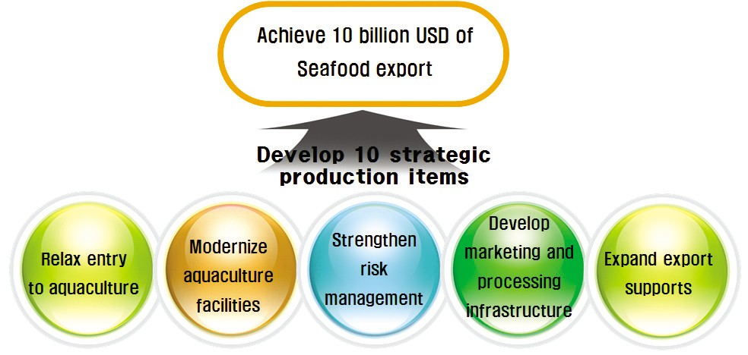

[Figure] Development plan for the 10 strategic production items

Contact information Name: Lee, Jung-sam
E-mail: jlee8793@kmi.re.kr Tel: +82-2-2105-2917

03

•A study to select a PMC company for coastal protection and management under climate change
•A Study on the integration of the Busan Fisheries Whole Sale Market and the Joint Fisheries Market
•A study on fairer and more transparent shipping charges
•The study on sustainable development of uninhabited islands
•Operation of the International Logistics Investment Analysis Center (3rd)
•Master plan for salmon industry in Yangyang-gun
•A basic plan for the comprehensive development of fishing villages
•The 1st stage development of the Shipping Market Information Network
•Modernization of Vietnamese Ports: sharing of Korea's experience
•A validity study on the establishment of the Jeju shipping authority
•Systemic improvement and ship finance for domestic production of national flag carriers
•Foundation for the Solar Salt Traceability System and Pilot Projects
•Action plans for building a fisheries distribution logistics center at consumption areas
•Plans to attract the ocean plant equipment industry and relevant companies
•A basic study on the development of the seafood complex in Donghae City
•A study on the development of intelligent subsea tree
•The 1st National Basic Plan on Maritime Affairs and Safety
•Safety measures for the exploration at the 8th mining area in the East sea
•A study on cruise passengers, facility demand and business value of the Incheon Port
•A validity study on logistics facility development in Southeast Asia
•Development of guidelines for ecosystem-based management
•A study on the introduction of ship financing
•Cooperation on multi-lateral marine environment of East Asia
•Basic plan for the comprehensive development of areas nearby Busan station
•Utilization of managerial right of port facilities at the Kyungin Port
•Domestic commercialization of CO2 storage at the ocean underground
•A study on the designation and management of marine protected species

Research Projects

•Land based pollution management and total pollution loads management (2nd)
•The enactment of the Aquaculture Industry Development Act and eco-friendly aquaculture
•A validity study on Phuoc An Port in Vietnam
•A study on the marine ecosystem industry
•2011 National Transportation Survey and Database
•Comprehensive port development plan (Chungchungnamdo)
•A price analysis on imported fisheries products
•A validity study on the Pohang new port’s swell improvement and its effects
•Negotiation governance for international fisheries bargaining power
•High value added fisheries development and export expansion
•Securement and management of new financial resources for Fisheries Development Fund
•Technology development for smart green container terminal
•A validity study on economic feasibility and financial analysis of port and logistics in the Philippines
•The study on the implementation of the single shipping market for ASEAN
•A study on long-term development of coastal passenger transportation industry
•Port basic plan system improvement for effective port policy implementation
•2011 port demand prediction
•Systemic response to international agreements on marine biological resources (2nd)
•An analysis on the Norwegian mackerel production and distribution system
•Demand prediction and validity study for Ganggu port development
•A validity study on Jeju-metropolitan area comprehensive logistics center
•A study on the development of mudflat fisheries
•Marine academic SOC international development and mid- and long-term development
•A study on mudflats affected by oil spill
•Cleaning methods for areas near by Busan Port

•The estimation of the car ferry cargo throughput and passenger demand at Incheon international passenger terminal
•Shipping & logistics crisis management system development and K-C-J logistics information standardization
•A study on domestic shell fish production area hygiene management
•Implementation system for integrated coastal management plan
•Introduction of ITQ fisheries resource management system
•The basic plan on sea areas under environmental management and plan for each sea areas
•Establishment of integrated logistics network for advancement into ASEAN
•The impacts of small fish catch on fisheries resources and demand/supply
•Northern and Northwestern part of Sri Lanka Aquaculture Development (2011 Yeosu project 2nd year study)
•A study on the South and East-South sea of Grenada (2011 Yeas project 2nd year study)
•A study on close cooperation between ports in Northeast Asia
•North Korean port basic plan
•Cameroon's coastal protection/development plan scenario and master plan
•Consigned operation of 2012 shipping, port, logistics information center

International Cooperation
04

The Symposium for Active Green ODA in Maritime and Fisheries Sector

- Time & Place: December 13, Palace hotel
- Topic: New direction for ODA in maritime and fisheries sector
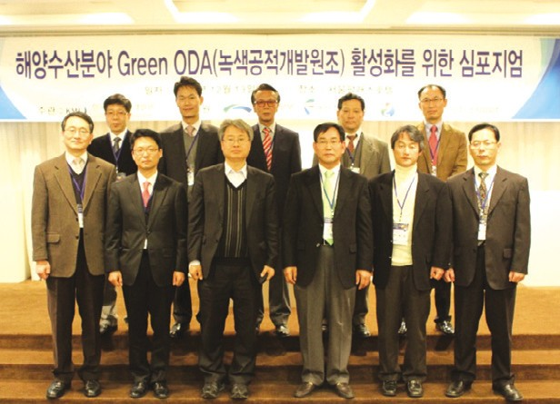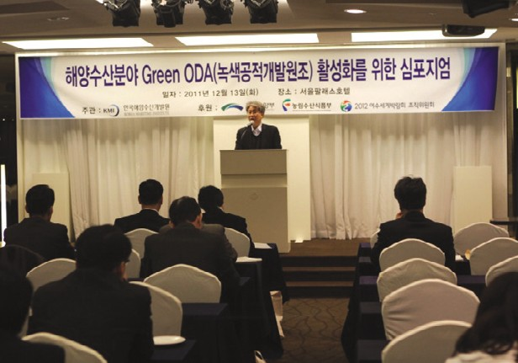
Source: KMI
Source: KMI

The Seminar on National Strategies to Expand ODA in Maritime and Fisheries Sector

- Time & Place: December 2, KMI
- Topic: Ocean color satellite observation of environmental changes
- Presenter: Son, Seung-hyun (Ph.D, NOAA)

The Fisheries Seminar with Overseas Scholar

- Time & Place: December 14, KMI
- Topic: New Forms of Marine Governance: Aspiration or Reality?
- Invited Scholar: Professor. Svein Jentoft (Norwegian College of Fishery Science, University of Tromso, Norway)
- 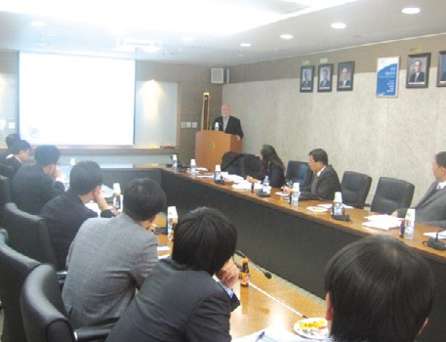Participant: Fisheries Policy Research Div., Ministry for Food, Agriculture, Forestry and Fisheries, and Korea Voluntary Management Association
Source: KMI

The Preparatory Meeting for Mongolia Shipping Cooperation Seminar

- Time & Place: December 13, MLTM
- Topic: The 3rd Korea-Mongolia Shipping Cooperation Seminar
- Sponsored by: Director general for shipping policy, MLTM

The Korea-China International Workshop

  - Time & Place: December 16, Di Jon Hotel, Shanghai
  - Topic: Latest logistics technology in Korea and China and the policy workshop

The 1st KMI-WTI Logistics Forum

  - 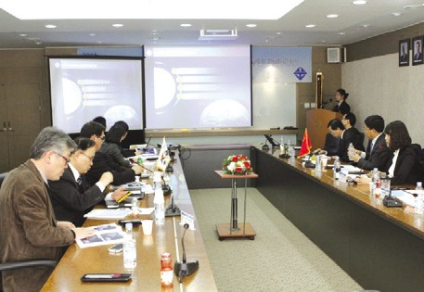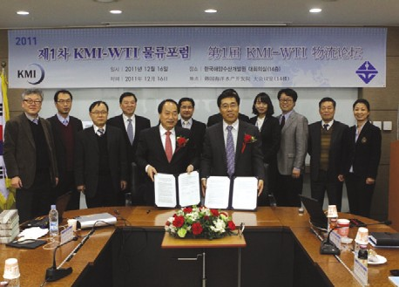Time & Place: December 16, KMI
Source: KMI
Source: KMI

The 2nd Overseas New Project Briefing

- Time & Place: December 19, KITA
- 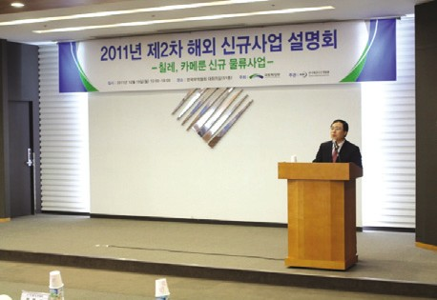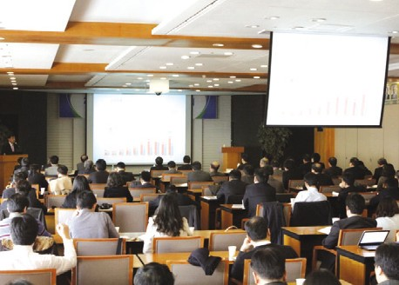Topic: Briefing on new logistics projects in Chile and Cameroon
Source: KMI
Source: KMI

Korea-Japan International Workshop

- Time & Place: December 20, Riga Royal Hotel, Tokyo, Japan
- Topic: Latest logistics technology and logistics policies in Korea and Japan

The Future Logistics Technology Forum Seminar

- Time & Place: December 27, coex
- Topic: Today and future of Korea’s logistics technology
- Participants: Kim, Sung-jin and Kim, Hak-so (President, KMI)

04. International Cooperation 13

05
News & Announcements

Major Activities Conducted in December, 2011

The Kick-off Meeting for Mud Flat Fisheries Analysis in the Oil Spilled Areas and Mud Flat Fisheries Development
- Time & Place: December 1, KMI
- Participants: Jung, Myung-saeng

The 9th Shipping Colloquium
- Time & Place: December 1
- Topic: Understanding on charter base of dray cargo ship
- Presenter: Jeong, Young-doo (KAMCO ship management)

The 2nd Korea-China-Japan Logistics Development Forum
- Time & Place: December 5~8, Hanzhou, China
- Topic: Korea-China-Japan ex/import logistics informatization seminar and 1st phase integrated information system

The Final Briefing on Commercialization for Aquaculture Insurance Item Expansion
- Time & Place: December 6, Suhyup
- Participant: Ryu, Jeong-gon (Research fellow, KMI)

KIMST Work Consultation Meeting
- Time & Place: December 6, KIMST
- Topic: Exploration of R&D projects in ocean plant dissolution

The 108th KMI Ocean Policy Forum
- Time & Place: December 6, Hotel Shilla
- Topic: Overseas construction and dream for a maritime power
- 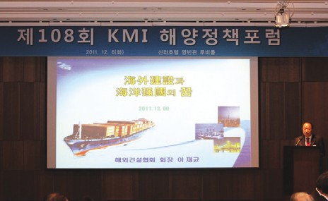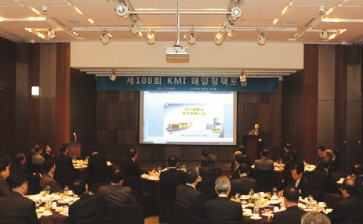Presenter: Lee, Jae-gyun (President, The International Contractors Association of Korea)
Source: KMI
Source: KMI

KMI Ocean Academy-Ocean Education Society Joint Seminar
- Time & Place: December 6, L-tower
- Topic: Active ocean education at school
- Participants: The Ocean Academy Promotion Group, members of the Ocean Education Society, MLTM and Ocean Culture Foundation

The Briefing for Institutional Investors in Ocean Plant Service Industry
- Time & Place: December 8, National Pension Service

The 19th Anniversary of the Foundation of Gyeongnam Development Institute and a Commemorative Seminar
- Time & Place: December 9, Gyongnam Development Institute
- Topic: Blue economy creation strategies for Gyongnam province
- Presentation: Park, Gwang-suh (Research fellow, KMI)

The Colloquium with Shipping Experts
- Time & Place: December 10, KMI
- Topic: Comparison of tourism/cruise demand prediction methodologies
- Presenter: Lee, Gang-wook (Researcher, Korea Culture & Tourism Institute)

The 3rd Ocean Vision Forum
- Time & Place: December 12, L-tower
- 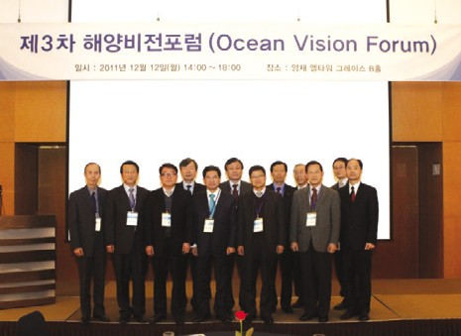Topic: Direction for ocean new industry development
Source: KMI

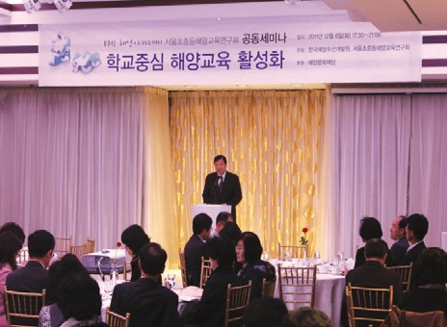
Source: KMI

The Policy Discussion on the Ocean Plant Service Industry Development
- Time & Place: December 19, National Assemblyman Hall
- Topic: Development of the ocean plant service industry and national wealth creation
- 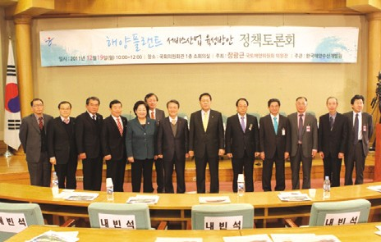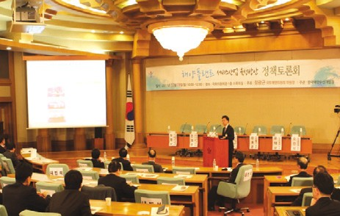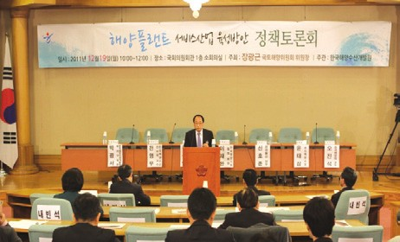Presentation: Park, Gwang-suh (Associate Research fellow, KMI)
Source: KMI
Source: KMI
Source: KMI

The Consultation Meeting for the Development of the Fishing Industry
  - Time & Place: December 20, KMI
  - Participant: Lee, Jung-sam (Researcher, KMI)

The Final Briefing on the 2011 Fisheries Traceability Consignment
  - Time & Place: December 20, MIFAFF
  - Participant: Joo, Moon-bae (Research fellow, KMI)

The Kick-off Meeting on High Value Added Aquaculture and Export Expansion
  - Time & Place: December 26, aT center
  - Participant: Ryu, Jeong-gon (Research fellow, KMI)

2011 4Q International Cooperation Review Meeting
  - Time & Place: December 26, MLTM
  - Topic: International cooperation in 4Q

The Evaluation Meeting of Studies on Ocean Cluster Vitalization in Busan Donsam Innovation Zone
  - Time & Place: December 27, Yongnam Sea Grant

The Kick-off Meeting on International Fisheries Cooperation Governance for Fisheries Bargaining Power
  - Time & Place: December 28, MIFAFF
  - Participant: Choi, Sung-ae (Research fellow, KMI)

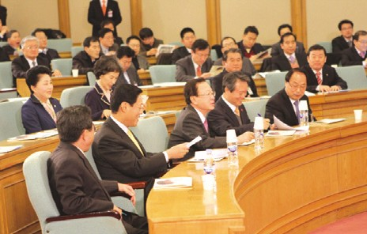
Source: KMI

16 KMI International News Bulletin`Ocean & Futurea

Major Activities Planned in January, 2012

•The Workshop on Maritime Safety Basic Plan
- Time & Place: January 3~5, The Training Institute for Land, Transport and Maritime Affairs
- Topic: Core tasks for each strategy and the final review on general tasks

•The Workshop on Smart Green Container Terminal Construction
- Time & Place: January 5, Busan
- Topic: Plans for smart green container terminal construction
- Participant: Researchers at KMI and Pusan National University

•Visit by the Vietnam Administration for Seas and Islands
- Time & Place: January 8~14
- Topic: Data collection on Korea’s policies and experience in marine science and technology

•KMI Ocean Academy (2012 January Ocean Education Job Training)
- Time & Place: January 10~14, Olympic Parktel
- Participant: 40 teachers at elementary, middle and high schools nationwide (30 hours of job training: 2 credits)

•The Preparatory Meeting for Korea Fisheries Policy CEO Forum
- Time & Place: January 17, KMI
- Topic: Membership maintenance and 2nd forum
- Participant: Kim, Jeong-bong (Research fellow, KMI)

•Preparation for MOU between Tokyo University of Marine Science and Technology and KMI
- Time & Place: January 18~20, KMI
- Participant: Kim, Jeong-bong (Research fellow, KMI)

•The Final Briefing on 2011 Solar Salt Traceability System and Pilot Projects
- Time & Place: January 20, aT center
- Participant: Joo, Moon-bae (Research fellow, KMI)

•The Rehearsal for Fisheries Outlook Conference
- Time & Place: January 27, KMI
- Participant: Kim, Jeong-bong (Research fellow) and T/F member

•The Fisheries Knowledge Sharing Seminar
- Time & Place: January 30, KMI
- Participant: Fisheries Policy Research Div., Global& Future Research Div. and Fisheries Outlook Center

Publisher
Kim, Hak So - President, Korea Maritime Institute

Editor-in-Chief
Kim, Jong Deog - Director General, Planning & Coordination Division

Editorial Board
Lim, Chin Soo - Director General, Ocean Knowledge Management Division Choi, Jae Sun - Director General, Global & Future Research Division
Rim, Jong Kwan - Director General, Maritime Industry Research Division Kim, Bum Jung - Director General, Port & Logistics Research Division Kim, Sung Gwi - Director General, Marine Policy Research Division Kim, Jung Bong - Director General, Fisheries Policy Research Division

Secretary
Kang, Myung Hee - Planning & Coordination Division Chung, Kyung Hwa - Planning & Coordination Division

Contact Information
Address: 21F KBS Media Center Bldg., #1652,
Sangam-dong, Mapo-gu, Seoul, 121-270, R.O. Korea Tel: +82-2-2105-2770, 2984
Fax: +82-2-2105-2730
Email: jdkim65@kmi.re.kr, myungheekang@kmi.re.kr

