ISSN 2093-3584

The KMI News Letter
Ocean & Future

April, 2014. Vol.49

- Opinion

Effective Ways are Necessary to Increase Coastal Cargo Volume
  - Arctic Shipping for Northeast Asia
  - Ever Larger Ships Ask for Responsive Measures in Port and Cargo Handling Sector

- Ocean Policy

The Enforcement of the New Stevedoring Rate for Busan North Port

- Research Projects

- Research Findings

A Study on the Better Polices of Economic Instruments for Coastal Environment & Ecosystem Conservation
  - Current State of Seafood Restaurant Industry and Development Direction

- KMI News & Events

Effective Ways are Necessary to Increase Coastal Cargo Volume

Coastal cargoes refer to those carried by coastal cargo ships between domestic ports (coastwise service) and in this respect, they are different from im/export cargoes transported through overseas service ships between domestic and foreign ports. With global warming and green house gas reduction topping the global agenda, co asta l transportation i s regarde d as g re ener transportation tool compared to land transportation modes. In fact, coastal transportation1 is leading Co2 reduction in transportation sector of major shipping countries.
Note 1) Coastal cargoes refer to those in port. The figure combined cargoes of both coastal cargo ships and passenger ships.
- Ocean-going cargoes include cargoes of international passenger ships and coastal cargoes include those of coastal passenger ships
- Coastal cargoes in 2013 do not include cargoes of coastal passenger ships.

<Annual Progress of Coastal Container Cargoes (2004-2013)>
Coastal containers (TEU)
600,000

Despite such importance, however, domestic costal cargo throughput has not changed much compared to 10 years ago. Rather, its share out of total seaborne cargoes has cut in half. With ocean-going cargoes increasing 5.6% on annual average since 2001, coastal cargoes have reduced 1.5%. Its share out of total cargoes decreased as well from 18.7% in 2001 to 9.7% in 2012. As for container

500,000

400,000

300,000

200,000

100,000

0

340,429

272,739

168,430

134,615
478,380

378,227

253,354

135,420

390,330

200,386

cargoes, those for coastwise service continued to drop from 340,000 TEU in 2004 to 135,000 TEU in 2008. After turning around in 2008, they kept increasing to hit 478,500 TEU in 2011 until took a dip again from 2012 and dropped to 200,000 TEU in 20132. These ups and downs of coastal container cargoes well show how hard for coastwise service to survive in the market.
2004 2005 2006 2007 2008 2009 2010 2011 2012 2013

Source: SPIDC (www.spidc.go.kr)

Previously, Korean government announced ‘ The Green Transportation Implementation Strategy’ which pledged to increase transportation share of railways (8% as of 2007) and shipping (19% as of 2007) to 20% and

<Annual Progress of Coastal Cargoes (2001-2013)>

Unit: 1,000 R/T

Type 2001 2005 2010 2011 2012 2013 Annual Increase
(2001-2012)(%)
Ocean-going cargoes  (%)  Coastal cargoes  (%)  Total | 610,910 | 754,936 | 966,193 | 1,069,566 | 1,108,538 | 1,123,204 | 5.57
 | 81.3 | 86.3 | 88.6 | 89.5 | 90.3 | 90.5
 | 140,544 | 119,410 | 124,225 | 125,588 | 119,057 | 117,725 | -1.50
 | 18.7 | 13.7 | 11.4 | 10.5 | 9.7 | 9.5
 | 751,454 | 874,346 | 1,090,418 | 1,195,154 | 1,227,595 | 1,240,929 | 4.56

Source: SPIDC (www.spidc.go.kr)

OPINION

  - According to the Korea Transport Institute (KOTI), road transportation emits 6.5 times more Co2 per km compared to coastal transportation.
  - Hanjin Shipping Co., Ltd stopped coastal container transportation on Busan-Incheon route and Gusan-Gwangyang route at the end of 2011. Later, Busan-Pohang route and Busan-Incheon route (both were operated by Hanjin Shipping New Port Co.,Ltd.) stopped operation in Sept 2012 and April 2013, putting an end to coastal transportation by domestic coastal shipping companies.

25% by 2020. It recently expanded subsidies for shift to shipping transportation mode and coastal ship modernization3 to boost coastal cargoes constantly. Despite such efforts, transportation share of railways and

  - In 2014, the Ministry of Oceans and Fisheries announced to increase shipbuilding subsidies by KRW 20 billion to KRW 50 billion for modernization of aging coastal ships.

shipping has decreased or been stagnant at best. This raised eyebrows about effectiveness of the policies.
surveys on coastal cargoes are essential to realize various policies. When these policies continue in harmony with

<Domestic Cargo Transportation (ton-km, 2001-2010)>

Unit: %

Year
Road |  |  | Railways | Shipping | Aviation | Total
For business | For non- business | Sub total
23.61 | 42.25 | 65.86 | 7.60 | 26.41 | 0.12 | 100.0
23.59 | 41.60 | 65.19 | 7.64 | 27.05 | 0.12 | 100.0
24.81 | 43.75 | 68.56 | 7.71 | 23.62 | 0.12 | 100.0
26.56 | 46.83 | 73.39 | 7.73 | 18.77 | 0.12 | 100.0
26.83 | 47.31 | 74.15 | 7.09 | 18.66 | 0.11 | 100.0
26.99 | 47.58 | 74.57 | 7.22 | 18.11 | 0.10 | 100.0
26.39 | 46.54 | 72.93 | 7.57 | 19.41 | 0.09 | 100.0
25.72 | 45.36 | 71.09 | 8.11 | 20.74 | 0.07 | 100.0
26.82 | 47.28 | 74.10 | 6.93 | 18.88 | 0.08 | 100.0
27.42 | 48.36 | 75.78 | 6.95 | 17.16 | 0.11 | 100.0

2001
2002
2003
2004
2005
2006
2007
2008
2009
2010
Source: KOTI, 「Nationwide/areal cargo transportation analysis」

To put it adequately, coastal shipping companies are on the brink of extinction. Long time consumption pushes down price competitiveness and drives way consumers, which reduces coastal cargo throughput in turn. Heated competition at transportation market cuts down transportation rates, which invites worsening management. Such vicious cycle tends to set in the coastal
players at coastal transportation market, domestic coastal cargo transportation will be able to open a new era.

< Coastal Cargo Share by Item (2001-2013)>

Unit: %
%
35.0

shipping industry.

Before the trends become permanent, government should come up with comprehensive and effective

30.0
25.0
20.0

23.9
15.5
31.8
28.6

21.2

19.4

25.5

23.4
15.1

24.8

21.3
14.8

prescriptive measures. Top on the list is supply of tax-free
15.0
12.3 12.2 12.6 13.5

oil for coastal ships. When fairness is considered compared to ocean-going ships and fishing ships, it is urgent and the most effective to provide coastal ships
10.0
5.0
0

8.3
8.1
9.7

8.8

10.9
12.2

with tax-free oil. Moreover, subsidies for shift to shipping transportation mode and coastal ship modernization need to be expanded both in quantity and quality. In order to secure stable throughput, measures to facilitate coastal containers and coastal container transportation should be reviewed. Cargoes which account for large share in total coastal cargoes can be designated as ‘specific cargoes’ and ‘modal shift measures for those specific cargoes’4 needs to be examined as well. In addition, basic
2001년 2005년 2010년 2013년
Cement Sand Other minerals and products Oil refined products Steel and steel products Others

Contact information Name: Lee, Ho-Choon
E-mail: leehochoon@kmi.re.kr Tel: +82-2-2105-2744

  - The plan analyzes individual distribution route of oil refined products, sand, steel products and cements which take up large share out of domestic coastal cargoes. It reviews possible change of their transportation mode from road and railway to coastal transportation.

Arctic Shipping for Northeast Asia

The Japanese Ministry of Land, Infrastructure, Transport and Tourism recently announced its plan to set up a committee or consultative body to promote Japanese involvement in Arctic shipping. The Ministry will try to help Japanese shipping companies as well as utility or resource companies to better use Arctic trade routes by sharing information or knowledge on, especially, Russian icebreaker services and costs. There is also hope for joint operations or voyages among Japanese companies. Taking advantage of a shorter distance via the Northern Sea Route (NSR) than through the Suez Canal, three vessels loaded with naphta and LNG (Liquefied Natural Gas) arrived in Japan last year.

OPINION

Japan has been interested in studying the NSR since the early 1990s. A Russian ice-breaking cargo vessel named the Kandalaksha ran an experimental voyage from Yokohama, Japan to Kirkenes, Norway in 1995. Despite the increasing number of voyages with opening of the Arctic shipping passages, only a few Japanese shipping companies tried to use the NSR due to economic reasons since the first transit by a Japanese-owned ship named Sanko Odyssey in 2011. The relatively expensive transit fees imposed on Russian icebreaking services, hazardous and risky operational conditions in the Arctic, additional insurance premiums, slow sailing speed in icy areas and unexpected waiting time for icebreakers still make the NSR economically non-viable against reduced fuel consumption and sailing time. However, the Japanese government is going to tackle uncertainties and risks involved in Arctic shipping in the hope of transporting more LNG or iron ores to Japan.

China, one of the largest energy and resource importers, has shown strategic ambitions in Arctic shipping when the Yong Sheng of the state-owned COSCO Shipping sailed through the NSR from Dalian, China to Rotterdam in the Netherlands with cargoes of steel and heavy equipment last year. The voyage took 35 days, around 10 days shorter than that via the Suez Canal. The NSR is becoming commercially feasible as a European-Asian corridor. Chinese shipping interests are hoping they will have more Arctic maritime trade in the years to come.

Korea, meanwhile, successfully conducted a pilot
voyage with Korean officers on board a chartered vessel of the Stena Polaris. Hyundai Glovis, a Korean company, in collaboration with Stena Bulk, a Swedish operator, transported naphtha from Russia to Korea in 2013. The Korean Ministry of Oceans and Fisheries plans to promote a commercial shipping potential in the Arctic Ocean. The Korean government hopes its shipping industry will gain a new opportunity to learn operation procedures and know-how in Arctic shipping as the sea- ice coverage declines. Since most of Korean shipping companies have neither ice-class vessels nor prior experiences in Arctic shipping so far, many voyages through the NSR are conducted by European or Russian operators. In addition to the governmental plans to participate in port and infrastructure development with Russia, the Korea Institute of Maritime and Fisheries Technology, a special agency to train sailors, is going to work closely with the Admiral Makarov State Maritime Academy in Russia, in areas of ice navigation, training of ice navigators, and etc.

The three countries, China, Japan and Korea, in Northeast Asia have already obtained permanent observer status in the Arctic Council and are trying to participate in and contribute to the development of the Arctic region. In terms of Arctic shipping, however, there are common interests in securing relevant cargoes and transporting them with their own ships. Currently, most cargoes like LNG, gas condensate, naphta, iron ore, and etc. are shipped eastbound to consumers in Northeast Asia. On the other hand, there are limited cargoes for westbound ships, with some exceptions of jet fuel or diesel. Thus, many vessels sailed through the NSR take ballast voyage or repositioning on the backhaul.

In this regard, there will be a window of opportunities for China, Japan and Korea to work together to make the NSR more economically viable. First, they can share information on navigation and weather conditions. Also, they can establish a platform to communicate in distress or emergency situations, buttressing safety and protection. Provided, joint and cooperative Arctic shipping among the three countries would ensure more effective access to the Arctic Ocean. The Northeast Asian countries could procure relevant cargoes together, cultivate ice navigators or officers under exchange

programs, build up navigational capacity by joint or caravan voyages and secure necessary infrastructure or facilities by co-investment.

Having cooperative platforms among these new participants in Arctic shipping, more efficient and environmentally friendly or risk-reduced navigations would be possible. Large reductions in sailing times and f uel consumption with higher confidence and
predictability should provide private shipping companies with more stable and informed advantages in the decision making process to trade off uncertainty and risk.

Contact information Name: Choe Yung-sok
E-mail: yschoe@kmi.re.kr Tel: +82-2-2105-2992

Ever Larger Ships Ask for Responsive Measures in Port and Cargo Handling Sector

Love for larger ships continues

Despite economic recession, global shipping companies continue to opt for larger ships. According to the order they placed, 283 ships of 10,000 TEU or larger and 26 ships of 16,000 TEU will be run on the route by 2015. In February 2013, the world’s largest container vessel of 18,000 TEU (of Maersk Group) was finally built

and launched and the United Arab Shipping Company (UASC) is thinking of ordering a vessel of 20,000 TEU. The industry watchers and organizations expect vessels with 24,000 TEU to be introduced soon. Mr. Andrew Penfold of Ocean shipping Consutants said at the 2013 TOC Europe conference that container vessels of 22,000 to 24,000 TEU would come to the market within years. Mr. Neil Davidson of Drewry Shipping Consultants Ltd. also voiced similar forecast that vessels of 22,000TEU

Future cargo handling system will be different

Nations beef up their responses to climate change while global shipping, port and logistics industry set the goal of halving CO2 emissions. Europe is implementing carbon trading system and Korea will follow the suit in 2015. There are rising needs for CO2 zero ports. Ports should emit zero CO2 if any are to be built after 2020 to meet the pledge goal of reducing GHG emissions by 30% compared to the BAU level by 2020. At CO2 zero ports, all equipment have electric powers or carbon free batteries. Port automation is worldwide trend and automation system will be installed at most of ports within 20 years. This will greatly contribute to enhancing operation competitiveness of port logistics companies. The operator of Busan North Port strongly wants to advance its operating system as automatic as Busan New Port.

Year | 1993 | 1996 | 2002 | 2006 | 2008 | 2010 | 2011 | 2012 | 2013 | 2014
Number | 1 | 1 | 2 | 1 | 1 | 3 | 4 | 3 | 4 | 3
AN | 1 | 2 | 4 | 5 | 6 | 9 | 13 | 16 | 20 | 23

Source: KOTI, 「Nationwide/areal cargo transportation analysis」

would enter the scene in early 2018. Very large container vessels will continue to be built until 2020 due to various reasons. The economy of scale (unit cost per TEU) reduce shipbuilding price and larger ships help to cut down greenhouse gas emissions.
If the 2013 MacKinsey report is any guide, the size of port logistics technology market (incl. port equipment and IT) will reach USD 182 billion by 2030. This translates into KRW11.1trillion each year. If port infrastructure market is included, a large market worth

USD 882 billion will be created. 5 Technological development for new types of container terminals can boost export of Terminal Operating System (TOS), automation system and port equipment in new concept.

New sophisticated equipment at domestic ports and needs for replacement of old ones

Cargo containerization and universal unit use for general cargoes are expediting mechanization of cargo handling equipment. Cutting edge technology, IT, computers and the latest cargo handling equipment
streamlined the process, posting remarkable efficiency. When vessels of 25,000 TEU enter the scene in 2020, customers, such as shipping companies and cargo owners want faster handling of cargoes. This, in turn, will lift demand for high-functioning and large scale cargo handling equipment. In general cargo handling, high functioning and automotive equipment reduce ship turnaround time and operating costs, pitting ports each other for higher competiveness. Excluding the latest and large container terminals, many aged equipment are still under operation well over their replacement time. Their future replacement will certainly incur huge costs.

  - The report expects that a total of USD 57.3 trillion will be invested in basic infrastructure such as road (USD16.6 trillion), railway (USD 4.5 trillion), port (USD 0.7 trillion), airport (USD 2 trillion), power generation (USD 12.2 trillion), water (USD 11.7 trillion) and communications (USD 9.5 trillion) over 18 years from 2013 to 2030. Investment into road, railway, port, airport and logistics infrastructure will constitute 41.5% of investment into the whole infrastructure, or USD 23.8 trillion. Investment into port and logistics technology (port equipment and IT) accounts for an estimated 26% out of investment into port infrastructure.
Contact information Name: Kim Woo-sun
E-mail: firstkim@kmi.re.kr Tel: +82-2-2105-2889

OCEAN POLICY

The Enforcement of the New Stevedoring Rate for Busan North Port

Container stevedoring rates refer to fees imposed on loading and unloading of cargoes at container terminal. Before 1998, the Korean government carried out the standard fare policy to be observed by the industry. Since 1998, market deregulation and requests of the time changed the standard rate system into competitive rate setting system in which container terminal operators voluntarily decide the stevedoring rates.

OCEAN POLICY

However, global economic slowdown in the late 2000s stalled container throughput increase, setting off fierce competition over cargoes between container terminal operators. Accordingly, container stevedoring rates nosedived and account balance of terminal operators got deteriorated. Since then this has posed serious problems to domestic container stevedoring market.
In response, the Ministry of Oceans and Fisheries is planning to re-introduce the standard rates directly set by the government, putting a brake on the current rate system where the industry decides the rates.

Considering current condition of container stevedoring market, the ministry will calculate the standard rates and introduce them to the market. The new rates are to be temporarily used for three years from September 2014 to 2018. The new system is expected to help the industry to reduce loss resulted from excessive competition and to turn around the normal market.

By the way, this adequate rate system will be used only at Busan North Port temporarily. This can raise logistics costs borne by shipping companies and cargo owners, making policy implication difficult as well. On balance,

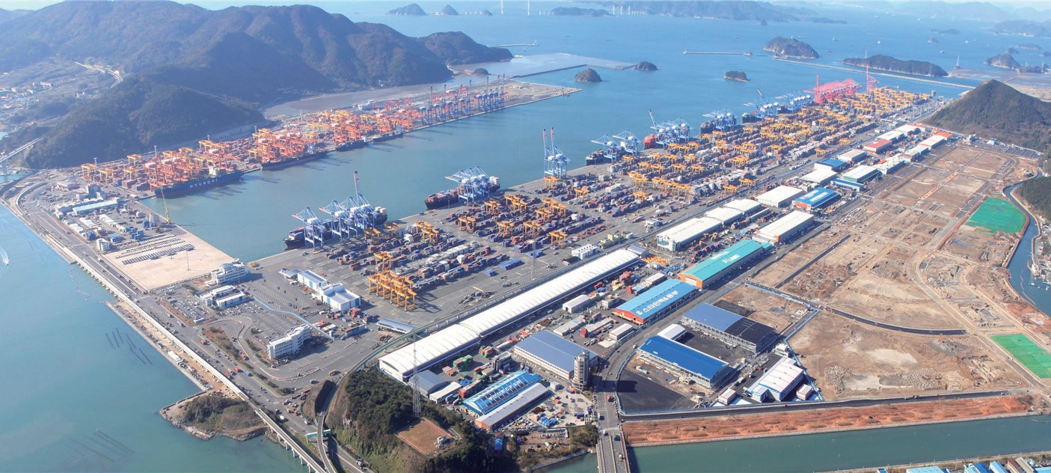

however, we hope that this adequate rate system relieves encouraging companies to improve service quality rather excessive competition at domestic container market, than pushing down stevedoring fees.

Contact information Name: Ha, Tae-Young E-mail: haty@kmi.re.kr Tel: +82-2-2105-2887

RESEARCH PROJECTS

- The 2nd fishing village and fishing port development plan
- Mid- and long-term plan on maritime safety future
technology
- A study on domestic commercialization of CO2 ocean
storage
- A study on policies for domestic commercialization of
CO2 ocean capture/storage
- TPP study in depth: fisheries sector
- R&D planning for integrated coastal management
- Institutional improvement for active logistics service at
Northeast oil hubs
- Strategies for negotiation on TPP fisheries subsidies
- Measures to enter the shipping and logistics market in
the Far East Siberia
- Responses to UN fish stock agreement the 10th
unofficial conference of parties
- Development of fisheries distribution and processing
technology
- Support for private-government-industry-academia committee at Ulsan & Gwangyang coast
- A study on the basic planning of maritime territory
management
- Analysis on Korea-Thailand, Korea-Malaysia FTA
(fisheries sector)
- Development of coastal erosion response technology
- A review on Donghae-Mukho port project proposal and
its validity
- A study on fisheries distribution system improvement
- Measures to use waterside of Incheon Port
- Korea's experience sharing with Saudi Arabia for its
land or coastal aquaculture
- Policy measures for modernization of offshore fishing

boats
  - A study on fisheries entrance into the Arctic Ocean
  - Abandoned wells for undersea tests of ocean drilling
equipment
  - Introduction of total pollution load management system
on Busan special management waters
  - A study on overseas port development cooperation
  - Issue development for response to international
organizations in shipbuilding and ocean sector
  - Foundation technology for the U-based shipping and
logistics system-policies for container searcher use
  - Port redevelopment project for Incheon yongjong island
dredged oil dump area
  - A validity study on small fishing grounds for fishing
villages (Mayhyang 2)
  - The basic plan on the operation of marine economic
special zone
  - Development of low carbon automation container
terminal technology
  - Korea-China-Japan transportation and logistics
cooperation measures
  - Foundation for self management fisheries cultivation
and support
  - A study on Busan Port Comprehensive Development Plan
  - Tasks and direction for reciprocal fisheries relationship
between Korea and Japan
  - Systematic response to international convention on
marine organism (2nd)
  - 2013 increase and restoration of marine life under
protection
  - Results of 2014 Wando International Seaweed Exhibition
  - Management plan per waters for environmental
management
  - A study on 2nd costal development plan (revised)
  - A study on conservation of 2013 marine life under
protection
  - Case studies on city planning against coastal erosion
and maintenance direction
  - Development of unified cargo handling equipment for
less time consumption of cargo vehicles
  - Functional relocation of Incheon port and employment
of dock workers
  - 3-1 stage project on shipping market network
construction
  - A validity study on North Sea Wall construction
(Donghae port 3 stage project)
  - Basic design for marina port base: utilization of marina
port for marine tourism
- Impacts of Korea-Austraila, Korea-Canada and Korea-
New Zealand FTAs
- Improvement measures for port modernization fund
operation system
- Estimation of adequate investment in port
infrastructure and policy direction
- Comprehensive plan on marina port development in
Choongchungnamdo
- A study on improvement and promotion of towage
system
- A study to promote cooperative relation among
Northeast Asian ports
- An estimation of social costs of maritime accidents
- Development of EBSA national report on biodiversity
convention
- Impacts of radioactivity on fisheries and radio activity
pollution cases
- Implementation plans for 'Beautiful Busan Port'
- A survey on promising fisheries export items to China
- Pilot supply and demand forecast under changing
environment and institutional improvements
- Circumpolar sea utilization measures based on analyses on polar policies of major countries and international organizations
- Industrial special categorization of fisheries industry
and statistics
- 2014 analysis on actual condition of beaches and
management types
- A study on environmental standard setting per water
- Follow-up measures to the Arctic Policy Master Plan
- 2014 Masan Bay special management water coastal total
pollution management
- A validity analysis on Boryong multifunctional
development and basic plan
- Regional model development for access to biological
resources and profit sharing
- 2014 operation of international logistics investment
analysis center
- Responsive measures to bilateral and multilateral
shipping service negotiation including Korea-China FTA
- A review on validity of international cruise tourism and
establishment of basic plan
- 2014 national transportation surveys and DB
establishment
- 2014 consigned operation of shipping, port logistics
information center homepage
- Good logistics warehouse certification within port area
- A study on expansion of aquaculture insurance items

A Study on the Better Polices of Economic Instruments for Coastal Environment & Ecosystem Conservation

Purpose

  - The study identified current operation of economic instruments and their matters in improving coastal environment. After analyzing and comparing domestic and international cases, the study presented direction for reorganizing economic instruments for coastal environmental improvement.

–It carried out theoretical studies on economic instruments involving natural capital and ecosystem service and analyzed similar cases at home and abroad to draw implications to Korea.
–It examined the current operation of fees for public water occupancy/usage, targets for the Marine Ecosystem Conservation Fund, its computation methods, fund operation, detailed cases and expert opinion to show problems of economic instruments and basic direction for their better operation.

Methodologies and Feature

Methodologies

  - To analyze statistics on public water occupancy/usage over the last five years (2007~2012) and price of land close to coastal waters based on the KLIS serial cadastral map.

  - To examine similar cases in China, the UK, the US, Germany and Japan and operation of occupancy/usage of public waters in Tongyong City

  - To hold workshops with experts in Chinese water
utilization and to analyze domestic experts’ awareness

Feature

  - The study presented ways to improve economic instruments for coastal management, such as the Marine Ecosystem Conservation Fund. It also suggested better ways for public water occupancy/utilization for shared future value of coastal ecosystem service, fair benefit distribution and realization of ecosystem-based
management.

Results

Summary

- Economic valuation of ecosystem service has long been an important issue from perspectives of evaluating natural resources, biodiversity and non-market goods.

–Economic valuation of ecosystem service is not about considering the service as commodity traded at market, but about helping rational policy decision for economic efficiency of ecosystem and biodiversity, consideration to the future generation and fair use of common asset of the mankind.
–The economic value of coastal ecosystem service is annually estimated at from KRW 40.46 trillion to KRW 42.54 trillion.

- Economic instruments are those which determine natural capital and ecosystem service at market price and internalize ecosystem costs and preference of future generation. Examples are allotment, charge, usage fees and environmental subsidies.

–The Marine Ecosystem Conservation Fund was established in 2006. A total of KRW 37.5 billion was imposed on 162 cases from 2007 to 2011. The money became vested in the Fisheries Development Fund.
–The Public Water Occupancy/Use Fee was introduced in 1962. As of 2012, the number of permissions was 8,946 and the areas under
permission reached 48.84㎢. The total amount of
fees stood at KRW 9.8 billion.
–Between 2007 from 2012, the number of cases and areas continued to increase. However, actual fees for usage or occupancy decreased.

- Similar cases in other countries included the Payment System for Marine Use (China), the Marine License System (the UK) and the Coastal Occupancy/Use Fees (Japan).

–The Payment System for Marine Use was based on the Marine Use Management Act. The fees were divided into the Coastal Occupancy/Use fees and the Fees for Coastal Nature Change. The collected amount was clarified per unit size according to type and areal classification.

RESEARCH FINDINGS
–The Marine Management Organization was in charge of the Marine Licensing of the UK. Acts which required the license were construction, landfill, dredging and incineration. The fees were imposed according to development size.
–The Coastal Occupancy/Use Fees were determined and imposed according to areas based on their characteristics.

  - Generally speaking, land price were determined according to policy, socioeconomic and psychological factors. However, occupancy/use fees of public waters were calculated according to land price (Publicly Notified Individual Land Price). Therefore, the fees failed to reflect environmental conditions or usage characteristics.

–According to category of land close to coastal waters, forest accounted for 35.9% of the lot (64.1% in size). As of 2012, the Individual Land Price per unit (㎡) was KRW 9,334/㎡, much lower than the Average Individual Land Price which stood at KRW 37,178/
㎡.
–Land price close to coastal waters was far lower than the total land price of City, Gun or Gu which were located in coastal areas.
–An analysis on public water occupancy and usage in Tongyong City showed that many of them were exempted from the fees. Special and environmental values of coastal waters as well as environmental impacts were not reflected.

  - According to an assessment on expert awareness, many agreed that economic instruments didn’t reflect coastal or ecological environmental values. They also said that a separate computation system should be prepared according to marine environment and usage characteristics.

–‘Economic benefits,’ ‘ecological environmental conditions’, and ‘current use of neighboring land and water’ should be considered when the computation
system for the Marine Environment Conservation Fund and Public Water Occupancy/Usage Charges are prepared
–A separate account should be prepared to rational operation of the Marine Environment Conservation Fund and Public Water Occupancy/Usage while integrated plan named ‘Coastal Ecosystem Compensation (Charges, tentatively named)’needs to be prepared.

- The study presented measures to improve economic
instruments for better coastal environment.

- To institutionalize economic instruments which consider value and public benefits of coastal ecosystem service
- To determine use purpose of each unit water and to categorize type of public water occupancy or usage
- To expand projects under the Marine Ecosystem Conservation Fund and to modify targets exempt from public water occupancy or usage
–To consider a possible integration of the Marine Ecosystem Conservation Fund and the Public Water Occupancy or Use Charges
- To calculate and notify economic and ecological values of coastal waters on the regular basis
- To introduce the traceability system for coastal water usage projects or acts

Policy contribution

- The study can be used as basic material in computing or improving the Marine Ecosystem Conservation Fund and the Public Water Occupancy or Use Charges

Expected benefits

- The study helps rational and effective operation of economic instruments for better coastal environment and ecosystems

–It presents direction for rational operation of economic instruments by reflecting values of coastal ecological service, characteristics of water environment usage and rational fund operation.

- The study contributes to improving the Marine
Ecosystem Conservation Fund and the Public Water

Occupancy or Use Charges.

– It presents direction for improving economic instruments for coastal environment and ecological management based on the Causer Pays Principle, the Benefit Principle, Prevention Principles, conservation of public benefits and future value.
Contact information Name: Choi, Ji-yeon
E-mail: jychoi@kmi.re.kr Tel: +82-2-2105-2773

Current State of Seafood Restaurant Industry and Development Direction

Purpose

RESEARCH FINDINGS

  - The study aims at presenting future development direction for seafood restaurant industry based on understanding of its actual condition and consumption pattern.

    - It seeks direction for systematic and comprehensive development which will build the foundation for seafood restaurant industry and enhance its competitiveness.

Methodologies and Feature

Methodologies

  - To analyze and draw implications from preceding
studies on food restaurant industry and consumption

  - To understand basic condition of seafood restaurant
industry

  - To conduct surveys with seafood restaurants and
consumers

  - To analyze seafood restaurant industry and hold
advisory meetings with experts

Feature

  - Fisheries consumption at restaurants has been on the rise amid rapid growth of food restaurant industry. Accordingly, there are clear consensus on development
of seafood restaurant industry and great expectations for connected development of fisheries industry. Nevertheless, research on seafood restaurant industry remains insufficient.

- Under the theme of seafood restaurant industry, this study conducts an empirical analysis on seafood restaurant industry and seafood consumption preference by the industry. Based on the results, it analyzes condition of seafood restaurant industry and seeks out its development direction.

Results

Summary

- Consumption of seafood through food restaurant industry is rapidly increasing. Moreover, given population and sociological prospects, the consumption will continue to grow. Therefore, development of seafood restaurant industry will help domestic fisheries and processed seafood products to grow, while advanced fisheries industry (rear industry) will contribute to increasing production of seafood restaurant industry and its added value. (input - output analysis)

- As domestic food restaurant industry takes a turn, seafood restaurant industry (particularly, seafood restaurants) is targeting high-end market and getting diversified in kind and size, responding to more sophisticated consumption trends.

– As for seafood usage and purchase, purchase of

original or trimmed products accounted for the largest share. As for consumer preference, food hygiene/quality and domestic fisheries are favored while imported ones are consumed due to their price and supply stability. Difficulties faced by seafood restaurant industry include rising price of food materials, high labor costs and agile responses to market changes. Therefore, pending issues are about building stable seafood material supply system, providing funds to seafood restaurant industry and promoting seafood consumption.

  - Amid rapid growth of seafood consumption at restaurants, sashimi and steamed dishes were found to be the favorite menu consumed at restaurants.

    - Aged consumers and those in high income bracket showed the highest rates of seafood consumption at restaurants. Popular menus for them were dishes which could not be easily cooked or processed at home. Meanwhile, ‘country of origin’ and ‘hygiene at restaurants’ became important as food safety emerged as a major issue.

  - Development direction for seafood restaurant industry
and policy suggestions

    - While Korean seafood restaurant industry is changing rapidly and responding to consumer preference, governmental responses have been limited, which requires urgent recognition of new development direction.
    - Development direction: under the vision of ‘Seafood Restaurant Industry with High Added-value based on Fisheries and Seafood,’ detailed direction are suggested as follows; ‘categorization of seafood restaurant businesses and industry,’ ‘inclusion of seafood restaurant industry into fisheries policy targets,’ ‘support for higher competitiveness of seafood restaurant industry,’ ‘better quality of domestic seafood materials,’ and ‘effective response to rising seafood consumption at restaurant.’
    - Policy suggestions: related regulations improvement and management system for seafood restaurant industry promotion, basic research on seafood restaurant industrial condition, improvement of supply base raw materials, fostering of professionals in the industry and support for good business cases
and foundation to expand seafood consumption at restaurants

Policy contribution

- This study acts as basic materials in preparing policies for seafood restaurant industry as well as seafood supply and demand.

- Policies for seafood restaurant industrial develop- ment
- Policies for supply and demand of domestic fisheries
- Policies for seafood restaurant industry and related development of domestic fisheries industry

Expected benefits

- This study will help to secure domestic fisheries
consumption base.

– With rising seafood consumption at restaurants, this study presents development direction for seafood restaurant industry to satisfy consumer preference. This will help to expand seafood consumption base.

- The study helps producers to secure markets and boosts
linked development of domestic fisheries industry.

– It helps to diversify domestic production areas and to improve their supply foundation to expand supply of seafood materials for food restaurant industry. Eventually, it will induce related development of fisheries industry.

- Other benefits

– The study provides those in the industry with information on seafood restaurant industry and seafood use/distribution.

Contact information Name: Lim, Kyung-hee E-mail: imkh@kmi.re.kr Tel: +82-2-2105-2852

Major Activities conducted in March, 2014

The 9th KMI Shanghai Logistics Forum with CEOs

- Time & Place: March 14, Marriott, Jangping
- Topic: IMO's greenhouse gas regulations and shipping,
shipbuilding and logistics paradigm shift
- Purpose: Network building in Shanghai, introduction of logistics strategies and policies and discussion on major issues

The NPARC Seminar

- Time & Place: March 18, Ocean Suites, Jeju
- Topic: Arctic issues and network building

2014 Inter-Korean Fisheries Cooperation Seminar

- Time & Place: March 20, the K-Seoul hotel
- Topic: Inter-Korean f isheries cooperation as a foundation for the unification era

Major Activities Planned in April, 2014

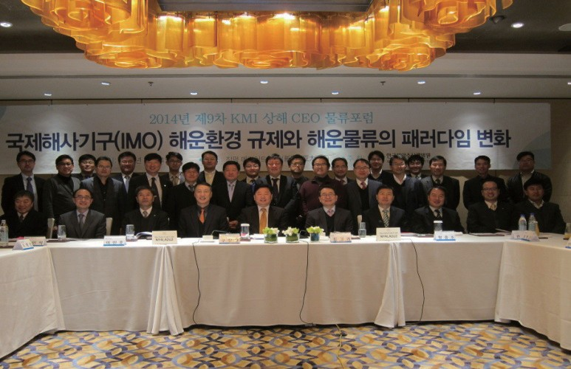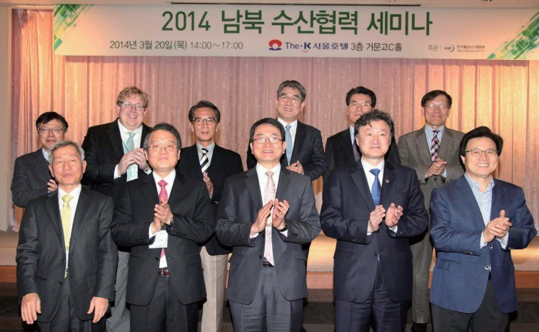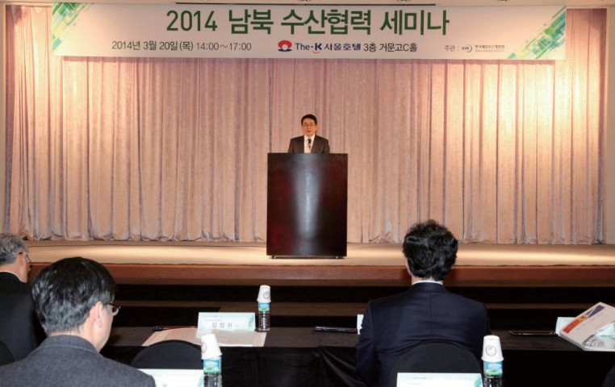The Yanbian International Seminar

  - Time & Place: April 11, Yanbian Baishan Hotel
  - Topic: Northward logistics changes in Northeast Asia and future strategies
  - Participants: Members of inter-Korean maritime and fisheries advisory committee and governmental officials

2014 International Colloquium by Future Logistics Technology Forum

- Time & Place: April 17, Korcham
- Topic: World latest logistics technology trends

Publisher
Kim, Sung Gwi - President, Korea Maritime Institute

Editor-in-Chief
Choi, Jae Sun - Director General, Planning & Coordination Division

Editorial Board
Mok, Jin Yong - Director General, Marine Policy Research Division
Joung, Myung Saeng - Director General, Fisheries Policy Research Division Kim, Woo Ho - Director General, Maritime Industry & Safety Research Division Jun, Chan Young - Director General, Port Policy Research Division
Kim, Jong Deog - Director General, Strategy Research Division

Secretary
Kim, Yu Jin - Planning & Coordination Division
Chung, Kyung Hwa - Planning & Coordination Division

Contact Information
Address: 21F KBS Media Center Bldg., #45, Maebongsanro, Mapo-gu, Seoul, 121-915, Korea
Tel: +82-2-2105-2700
Fax: +82-2-2105-2800
Email: jschoi@kmi.re.kr, kimyujin@kmi.re.kr

